**Title**

Cascading palaeoclimate interactions affect origination rates of marine genera

**Abstract**

Biodiversity dynamics are shaped by a complex interplay between current conditions and historic legacy. While a simple relationship is often used to link evolution with temperature, short-term climate change likely interacts with previous temperature trends when influencing the pace of origination. Such palaeoclimate interactions have been demonstrated for extinction risk but the effect on evolutionary dynamics is untested. Here we show that origination probability in marine fossil groups is strongly affected by palaeoclimate interactions. Short-term cooling adding to a long-term cooling trend increases the origination probability by 24.4% on average, 95% Confidence Interval [23.8%, 24.9%] . This large effect is consistent through time and all studied groups. The mechanisms of the detected effect might be manifold but are likely connected to eustatic sea level drop caused by sustained global cooling, resulting in increased allopatric speciation. This complex and cascading nature of palaeoclimate interactions might explain the ambiguous conclusions of previous studies on the relationship between temperature and diversity.

**Introduction**

Biodiversity responses to modern climate change are dependent on past climate (Antão et al., 2020; Mathes et al., 2021; Svenning et al., 2015). Palaeoclimate was an important driver of both extinction and diversification dynamics in the Quaternary (Lister, 2004; Maldonado-Coelho, 2012; Postigo-Mijarra et al., 2010; Svenning et al., 2015). However, the effect of palaeoclimate on deep-time origination dynamics is largely unknown.

Palaeoclimate might affect origination dynamics through a wide variety of ecological mechanism. If short-term change adds to a long-term temperature trend in the same direction (e.g. a short-term cooling following a prolonged cooling trend), species are more likely to loose adaptations to the climatic situation due to niche conservatism (Hopkins et al., 2014; Stigall, 2014; Wiens & Graham, 2005). This maladjustment might result in bottleneck and subsequent founder effects, as well as ecological releases (Button, 2017; Gilman et al., 2010; Raup, 1979). These ecological effects have been shown to influence rates of evolution and speciation (Templeton, 2008; Wahl et al., 2002). Additionally, palaeoclimate can hypothetically drive origination rates of marine genera through global sea level changes, affecting the amount of habitat fragmentation in the continental shelf area. Habitat fragmentation and loss is known to be correlated to the rate of ecological interactions (Schuler et al., 2017; Tilman, 1994; Valentine, 1968) and speciation rates (Alroy, 2008; Mayr & O’Hara, 1986).

Building on these ecological concepts through which palaeoclimate might affect origination dynamics, we expect that the interaction between climate change with previous temperature trends is a strong determinant of origination rates in the deep-time fossil record. We explicitly hypothesize that origination processes are stronger influenced by temperature change if the change adds to a previous temperature trend in the same direction (synergistic palaeoclimate interaction) rather than if the focal change withdraws previous trends (antagonistic palaeoclimate interaction).

Here we analyze how global trajectories of palaeoclimate can affect origination probabilities of twelve marine fossil phyla in the last 485 million years (Annelida, Arthropoda, Brachiopoda, Bryozoa, Chordata, Cnidaria, Echinodermata, Foraminifera, Hemichordata, Hyolitha, Mollusca, Porifera). We use palaeoclimate interactions as explanatory variables, which are defined as the interaction of short-term climate change with long-term temperature trends. We first apply regression models using traditional palaeo-temperature variables and sample-standardized genus-level fossil data. We then test whether cumulative palaeoclimate interactions increase the origination probability of fossil taxa. Our results show, on average, a substantial increase in origination rates whenever a short-term cooling adds on a long-term cooling trend. To estimate whether this increase is caused by a reduction in available habitat space subsequently to cooling-cooling palaeoclimate interaction, we then analyzed the effect of a proxy for shelf-area habitat space on origination rates using the same modeling framework.

**Results**

*Origination probability*

Cooling-cooling palaeoclimate interactions resulted in an increased origination probability (Fig. 2, Suppl. Table 2). We compared the origination probability for marine groups per palaeoclimate interaction, based on the output of our regression models. The overall origination response was on average lower after cooling-warming, warming-cooling, and warming-warming palaeoclimate interactions compared to the average origination probability of 13.4%. On the contrary, cooling-cooling palaeoclimate interactions resulted in an increased mean origination response of 15.1%.

*Effect size*

The effect of cooling-cooling palaeoclimate interactions on origination probability is large (Fig. 3, Suppl. Table 3). The absolute difference between the mean origination probability of cooling-cooling compared to all other palaeoclimate interactions was 4.2 (95% Confidence Interval (CI) [4.1, 4.3]). This difference represents a 31.3% percentage increase compared to all other interactions (95% CI [30.8%, 31.8%]). We evaluated the effect size of cooling-cooling on origination probability using Cohen’s d statistic, a frequently applied measure used to indicate the standardised difference between two means. Cohen’s d for cooling-cooling was greater than 1, indicating a large effect size. All results for the absolute difference, the percentage change, and the effect size are based on generalized mixed effect models and stay consistent when analyzed in a bayesian regression framework.

*Group differences*

We additionally tested whether cooling-cooling palaeoclimate interactions raised the origination probability of all studied marine groups and if the signal remains robust through time (Fig. 4, Suppl. Table 4). This was the case for all major phyla with sufficient data and throughout all 94 geologic stages, as all log-odds values including 95% CI’s were above 0. Among all groups, Arthropoda, Brachiopoda, and Bryozoa showed a higher than average response to cooling-cooling palaeoclimate interactions. Through time, the oldest period (Tremadocian to Lochkovian) showed the highest likelihoods. We hence found a large effect size of cooling-cooling palaeoclimate on origination probability, which remained consistent throughout all studied groups and throughout the whole Phanerozoic.

**Discussion**

The interplay of short-term climate cooling adding to a long-term average global cooling resulted in a profound increase of origination probability. We found this effect to be consistent through time and across all studied groups. Previous studies on the relationship between temperature and origination came to ambiguous conclusions, ranging from a negative relationship (Mayhew et al., 2008), no relationship (Alroy et al., 2000; Prothero, 1999), to a positive one (Mayhew et al., 2012). Our results show that the relationship between origination rates and temperature are dependent on baseline conditions which were not considered in previous analysis frameworks. The large effect size and the cascading nature of palaeoclimate interactions might have obscured or even inverted any apparent relationship between temperature and origination. Explicitly accounting for dynamic interactions in future analysis frameworks will hence provide a more robust foundation to assess the relationship between Phanerozoic marine diversity and climate. This has been recently demonstrated for modern terrestrial and marine assemblages, where biodiversity responses to recent climate change were conditional on the baseline climate (Antão et al., 2020).

Our results are remarkable as we expected to detect a weakened origination signal after cooling-cooling palaeoclimate interactions due to the “common cause” hypothesis (Peters, 2005). Sampling biases caused by low sea levels arise from the removal of originating taxa from the fossil record or a shift of their detection to a later origination datum, leading to an artificially reduced origination probability. These extrinsic biases of fossil data cannot be addressed by sampling standardization (Peters, 2006). The apparently large effect size of cooling-cooling palaeoclimate interactions might hence even be an underestimation of the true magnitude. However, we only tested the effect of temperature on diversity and did not include other environmental parameters potentially affecting origination rates (e.g., sea-level, nutrient inputs, continental dispersion). The large effect size found in this study is thus related to temperature estimates only and could potentially be less relevant when compared to other environmental parameters. Nevertheless, current research shows that temperature remains a significant predictor of origination rates after accounting for additional environmental parameters (Mayhew et al., 2012). Further, temperature can act as a top-down effect, driving the change in other environmental parameters such as sea-level and shelf area weathering. Directly correlating temperature to origination rates, instead of fitting additional mediatory variables, might hence give a more precise estimate of the relationship between climate and evolutionary dynamics.

We emphasize that our results can only provide statistical conclusions, but no causal inferences. Causes for the detected effect might be manifold but are likely connected to eustatic sea level subsidence caused by global cooling. A drop in sea level due to glaciation results in reduced continental shelf area, which is the main habitat for the majority of the studied fossil groups. Increased habitat fragmentation and loss is correlated to the rate of ecological interactions (Schuler et al., 2017; Tilman, 1994; Valentine, 1968) and speciation rates (Alroy, 2008; Mayr & O’Hara, 1986). Low sea levels lead to increased nutrient availability in the marine realm through exposure of continental shelf area to weathering (Broecker & Peng, 1982), a process known to drive genus origination rates (Cárdenas & Harries, 2010). The combination of short-term cooling on top of a long-term cooling trend exacerbates eustatic sea level drop, thus potentially reinforcing habitat fragmentation and loss as well as nutrient availability, leading to increased origination rates.

Cooling-cooling palaeoclimate interactions have been shown to be major driver of temperature related extinctions in the fossil record, with warming-warming interactions showing the same but less severe signal (Mathes et al., 2020). The synergetic combination of same-directional temperature changes is thought to move taxa out of their adaptation space, which is phylogenetically retained (Hopkins et al., 2014; Stigall, 2014; Wiens & Graham, 2005) When the environment changes so drastically that taxa are no longer adapted to it, they will either migrate, adapt through evolutionary change, or go extinct (Nogués-Bravo et al., 2018). During warming-warming palaeoclimate interactions, marine taxa could potentially escape adverse environment through range shifts. During cooling-cooling, however, geographic barriers resulting from sea level drop might impede migration, resulting in the observed increased extinction risk (Mathes et al., 2020) and origination probability (this study).

Our study shows that evolutionary processes interact with climate by complex cascading effects. Explicitly integrating these effects within a dynamic modelling framework leads to an improved discernment of origination patterns in the fossil record. Previous studies on the relationship of temperature and biodiversity in Earth’s history came to ambiguous conclusions, a non-conformance likely to be fixed in the future by accounting for palaeoclimate interactions. However, the mechanisms underlying the large association between evolution and the observed effect are still unclear. The interpretation offered here, a combination of niche conservatism and ecological effects arising from sea level change, could be at least partially tested by comparing responses of terrestrial and marine fossil groups to palaeoclimate interactions. If sea level subsidence plays a key role, terrestrial groups should show a significantly lower response to cooling-cooling than marine groups. Given the large effect of palaeoclimate interactions on both extinction and origination, as well as the consistency of this effect through time and studied groups, determining the underlying causes of palaeoclimate interactions will improve our mechanistic comprehension of evolutionary dynamics in Earths history (Jablonski, 2008).

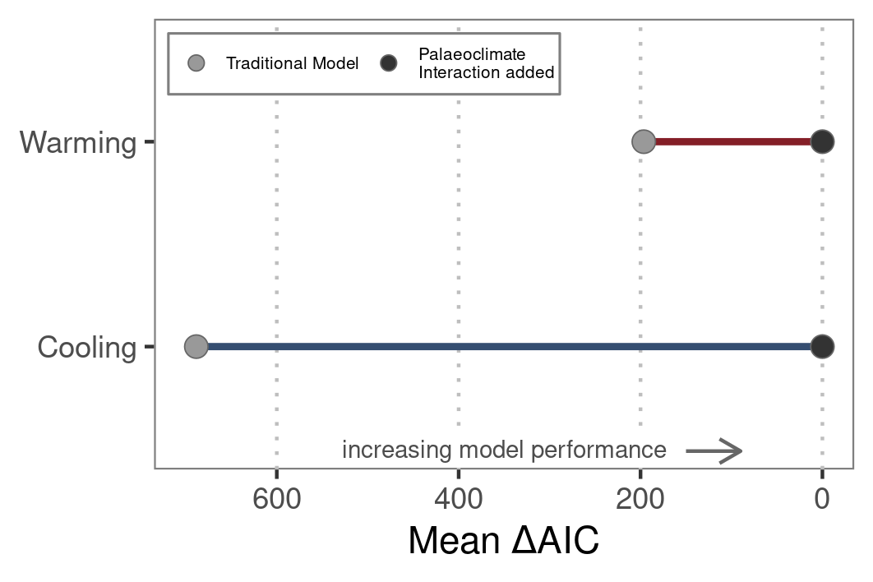Figure 1 | Model comparison. Comparison of model performance for traditional models covering first- and second-order relationships of origination and temperature versus models allowing for palaeoclimate interactions. The latter are based on the same model structure, but explicitly allow for interactions of long-term temperature trends and short-term climate changes within a dynamic modeling framework.

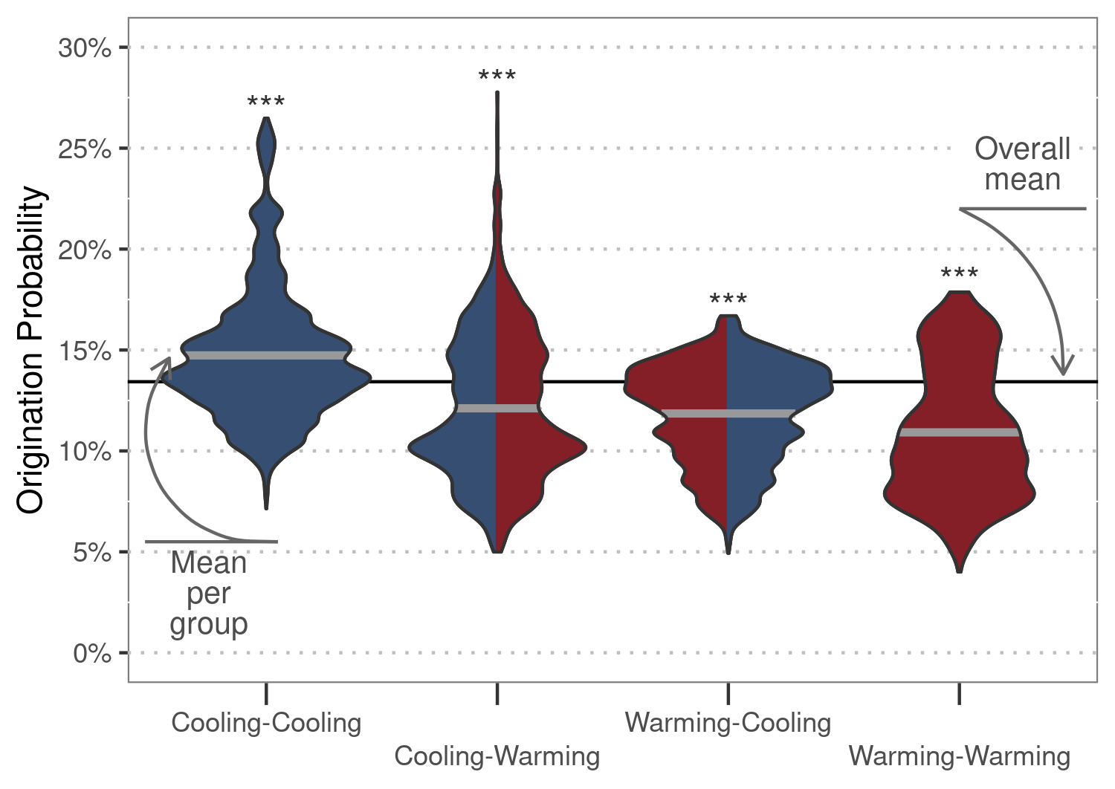

Figure 2 | Origination probability. Total response distributions to palaeoclimate interactions as predicted by generalised linear mixed effect models. Thick grey lines show the mean origination probability per palaeoclimate interaction, and the black line depicts the mean probability for all interactions combined. Asterisks indicate significance for differences of means compared to the overall mean, based on Wilcoxon rank sum tests.

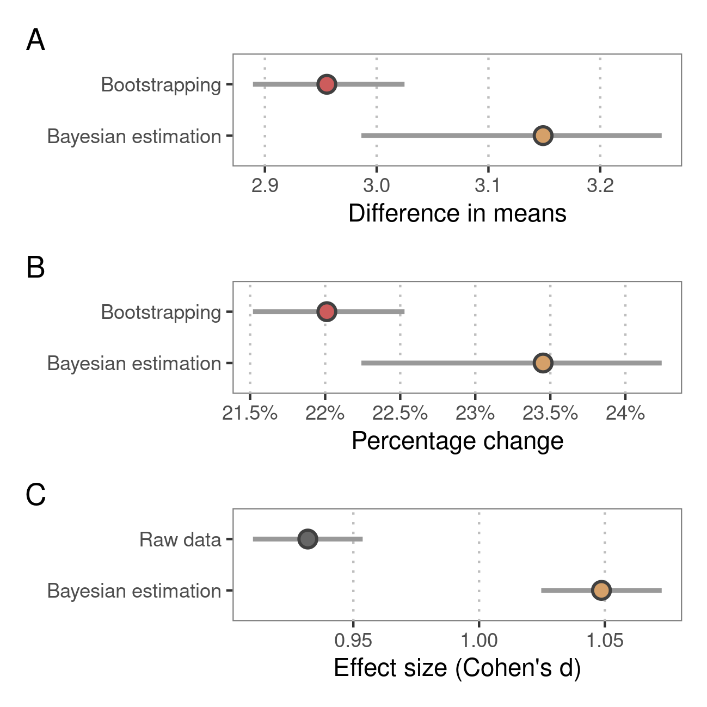Figure 3 | Effect size. A) Difference in means between origination probability after cooling-cooling compared to all other palaeoclimate interactions. B) Overall increase of origination probability after cooling-cooling palaeoclimate interactions compared to baseline probability. C) Cohen’s d effect size of the observed change in probability after cooling-cooling palaeoclimate interactions. Red points show estimates given by bootstrapping simulation, brown points estimates given by Bayesian regression, and grey points estimates based on raw output of generalised linear mixed effect models. Grey lines delineate 95% confidence intervals.

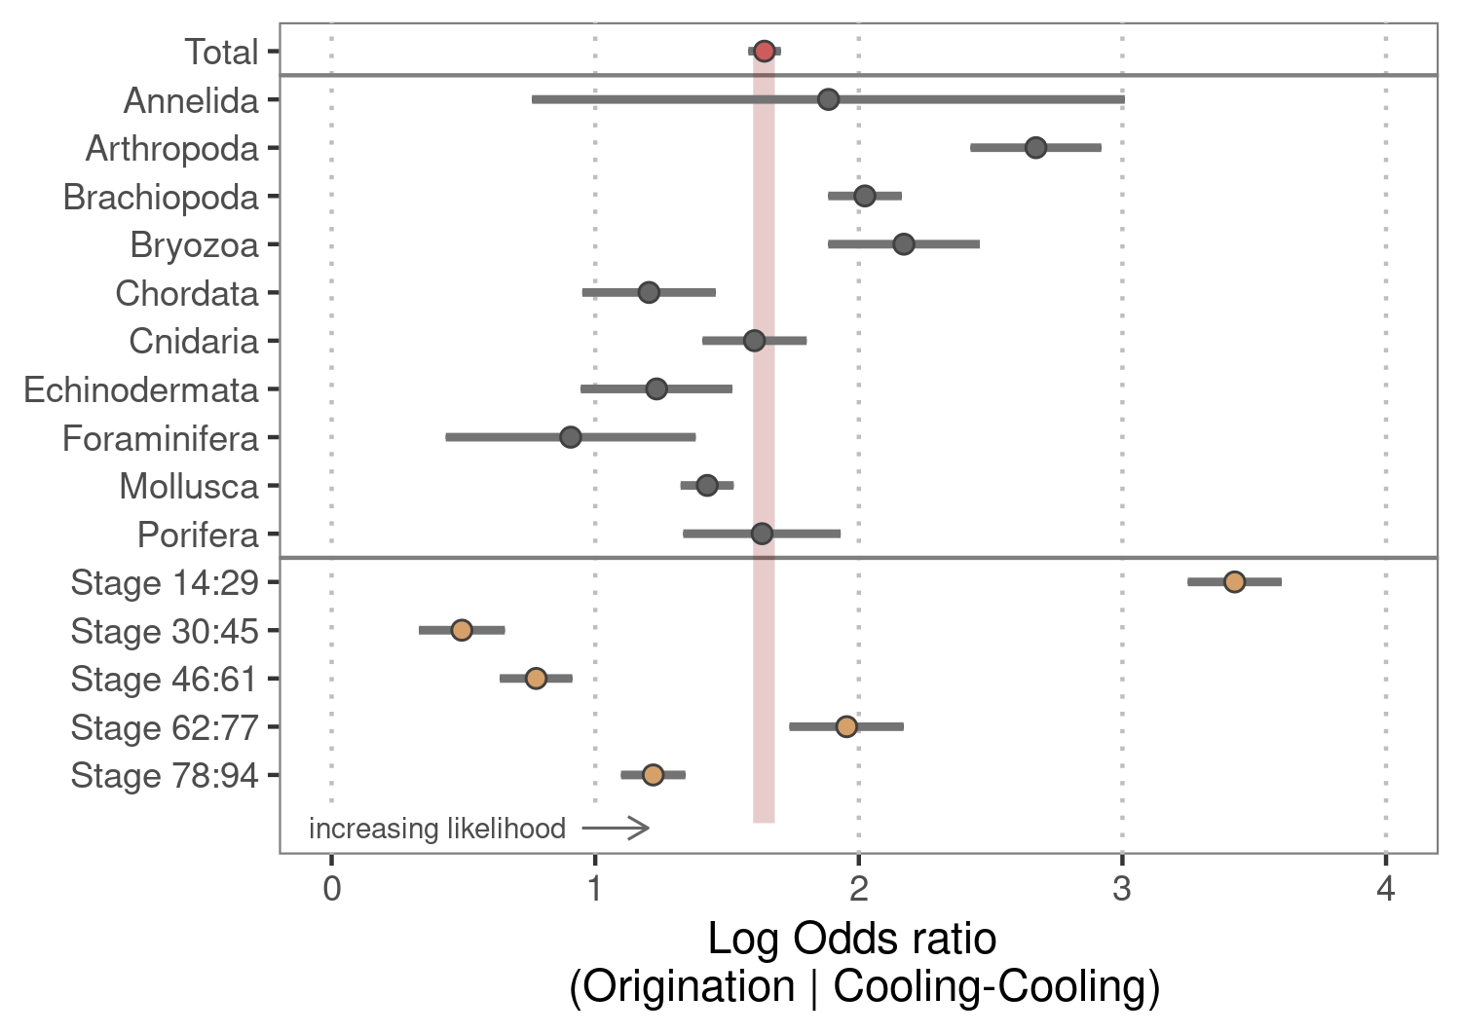Figure 4 | Group differences. Origination likelihood for all major phyla and across time after cooling-cooling compared to all other palaeoclimate interactions. The red point shows the overall response, grey points per phyla, and brown points response per time slice. Grey lines show 95% confidence intervals. Stage 14 is the oldest stage included in analysis, and stage 94 the youngest. The phyla Hemichordata and Nematoda were removed from the analysis due to insufficient data.

**Methodology**

Fossil data

We accessed data from the Paleobiology Database (PaleoDB, paleobiodb.org) using the chronosphere package interface (Kocsis & Raja, 2020) on 03 December 2020, including all occurrences from the Ediacaran to the Holocene. All analyses were conducted at the genus level. This taxonomic level is a compromise between uncertainty in the species level taxonomy of fossils and data loss at coarser taxonomic resolutions (Valentine, 1974). We filtered the data to only comprise marine animal taxa and heterotrophic protists, i.e. the same taxonomic groups listed in Sepkoski’s (2002) compendium, following common processing recommendations (Kocsis et al., 2019). Previous studies on the relationship between temperature and biodiversity were mainly based on Sepkoski’s compendium, rendering this data optimal for comparison purposes of our novel model structures. We binned the data to one of 80 geological stages (Ogg et al., 2016), ranging from the Ordovician to the Pleistocene. The Holocene as well as stages older than the Ordovician were excluded from the analysis. Ordovician stages were resolved using biozone and formation entries due to potential stratigraphic errors (Kocsis et al., 2019). Further data cleaning included removal of uncertain taxonomical ranks, duplicates in bins, single-collection, and single-reference taxa as well as missing higher-level taxonomy. Taxa confined to a single stage (singletons) were excluded as they tend to produce undesirable distortions of the fossil record (Foote, 2000). Collections from unlithified sediments were omitted to reduce sampling bias (Alroy et al., 2008). We then applied shareholder quorum subsampling (SQS) for sampling standardisation (Alroy, 2010). SQS is based on frequency distribution coverage of taxa, drawing collections until estimated coverage reaches a fixed target (i.e., until a shareholder quorum is attained). For this, we used a shareholder quorum of 0.8. SQS was applied excluding dominant taxa from all calculations involving frequencies and with a separate treatment of the largest collection in each time slice. We then transformed occurrence data into ranges congruent to a time series with one single origination and extinction event for each genus. The final data set contained ten major marine fossil phyla (Suppl. Figure 2, Suppl. Table 5).

Climate proxy data

To reconstruct temperature change over time, we used the tropical whole surface water (mixed layers < 300 m deep) oxygen isotope dataset from a compilation of marine carbonate isotopes (Veizer & Prokoph, 2015). The δ18O values of well-preserved calcareous shells are often considered as the best available temperature proxy for the fossil record (Song et al., 2019). To reduce bias while calculating palaeotemperature from the raw δ18O values, we followed the recommended data processing of (Veizer & Prokoph, 2015), including adjustments for the long-term trend in oxygen isotopic composition of seawater as well as averaging of tropical and subtropical records. We subsequently binned temperature data based on isotope values to geological stages to provide global mean temperature for each of the 81 stages used in our analysis.

Statistical analysis

*Generalised linear mixed effect models*

All analyses were carried out in R (R Core Team, 2020). We used the lme4 package (Bates et al., 2014) to perform the analysis, and the tidyverse package compendium (Wickham et al., 2019) for data processing and visualisation. We quantified the effect of temperature change interacting with past temperature trends on origination probability using generalised linear mixed effect models with a binomial family error (GLMMs) (Bolker et al., 2009). The additive and multiplicative effects of cumulative temperature change were tested against the probability of origination in each time interval in the form:   
glm (extinct ~ ∆Ttrend : ∆Tchange + (1 | Genus), family = binomial).

We calculated the change in temperature for each geologic change compared to the previous stage (∆Tchange). We computed long-term temperature trends (∆Ttrend) from ordinary least squares. Each of the trends covered a successively growing time of temperature history: Trend.st1 ranged one stage back, trend.st2 two stages, …, trend.st10 ten stages. To exclude ∆Tchange from the long-term trend, each ∆Ttrend started one stage prior to the focal stage. We controlled for the fact that observations on the same genus are non-independent by including genus identity as a random effect. We used a dynamic model framework to select the best performing ∆Ttrend (Suppl. Table 6). This implies calculating 10 GLMMs for each ∆Ttrend while keeping ∆Tchange fixed. Instead of calculating one model for all ∆Tchange, we distinguished short-term warming from short-term cooling. This enabled us to quantify the differences in origination likelihood per palaeoclimate interaction (cooling-cooling, warming-cooling, cooling-warming, warming-warming, where the first word denotes the long-term temperature trend, and the second word the short-term temperature change). For comparison of model performance, Akaike’s information criterion (AIC) was used. For likelihood approximation, we applied adaptive Gauss-Hermite quadrature (Pinheiro & Chao, 2006), which reduces bias and is more robust than other approximation methods (Bolker et al., 2009). We used 25 quadrature points per scalar integral, which is the maximum number of nodes in the quadrature formula of the lme4 package.

*Model comparison*

Previous studies used different estimates of temperature to deduce an association between origination and temperature (Cárdenas & Harries, 2010; Krug et al., 2009; Mayhew et al., 2008, 2012). Simple models correlate static temperature estimates at each interval to biodiversity at the same interval. More complex models include temporal lags of temperature, allowing for a suspended response of biota to temperature change. Most recent models are based on both estimates but additionally allow for interactions of static estimates and temporal lags. We hence calculated a GLMM for each model structure from simple to complex. We compared the performance of each model to a model allowing for palaeoclimate interactions. The latter were based on the same model structure, but explicitly allowed for interactions of long-term temperature trends and short-term climate changes within a dynamic modelling framework. Dynamic implies that we let the long-term trend vary for each palaeoclimate interaction, and subsequently selected the best performing model. Comparison of model performance was based on AIC values with results being consistent with Bayesian information criterion.

*Origination probability*

We separated the predicted origination response for each type of palaeoclimate interaction from our GLMMs using the predict() function. To test whether the response after a specific palaeoclimate interaction significantly differs from the mean origination probability, we used Wilcoxon rank sum tests.

*Effect size*

We applied non-parametric bootstrapping (Mooney, 1996) and Bayesian estimation (Kruschke, 2013) to the predicted origination response of our GLMMS to calculate the difference in means between origination probability after cooling-cooling compared to all other palaeoclimate interactions (Suppl. Figure 3). While doing so, we accounted for the non-parametric nature of data (Suppl. Figure 4). Bootstrapping was based on 2000 repetitions. For Bayesian estimation, we used a markov chain monte carlo method with four chains, 1000 iterations, and 500 warm-up iterations. We used an informed prior for the group mean based on the origination response of the whole sample, and a default exponential prior with a rate of 1/29 for the group variances. Overall increase of origination probability after cooling-cooling palaeoclimate interactions was calculated by dividing the estimated difference of means by the baseline probability of origination. Further, we calculated Cohen’s d effect size based on the raw output of our GLMMs as well as posterior distributions after Bayesian estimation using the formula:

$\frac{\left(μ_{1}−μ_{2}\right)}{\sqrt{{\left(σ_{1}^{2}+σ_{2}^{2}\right)}/2}}$

*Group differences*

Based on the results from our GLMMS, we calculated the log-odds ratio for each major fossil group and for five periods spanning all studied stages. The oldest period ranged from the Tremadocian to Lochkovian, the second from the Pragian to Artinskian, the third from the Kungurian to Pliensbachian, the fourth from the Toarcian to Turonian, and the youngest period from the Coniacian to Pleistocene. Grouping of the stages was necessary to obtain a sufficient number of observations to calculate the log-odds ratio. Likewise, we did not calculate group differences for both phyla Hemichordata and Nematoda, as data for those phyla were insufficient.

**References**

Alroy, J. (2008). Dynamics of origination and extinction in the marine fossil record. *Proceedings of the National Academy of Sciences*, *105*(Supplement 1), 11536–11542. https://doi.org/10.1073/pnas.0802597105

Alroy, J. (2010). Fair sampling of taxonomic richness and unbiased estimation of origination and extinction rates. *The Paleontological Society Papers*, *16*, 55–80.

Alroy, J., Aberhan, M., Bottjer, D. J., Foote, M., Fürsich, F. T., Harries, P. J., Hendy, A. J., Holland, S. M., Ivany, L. C., & Kiessling, W. (2008). Phanerozoic trends in the global diversity of marine invertebrates. *Science*, *321*(5885), 97–100.

Alroy, J., Koch, P. L., & Zachos, J. C. (2000). Global Climate Change and North American Mammalian Evolution. *Paleobiology*, *26*(4,), 259–288.

Antão, L. H., Bates, A. E., Blowes, S. A., Waldock, C., Supp, S. R., Magurran, A. E., Dornelas, M., & Schipper, A. M. (2020). Temperature-related biodiversity change across temperate marine and terrestrial systems. *Nature Ecology & Evolution*, *4*(7), 927–933. https://doi.org/10.1038/s41559-020-1185-7

Bates, D., Mächler, M., Bolker, B., & Walker, S. (2014). Fitting linear mixed-effects models using lme4. *ArXiv Preprint ArXiv:1406.5823*.

Bolker, B. M., Brooks, M. E., Clark, C. J., Geange, S. W., Poulsen, J. R., Stevens, M. H. H., & White, J.-S. S. (2009). Generalized linear mixed models: A practical guide for ecology and evolution. *Trends in Ecology & Evolution*, *24*(3), 127–135.

Broecker, W. S., & Peng, T.-H. (1982). Tracers in the sea. *Radiocarbon*, *24*(3), b1–b2. https://doi.org/10.1017/S0033822200005221

Button, D. J. (2017). Mass extinctions drove increased global faunal cosmopolitanism on the supercontinent Pangaea. *NATURE COMMUNICATIONS*, 8. https://doi.org/10.1038/s41467-017-00827-7

Cárdenas, A. L., & Harries, P. J. (2010). Effect of nutrient availability on marine origination rates throughout the Phanerozoic eon. *Nature Geoscience*, *3*(6), 430–434. https://doi.org/10.1038/ngeo869

Douglas, E. H. (2009). Climate as a Driver of Evolutionary Change. *Current Biology*, *19*(14), R575–R583. https://doi.org/10.1016/j.cub.2009.05.047

Foote, M. (2000). Origination and extinction components of taxonomic diversity: General problems. *Paleobiology*, *26*(sp4), 74–102.

Gilman, S. E., Urban, M. C., Tewksbury, J., Gilchrist, G. W., & Holt, R. D. (2010). A framework for community interactions under climate change. *Trends in Ecology & Evolution*, *25*(6), 325–331. https://doi.org/10.1016/j.tree.2010.03.002

Hopkins, M. J., Simpson, C., & Kiessling, W. (2014). Differential niche dynamics among major marine invertebrate clades. *Ecology Letters*, *17*(3), 314–323. https://doi.org/10.1111/ele.12232

Jablonski, D. (2008). Extinction and the spatial dynamics of biodiversity. *Proceedings of the National Academy of Sciences*, *105*(Supplement 1), 11528–11535. https://doi.org/10.1073/pnas.0801919105

Kocsis, À. T., & Raja, N. B. (2020). *chronosphere: Earth system history variables* (0.4.0) [R]. https://doi.org/10.5281/zenodo.3530703

Kocsis, À. T., Reddin, C. J., Alroy, J., & Kiessling, W. (2019). The R package divDyn for quantifying diversity dynamics using fossil sampling data. *Methods in Ecology and Evolution*, *10*(5), 735–743.

Krug, A. Z., Jablonski, D., Valentine, J. W., & Roy, K. (2009). Generation of Earth’s First-Order Biodiversity Pattern. *Astrobiology*, *9*(1), 113–124. https://doi.org/10.1089/ast.2008.0253

Kruschke, J. K. (2013). Bayesian estimation supersedes the t test. *Journal of Experimental Psychology: General*, *142*(2), 573.

Lister, A. M. (2004). The impact of Quaternary Ice Ages on mammalian evolution. *Philosophical Transactions of the Royal Society B: Biological Sciences*, *359*(1442), 221–241.

Maldonado-Coelho, M. (2012). Climatic oscillations shape the phylogeographical structure of Atlantic Forest fireeye antbirds (Aves: Thamnophilidae). *Biological Journal of the Linnean Society*, 25.

Mathes, G. H., van Dijk, J., Kiessling, W., & Steinbauer, M. J. (2021). Extinction risk controlled by interaction of long-term and short-term climate change. *Nature Ecology & Evolution*, *5*(3), 304–310. https://doi.org/10.1038/s41559-020-01377-w

Mayhew, P. J., Bell, M. A., Benton, T. G., & McGowan, A. J. (2012). Biodiversity tracks temperature over time. *Proceedings of the National Academy of Sciences*, *109*(38), 15141–15145. https://doi.org/10.1073/pnas.1200844109

Mayhew, P. J., Jenkins, G. B., & Benton, T. G. (2008). A long-term association between global temperature and biodiversity, origination and extinction in the fossil record. *Proceedings of the Royal Society B: Biological Sciences*, *275*(1630), 47–53. https://doi.org/10.1098/rspb.2007.1302

Mayr, E., & O’Hara, R. J. (1986). The biogeographic evidence supporting the Pleistocene forest refuge hypothesis. *Evolution*, *40*(1), 55–67. https://doi.org/10.1111/j.1558-5646.1986.tb05717.x

Mooney, C. Z. (1996). Bootstrap statistical inference: Examples and evaluations for political science. *American Journal of Political Science*, 570–602.

Nogués-Bravo, D., Rodríguez-Sánchez, F., Orsini, L., de Boer, E., Jansson, R., Morlon, H., Fordham, D. A., & Jackson, S. T. (2018). Cracking the Code of Biodiversity Responses to Past Climate Change. *Trends in Ecology & Evolution*, *33*(10), 765–776. https://doi.org/10.1016/j.tree.2018.07.005

Ogg, J. G., Ogg, G. M., & Gradstein, F. M. (2016). *A concise geologic time scale: 2016*. Elsevier.

Peters, S. E. (2005). Geologic constraints on the macroevolutionary history of marine animals. *Proceedings of the National Academy of Sciences*, *102*(35), 12326–12331. https://doi.org/10.1073/pnas.0502616102

Peters, S. E. (2006). Genus extinction, origination, and the durations of sedimentary hiatuses. *Paleobiology*, *32*(3), 387–407. https://doi.org/10.1666/05081.1

Pinheiro, J. C., & Chao, E. C. (2006). Efficient Laplacian and adaptive Gaussian quadrature algorithms for multilevel generalized linear mixed models. *Journal of Computational and Graphical Statistics*, *15*(1), 58–81.

Postigo-Mijarra, J. M., Morla, C., Barrón, E., Morales-Molino, C., & García, S. (2010). Patterns of extinction and persistence of Arctotertiary ﬂora in Iberia during the Quaternary. *Review of Palaeobotany and Palynology*, 12.

Prothero, D. R. (1999). Does climatic change drive mammalian evolution? *GSA Today*, *9*(9), 1.

R Core Team. (2020). *R: A Language and Environment for Statistical Computing* [R]. R Foundation for Statistical Computing. https://www.R-project.org/

Raup, D. M. (1979). Size of the Permo-Triassic Bottleneck and Its Evolutionary Implications. *Science*, *206*(4415), 217–218. https://doi.org/10.1126/science.206.4415.217

Ritterbush, K. A., & Foote, M. (2017). Association between geographic range and initial survival of Mesozoic marine animal genera: Circumventing the confounding effects of temporal and taxonomic heterogeneity. *Paleobiology*, *43*(2), 209–223. https://doi.org/10.1017/pab.2016.25

Schuler, M. S., Chase, J. M., & Knight, T. M. (2017). Habitat patch size alters the importance of dispersal for species diversity in an experimental freshwater community. *Ecology and Evolution*, *7*(15), 5774–5783. https://doi.org/10.1002/ece3.2858

Sepkoski, J. J. (2002). A compendium of fossil marine animal genera. *Bulletins of American Paleontology*, *363*, 1–560.

Song, H., Wignall, P. B., Song, H., Dai, X., & Chu, D. (2019). Seawater temperature and dissolved oxygen over the past 500 million years. *Journal of Earth Science*, *30*(2), 236–243.

Stigall, A. L. (2013). Analysing links between biogeography, niche stability and speciation: The impact of complex feedbacks on macroevolutionary patterns: Biotic and environmental impacts on speciation. *Palaeontology*, *56*(6), 1225–1238. https://doi.org/10.1111/pala.12003

Stigall, A. L. (2014). When and how do species achieve niche stability over long time scales? *Ecography*, *37*(11), 1123–1132. https://doi.org/10.1111/ecog.00719

Svenning, J.-C., Eiserhardt, W. L., Normand, S., Ordonez, A., & Sandel, B. (2015). The Influence of Paleoclimate on Present-Day Patterns in Biodiversity and Ecosystems. *Annual Review of Ecology, Evolution, and Systematics*, *46*(1), 551–572. https://doi.org/10.1146/annurev-ecolsys-112414-054314

Templeton, A. R. (2008). The reality and importance of founder speciation in evolution. *BioEssays*, *30*(5), 470–479. https://doi.org/10.1002/bies.20745

Tilman, D. (1994). Competition and Biodiversity in Spatially Structured Habitats. *Ecology*, *75*(1), 2–16. https://doi.org/10.2307/1939377

Valentine, J. W. (1968). Climatic Regulation of Species Diversification and Extinction. *Geological Society of America Bulletin*, *79*(2), 273. https://doi.org/10.1130/0016-7606(1968)79[273:CROSDA]2.0.CO;2

Valentine, J. W. (1974). Temporal bias in extinctions among taxonomic categories. *Journal of Paleontology*, 549–552.

Veizer, J., & Prokoph, A. (2015). Temperatures and oxygen isotopic composition of Phanerozoic oceans. *Earth-Science Reviews*, *146*, 92–104.

Wahl, L. M., Gerrish, P. J., & Saika-Voivod, I. (2002). Evaluating the Impact of Population Bottlenecks in Experimental Evolution. *Genetics Society of America*, *162*, 12.

Wickham, H., Averick, M., Bryan, J., Chang, W., McGowan, L. D., François, R., Grolemund, G., Hayes, A., Henry, L., & Hester, J. (2019). Welcome to the Tidyverse. *Journal of Open Source Software*, *4*(43), 1686.

Wiens, J. J., & Graham, C. H. (2005). Niche Conservatism: Integrating Evolution, Ecology, and Conservation Biology. *Annual Review of Ecology, Evolution, and Systematics*, *36*(1), 519–539. https://doi.org/10.1146/annurev.ecolsys.36.102803.095431