**Title**

Evolutionary bursts linked to interactions of past temperature trends with short-term climate change

**Abstract**

Biodiversity dynamics are shaped by a complex interplay between current conditions and historic legacy. While a simple relationship is often used to link evolution with temperature change, short-term climate change likely interacts with the previous temperature trends when influencing the pace of origination. Such a palaeoclimate interactions has been demonstrated for extinction risk but the effect on evolutionary dynamics is untested. Here we show that origination probability in marine fossil groups is largely affected by palaeoclimate interactions. Short-term cooling adding to a long-term cooling trend increases the origination probability by 23.7%. This large effect is consistent through time and all studied groups. Our results demonstrate that biodiversity is controlled by a complex array of ecological and evolutionary factors, with mutual interactions. Accounting for these interactions using a more flexible modelling approach improves existing models and enables a better mechanistic discernment of processes that control biodiversity.

**Introduction**

Deciphering the relationship between temperature and the history of life on Earth on multiple scales is a major goal of nature sciences (Dietl et al. 2015; Humboldt 1808). While biodiversity consistently decreases with latitude beyond small geographic scales (Willig et al. 2003; Krug et al. 2009; Hillebrand 2004), no such general pattern seems to occur through time (Mayhew et al. 2012; Mayhew et al. 2008; Erwin 2009). Current analyses show that fossil biodiversity interacts with temperature by complex cascading effects (Mathes et al. 2020, van Dyik et al. 2020), which could blur general patterns. While these interactions of past temperature trends with short-term climate change have shown to be major drivers of extinction events in Earth’s history (Mathes et al. 2020), their effect on origination is untested.

Palaeobiological models generally test first- or second-order relationships between Phanerozoic marine diversity and climate (Krug et al. 2009; Mayhew et al. 2008; Erwin 2009; Cárdenas und Harries 2010). Recent models additionally allow for static interactions of global temperature estimates at a given time frame and their focal temporal lags (Mayhew et al. 2012). Despite arguing that cascading evolutionary effects might be exacerbated by the interaction of long-term temperature trends and short-term climate change (Mayhew et al. 2008), none of these approaches include the direction of temperature change through time or take advantage of a dynamic modelling framework.

Here we analyse how global trajectories of palaeoclimate can affect origination likelihoods of marine fossil groups in the last 485 myr. We use palaeoclimate interactions as explanatory variables, which are defined as the interaction of short-term climate change with long-term temperature trends. We first apply traditional model structures to sample-standardized fossil data and compare performances to our models including palaeoclimate interactions within a dynamic modelling framework. Considering the general complexity of evolutionary processes, we hypothesize that incorporating dynamic interactions can lead to an improved mechanistic understanding of evolutionary patterns. Second, we test whether cumulative palaeoclimate interactions increase the origination probability of fossil taxa, which might explain the perceived ambiguity of existing studies on the relationship of temperature and biodiversity in Earth’s history.

**Results**

*Model comparison*

Models including dynamic palaeoclimate interactions performed better than their traditional counterparts in 6 out of 6 cases (Fig. 1), based on Akaike’s information criterion (AIC) and Bayesian information criterion (BIC). Models covering short-term cooling improved on average by 586 AIC values (562 BIC values), and models covering short-term warming by 218 AIC values (194 BIC values). Both AIC and BIC values indicate that all models including palaeoclimate interactions are more parsimonious than their counterparts, despite their increased complexity.

*Origination probability*

Cooling-cooling palaeoclimate interactions resulted in an increased origination probability (Fig. 2). We compared the origination probability for marine groups per palaeoclimate interaction, based on the output of our models. The overall origination response was on average lower after cooling-warming, warming-cooling and warming-warming palaeoclimate interactions compared to the average origination probability of 13.2% (p < 0.001, Wilcoxon rank sum test). On the contrary, cooling-cooling palaeoclimate interactions resulted in a mean origination response of 14.8%, significantly above the average origination probability (p < 0.001, Wilcoxon rank sum test).

*Effect size*

The effect of cooling-cooling palaeoclimate interactions on origination probability is large (Fig. 3). The absolute difference between the mean origination probability of cooling-cooling compared to all other palaeoclimate interactions was 3.2 (Bayesian estimation, 95% CI [3.1, 3.2]). This difference represents a 23.7% increase compared to all other interactions (Bayesian estimation, 95% CI [23.2%, 24.2%]). Cohen’s d statistic for cooling-cooling was greater than 1, indicating a large effect size (following the classification scheme of Sawilowsky 2009, Bayesian estimation, 95% CI [1.0, 1.1]). All results are consistent with bootstrapping resampling and raw output from generalised linear mixed effect models.

*Group differences*

We additionally tested whether cooling-cooling palaeoclimate interactions raised the origination probability of all marine groups studied and if the signal remains robust through time (Fig. 4). This was the case for all 10 major groups and throughout all 94 geologic stages. Within the groups, hemichordates, bryozoans, brachiopods, and arthropods showed a higher than average response to cooling-cooling palaeoclimate interactions. Through time, the youngest and oldest periods (stage 78 to 94, and 14 to 29) showed the highest likelihoods. We hence found a large effect size of cooling-cooling palaeoclimate on origination probability, which remained consistent throughout all studied groups and throughout the whole Phanerozoic.

**Discussion**

Using a novel model framework to describe the relationship between temperature and the history of life on Earth, we found a large and previously unknown response of marine groups to global climate trajectories. Specifically, the interplay of short-term climate cooling adding to a long-term average global cooling resulted in a sharp increase of origination probability. We found this effect to be consistent through time and all studied groups. Previous studies on the relationship between temperature and origination came to ambiguous conclusions, ranging from a negative relationship (Mayhew et al. 2008), no relationship (Alroy et al. 2000; Prothero 1999), to a positive one (Mayhew et al. 2012). Our results show that including dynamic palaeoclimate interactions improves the relative quality of these existing models. The large effect size and the cascading nature of palaeoclimate interactions might have obscured or even inverted the apparent relationship between temperature and origination, as it has been shown for other interactions in the fossil record (Stigall 2013; Ritterbush und Foote 2017). Explicitly accounting for dynamic interactions within a flexible modelling framework will hence provide a more robust foundation to assess the relationship between Phanerozoic marine diversity and climate.

We emphasize that our results can only provide statistical conclusions, but no causal inferences. Causes for the detected effect might be manifold, but are likely connected to eustatic sea level subsidence caused by global cooling. A drop in sea level due to glaciation results in reduced continental shelf area, which is the main habitat for the majority of the studied fossil groups (Sepkoski 2002). Increased habitat fragmentation and loss is correlated to the rate of ecological interactions (Tilman 1994; Valentine 1968; Schuler et al. 2017) and speciation rates (Mayr und O'Hara 1986; Alroy 2008). Low sea levels lead to increased nutrient availability in the marine realm through exposure of continental shelf area to weathering (Broecker und Peng 1982), a process known to drive genus origination rates (Cárdenas und Harries 2010). The combination of short-term cooling on top of a long-term cooling trend exacerbates eustatic sea level subsidence, thus potentially reinforcing the ecological mechanism leading to increased origination rates.

Our results are insofar remarkably as we expected to detect a weakened origination signal after cooling-cooling palaeoclimate interactions due to the “common cause” hypothesis (Peters und Foote 2001; Peters 2006, 2005). Sampling biases caused by low sea levels arise from the removal of originating taxa from the fossil record or a shift of their detection to a later origination datum, leading to an artificially reduced origination probability. The subsampling procedure applied to our data might reduce the bias but is unlikely to remove it entirely (Alroy et al. 2001; Alroy 2020). The apparently large effect size of cooling-cooling palaeoclimate interactions might hence even be an underestimation of the true effect size.

Cooling-cooling palaeoclimate interactions have been shown to be major driver of temperature related extinctions in the fossil record, with warming-warming interactions showing the same but less severe signal (Mathes et al. 2020). The synergetic combination of same-directional temperature changes is thought to move taxa out of their adaptation space, which is phylogenetically retained (Wiens und Graham 2005; Hopkins et al. 2014; Stigall 2014). When the environment changes so drastically that taxa are no longer adapted to it, they are forced to respond through evolutionary change, migration or extinction (Nogués-Bravo et al. 2018). During warming-warming palaeoclimate interactions, marine taxa could potentially escape adverse environment through range shifts (Chen et al. 2011). During cooling-cooling, however, geographic barriers resulting from sea level subsidence might impede migration, resulting in the observed increased extinction risk (Mathes et al. 2020) and origination probability (this study).

Major biodiversity crises are often associated with hyperthermals (Foster et al. 2018). Hyperthermals adding to long-term warming often show even higher biotic responses than hyperthermals adding to long-term cooling (Mathes et al. 2020). This pattern might emerge from the combined effects of palaeoclimate interactions on origination and extinction processes, with warming-warming palaeoclimate interactions resulting in increased extinction risk without increasing origination probability. Again, testing this hypothesis of mass extinctions emerging from palaeoclimate interactions will require further work on the underlying causes of palaeoclimate interactions. This implies progressing from a currently strict descriptive towards a more explanatory mechanistic approach. The cause for palaeoclimate interactions offered here, a combination of niche conservatism and ecological effects arising from sea level subsidence, could be at least partially tested by comparing responses of terrestrial and marine fossil groups to palaeoclimate interactions. If sea level subsidence plays a key role, terrestrial groups should show a significantly lower response to cooling-cooling than marine groups.

Our study shows that evolutionary processes interact with climate by complex cascading effects. Explicitly integrating these effects within a dynamic modelling framework leads to an improved discernment of origination patterns in the fossil record. Previous studies on the relationship of temperature and biodiversity in Earth’s history came to ambiguous conclusions, a non-conformance we are confident to be fixed in the future by accounting for palaeoclimate interactions. However, the mechanisms underlying the large association between evolution and the observed effect are still unclear. Improving our mechanistic comprehension of palaeoclimate interactions will facilitate the interpretation of biodiversity responses to climatic changes, and hence enable improved predictions of biotic responses to current climate change.

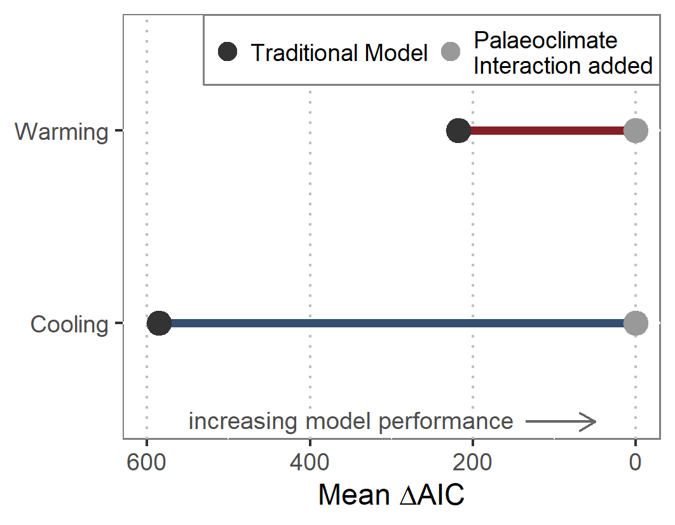

Fig. 1 | Model comparison. Comparison of model performance for traditional models covering first- and second-order relationships of origination and climate versus models allowing for palaeoclimate interactions. The latter are based on the same model structure, but explicitly allow for interactions of long-term temperature trends and short-term climate changes within a dynamic modeling framework.

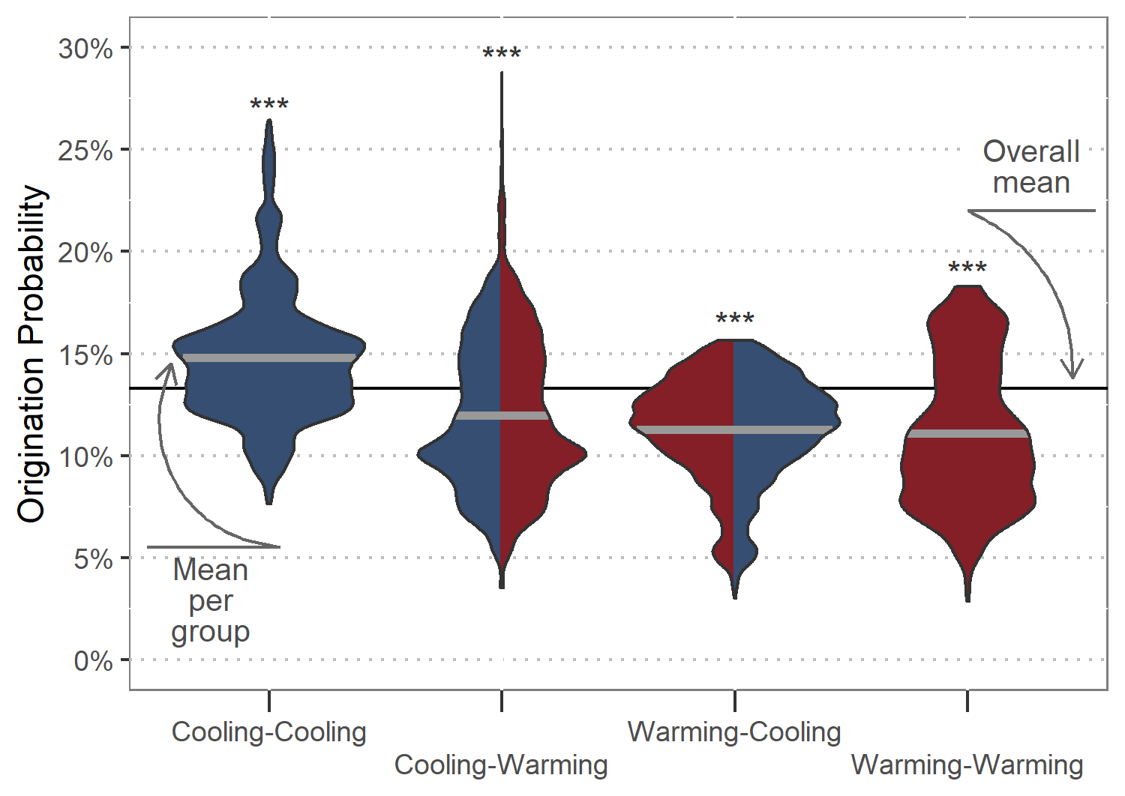

Fig. 2 | Origination probability. Total response distributions to palaeoclimate interactions as predicted by generalised linear mixed effect models. Thick grey lines show the mean origination probability per palaeoclimate interaction, and the black line depicts the mean probability for all interactions combined.

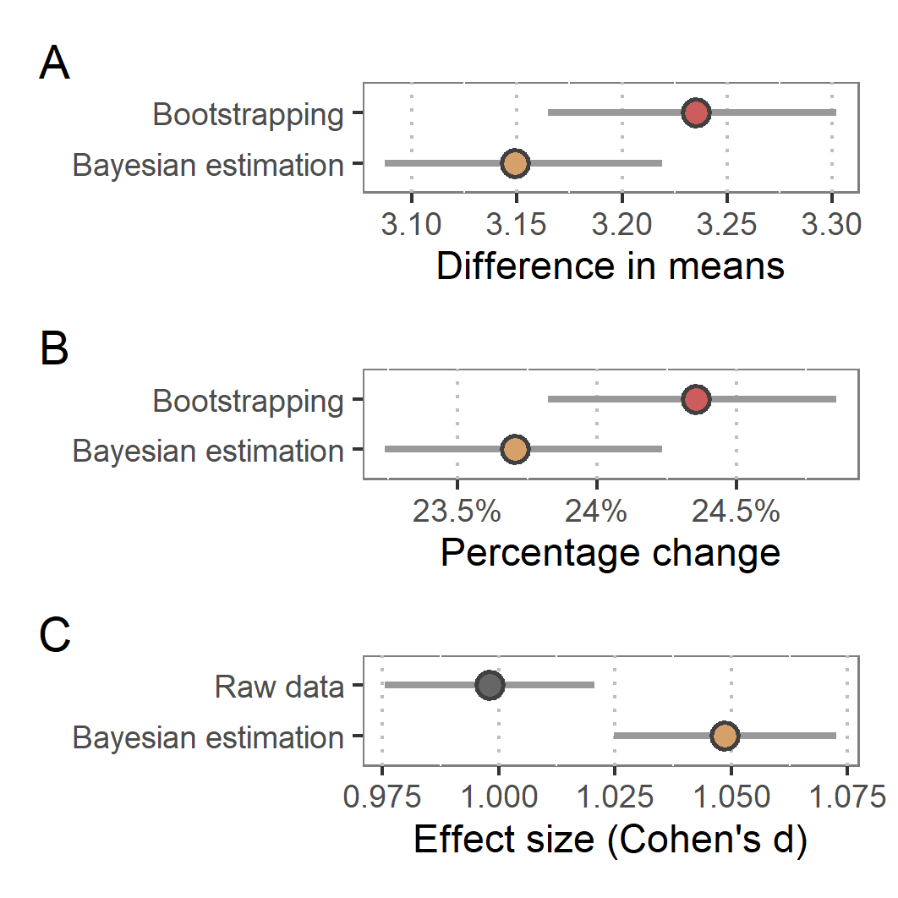

Fig. 3 | Effect size. A) Difference in means between origination probability after cooling-cooling compared to all other palaeoclimate interactions. B) Overall increase of origination probability after cooling-cooling palaeoclimate interactions compared to baseline probability. C) Cohen’s d effect size of the observed change in probability after cooling-cooling palaeoclimate interactions. Red points show estimates given by bootstrapping simulation, brown points estimates given by Bayesian regression, and grey points estimates based on raw output of generalised linear mixed effect models. Grey lines delineate 95% confidence intervals.

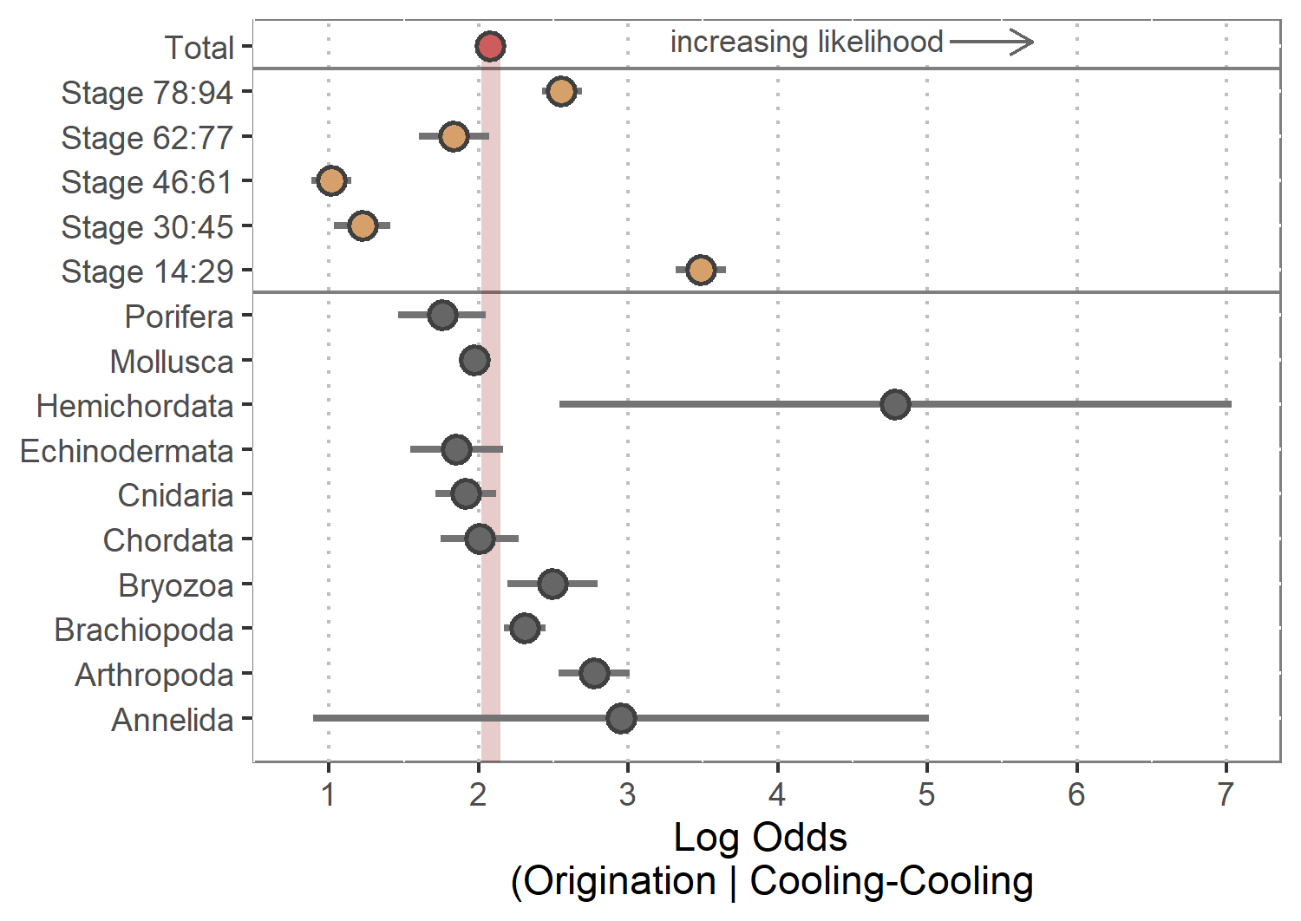

Fig. 4 | Group differences. Origination probability for all major phyla and throughout time after cooling-cooling compared to all other palaeoclimate interactions. The red point shows the overall response, brown points response per time slice, and grey points per phyla. Grey lines show 95% confidence intervals. Stage 14 is the oldest stage included in analysis, and stage 94 the youngest.

**Methodology**

Fossil data

We downloaded data from the Paleobiology Database (PaleoDB, paleobiodb.org) on 26 January 2020, including all occurrences from the Ediacaran to the Holocene. All analyses were conducted at the genus level. This taxonomic level is a compromise between uncertainty in the species level taxonomy of fossils and data loss at coarser taxonomic resolutions (Valentine 1974). We filtered the data to only comprise marine animal taxa and heterotrophic protists, i.e. the same taxonomic groups listed in Sepkoski’s (2002) compendium following common processing recommendations (Kocsis et al. 2019). Previous studies on the relationship between temperature and biodiversity were mainly based on Sepkoski’s compendium, rendering this data optimal for comparison purposes of our novel model structures. We binned the data to one of 80 geological stages (Ogg et al. 2016), ranging from the Ordovician to the Pleistocene. The Holocene as well as stages older than the Ordovician were excluded from the analysis. Ordovician stages were resolved using biozone and formation entries due to potential stratigraphic errors (Kocsis et al. 2019). Further data cleaning included removal of uncertain taxonomical ranks, duplicates in bins, single-collection and single-reference taxa as well as missing higher-level taxonomy. Taxa confined to a single stage (singletons) were excluded as they tend to produce undesirable distortions of the fossil record (Foote 2000). Collections from unlithified sediments were omitted to reduce sampling bias (Alroy et al. 2008). We then transformed occurrence data into ranges congruent to a time series with one single origination and extinction event for each genus.

Climate proxy data

To reconstruct temperature change over time, we used the tropical whole surface water (mixed layers < 300 m deep) oxygen isotope dataset from a compilation of marine carbonate isotopes (Veizer und Prokoph 2015). The δ18O values of well-preserved calcareous shells are often considered as the best available temperature proxy for the fossil record (Song et al. 2019). To reduce bias while calculating palaeotemperature from the raw δ18O values, we followed the data processing of Reddin et al. (2018), including adjustments for the long-term trend in oxygen isotopic composition of seawater as well as averaging of tropical and subtropical records. We subsequently binned temperature data based on isotope values to geological stages to provide global mean temperature for each of the 80 stages used in our analysis.

Statistical analysis

*Generalised linear mixed effect models*

All analyses were carried out in R (R Core Team 2020). We used the lme4 package (Bates et al. 2015) to perform the analysis, and the tidyverse package (Wickham et al. 2019) for data processing and visualisation. We quantified the effect of temperature change interacting with past temperature trends on origination probability using generalised linear mixed effect models with a binomial family error (GLMMs) (Bolker et al. 2009; Quené und van den Bergh 2008; Malik et al. 2019). The additive and multiplicative effects of cumulative temperature change were tested against the probability of origination in each time interval in the form:   
glm (extinct ~ ∆Ttrend : ∆Tchange + (1 | Genus), family = binomial).

We calculated the change in temperature for each geologic change compared to the previous stage (∆Tchange). We computed long-term temperature trends (∆Ttrend) from ordinary least squares, starting one stage prior to the focal stage to exclude ∆Tchange from the long-term trend. Each of the trends covered a successively growing time of temperature history: Trend.st1 ranged one stage back, trend.st2 two stages, …, trend.st10 ten stages. We controlled for the fact that observations on the same genus are non-independent by including genus identity as a random effect. We used a dynamic model framework to select the best performing ∆Ttrend. This implies calculating 10 GLMMs for each ∆Ttrend while keeping ∆Tchange fixed. Instead of calculating one model for all ∆Tchange, we distinguished short-term warming from short-term cooling. This enabled us to quantify the differences in origination likelihood per palaeoclimate interaction (cooling-cooling, warming-cooling, cooling-warming, warming-warming). For comparison of model performance, Akaike’s information criterion (AIC) was used (Burnham und Anderson 2002). For likelihood approximation, we used adaptive Gauss-Hermite quadrature (Pinheiro und Chao 2006), which reduces bias and is more robust than other approximation methods. We used 25 quadrature points per scalar integral, which is the maximum number of nodes in the quadrature formula of the lme4 package.

*Model comparison*

Previous studies used different estimates of temperature to deduce an association between origination and temperature (Cárdenas und Harries 2010; Erwin 2009; Krug et al. 2009; Mayhew et al. 2008; Mayhew et al. 2012). Simple models correlate static temperature estimates at each interval to biodiversity at the same interval. More complex models include temporal lags of temperature, allowing for a suspended response of biota to temperature change. Most recent models are based on both estimates but additionally allow for interactions of static estimates and temporal lags. We hence calculated a GLMM for each model structure from simple to complex. We compared the performance of each model to a model allowing for palaeoclimate interactions. The latter were based on the same model structure, but explicitly allowed for interactions of long-term temperature trends and short-term climate changes within a dynamic modelling framework. Dynamic implies that we let the long-term trend vary for each palaeoclimate interaction, and subsequently selected the best performing model. Comparison of model performance was based on AIC values with results being consistent with Bayesian information criterion (Neath und Cavanaugh 2012).

*Origination probability*

We separated the predicted origination response for each type of palaeoclimate interaction from our GLMMs. To test whether the response after a specific palaeoclimate interaction significantly differs from the mean origination probability, we used Wilcoxon rank sum tests.

*Effect size*

We applied bootstrapping (Mooney und Duval 1993) and Bayesian estimation (Kruschke 2013) to the predicted origination response of our GLMMS to calculate the difference in means between origination probability after cooling-cooling compared to all other palaeoclimate interactions. Bootstrapping was based on 2000 repetitions. For Bayesian estimation, we used a markov chain monte carlo method with four chains, 1000 iterations, and 500 warm-up iterations. Overall increase of origination probability after cooling-cooling palaeoclimate interactions was calculated by dividing the estimated difference of means by the baseline probability of origination. Cohen’s d effect size was calculated based on the raw output of our GLMMs as well as posterior distributions after Bayesian estimation using the formula:

*Group differences*

Based on the predicted results from our GLMMS, we calculated the log-odds ratio for each major fossil group and for five periods spanning all studied stages. The oldest period ranged from the Tremadocian to Lochkovian, the second from the Pragian to Artinskian, the third from the Kungurian to Pliensbachian, the fourth from the Toarcian to Turonian, and the youngest period from the Coniacian to Pleistocene.

References

Alroy, John (2008): Dynamics of origination and extinction in the marine fossil record. In: *Proceedings of the National Academy of Sciences* 105 (Supplement 1), S. 11536–11542.

Alroy, John (2020): On four measures of taxonomic richness. In: *Paleobiology* 41, S. 1–18. DOI: 10.1017/pab.2019.40.

Alroy, John; Aberhan, Martin; Bottjer, David J.; Foote, Michael; Fürsich, Franz T.; Harries, Peter J. et al. (2008): Phanerozoic trends in the global diversity of marine invertebrates. In: *Science* 321 (5885), S. 97–100.

Alroy, John; Koch, Paul L.; Zachos, James C. (2000): Global climate change and North American mammalian evolution. In: *Paleobiology* 26 (S4), S. 259–288.

Alroy, John; Marshall, C. R.; Bambach, R. K.; Bezusko, K.; Foote, M.; Fürsich, F. T. et al. (2001): Effects of sampling standardization on estimates of Phanerozoic marine diversification. In: *Proceedings of the National Academy of Sciences* 98 (11), S. 6261–6266.

Bates, Douglas; Mächler, Martin; Bolker, Ben; Walker, Steve (2015): Fitting Linear Mixed-Effects Models Using lme4. In: *J. Stat. Soft.* 67 (1). DOI: 10.18637/jss.v067.i01.

Bolker, Benjamin M.; Brooks, Mollie E.; Clark, Connie J.; Geange, Shane W.; Poulsen, John R.; Stevens, M. Henry H.; White, Jada-Simone S. (2009): Generalized linear mixed models: a practical guide for ecology and evolution. In: *Trends in ecology & evolution* 24 (3), S. 127–135.

Broecker, Wallace S.; Peng, Tsung-Hung (1982): Tracers in the Sea. In: *Lamont-Doherty Geol. Observ. Publ.*

Burnham, Kenneth P.; Anderson, David R. (2002): A practical information-theoretic approach. In: *Model selection and multimodel inference, 2nd ed. Springer, New York*.

Cárdenas, Andrés L.; Harries, Peter J. (2010): Effect of nutrient availability on marine origination rates throughout the Phanerozoic eon. In: *Nature Geoscience* 3 (6), S. 430–434.

Chen, I-Ching; Hill, Jane K.; Ohlemüller, Ralf; Roy, David B.; Thomas, Chris D. (2011): Rapid range shifts of species associated with high levels of climate warming. In: *Science* 333 (6045), S. 1024–1026.

Dietl, Gregory P.; Kidwell, Susan M.; Brenner, Mark; Burney, David A.; Flessa, Karl W.; Jackson, Stephen T.; Koch, Paul L. (2015): Conservation Paleobiology: Leveraging Knowledge of the Past to Inform Conservation and Restoration. In: *Annu. Rev. Earth Planet. Sci.* 43 (1), S. 79–103.

Erwin, Douglas H. (2009): Climate as a driver of evolutionary change. In: *Current Biology* 19 (14), R575-R583.

Foote, Mike (2000): Origination and extinction components of taxonomic diversity: general problems. In: *Paleobiology* 26 (S4), S. 74–102.

Foster, Gavin L.; Hull, Pincelli; Lunt, Daniel J.; Zachos, James C. (2018): Placing our current ‘hyperthermal’in the context of rapid climate change in our geological past: The Royal Society Publishing.

Hillebrand, Helmut (2004): On the generality of the latitudinal diversity gradient. In: *The American Naturalist* 163 (2), S. 192–211.

Hopkins, Melanie J.; Simpson, Carl; Kiessling, Wolfgang (2014): Differential niche dynamics among major marine invertebrate clades. In: *Ecology letters* 17 (3), S. 314–323.

Humboldt, Alexander von (1808): Ansichten der Natur mit Wissenschaftlichen Erlåuterungen, Vol. 1: Tübingen.

Kocsis, Adam T.; Reddin, Carl J.; Alroy, John; Kiessling, Wolfgang (2019): The R package divDyn for quantifying diversity dynamics using fossil sampling data. In: *Methods in Ecology and Evolution* 10 (5), S. 735–743.

Krug, Andrew Z.; Jablonski, David; Valentine, James W.; Roy, Kaustuv (2009): Generation of Earth's first-order biodiversity pattern. In: *Astrobiology* 9 (1), S. 113–124.

Kruschke, John K. (2013): Bayesian estimation supersedes the t test. In: *Journal of Experimental Psychology: General* 142 (2), S. 573.

Malik, Waqas Ahmed; Marco-Llorca, Carles; Berendzen, Kenneth; Piepho, Hans-Peter (2019): Choice of link and variance function for generalized linear mixed models: a case study with binomial response in proteomics. In: *Communications in Statistics-Theory and Methods*, S. 1–20.

Mayhew, Peter J.; Bell, Mark A.; Benton, Timothy G.; McGowan, Alistair J. (2012): Biodiversity tracks temperature over time. In: *Proceedings of the National Academy of Sciences of the United States of America* 109 (38), S. 15141–15145.

Mayhew, Peter J.; Jenkins, Gareth B.; Benton, Timothy G. (2008): A long-term association between global temperature and biodiversity, origination and extinction in the fossil record. In: *Proceedings. Biological sciences* 275 (1630), S. 47–53.

Mayr, Ernst; O'Hara, Robert J. (1986): The biogeographic evidence supporting the Pleistocene forest refuge hypothesis. In: *Evolution* 40 (1), S. 55–67.

Mooney, Christopher Z.; Duval, Robert D. (1993): Bootstrapping: A nonparametric approach to statistical inference: sage (95).

Neath, Andrew A.; Cavanaugh, Joseph E. (2012): The Bayesian information criterion: background, derivation, and applications. In: *Wiley Interdisciplinary Reviews: Computational Statistics* 4 (2), S. 199–203.

Nogués-Bravo, David; Rodríguez-Sánchez, Francisco; Orsini, Luisa; Boer, Erik de; Jansson, Roland; Morlon, Helene et al. (2018): Cracking the code of biodiversity responses to past climate change. In: *Trends in ecology & evolution* 33 (10), S. 765–776.

Ogg, James George; Ogg, Gabi M.; Gradstein, Felix M. (2016): A concise geologic time scale: 2016: Elsevier.

Peters, Shanan E. (2005): Geologic constraints on the macroevolutionary history of marine animals. In: *Proceedings of the National Academy of Sciences* 102 (35), S. 12326–12331.

Peters, Shanan E. (2006): Genus extinction, origination, and the durations of sedimentary hiatuses. In: *Paleobiology* 32 (3), S. 387–407.

Peters, Shanan E.; Foote, Michael (2001): Biodiversity in the Phanerozoic: a reinterpretation. In: *Paleobiology* 27 (4), S. 583–601.

Pinheiro, José C.; Chao, Edward C. (2006): Efficient Laplacian and adaptive Gaussian quadrature algorithms for multilevel generalized linear mixed models. In: *Journal of Computational and Graphical Statistics* 15 (1), S. 58–81.

Prothero, Donald R. (1999): Does climatic change drive mammalian evolution. In: *GSA today* 9 (9), S. 1–7.

Quené, Hugo; van den Bergh, Huub (2008): Examples of mixed-effects modeling with crossed random effects and with binomial data. In: *Journal of Memory and Language* 59 (4), S. 413–425.

R Core Team (2020): R. A language and environment for statistical computing. Version 4.0.0 (2020-04-24). Vienna, Austria: R Foundation for Statistical Computing. Online verfügbar unter https://www.R-project.org/.

Reddin, Carl J.; Kocsis, Ádám T.; Kiessling, Wolfgang (2018): Marine invertebrate migrations trace climate change over 450 million years. In: *Global Ecology and Biogeography* 27 (6), S. 704–713.

Ritterbush, Kathleen A.; Foote, Michael (2017): Association between geographic range and initial survival of Mesozoic marine animal genera: circumventing the confounding effects of temporal and taxonomic heterogeneity. In: *Paleobiology* 43 (2), S. 209–223.

Sawilowsky, Shlomo S. (2009): New effect size rules of thumb. In: *Journal of Modern Applied Statistical Methods* 8 (2), S. 26.

Schuler, Matthew S.; Chase, Jonathan M.; Knight, Tiffany M. (2017): Habitat patch size alters the importance of dispersal for species diversity in an experimental freshwater community. In: *Ecology and evolution* 7 (15), S. 5774–5783.

Sepkoski, J. John (2002): A compendium of fossil marine animal genera. In: *Bulletins of American paleontology* 363, S. 1–560.

Song, Haijun; Wignall, Paul B.; Song, Huyue; Dai, Xu; Chu, Daoliang (2019): Seawater temperature and dissolved oxygen over the past 500 million years. In: *Journal of Earth Science* 30 (2), S. 236–243.

Stigall, Alycia L. (2013): Analysing links between biogeography, niche stability and speciation: the impact of complex feedbacks on macroevolutionary patterns. In: *Palaeontology* 56 (6), S. 1225–1238.

Stigall, Alycia L. (2014): When and how do species achieve niche stability over long time scales? In: *Ecography* 37 (11), S. 1123–1132.

Tilman, David (1994): Competition and biodiversity in spatially structured habitats. In: *Ecology* 75 (1), S. 2–16.

Valentine, James W. (1968): Climatic regulation of species diversification and extinction. In: *Geological Society of America Bulletin* 79 (2), S. 273–276.

Valentine, James W. (1974): Temporal bias in extinctions among taxonomic categories. In: *Journal of Paleontology*, S. 549–552.

Veizer, Jan; Prokoph, Andreas (2015): Temperatures and oxygen isotopic composition of Phanerozoic oceans. In: *Earth-Science Reviews* 146, S. 92–104.

Wickham, Hadley; Averick, Mara; Bryan, Jennifer; Chang, Winston; McGowan, Lucy; François, Romain et al. (2019): Welcome to the Tidyverse. In: *Journal of Open Source Software* 4 (43), S. 1686.

Wiens, John J.; Graham, Catherine H. (2005): Niche conservatism: integrating evolution, ecology, and conservation biology. In: *Annual review of ecology, evolution, and systematics* 36, S. 519–539.

Willig, Michael R.; Kaufman, Dawn M.; Stevens, Richard D. (2003): Latitudinal gradients of biodiversity: pattern, process, scale, and synthesis. In: *Annual review of ecology, evolution, and systematics* 34 (1), S. 273–309.

Ein Bild, das Karte, Text, Tisch enthält.
Supplemental Information

Ein Bild, das Karte, Text enthält.

Ein Bild, das Karte enthält.

Ein Bild, das Text, Karte enthält.

Ein Bild, das Text, Karte enthält.

Ein Bild, das Screenshot enthält.
