**Title**

Cascading paleoclimate interactions affect origination rates of marine genera

**Abstract**

Biodiversity dynamics are shaped by a complex interplay between current conditions and historic legacy. While a simple relationship is often used to link evolution with temperature, short-term climate change likely interacts with previous temperature trends when influencing the pace of origination. Such paleoclimate interactions have been demonstrated for extinction risk but the effect on evolutionary dynamics is untested. Here we show that origination probability in marine genera is strongly affected by paleoclimate interactions. Short-term cooling adding to a long-term cooling trend increases the origination probability by 24.4% (95% Confidence Interval [23.8%, 24.9%]). This large effect is consistent through time and all studied groups. The mechanisms of the detected effect might be manifold but are likely connected to eustatic sea level drop caused by sustained global cooling, resulting in increased allopatric speciation. This complex and cascading nature of paleoclimate interactions might explain the ambiguous conclusions of previous studies on the relationship between temperature and origination.

**Introduction**

Biodiversity responses to modern climate change are dependent on past climate (Antão et al., 2020; Mathes et al., 2021; Svenning et al., 2015). Paleoclimate was an important driver of both extinction and diversification dynamics in the Quaternary (Lister, 2004; Maldonado-Coelho, 2012; Postigo-Mijarra et al., 2010; Svenning et al., 2015). However, the effect of paleoclimate on deep-time origination dynamics is largely unknown.

Paleoclimate might affect origination dynamics through a wide variety of ecological mechanisms. If short-term change adds to a long-term temperature trend in the same direction (e.g. a short-term cooling following a prolonged cooling trend), species are less likely to have adaptations to the climatic situation due to niche conservatism (Hopkins et al., 2014; Stigall, 2014; Wiens & Graham, 2005). This maladjustment might result in bottleneck and subsequent founder effects, as well as ecological releases (Button, 2017; Gilman et al., 2010; Raup, 1979). These ecological effects have been shown to influence rates of evolution and speciation (Templeton, 2008; Wahl et al., 2002). Additionally, paleoclimate can hypothetically drive origination rates of marine genera through global sea level changes, affecting the amount of habitat fragmentation in the continental shelf area. Habitat fragmentation and loss is known to be correlated to the rate of ecological interactions (Schuler et al., 2017; Tilman, 1994; James W. Valentine, 1968) and speciation rates (Alroy, 2008; Mayr & O’Hara, 1986).

Building on these ecological concepts through which paleoclimate might affect origination dynamics, we expect that the interaction between climate change with previous temperature trends is a strong determinant of origination rates in the deep-time fossil record. We explicitly hypothesize that origination processes are stronger influenced by temperature change, if the change adds to a previous temperature trend in the same direction (synergistic paleoclimate interaction) rather than if the focal change withdraws previous trends (antagonistic paleoclimate interaction).

Here we analyze how global trajectories of paleoclimate can affect origination probabilities of twelve marine fossil phyla in the last 485 million years (Annelida, Arthropoda, Brachiopoda, Bryozoa, Chordata, Cnidaria, Echinodermata, Foraminifera, Hemichordata, Hyolitha, Mollusca, Porifera). We use paleoclimate interactions as explanatory variables, which are defined as the interaction of short-term climate change with long-term temperature trends. We first apply regression models using traditional paleo-temperature variables and sample-standardized genus-level fossil data using a dynamic modeling framework. Dynamic implies that we let the long-term trend vary for each paleoclimate interaction, and subsequently select the best performing model. We then test whether cumulative paleoclimate interactions increase the origination probability of fossil taxa. Our results show, on average, a substantial increase in origination rates whenever a short-term cooling adds on a long-term cooling trend. To estimate whether this increase is caused by a reduction in available habitat space subsequently to cooling-cooling paleoclimate interaction, we then analyzed the effect of a proxy for shelf-area habitat space on origination rates using the same modeling framework.

**Results**

*Origination probability*

Cooling-cooling paleoclimate interactions resulted in an increased origination probability (Fig. 1, Suppl. Table 1). We compared the origination probability for marine groups per paleoclimate interaction, based on the output of our regression models. The overall origination probability was lower after cooling-warming, warming-cooling, and warming-warming paleoclimate interactions compared to the average origination probability of 13.4% per geological stage. On the contrary, cooling-cooling paleoclimate interactions resulted in an increased mean origination probability of 15.1%, whereas the origination probability in all other cases was 15.1-4.2%.

*Effect size*

The effect of cooling-cooling paleoclimate interactions on origination probability is large (Fig. 2, Suppl. Table 2). The absolute difference between the mean origination probability of cooling-cooling compared to all other paleoclimate interactions was 4.2 (95% Confidence Interval (CI) [4.1, 4.3]). This difference represents a 31.3% percentage increase compared to all other interactions (95% CI [30.8%, 31.8%]). We evaluated the effect size of cooling-cooling on origination probability using Cohen’s d statistic, a frequently applied measure used to indicate the standardized difference between two means. Cohen’s d for cooling-cooling was greater than 1, indicating a large effect size. All results for the absolute difference, the percentage change, and the effect size are based on generalized mixed effect models and stay consistent when analyzed in a Bayesian regression framework (Fig. 2).

*Group differences*

We additionally tested whether cooling-cooling paleoclimate interactions raised the origination probability of all studied marine groups and if the signal remains robust through time (Fig. 3, Suppl. Table 3). This was the case for all major phyla with sufficient data and throughout all 94 geologic stages, as all log-odds values including 95% CI’s were above 0. Among all groups, Arthropoda, Brachiopoda, and Bryozoa showed a higher than average response to cooling-cooling paleoclimate interactions. Through time, the oldest time interval (Tremadocian to Lochkovian = earliest Ordovician to earliest Devonian) showed the highest probabilities. Our large effect size of cooling-cooling interactions on origination probability, remained consistent throughout all studied groups and throughout the whole Phanerozoic.

*Habitat fragmentation*

Approximating potential causal paths through which paleoclimate can act on origination rates, we further tested the effect of continental fragmentation on origination within our modeling framework. We found that a short-term increase in continental fragmentation following on a long-term increase resulted in a substantial spike in origination rates (Fig. 4). The origination probability after such a continental fragmentation interaction was 22% (95% CI [21.1%, 23%]) greater than the average origination rate.

**Discussion**

The interplay of short-term climate cooling adding to a long-term average global cooling resulted in a profound increase of origination probability. We found this effect to be consistent through time and across all studied groups. Previous studies on the relationship between temperature and origination came to ambiguous conclusions, ranging from a negative relationship (Mayhew et al., 2008), no relationship (Alroy et al., 2000; Prothero, 1999), to a positive one (Mayhew et al., 2012). Our results show that the relationship between origination rates and temperature are dependent on baseline conditions which were not considered in previous analyses. The large effect size and the cascading nature of paleoclimate interactions might have obscured or even inverted any apparent relationship between temperature and origination. Explicitly accounting for dynamic interactions in future analysis frameworks will hence provide a more robust foundation to assess the relationship between Phanerozoic marine diversity and climate. This has been recently demonstrated for modern terrestrial and marine assemblages, where biodiversity responses to recent climate change were conditional on the baseline climate (Antão et al., 2020).

Our results are remarkable as we expected to detect a weakened origination signal after cooling-cooling paleoclimate interactions due to the “common cause” hypothesis (Peters, 2005). Sampling biases caused by low sea levels arise from the removal of originating taxa from the fossil record or a shift of their detection to a later origination datum, leading to an artificially reduced origination probability. These extrinsic biases of fossil data cannot be addressed by sampling standardization (Peters, 2006). The large effect size of cooling-cooling paleoclimate interactions might hence even be an underestimation of the true magnitude. However, we only tested the effect of temperature on origination rates and did not include other environmental parameters (e.g., sea-level, nutrient inputs), which could be more direct drivers of origination rates than temperature. Nevertheless, current research shows that temperature remains a significant predictor of biodiversity after accounting for additional environmental parameters (Mayhew et al., 2012). Further, temperature can act as a top-down effect, driving the change in other environmental parameters such as sea-level and shelf area weathering. Directly correlating temperature to origination rates, instead of fitting additional mediatory variables, might hence give a more precise estimate of the relationship between climate and origination dynamics.

However, other abiotic factors affecting origination probability are not related to temperature. Continental fragmentation can drive the amount of geographic barriers to the movement of animals and hence allopatric speciation rates (Kiessling, 2010; J. W. Valentine & Moores, 1970; Zaffos et al., 2017). Our results show that this is particularly the case when a short-term increase in continental fragmentation follows on a long-term increase. Similarly, cooling-cooling paleoclimate interaction might result in a drop in eustatic sea level due to glaciation, leading to reduced continental shelf area and emerging barriers in this main habitat of the majority of the studied fossil groups. Increased habitat fragmentation and loss is correlated to the rate of ecological interactions (Schuler et al., 2017; Tilman, 1994; James W. Valentine, 1968) and speciation rates (Alroy, 2008; Mayr & O’Hara, 1986). Both variables used in our analysis, paleoclimate and continental fragmentation, thus share a common causal mechanism to drive origination probabilities. Our results are therefore in line with allopatric speciation through vicariance in the deep-time fossil record (Eldredge, 1971; Mayr, 1963; Stigall et al., 2017).

Cooling-cooling paleoclimate interactions have been shown to be major driver of temperature related extinctions in the fossil record, with warming-warming interactions showing the same signal albeit with lower effect size (Mathes et al., 2021). Vicariance might explain why the effect size for warming-warming interactions on extinction risk is reduced, even though the supposed underlying mechanism of niche conservatism does not differentiate between the two types of synergistic paleoclimate interactions (Hopkins et al., 2014; Stigall, 2014; Wiens & Graham, 2005) . During warming-warming paleoclimate interaction, marine taxa could potentially escape adverse environment through range shifts. During cooling-cooling, however, geographic barriers resulting from sea level drop might impede migration, resulting in the observed increased extinction risk (Mathes et al., 2021) and origination probability (this study).

Our study supports that evolutionary processes interact with climate by complex cascading effects. Explicitly integrating these effects within a dynamic modeling framework leads to an improved discernment of origination patterns in the fossil record. Previous studies on the relationship of temperature and biodiversity in Earth’s history came to ambiguous conclusions, a non-conformance likely to be fixed in the future by accounting for paleoclimate interactions. However, the mechanisms underlying the grand association between evolution and the observed effect are still unclear. The interpretation offered here, a combination of niche conservatism and ecological effects arising from sea level change resulting in vicariance and allopatric speciation, could be at least partially tested by comparing responses of terrestrial and marine fossil groups to paleoclimate interactions. If sea-level change plays a key role, terrestrial groups should show a significantly lower response to cooling-cooling than marine groups. Given the large effect of paleoclimate interactions on both extinction and origination, as well as the consistency of this effect through time and studied groups, determining the underlying causes of paleoclimate interactions will improve our mechanistic comprehension of evolutionary dynamics in Earth’s history (Jablonski, 2008).

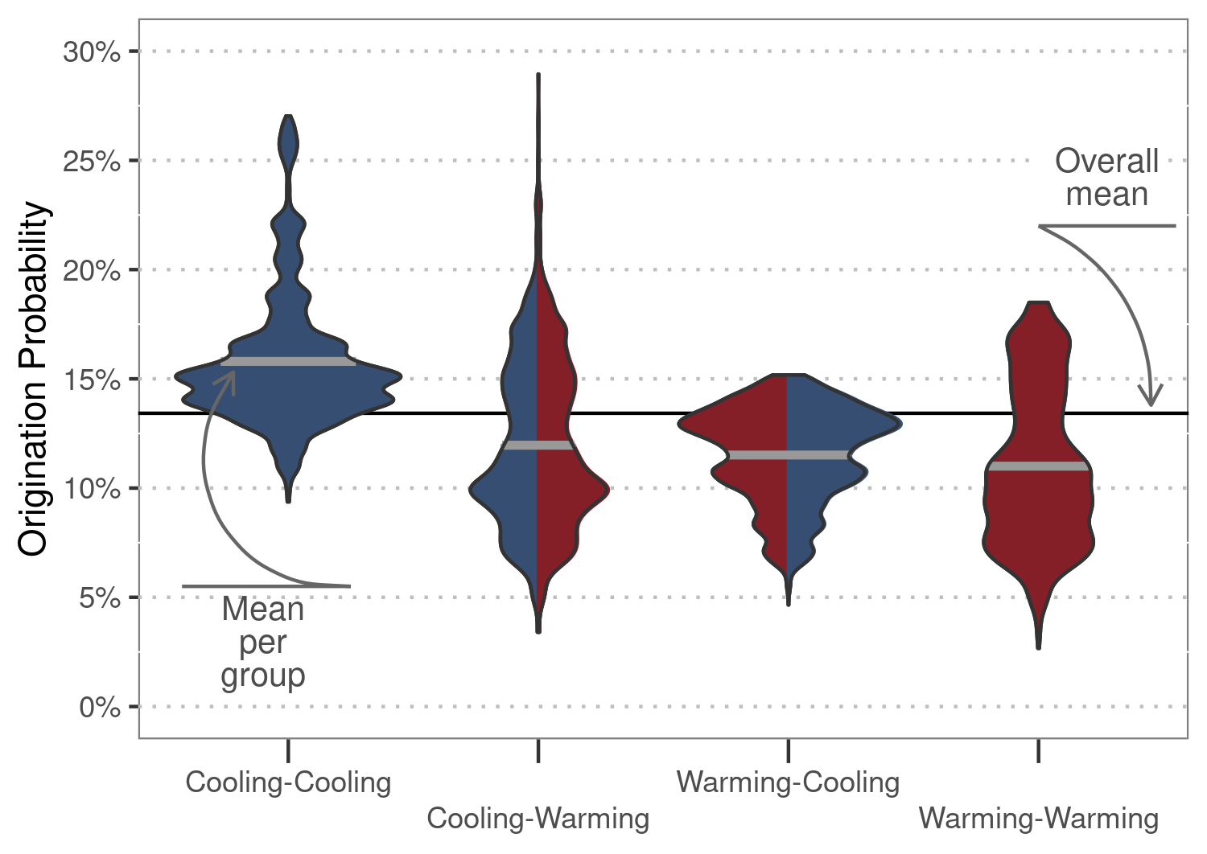

Figure 1 | Origination probability. Total response distributions to paleoclimate interactions as predicted by generalized linear mixed effect models. Thick gray lines show the mean origination probability per paleoclimate interaction, and the black line depicts the mean probability for all interactions combined.

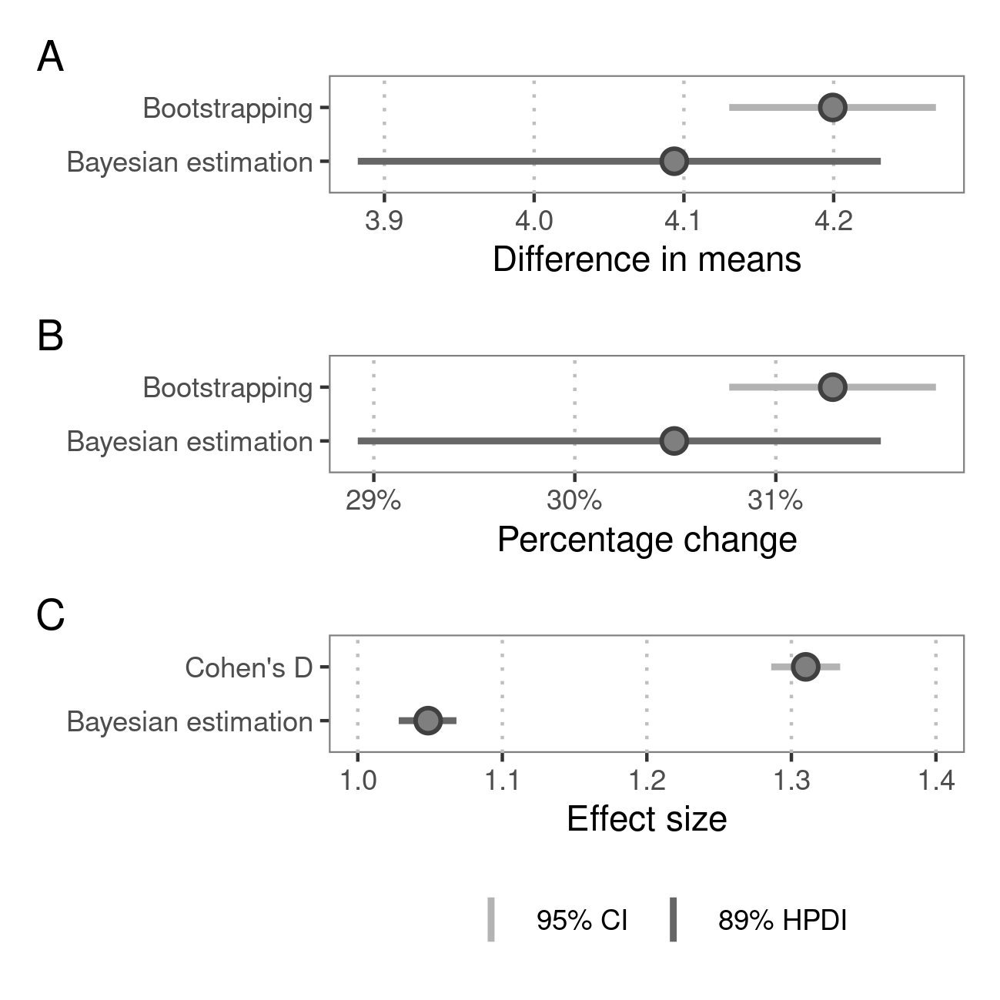

Figure 2 | Effect size. A) Difference in means between origination probability after cooling-cooling compared to all other paleoclimate interactions. B) Overall increase of origination probability after cooling-cooling paleoclimate interactions compared to baseline probability. C) Cohen’s d effect size of the observed change in probability after cooling-cooling paleoclimate interactions. Points show mean estimates. Light gray lines delineate 95% confidence intervals (CI) based on non-parametric bootstrapping. Dark gray lines depict 89% highest posterior density intervals (HPDI) based on Bayesian regression.

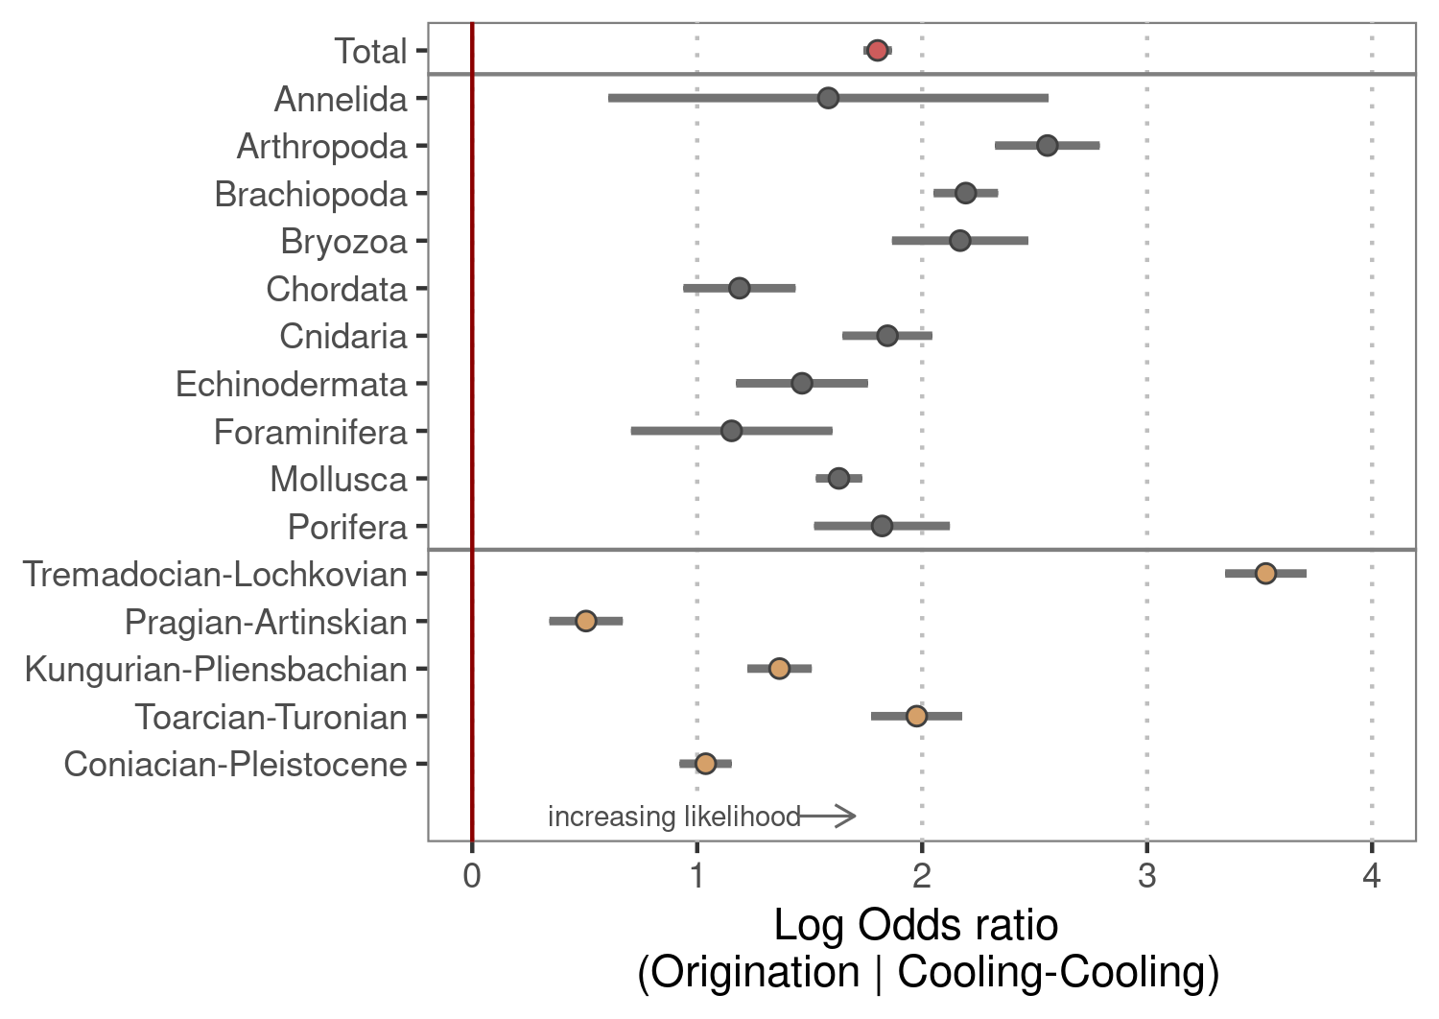

Figure 3 | Group differences. Origination likelihood for all major phyla and across time after cooling-cooling compared to all other paleoclimate interactions. The red point shows the overall response, gray points per phyla, and brown points response per time period. Gray lines show 95% confidence intervals. The Tremadocian is the oldest stage included in analysis, and the Pleistocene the youngest. The phyla Hemichordata and Nematoda were removed from the analysis due to insufficient data.

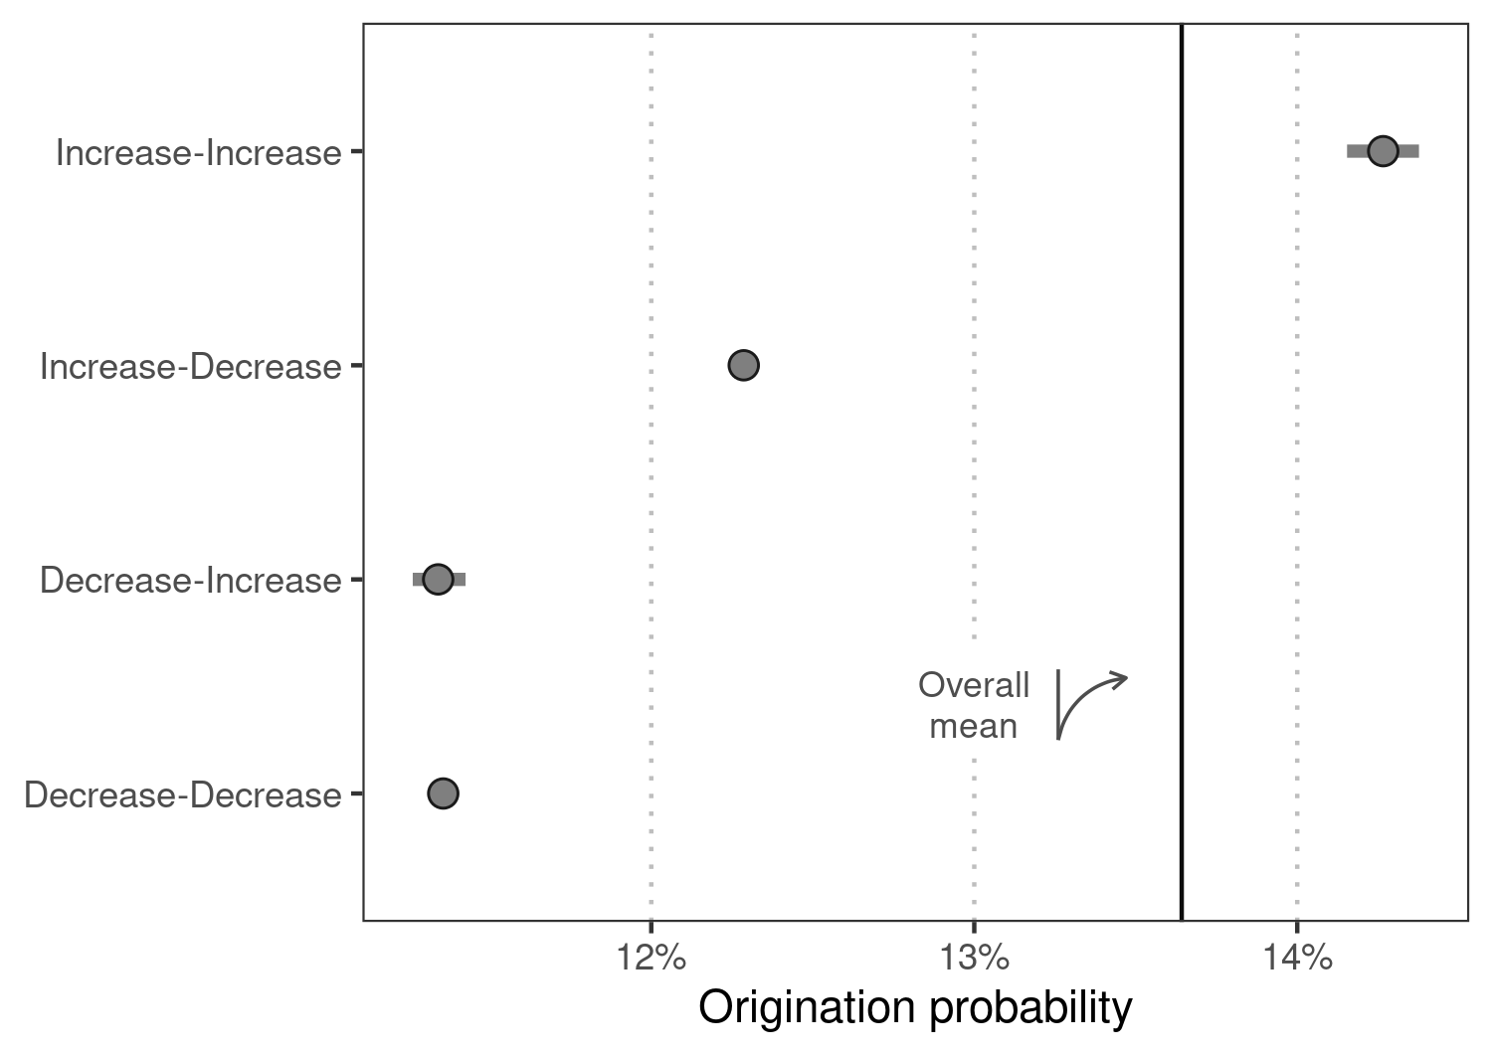

Figure 4 | Continental fragmentation. Mean origination response per continental fragmentation interaction as predicted by generalized linear mixed effect models based on a continental fragmentation index. The black line depicts the mean origination probability for all marine genera, and gray lines delineate 95% confidence intervals.

**Methodology**

Fossil data

All analyses were conducted at the genus level. We accessed data from the Paleobiology Database (PaleoDB, paleobiodb.org) using the chronosphere package interface (Kocsis & Raja, 2020) on 03 March 2021, including all occurrences from the Ediacaran to the Holocene. We filtered the data to only comprise marine animal taxa and heterotrophic protists, i.e. the same taxonomic groups listed in Sepkoski’s (2002) compendium, following common processing recommendations (Kocsis et al., 2019). Previous studies on the relationship between temperature and biodiversity were mainly based on Sepkoski’s compendium, rendering this data optimal for comparison purposes of our model structures. We binned the data to one of 80 geological stages (Ogg et al., 2016), ranging from the Ordovician to the Pleistocene. Ordovician stages were resolved using biozone and formation entries due to potential stratigraphic errors (Kocsis et al., 2019). Further data cleaning included removal of uncertain taxonomical ranks, duplicates in bins, single-collection, and single-reference taxa as well as missing higher-level taxonomy. Taxa confined to a single stage (singletons) were excluded as they tend to produce undesirable distortions of the fossil record (Foote, 2000). Collections from unlithified sediments were omitted to reduce sampling bias (Alroy et al., 2008). We then applied shareholder quorum subsampling (SQS) for sampling standardization (Alroy, 2010). SQS is based on frequency distribution coverage of taxa, drawing collections until estimated coverage reaches a fixed target (i.e., until a shareholder quorum is attained). For this, we used a shareholder quorum of 0.8. SQS was applied excluding dominant taxa from all calculations involving frequencies and with a separate treatment of the largest collection in each time slice. We then transformed occurrence data into ranges congruent to a time series with one single origination and extinction event for each genus. The final data set contained twelve major marine fossil phyla with sufficient data to include in the subsequent analysis (Suppl. Figure 1, Suppl. Table 4).

Climate proxy data

To reconstruct temperature change over time, we used the tropical whole surface water (mixed layers < 300 m deep) oxygen isotope data set from a compilation of marine carbonate isotopes (Veizer & Prokoph, 2015). This temperature proxy is based on δ18O values of well-preserved calcareous shells. To get from raw δ18O values to temperature estimates, we applied the recommended data processing steps of Veizer & Prokoph (2015). We first adjusted for the long-term trend in oxygen isotopic composition of seawater and averaged records from tropical and subtropical records. We then assigned the temperature data to geological stages to provide global mean temperature for each of the 81 stages used in our analysis.

Statistical analysis

*Generalized linear mixed effect models*

All analyses were carried out in R (R Core Team, 2020). We used the lme4 package (Bates et al., 2014) to perform the analysis, and the tidyverse package compendium (Wickham et al., 2019) for data processing and visualization. We quantified the effect of temperature change interacting with past temperature trends on origination probability using generalized linear mixed effect models with a binomial family error (GLMMs) (Bolker et al., 2009). We used the origination signal from the fossil data as a response variable and a single interaction term including the long-term temperature trend and the short-term temperature change as a predictor variable:   
GLM (Origination ~ Trend : Change + (1 | Genus), Family = Binomial).

Using the genus-level as a random effect, we accounted for the multiple occurrence of the same genus within the time-series fossil data. The short-term temperature change was calculated as the change in temperature for each geologic stage compared to the previous stage. Long-term temperature trends were calculated using ordinary least squares following the processing steps of Mathes et al. (2021). For each stage included in the analysis, we calculated ten stages starting one stage prior to the focal stage, each covering a successively growing time of temperature history. We then used a dynamic model framework to select the best performing long-term trend(Suppl. Table 5). This implies calculating 10 GLMMs for each trend while keeping the short-term change fixed. From these 10 GLMMs, we then selected the best performing model using Akaike’s Information Criterion (AIC). Instead of calculating one model for all short-term changes, we distinguished short-term warming from short-term cooling. This enabled us to quantify the differences in origination probability per paleoclimate interaction (cooling-cooling, warming-cooling, cooling-warming, warming-warming, where the first word denotes the long-term temperature trend, and the second word the short-term temperature change). We used AIC to compare model performance. For likelihood approximation, we applied adaptive Gauss-Hermite quadrature (Pinheiro & Chao, 2006), which reduces bias and is more robust than other approximation methods (Bolker et al., 2009). We used 25 quadrature points per scalar integral, which is the maximum number of nodes in the quadrature formula of the lme4 package.

*Origination probability*

We separated the predicted origination response for each type of paleoclimate interaction from our GLMMs using the predict() function on the actual fossil data. Any resulting distributions for the origination probability hence reflect climate conditions experienced by the focal fossil group. We calculated the average origination probability as the mean of both model coefficients (i.e. of the model for short-term warming and for short-term cooling).

*Effect size*

We applied non-parametric bootstrapping (Mooney, 1996, Suppl. Figure 2) and Bayesian estimation (Kruschke, 2013) to the predicted origination response of our GLMMs to calculate the difference in means between origination probability after cooling-cooling compared to all other paleoclimate interactions. While doing so, we accounted for the non-parametric nature of the data (Suppl. Figure 3). Bootstrapping was based on 2000 repetitions. For Bayesian estimation, we used a Markov Chain Monte Carlo method with four chains, 1000 iterations, and 500 warm-up iterations. We used an informed prior for the group mean based on the origination response of the whole sample and bound between 0 and 1. We set a default exponential prior with a rate of 1/29 for the group variances. All model estimates successfully converged using these priors and model parameters. The overall increase of origination probability after cooling-cooling paleoclimate interactions was calculated by dividing the estimated difference of means by the baseline probability of origination. Further, we calculated Cohen’s d effect size based on the raw output of our GLMMs as well as posterior distributions after Bayesian estimation using the formula:

$$\frac{\left(μ_{1}-μ_{2}\right)}{\sqrt{{\left(σ_{1}^{2}+σ_{2}^{2}\right)}/2}}$$

We then calculated 95% Wald confidence intervals for the applied non-parametric bootstrapping results and 89% highest posterior density intervals for the Bayesian estimation (McElreath, 2020).

*Group differences*

Based on the results from our GLMMs, we calculated the log-odds ratio for each major fossil group and for five intervals spanning all studied stages. The oldest interval ranged from the Tremadocian to Lochkovian, the second from the Pragian to Artinskian, the third from the Kungurian to Pliensbachian, the fourth from the Toarcian to Turonian, and the youngest period from the Coniacian to Pleistocene. Grouping of the stages was necessary to obtain a sufficient number of observations to calculate the log-odds ratio and was based on the number of stages included, resulting in evenly spaced intervals. We did not calculate group differences for phyla where data were insufficient to get a log-odds ratio estimate.

*Continental fragmentation*

To estimate whether habitat space and vicariance might be the mechanisms through which paleoclimate interactions act on origination probability, we included continental fragmentation as an explanatory variable in our model framework. We used a continental fragmentation index (Zaffos et al., 2017) accessed via the chronosphere package. Data processing was similar to processing of temperature data, including the calculation of short-term changes and long-term trends in continental fragmentation. We then compared the origination probability for marine genera for each possible interaction of short-term and long-term continental fragmentation (increase-increase, increase-decrease, decrease-increase, decrease-decrease) using the same analysis as for paleoclimate.

*Model comparison*

Previous studies used different estimates of temperature to deduce an association between origination and temperature (Cárdenas & Harries, 2010; Krug et al., 2009; Mayhew et al., 2008, 2012). Generally, simple models correlate static temperature estimates at each interval to biodiversity in the same interval. More complex models include temporal lags of temperature, allowing for a suspended response of biota to temperature change (Cárdenas & Harries, 2010; Mayhew et al., 2008). Most recent models are based on both estimates but additionally allow for interactions of static estimates and temporal lags (Mayhew et al., 2012). To test whether paleoclimate interactions perform better than these traditional model estimates, we calculated a GLMM for each model structure from simple to complex. We then compared the performance of each model to a model allowing for paleoclimate interactions (Suppl. Figure 4 and Suppl. Figure 5). The interaction models were based on the same model structure, but explicitly allowed for interactions of long-term temperature trends and short-term climate changes within a dynamic modeling framework. Comparison of model performance was based on AIC values with results being consistent with Bayesian information criterion (Suppl. Table 6).

**References**

Alroy, J. (2008). Dynamics of origination and extinction in the marine fossil record. *Proceedings of the National Academy of Sciences*, *105* (Supplement 1), 11536–11542. https://doi.org/10.1073/pnas.0802597105

Alroy, J. (2010). Fair sampling of taxonomic richness and unbiased estimation of origination and extinction rates. *The Paleontological Society Papers*, *16*, 55–80.

Alroy, J., Aberhan, M., Bottjer, D. J., Foote, M., Fürsich, F. T., Harries, P. J., Hendy, A. J., Holland, S. M., Ivany, L. C., & Kiessling, W. (2008). Phanerozoic trends in the global diversity of marine invertebrates. *Science*, *321*(5885), 97–100.

Alroy, J., Koch, P. L., & Zachos, J. C. (2000). Global Climate Change and North American Mammalian Evolution. *Paleobiology*, *26* (4,), 259–288.

Antão, L. H., Bates, A. E., Blowes, S. A., Waldock, C., Supp, S. R., Magurran, A. E., Dornelas, M., & Schipper, A. M. (2020). Temperature-related biodiversity change across temperate marine and terrestrial systems. *Nature Ecology & Evolution*, *4* (7), 927–933. https://doi.org/10.1038/s41559-020-1185-7

Bates, D., Mächler, M., Bolker, B., & Walker, S. (2014). Fitting linear mixed-effects models using lme4. *ArXiv Preprint ArXiv:1406.5823*.

Bolker, B. M., Brooks, M. E., Clark, C. J., Geange, S. W., Poulsen, J. R., Stevens, M. H. H., & White, J.-S. S. (2009). Generalized linear mixed models: A practical guide for ecology and evolution. *Trends in Ecology & Evolution*, *24*(3), 127–135.

Button, D. J. (2017). Mass extinctions drove increased global faunal cosmopolitanism on the supercontinent Pangaea. *Nature Communications*, 8. https://doi.org/10.1038/s41467-017-00827-7

Cárdenas, A. L., & Harries, P. J. (2010). Effect of nutrient availability on marine origination rates throughout the Phanerozoic eon. *Nature Geoscience*, *3*(6), 430–434. https://doi.org/10.1038/ngeo869

Eldredge, N. (1971). The Allopatric Model and Phylogeny in Paleozoic Invertebrates. *Evolution*, *25* (1), 156. https://doi.org/10.2307/2406508

Foote, M. (2000). Origination and extinction components of taxonomic diversity: General problems. *Paleobiology*, *26* (sp4), 74–102.

Gilman, S. E., Urban, M. C., Tewksbury, J., Gilchrist, G. W., & Holt, R. D. (2010). A framework for community interactions under climate change. *Trends in Ecology & Evolution*, *25* (6), 325–331. https://doi.org/10.1016/j.tree.2010.03.002

Hopkins, M. J., Simpson, C., & Kiessling, W. (2014). Differential niche dynamics among major marine invertebrate clades. *Ecology Letters*, *17* (3), 314–323. https://doi.org/10.1111/ele.12232

Jablonski, D. (2008). Extinction and the spatial dynamics of biodiversity. *Proceedings of the National Academy of Sciences*, *105* (Supplement 1), 11528–11535. https://doi.org/10.1073/pnas.0801919105

Kiessling, W. (2010). Promoting marine origination. *Nature Geoscience*, *3*(6), 388–389. https://doi.org/10.1038/ngeo874

Kocsis, À. T., & Raja, N. B. (2020). *chronosphere: Earth system history variables* (0.4.0) [R]. https://doi.org/10.5281/zenodo.3530703

Kocsis, À. T., Reddin, C. J., Alroy, J., & Kiessling, W. (2019). The R package divDyn for quantifying diversity dynamics using fossil sampling data. *Methods in Ecology and Evolution*, *10* (5), 735–743.

Krug, A. Z., Jablonski, D., Valentine, J. W., & Roy, K. (2009). Generation of Earth’s First-Order Biodiversity Pattern. *Astrobiology*, *9* (1), 113–124. https://doi.org/10.1089/ast.2008.0253

Kruschke, J. K. (2013). Bayesian estimation supersedes the t test. *Journal of Experimental Psychology: General*, *142* (2), 573.

Lister, A. M. (2004). The impact of Quaternary Ice Ages on mammalian evolution. *Philosophical Transactions of the Royal Society B: Biological Sciences*, *359* (1442), 221–241.

Maldonado-Coelho, M. (2012). Climatic oscillations shape the phylogeographical structure of Atlantic Forest fireeye antbirds (Aves: Thamnophilidae). *Biological Journal of the Linnean Society*, 25.

Mathes, G. H., van Dijk, J., Kiessling, W., & Steinbauer, M. J. (2021). Extinction risk controlled by interaction of long-term and short-term climate change. *Nature Ecology & Evolution*, *5* (3), 304–310. https://doi.org/10.1038/s41559-020-01377-w

Mayhew, P. J., Bell, M. A., Benton, T. G., & McGowan, A. J. (2012). Biodiversity tracks temperature over time. *Proceedings of the National Academy of Sciences*, *109* (38), 15141–15145. https://doi.org/10.1073/pnas.1200844109

Mayhew, P. J., Jenkins, G. B., & Benton, T. G. (2008). A long-term association between global temperature and biodiversity, origination and extinction in the fossil record. *Proceedings of the Royal Society B: Biological Sciences*, *275* (1630), 47–53. https://doi.org/10.1098/rspb.2007.1302

Mayr, E. (1963). Animal species and evolution. *Animal Species and Evolution.*

Mayr, E., & O’Hara, R. J. (1986). The biogeographic evidence supporting the Pleistocene forest refuge hypothesis. *Evolution*, *40* (1), 55–67. https://doi.org/10.1111/j.1558-5646.1986.tb05717.x

McElreath, R. (2020). *Statistical Rethinking, 2nd Edition*. https://learning.oreilly.com/library/view/-/9780429639142/?ar

Mooney, C. Z. (1996). Bootstrap statistical inference: Examples and evaluations for political science. *American Journal of Political Science*, 570–602.

Ogg, J. G., Ogg, G. M., & Gradstein, F. M. (2016). *A concise geologic time scale: 2016*. Elsevier.

Peters, S. E. (2005). Geologic constraints on the macroevolutionary history of marine animals. *Proceedings of the National Academy of Sciences*, *102*(35), 12326–12331. https://doi.org/10.1073/pnas.0502616102

Peters, S. E. (2006). Genus extinction, origination, and the durations of sedimentary hiatuses. *Paleobiology*, *32*(3), 387–407. https://doi.org/10.1666/05081.1

Pinheiro, J. C., & Chao, E. C. (2006). Efficient Laplacian and adaptive Gaussian quadrature algorithms for multilevel generalized linear mixed models. *Journal of Computational and Graphical Statistics*, *15*(1), 58–81.

Postigo-Mijarra, J. M., Morla, C., Barrón, E., Morales-Molino, C., & García, S. (2010). Patterns of extinction and persistence of Arctotertiary ﬂora in Iberia during the Quaternary. *Review of Palaeobotany and Palynology*, 12.

Prothero, D. R. (1999). Does climatic change drive mammalian evolution? *GSA Today*, *9*(9), 1.

R Core Team. (2020). *R: A Language and Environment for Statistical Computing* [R]. R Foundation for Statistical Computing. https://www.R-project.org/

Raup, D. M. (1979). Size of the Permo-Triassic Bottleneck and Its Evolutionary Implications. *Science*, *206*(4415), 217–218. https://doi.org/10.1126/science.206.4415.217

Schuler, M. S., Chase, J. M., & Knight, T. M. (2017). Habitat patch size alters the importance of dispersal for species diversity in an experimental freshwater community. *Ecology and Evolution*, *7*(15), 5774–5783. https://doi.org/10.1002/ece3.2858

Sepkoski, J. J. (2002). A compendium of fossil marine animal genera. *Bulletins of American Paleontology*, *363*, 1–560.

Stigall, A. L. (2014). When and how do species achieve niche stability over long time scales? *Ecography*, *37*(11), 1123–1132. https://doi.org/10.1111/ecog.00719

Stigall, A. L., Bauer, J. E., Lam, A. R., & Wright, D. F. (2017). Biotic immigration events, speciation, and the accumulation of biodiversity in the fossil record. *Global and Planetary Change*, *148*, 242–257. https://doi.org/10.1016/j.gloplacha.2016.12.008

Svenning, J.-C., Eiserhardt, W. L., Normand, S., Ordonez, A., & Sandel, B. (2015). The Influence of Paleoclimate on Present-Day Patterns in Biodiversity and Ecosystems. *Annual Review of Ecology, Evolution, and Systematics*, *46*(1), 551–572. https://doi.org/10.1146/annurev-ecolsys-112414-054314

Templeton, A. R. (2008). The reality and importance of founder speciation in evolution. *BioEssays*, *30*(5), 470–479. https://doi.org/10.1002/bies.20745

Tilman, D. (1994). Competition and Biodiversity in Spatially Structured Habitats. *Ecology*, *75*(1), 2–16. https://doi.org/10.2307/1939377

Valentine, J. W., & Moores, E. M. (1970). Plate-tectonic Regulation of Faunal Diversity and Sea Level: A Model. *Nature*, *228*(5272), 657–659. https://doi.org/10.1038/228657a0

Valentine, James W. (1968). Climatic Regulation of Species Diversification and Extinction. *Geological Society of America Bulletin*, *79*(2), 273. https://doi.org/10.1130/0016-7606(1968)79[273:CROSDA]2.0.CO;2

Veizer, J., & Prokoph, A. (2015). Temperatures and oxygen isotopic composition of Phanerozoic oceans. *Earth-Science Reviews*, *146*, 92–104.

Wahl, L. M., Gerrish, P. J., & Saika-Voivod, I. (2002). Evaluating the Impact of Population Bottlenecks in Experimental Evolution. *Genetics Society of America*, *162*, 12.

Wickham, H., Averick, M., Bryan, J., Chang, W., McGowan, L. D., François, R., Grolemund, G., Hayes, A., Henry, L., & Hester, J. (2019). Welcome to the Tidyverse. *Journal of Open Source Software*, *4*(43), 1686.

Wiens, J. J., & Graham, C. H. (2005). Niche Conservatism: Integrating Evolution, Ecology, and Conservation Biology. *Annual Review of Ecology, Evolution, and Systematics*, *36*(1), 519–539. https://doi.org/10.1146/annurev.ecolsys.36.102803.095431

Zaffos, A., Finnegan, S., & Peters, S. E. (2017). Plate tectonic regulation of global marine animal diversity. *Proceedings of the National Academy of Sciences*, *114*(22), 5653–5658. https://doi.org/10.1073/pnas.1702297114