| Palaeoclimate Interaction | Lower Quartile | Median | Upper Quartile |
| --- | --- | --- | --- |
| Cooling-Cooling | 0.139 | 0.151 | 0.166 |
| Cooling-Warming | 0.091 | 0.112 | 0.149 |
| Warming-Cooling | 0.102 | 0.119 | 0.132 |
| Warming-Warming | 0.081 | 0.104 | 0.140 |

Suppl. Table 1 | Distribution of origination probability after each palaeoclimate interaction for all studied fossil groups based on predictions of final GLMMs.

| Parameter | Lower | Estimate | Upper | Method |
| --- | --- | --- | --- | --- |
| Difference in means | 4.13 | 4.20 | 4.27 | Bootstrapping |
| 3.88 | 4.09 | 4.23 | Bayesian Estimate |
| Percentage change | 30.77 | 31.28 | 31.80 | Bootstrapping |
| 28.92 | 30.50 | 31.52 | Bayesian Estimate |
| Effect size | 1.29 | 1.31 | 1.33 | Cohen's D |
| 1.03 | 1.05 | 1.07 | Bayesian Estimate |

Suppl. Table 2 | Effect size estimates for the difference in means of origination probability, overall increase of origination probability and Cohen’s d effect size including lower and upper bounds for 95% confidence intervals (bootstrapping) and 89% highest posterior density estimates (Bayesian estimate).

| Group | Lower CI | Log Odds ratio | Upper CI |
| --- | --- | --- | --- |
| Total | 1.74 | 1.80 | 1.86 |
| Annelida | 0.60 | 1.58 | 2.56 |
| Arthropoda | 2.32 | 2.56 | 2.79 |
| Brachiopoda | 2.05 | 2.19 | 2.34 |
| Bryozoa | 1.87 | 2.17 | 2.47 |
| Chordata | 0.94 | 1.19 | 1.44 |
| Cnidaria | 1.65 | 1.85 | 2.04 |
| Echinodermata | 1.17 | 1.47 | 1.76 |
| Foraminifera | 0.71 | 1.15 | 1.60 |
| Mollusca | 1.53 | 1.63 | 1.73 |
| Porifera | 1.52 | 1.82 | 2.12 |
| Tremadocian-Lochkovian | 3.35 | 3.53 | 3.71 |
| Pragian-Artinskian | 0.34 | 0.51 | 0.67 |
| Kungurian-Pliensbachian | 1.22 | 1.37 | 1.51 |
| Toarcian-Turonian | 1.77 | 1.98 | 2.18 |
| Coniacian-Pleistocene | 0.92 | 1.04 | 1.15 |

Suppl. Table 3 | Origination probability for all major phyla and throughout time after cooling-cooling compared to all other palaeoclimate interactions calculated as log odds ratio, including 95% confidence intervals. The Tremadocian is the oldest stage included in analysis, and the Pleistocene the youngest. The phyla Hemichordata and Nematoda were removed from the analysis due to insufficient data.

| Phylum | Class | Order | Family | Genus |
| --- | --- | --- | --- | --- |
| Annelida | 1 | 2 | 4 | 14 |
| Arthropoda | 4 | 20 | 162 | 623 |
| Brachiopoda | 6 | 22 | 304 | 1,296 |
| Bryozoa | 2 | 13 | 123 | 266 |
| Chordata | 9 | 104 | 250 | 488 |
| Cnidaria | 3 | 16 | 185 | 573 |
| Echinodermata | 8 | 50 | 135 | 249 |
| Foraminifera | 3 | 7 | 31 | 89 |
| Hemichordata | 1 | 3 | 7 | 20 |
| Hyolitha | 1 | 1 | 1 | 1 |
| Mollusca | 8 | 80 | 628 | 2,475 |
| Porifera | 5 | 32 | 109 | 240 |

Suppl. Table 4 | Number of classes, order, families, and genera within every major phylum after data-cleaning and sampling-standardization.

| Type | Model | Intercept | Interaction |
| --- | --- | --- | --- |
| Warming | trend.st1 | -1.9 +- 0.02 *** | 0.01 +- 0.05 |
| trend.st2 | -1.91 +- 0.02 *** | -0.26 +- 0.06 *** |
| trend.st3 | -1.92 +- 0.02 *** | -0.38 +- 0.1 *** |
| trend.st4 | -1.91 +- 0.03 *** | -0.26 +- 0.11 * |
| trend.st5 | -1.92 +- 0.03 *** | -0.47 +- 0.1 *** |
| trend.st6 | -1.94 +- 0.03 *** | -0.64 +- 0.1 *** |
| trend.st7 | -1.94 +- 0.03 *** | -0.68 +- 0.11 *** |
| trend.st8 | -1.94 +- 0.03 *** | -0.7 +- 0.11 *** |
| trend.st9 | -1.91 +- 0.03 *** | -0.27 +- 0.13 * |
| trend.st10 | -1.9 +- 0.02 *** | -0.01 +- 0.13 |
| Cooling | trend.st1 | -1.82 +- 0.02 *** | 0.19 +- 0.04 *** |
| trend.st2 | -1.83 +- 0.02 *** | 0.27 +- 0.06 *** |
| trend.st3 | -1.82 +- 0.02 *** | 0.86 +- 0.1 *** |
| trend.st4 | -1.79 +- 0.02 *** | 1.44 +- 0.1 *** |
| trend.st5 | -1.81 +- 0.02 *** | 1.34 +- 0.11 *** |
| trend.st6 | -1.83 +- 0.02 *** | 1.32 +- 0.1 *** |
| trend.st7 | -1.85 +- 0.02 *** | 1.25 +- 0.11 *** |
| trend.st8 | -1.87 +- 0.02 *** | 1.22 +- 0.12 *** |
| trend.st9 | -1.88 +- 0.02 *** | 1.26 +- 0.13 *** |
| trend.st10 | -1.88 +- 0.02 *** | 1.31 +- 0.13 *** |

Suppl. Table 5 | Selection of the final model using a dynamic model framework. 10 GLMMs for each ∆Ttrend were calculated while keeping ∆Tchange fixed. The final model for both short-term warming and cooling was then selected using the AIC of each model.

| Model Structure | Overdispersed | AIC | BIC |
| --- | --- | --- | --- |
| ~ Warming | no *** | 16,678 | 16,702 |
| ~ Warming + Pal. Int. | no *** | 16,620 | 16,652 |
| ~ Cooling + Lag | no *** | 19,502 | 19,527 |
| ~ Cooling + Pal. Int. | no *** | 18,861 | 18,893 |
| ~ Warming + Lag | no *** | 15,898 | 15,929 |
| ~ Warming + Lag + Pal. Int. | no *** | 15,812 | 15,852 |
| ~ Cooling + Lag | no *** | 15,672 | 15,704 |
| ~ Cooling + Lag + Pal. Int. | no *** | 15,650 | 15,690 |
| ~ Warming + Lag + Warming:Lag | no *** | 15,889 | 15,928 |
| ~ Warming + Lag + Warming:Lag + Pal. Int. | no *** | 15,791 | 15,839 |
| ~ Cooling + Lag + Cooling:Lag | no *** | 15,554 | 15,594 |
| ~ Cooling + Lag + Cooling:Lag + Pal. Int. | no *** | 15,535 | 15,583 |

Suppl. Table 6 | Comparison of model performance for traditional models covering first- and second-order relationships of origination and climate versus models allowing for paleoclimate interactions. The latter are based on the same model structure, but explicitly allow for interactions of long-term temperature trends and short-term climate changes within a dynamic modeling framework (+ Pal. Int). Each model was tested for overdispersion including significance (indicated by stars, based on adaptive Gauss-Hermite quadrature approximation). Model comparison was based on Akaikes information criterion (AIC) and is consistent with Bayesian information criterion (BIC).

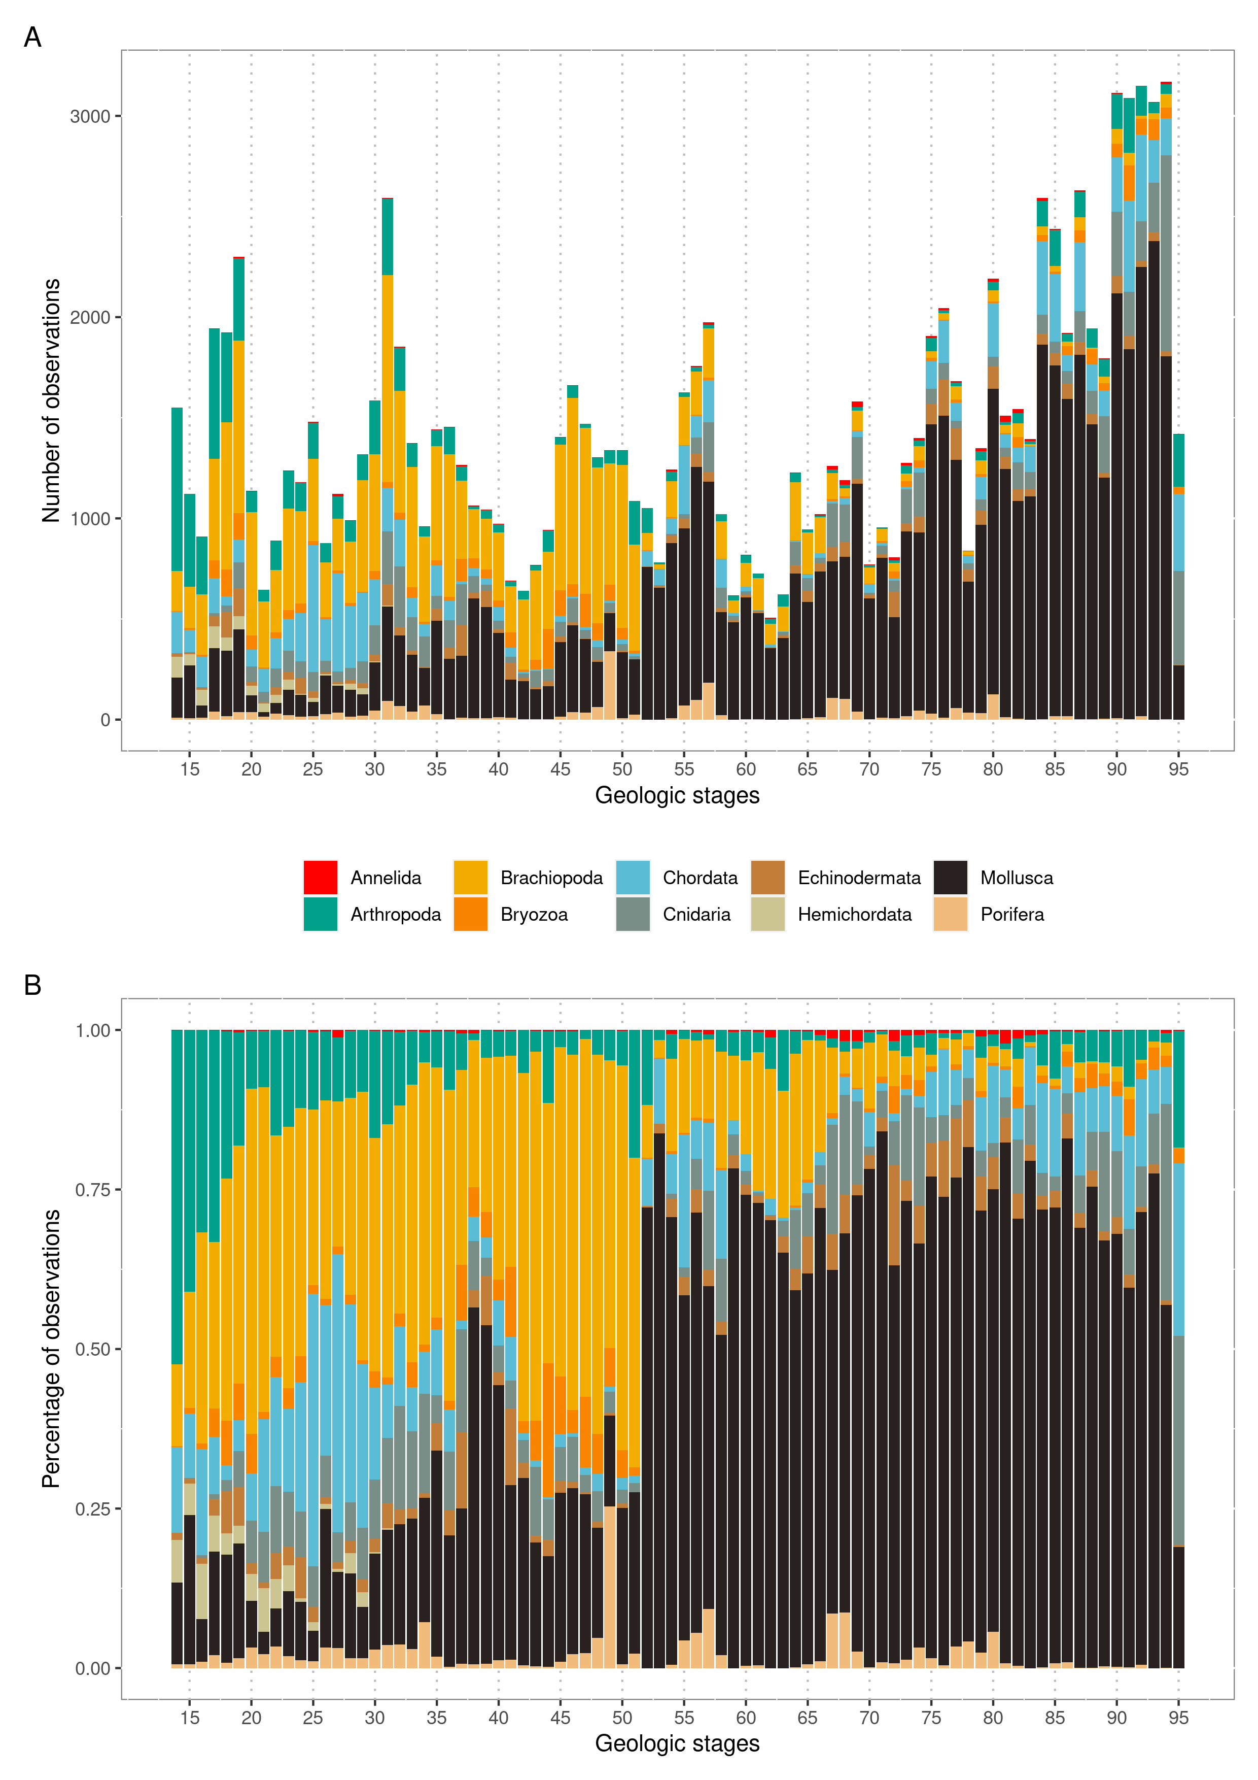

Suppl. Figure 1 | A) Total number of observations per phyla and stage. B) Percentage of total number of observations per phyla and stage. Stage 14 is the oldest, and stage 95 the youngest period.

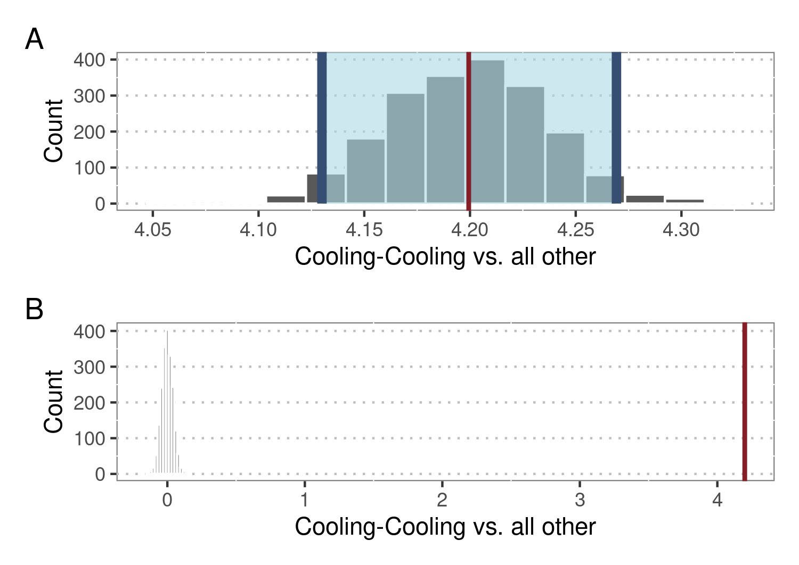

Suppl. Figure 2 | Difference in means of origination responses after cooling-cooling compared to all other palaeoclimate interactions, based on bootstrapping resampling. A) Bootstrapped distribution of differences in means. Red line shows observed difference and shaded area shows 95% confidence interval. B) Simulation-based null distribution of difference in means compared to observed difference (red line).

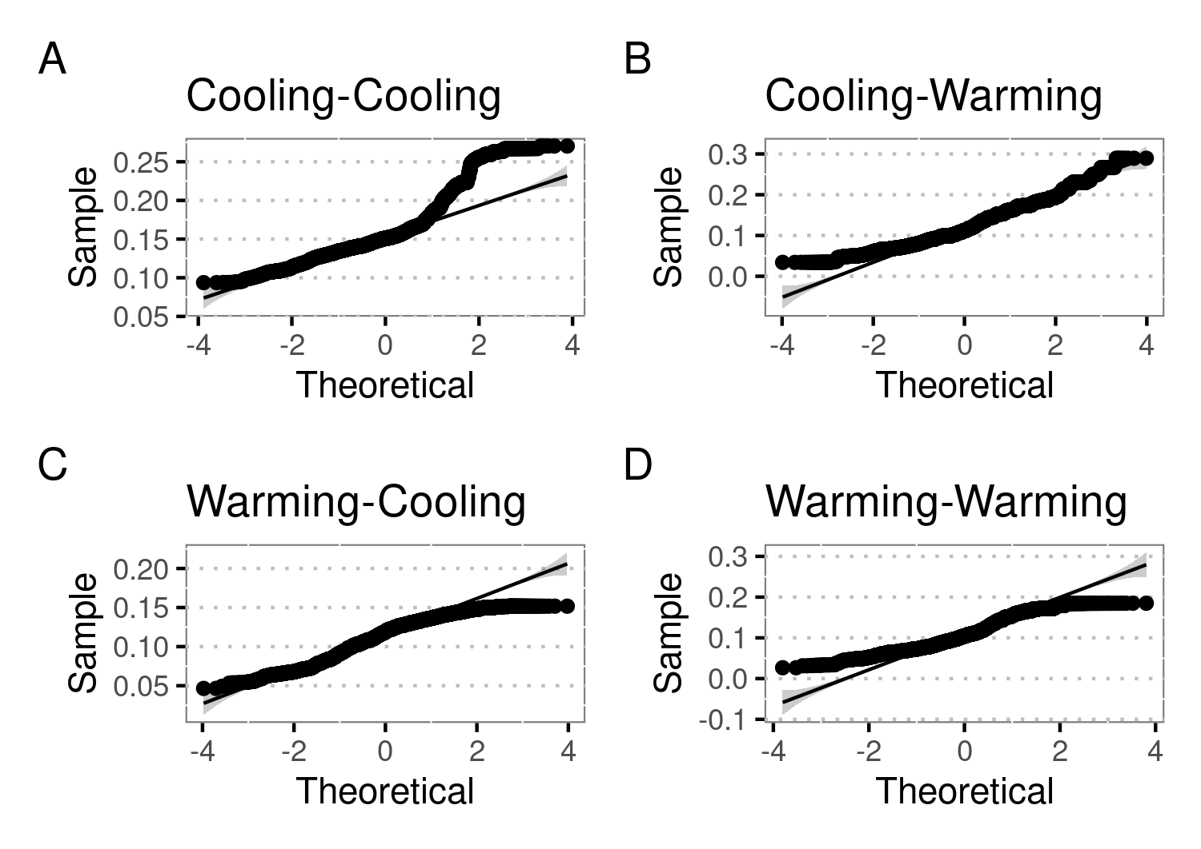

Suppl. Figure 3 | Quantile-quantile plots for predicted responses of marine fossil groups after palaeoclimate interactions. As these plots indicate deviations from normality, further estimates (difference in means, percentage change, effect change) were calculated using non-parametric methods.

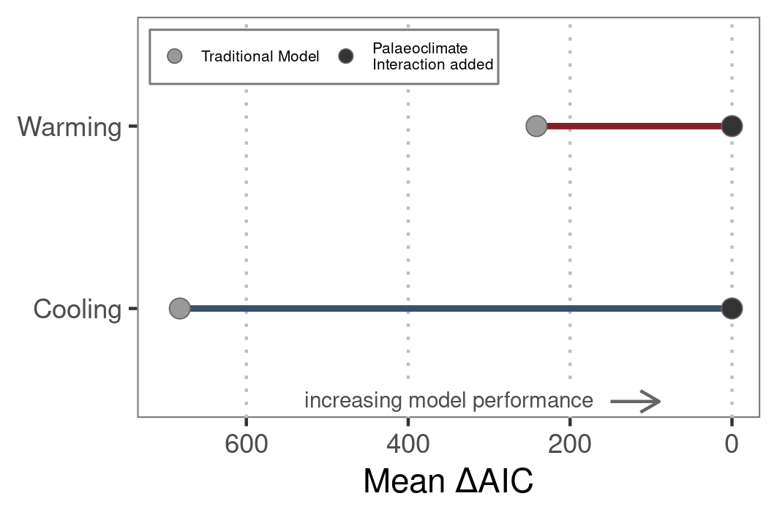

Suppl. Figure 4 | Comparison of model performance for traditional models covering first- and second-order relationships of origination and temperature versus models allowing for palaeoclimate interactions. The latter are based on the same model structure, but explicitly allow for interactions of long-term temperature trends and short-term climate changes within a dynamic modeling framework.

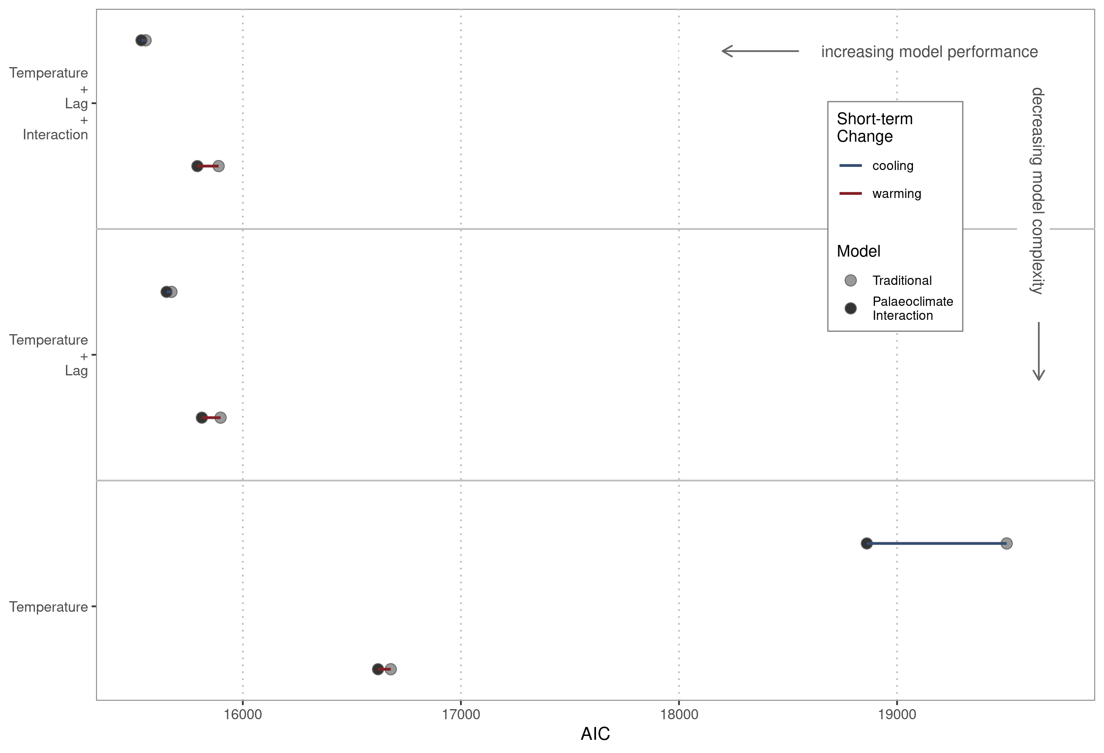

Suppl. Figure 5 | Comparison of model performance for traditional models covering first- and second-order relationships of origination and temperature versus models allowing for paleoclimate interactions. The latter are based on the same model structure, but explicitly allow for interactions of long-term temperature trends and short-term climate changes within a dynamic modeling framework.

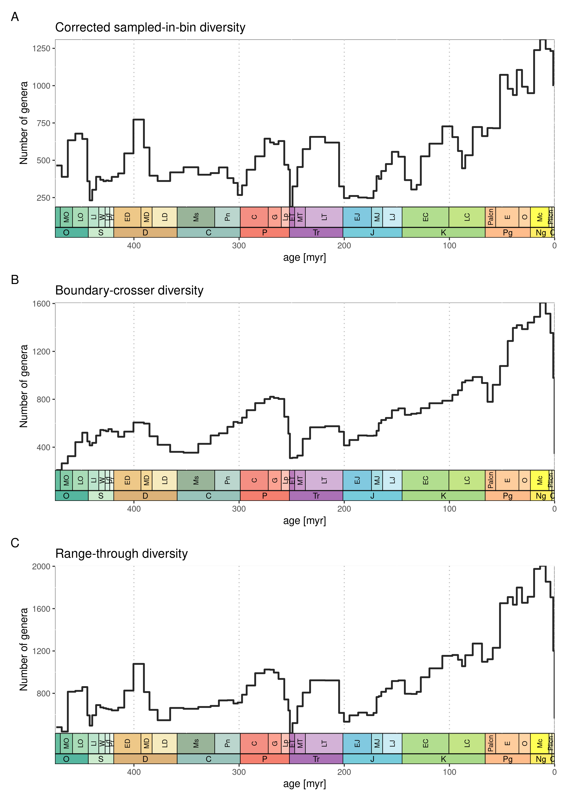Suppl. Figure 6 | Number of fossil genera within data sets. Diversity metrics shown here are based on filtered and sampling-standardised data. A) Sampled-in-bin diversity corrected for three-timer sampling completeness. B) Boundary-crosser diversity, which is the number of taxa with ranges crossing the boundaries of the interval. C) Range-through diversity, which is based on all taxa in the interval.

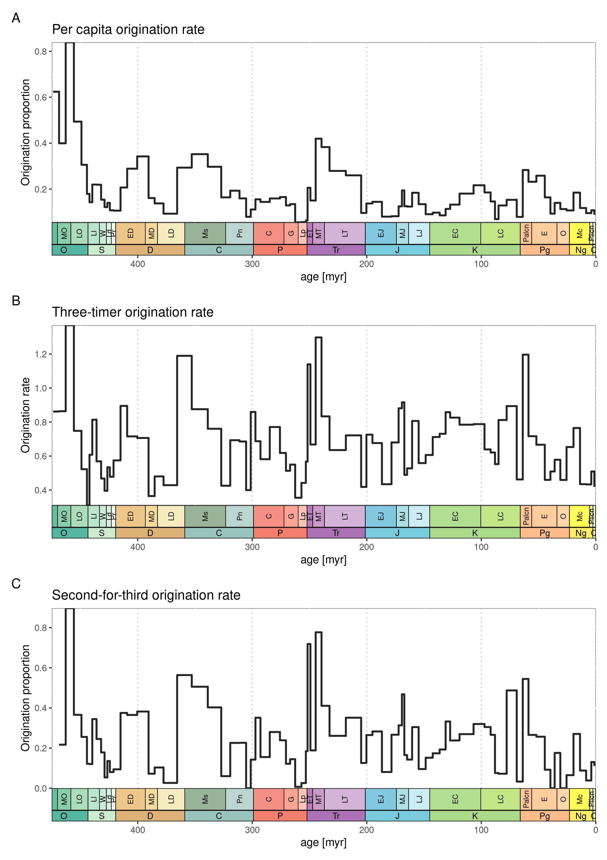Suppl. Figure 7 | Origination rates for all studied phyla based on filtered and sampling-standardized data. A) Per-capita origination with values not normalized with bin lengths. B) Three-timer origination rates with values normalized with bin lengths. C) Second-for-third extinction proportions based on second-for-third substitution of taxa categories.