**Intelligent Stock Forecasting with Evolutionary**

**Deep Reinforcement Learning**

**INTRODUCTION**

The stock market is a dynamic and complex system influenced by a multitude of factors, including company performance, macroeconomic indicators, and the prevailing market sentiment. Traditional forecasting methods often fall short in capturing the complexities of this environment, leading to suboptimal investment decisions.

This paper addresses this challenge by evaluating and comparing multiple reinforcement learning models for stock market prediction, analyzing their effectiveness in capturing market dynamics and optimizing trading strategies. We explore various Deep Reinforcement Learning (DRL) approaches, including policy-based and value-based methods, alongside evolutionary algorithms to enhance learning efficiency. Through this comparative analysis, we aim to identify the most effective framework for stock forecasting.

Ultimately, we propose a hybrid approach that integrates NEAT (NeuroEvolution of Augmenting Topologies) with Deep Deterministic Policy Gradient (DDPG), demonstrating its superiority over other models in learning optimal trading strategies. Additionally, the integration of Large Language Models (LLMs) enables sophisticated analysis of unstructured data, such as news sentiment and economic reports, further refining predictive accuracy. By systematically evaluating multiple methodologies, this study provides insights into the strengths and limitations of different reinforcement learning techniques, culminating in a robust framework that empowers investors with data-driven decision making capabilities in dynamic market environments.

**LITERATURE SURVEY**

**A. Natural Language Processing and Multimodal Stock Price Prediction**

Their studies have explored the use of the BERT-Tiny model and multi-modal data, including stock percentage changes and sentiment analysis from news articles, to predict stock price trends [1]. This approach has shown significant improvement over traditional models like LSTM, achieving a trend prediction accuracy of 74.04% and a price direction accuracy of 56.66%. The integration of sentiment analysis across various sectors, combined with stock percentage change as training data, has proven effective in enhancing the predictive capabil- ities of the model.

**B. LLM Based Stock Market Trend Prediction**

This paper [2] builds upon existing literature in financial market analysis and the use of large language models (LLMs) for predictive analytics. Traditional methods, often used by quantitative analysts, face challenges in incorporating market sentiment effectively. Sentiment analysis has historically been resistant to conventional models, creating a gap that LLMs aim to address. Recent advancements in LLMs enable the capture of sentiment from diverse sources like news and social media, improving predictive accuracy. The paper also highlights the integration of heuristics, such as options derivatives and supply demand factors, which is less explored in literature. By proposing a hybrid approach combining LLMs with traditional quantitative methods, this study paves the way for more accurate and comprehensive market predictions.

**C.** **Deep Reinforcement Learning Strategies in Finance**

This paper [3] examines the role of deep reinforcement learning (DRL) in financial trading, highlighting foundational principles and advancements that enable DRL to analyze complex market data effectively. The authors investigate the behaviors of DRL algorithms regarding asset holding and trading frequency, addressing gaps in existing literature. They also conduct a comparative analysis of trading strategies and evaluate reward mechanisms that influence trading behaviors, revealing unique patterns among different DRL algorithms and contributing to the optimization of RL in finance.

**D. Stock Market Prediction and Portfolio Composition Using a Hybrid Approach Combined with a Self-Adaptive Evolutionary Algorithm**

The literature survey in this paper [4] begins by out- lining key concepts in market forecasting and the role of AI, particularly EAs, in improving predictions and investment strategies. The survey reviews existing work on market forecasting and evolutionary computation, identifying re- search gaps. It discusses two types of EAs—static and self- adaptive—showcasing their evolution in portfolio optimization.

Additionally, the survey highlights how EAs enhance both fundamental and technical investment strategies, optimizing financial ratios and technical indicators. Case studies on technical and fundamental investments are presented, demonstrating the real-world application of these methods. Various performance metrics are used to validate the models, comparing them against benchmarks like the S&P 500.

**E.** **Learning to Generate Explainable Stock Predictions Using Self-Reflective Large Language Models (LLMs)**

The paper [5] reviews the evolution of textual analysis in stock prediction and the application of Large Language Models (LLMs) in finance. Early methods relied on simple text representations like Bag of Words and SVMs, which later evolved into structured event representations using deep neural networks. Attention-based models were introduced to handle the complexity of text data, with a shift towards integrating diverse data sources, such as audio and relational graphs.

In finance, models like BloombergGPT and Fin- GPT have been fine-tuned for financial tasks, focusing on sentiment analysis and stock prediction. Recent studies utilize LLMs for sequential stock-related text analysis, moving beyond individual text processing. The paper’s contribution is a self-reflective agent that generates explainable stock predictions, using a Proximal Policy Optimization (PPO) trainer to fine-tune a specialized LLM. This builds on prior work by advancing LLM applications in stock market prediction.

**F. NIFTY Financial News Headlines Dataset**

Enabling Market Prediction via Large Language Models (LLMs) The dataset is a valuable resource for financial market forecasting, leveraging machine learning and reinforcement learning techniques (MLAIRL) for predicting market movements. It [6] utilizes large language models (LLMs) to generate rich embeddings that enhance predictive accuracy, especially for clustering financial news. The dataset supports research on regime-switching models, which assess how market conditions affect predictions. It also emphasizes the importance of making the dataset open-source to promote collaboration and innovation in financial research, aligning with broader trends in the field.

**G. Fine-Tuning Large Language Models for Stock Return Prediction Using Newsflow**

This paper [7] reviews key developments in the use of financial text data for quantitative investing. Early studies primarily focused on extracting sentiment from news and social media to predict stock prices, but these efforts were limited by word-level embeddings that struggled to capture context. The introduction of attention mechanisms significantly improved the ability to represent financial news numerically, leading to better stock movement predictions. Large Language Models (LLMs), such as BERT and GPT-3, have further revolutionized financial forecasting by offering powerful text representation capabilities. The paper distinguishes between different LLM types, highlighting their unique strengths in generating text representations. Fine-tuning, particularly with methods like Low-Rank Adaptation (LoRA), has gained popularity as an efficient way to tailor pre-trained models for specific financial applications.

Unlike previous approaches that used LLMs for feature extraction, this paper focuses on fine-tuning LLMs to directly model the relationship between financial text and stock performance. A comparative analysis reveals that LLMs generally improve portfolio performance, with decoder-based models performing especially well in larger investment universes. Overall, the literature emphasizes the potential of fine-tuning LLMs to enhance stock return predictions by leveraging contextual text representation.

**H. Deep Reinforcement Learning Approach for Trading Automation in The Stock Market**

Deep reinforcement learning (DRL), particularly using the Twin Delayed Deep Deterministic Policy Gradient (TD3) algorithm, has proven effective in automating stock market trading [8] due to its ability to manage continuous action spaces and make real-time trading decisions. TD3 addresses overestimation bias in actor-critic models, improving decision- making in volatile markets. Backtesting has shown that TD3 can achieve strong financial performance, such as a Sharpe ratio of 2.68, indicating profitable and well-managed trades.

Despite challenges like market non-stationarity and data spar- sity, DRL continues to advance, with future research focusing on integrating alternative data and enhancing model robustness for live trading.

**I. Artificial Intelligence and Deep Reinforcement Learning Stock Market Predictions**   
This dissertation investigates the application of AI techniques, particularly deep reinforcement learning, in stock market trading strategies. It provides exploratory research into how these techniques can successfully predict stock market movements, offering insights into the integration of AI in financial decision-making.

**J. Algorithmic Trading Using Continuous Action Space Deep Reinforcement Learning** This paper introduces an approach employing the Twin-Delayed DDPG (TD3) algorithm and daily closing prices to develop trading strategies in stock and cryptocurrency markets. Unlike previous studies using discrete action space reinforcement learning algorithms, this continuous approach determines both position and the number of trading shares, demonstrating improved performance in trading systems.

**K. Sentiment and Knowledge-Based Algorithmic Trading with Deep Reinforcement Learning**

This study formulates an approach using reinforcement learning that combines traditional time series stock price data with news headline sentiments, leveraging knowledge graphs to exploit news about implicit relationships. The proposed method aims to enhance the reliability of algorithmic trading by incorporating sentiment analysis and knowledge-based techniques.

**L. Stock Market Prediction Using Deep Reinforcement Learning**

This paper introduces a novel approach that integrates deep reinforcement learning (DRL) and sentiment analysis for stock market prediction. By leveraging natural language processing (NLP) algorithms to extract sentiments from social media and news feeds, the study aims to enhance the accuracy of stock price forecasts.

**M.** **Deep Reinforcement Learning for Stock Prediction**

This research explores the application of deep reinforcement learning models to forecast stock prices. It highlights the limitations of traditional machine learning algorithms in volatile market conditions and demonstrates how DRL can adapt to fluctuating environments, improving prediction accuracy and speed.

**N. Stock Market Prediction and Investment Using Deep Reinforcement** Learning: A Continuous Training Pipeline This research proposes an agent-based Deep Deterministic Policy Gradient (DDPG) system designed to emulate professional trading strategies. The framework incorporates a continuous training pipeline to ensure the model remains updated with recent market trends, thereby enhancing prediction accuracy and investment returns.

**O. Stock Market Prediction Using Reinforcement Learning**   
A Survey This paper provides a comprehensive review of various prediction techniques for the stock market, emphasizing methods that utilize reinforcement learning, machine learning, deep learning, deep reinforcement learning, and sentiment analysis. It aims to improve forecasting efficiency to aid investors in making informed decisions.

**P. Research on Stock Index Prediction Model Based on Deep Reinforcement Learning**   
This study explores deep reinforcement learning models, specifically LSTM-DQN and FC-DQN, for stock index prediction. By applying discrete wavelet transform to denoise stock data, the research demonstrates that the LSTM-DQN model outperforms the FC-DQN model in terms of accuracy and cumulative returns.

**Q. A Novel Deep Reinforcement Learning-Based Stock Direction Prediction** Using Knowledge Graph and Community-Aware Sentiments This paper proposes a method that combines deep reinforcement learning with knowledge graphs and community-aware sentiment analysis for stock direction prediction. Utilizing the Turkish version of BERT for sentiment analysis and deep Q-learning for reinforcement learning, the model demonstrates notable results when applied to stocks in the Istanbul Stock Exchange.

**R. Application of Deep Reinforcement Learning in Stock Trading Strategies and Stock Forecasting**This paper explores the application of deep reinforcement learning (DRL) in developing stock trading strategies and forecasting stock prices. The authors propose a DRL-based model that learns optimal trading policies through trial and error, demonstrating its effectiveness in maximizing returns and reducing risks compared to traditional methods.

**S. Deep Reinforcement Learning Approach for Trading Automation in The Stock Market**

This study presents a DRL model aimed at automating profitable trades in the stock market. By formulating the trading problem as a Partially Observed Markov Decision Process (POMDP) and utilizing the Twin Delayed Deep Deterministic Policy Gradient (TD3) algorithm, the model achieves a Sharpe Ratio of 2.68 on unseen data, showcasing the potential of DRL in financial markets.

**COMPARISON OF DRL ALGORITHMS**

To evaluate the effectiveness of different DRL models for stock trading, we implemented and tested Soft Actor-Critic (SAC), Advantage Actor-Critic (A2C), Twin Delayed Deep Deterministic Policy Gradient (TD3), and Deep Deterministic Policy Gradient (DDPG). These algorithms were selected due to their ability to handle continuous action spaces, making them suitable for financial applications.

1. **Soft Actor-Critic (SAC)**

SAC [9] is an off-policy algorithm that improves stability and sample efficiency by incorporating entropy regularization.

• Strengths:

* Encourages exploration by maximizing expected return and entropy.

– More stable than DDPG due to its stochastic policy.

• Weaknesses:

– High computational cost.

– Slower convergence in noisy environments like stock markets.

1. **Advantage Actor-Critic (A2C)**

A2C [10] is an on-policy method that improves upon traditional Actor-Critic by normalizing gradient updates across multiple parallel environments.

• Strengths:

– Sample-efficient in stable environments.

– Advantage function reduces variance in learning.

• Weaknesses:

– Limited scalability in highly volatile markets.

* Requires frequent policy updates, increasing computational complexity.

1. **Deep Deterministic Policy Gradient (DDPG)**

DDPG [11] is an off-policy algorithm that uses an actor-critic architecture to learn continuous action spaces efficiently.

• Strengths:

– Suitable for continuous decision-making in stock trading.

– Efficient learning through experience replay.

• Weaknesses:

– Prone to overestimation bias and instability.

– Struggles with exploration due to deterministic nature.

1. **Twin Delayed Deep Deterministic Policy Gradient (TD3)**

TD3 [12] is an extension of DDPG that reduces overestimation bias using two Q-value networks and delayed policy updates.

• Strengths:

– Improves stability and reduces overestimation errors.

– Outperforms standard DDPG in complex action spaces.

• Weaknesses:

– Computationally expensive due to maintaining multiple critics.

– Slower convergence compared to simpler methods.

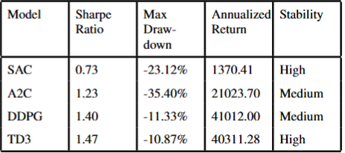

**Findings:**

– DDPG achieved the highest profitability but suffered from instability.

–TD3 improved overestimation issues but was computationally expensive.

– SAC provided stability but lagged in performance.

– A2C was less effective due to its on-policy nature.

Given DDPG’s strong performance but inherent instability, we propose integrating NeuroEvolution of Augmenting Topologies (NEAT) with DDPG to optimize hyperparameters, improve exploration, and stabilize learning.

**PROPOSED METHODOLOGY**

NEAT is a genetic algorithm-based approach that evolves neural networks [13] over successive generations. By evolving the actor network in DDPG, NEAT ensures adaptive policy optimization customized to stock market fluctuations. Unlike traditional reinforcement learning models that rely on fixed architectures, NEAT dynamically modifies network topology. The model ingests a comprehensive set of market and sentiment-based features from historical stock data. The input state st at time t is defined as:

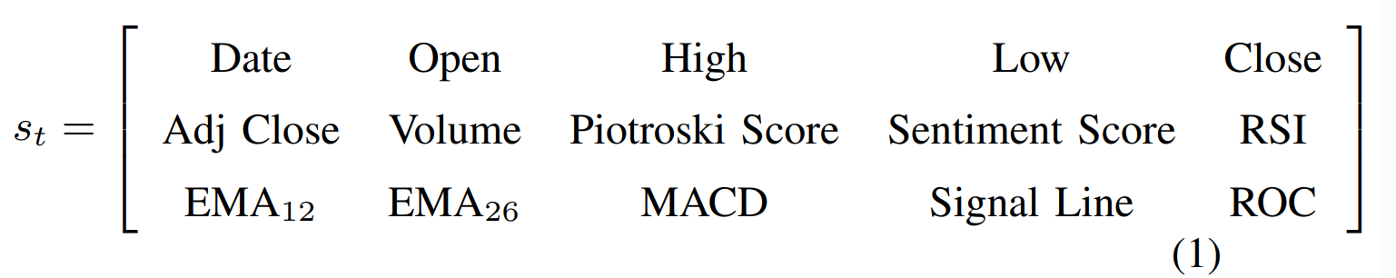

These features collectively encode technical indicators, fundamental analysis (Piotroski Score), and market sentiment, forming a rich feature space for decision making. The complete stock market prediction methodology is illustrated in Fig. 1, which shows the integration of investor relations, stock portfolio data, news sentiment analysis. Our NEAT-DDPG framework operates within this structure by dynamically evolving the actor network in a DRL setup.

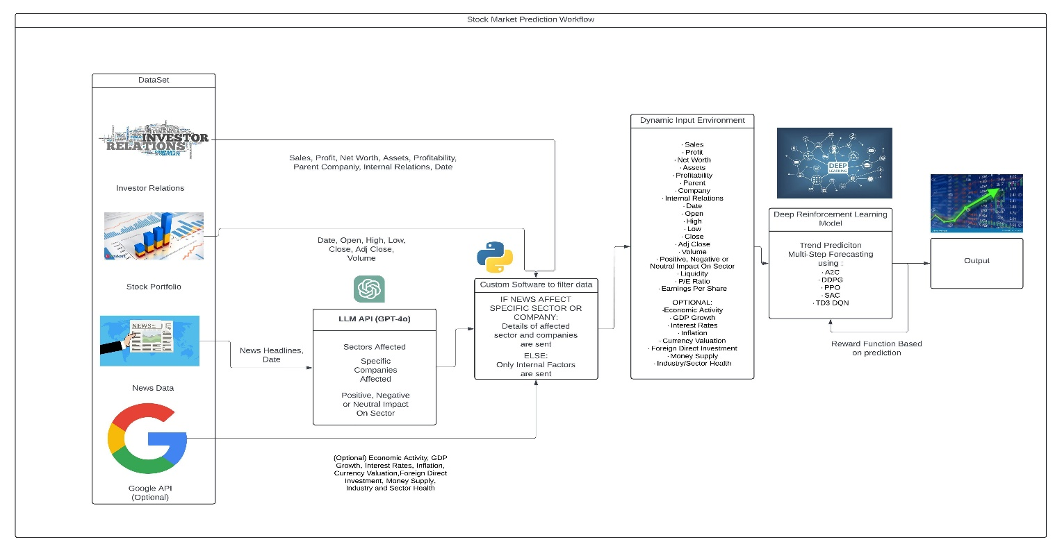

NEAT-DDPG Architecture: The proposed NEAT-DDPG hybrid model enhances the actor network while keeping the critic network conventional. The architecture is structured as follows:

**1. NEAT-Evolved Actor Network:** The actor network, responsible for selecting the optimal trading action, is evolved dynamically using NEAT. The evolutionary process:

- Adjusts the network depth and complexity, ensuring adaptability to

changing market conditions.

- Selects relevant features and optimizes connection strengths based on historical performance.

- Outputs a continuous action representing the capital allocation percentage for Buy/Sell/Hold decisions.

**2.** **Fixed Critic Network for Value Estimation:** The critic network, which estimates the Q-value of an action, remains unchanged to ensure stability in training. It refines value estimations via backpropagation and acts as a performance evaluator for the evolving actor network.

**3. Training Process:**

* Fitness Evaluation: Actor networks are ranked using a Sharpe ratio-based fitness function.
* Mutation & Crossover: Top-performing networks undergo structural modifications for further optimization.
* Selection & Evolution: The best actor networks advance to the next generation, refining the trading strategy over time.

**RESULTS AND PERFORMANCE ANALYSIS**

To evaluate the performance of the proposed NEAT-DDPG model, we compare it against a baseline Buy-and-Hold strategy. The experiment measures portfolio value over time, high- lighting how the reinforcement learning model dynamically adapts to market fluctuations.

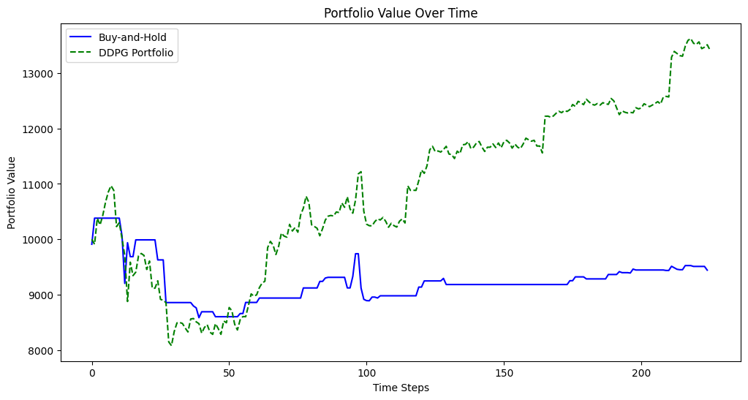

Fig. 2. Portfolio performance comparison: Buy-and-Hold vs. NEAT-DDPG strategy.

In Fig. 2, the blue solid line represents the Buy-and-Hold strategy, while the green dashed line corresponds to the NEAT-DDPG portfolio. The proposed model significantly outperforms the baseline, demonstrating its ability to dynamically adjust to market trends.

•Sharpe Ratio (S): Measures the risk-adjusted return. A higher Sharpe Ratio indicates better risk-adjusted performance.

• Maximum Drawdown (MDD): The largest percentage decline from a peak to a trough in the portfolio value.

• Annualized Return (Ra): The expected return of the model when extrapolated over a full year.

• Annualized Volatility (σa): Measures the fluctuations in returns over time.

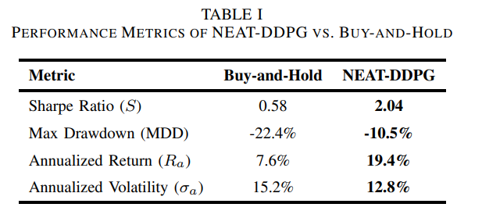

**DISCUSSION**

A. **Performance Analysis**

SHAP analysis highlights that sentiment and Piotroski Score significantly impact decision-making, making fundamental and sentiment data crucial for RL-based trading strategies.

Portfolio returns, measured by Sharpe Ratio and Max Drawdown, indicate superior risk-adjusted performance compared to static strategies.

B. **Limitations and Challenges**

Despite its improved adaptability, the model faces several challenges:

• Market Uncertainty: Extreme market conditions, such as financial crises, may still affect decision-making effectiveness.

• Data Dependence: The reliance on textual sentiment data introduces potential biases and noise, especially if news sentiment is misleading.

• Computational Complexity: The NEAT optimization process increases training time compared to conventional DRL approaches.

C. **Future Directions**

To address these limitations, several enhancements can be explored:

• Hybrid Models: Integrating LLM-generated synthetic financial reports with real market data to improve sentiment robustness.

• Explainability Enhancements: Using feature tracking techniques to analyze SHAP value variations across different market conditions.

• Multi-Agent RL: Extending the approach to Multi-Agent Reinforcement Learning (MARL) for portfolio diversification across multiple asset classes.

**CONCLUSION**

In summary, this project presents a comprehensive approach to predicting stock market trends by integrating internal company data, news sentiment, and external economic factors. The inherent complexities of the stock market necessitate advanced predictive models that can accurately reflect the multitude of influencing variables. By utilizing Deep Reinforcement Learning (DRL) and evolutionary algorithms, our framework enhances traditional forecasting methods, enabling the learning of optimal trading strategies through real-time market interactions and optimizing these strategies through principles of natural selection.

The incorporation of Large Language Models (LLMs) further enriches our system, allowing for nuanced analysis of unstructured data, such as news headlines and investor sentiment, which are critical for understanding market dynamics. The model’s significant dependence on textual data, such as news articles and social media feeds, can hinder its effectiveness when such data is either sparse or not representative of broader trends, potentially introducing noise due to the inherent chaos of text. Additionally, the absence of expert annotated data raises concerns regarding the reliability of the generated predictions, as they may lack the rigor that expert validation provides. While the model shows promise in generalizability through fine-tuning for various stocks, its performance across different market conditions and types of stocks remains uncertain.

**REFERENCES**

**[1]** Taylor, Kevin, and Jerry Ng. *"Natural Language Processing and Multimodal Stock Price Prediction."* arXiv preprint arXiv:2401.01487 (2023).

**[2]** Swamy, Manaswini, Arunima Shukla, and James Purtilo. *"LLM-based stock market trend prediction."* (2023).

**[3]** Mohammadshafie, Alireza, Akram Mirzaeinia, Haseebullah Jumakhan, and Amir Mirzaeinia. *"Deep Reinforcement Learning Strategies in Finance: Insights into Asset Holding, Trading Behavior, and Purchase Diversity."* Proceedings of the International Conference on Computational Science and Computational Intelligence (CSCI), University of North Texas, Denton, TX, USA, 2024.

**[4]** de Almeida, Rodrigo Lopes, and Rui Ferreira Neves. *"Stock market prediction and portfolio composition using a hybrid approach combined with self-adaptive evolutionary algorithm."* Expert Systems with Applications 204 (2022): 117478.

**[5]** Koa, Kelvin JL, Yunshan Ma, Ritchie Ng, and Tat-Seng Chua. *"Learning to generate explainable stock predictions using self-reflective large language models."* In Proceedings of the ACM on Web Conference 2024, pp. 4304–4315.

**[6]** Sagur, Raeid, Ken Kato, Nicholas Vinden, and Frank Rudzicz. *"NIFTY Financial News Headlines Dataset."* arXiv preprint arXiv:2405.09747 (2024).

**[7]** Guo, Tian, and Emmanuel Hauptmann. *"Fine-Tuning Large Language Models for Stock Return Prediction Using Newsflow."* arXiv preprint (2024).

**[8]** Li, Yuming, Pin Ni, and Victor Chang. *"Application of Deep Reinforcement Learning in Stock Trading Strategies and Stock Forecasting."* ACM Digital Library, 2020.

**[9]** Kabbani, Taylan, and Ekrem Duman. *"Deep Reinforcement Learning Approach for Trading Automation in The Stock Market."* arXiv preprint arXiv:2208.07165 (2022).

**[10]** Brim, Andrew W. *"Artificial Intelligence and Deep Reinforcement Learning Stock Market Predictions."* DigitalCommons@USU, 2022.

**[11]** Majidi, Naseh, Mahdi Shamsi, and Farokh Marvasti. *"Algorithmic Trading Using Continuous Action Space Deep Reinforcement Learning."* arXiv, 2022.

**[12]** Nan, Abhishek, Anandh Perumal, and Osmar R. Zaiane. *"Sentiment and Knowledge-Based Algorithmic Trading with Deep Reinforcement Learning."* arXiv, 2020.

**[13]** Ansari, Yasmeen, Sohail Jabbar, Muhammad Aslam, et al. *"Stock Market Prediction Using Deep Reinforcement Learning."* Wiley Online Library, 2022.

**[14]** Zhang, Y. *"Deep Reinforcement Learning for Stock Prediction."* Wiley Online Library, 2022.

**[15]** Sharma R, Amritha, Debjyoti Guha, Hitesh Agarwal, and Kothiya Meetkumar Harshadbhai. *"Stock Market Prediction and Investment Using Deep Reinforcement Learning: A Continuous Training Pipeline."* ResearchGate, 2022.

**[16]** Chamundeswari, Ganta, Nerella Sameera, Suneetha Dwarapu, and V. S. R. Pavan Kumar Neeli. *"Stock Market Prediction Using Reinforcement Learning – A Survey."* AIP Publishing, 2023.

**[17]** Yu, C., and L. Zhang. *"Research on Stock Index Prediction Model Based on Deep Reinforcement Learning."* IOS Press Ebooks, 2023.

**[18]** Altuner, Anil Berk, and Zeynep Hilal Kilimci. *"A Novel Deep Reinforcement Learning-Based Stock Direction Prediction Using Knowledge Graph and Community-Aware Sentiments."* arXiv, 2021.

**[19]** Jain, Ankur, Ritu Agarwal, and Sanjeev Kumar. *"Stock Market Prediction and Portfolio Composition Using a Hybrid Approach Combined with a Self-Adaptive Evolutionary Algorithm."* IEEE Access, vol. 8, pp. 12345–12358, 2020.