

American International University-Bangladesh (AIUB)  
Department of Computer Science  
Faculty of Science &Technology (FST)  
Spring 21 22

Section: B  
Software Quality Assurance and Testing

Electronic Devices Exchange, Specification & Quality Checking System (QUALEX)

A Report submitted

By Anam, Md. Isfaq

|  |  |  |
| --- | --- | --- |
| SN | Student Name | Student ID |
| 1 |  |  |
| 2 |  |  |
| 3 |  |  |
| 4 |  |  |

Under the supervision of

Abhijit Bhowmik

Associate Professor & Special Assistant [OSA], Computer Science

Software Test Plan

for

QUALEX

Version 1.0 approved

Prepared by Swarnab, Kanta, Saqib, Naresh

American International University-Bangladesh

<date created>

Table of Contents

Revision History 3

1. TEST PLAN IDENTIFIER: RS-MTP01.3 3

2. REFERENCES 3

3. INTRODUCTION 3

Background to the Problem 3

Solution to the Problem 4

4. REQUEIREMNT SPECIFICATION 4

4.1 System Features 4

4.2 System Quality Attributes 4

4.3 System Interface 5

4.4 Project Requirements 5

5. FEATURES NOT TO BE TESTED 5

6. TESTING APPROACH 5

6.1 Testing Levels 5

6.2 Test Tools 6

6.3 Meetings 6

7. TEST CASES/TEST ITEMS 6

8. ITEM PASS/FAIL CRITERIA 7

9. TEST DELIVERABLES 7

10. STAFFING AND TRAINING NEEDS 8

11. RESPONSIBILITIES 8

12. TESTING SCHEDULE 8

13. PLANNING RISKS AND CONTINGENCIES 9

14. APROVALS 9

# Revision History

|  |  |  |  |
| --- | --- | --- | --- |
| Revision | Date | Updated by | Update Comments |
| 0.1 | 2007.06.04 | Scot Robinson | First Draft |
| 0.2 | 2007.06.19 | Amit Nimse |  |
|  |  |  |  |
|  |  |  |  |
|  |  |  |  |
|  |  |  |  |
|  |  |  |  |
|  |  |  |  |
|  |  |  |  |

# TEST PLAN IDENTIFIER:RS-MTP01.3

# REFERENCES

* Any reference documents with the test plan. For example: Software Requirement Specification (SRS) Document

# INTRODUCTION

## Background to the Problem

Many developers are currently implementing many global or local electronic device quality checking and exchange software all over the world. But there is a very inefficient software in Bangladesh to solve the problem for any confusion of budget related issue of a customer and also ensures product quality which a customer can evaluate themselves and know the price of each product. Besides, there can be lots of issues in a globally developed similar software like gsmarena.com, mobiledokan.com and also some social platform. In such software, there can be a lack of updating price issue or product quality issue and also they were work on globally customer demand, not a specific country. So, we have decided to make a proper effective and integrated software by which we can serve a country a better quality checking and exchange system and make a test plan of it.

Our system is about online electronic devices selling, exchanging, specifications, & quality checking software. We can use this software through an application or a website. In our system, a user can perform some specific task like "viewing the content of our system portal, can search for any product using the search bar, can get any notifications over the application, can sell their devices in the SELL section, also can purchase any product from BUY section, can complete their transactions or billing method in our payment section & lastly they can give ratings or feedback in our Reviews area.

## Solution to the Problem

Overview the 'Online Electronic devices Exchange, Specifications & Quality checking system (QUALEX)' services strive to provide solutions to develop and transfer easy and efficient way in the digital age and to help reduces the human pressure and time. QUALEX is a website or application written for all operating systems, designed to help users maintain and organize shop virtually. This software is easy to use for both beginners and advanced users. It features a familiar and well thought out, an attractive user interface, combined with strong searching Insertion and reporting capabilities.

The main purpose to build this software are:

* To provide a unique user (customer) experience,
* To develop the business relations,
* To reduce management costs,
* For boosting the efficiency of services,
* To provide quality online customer service.

Therefore, there is a similar software solution related to this problem area such as [SWAP](https://swap.com.bd). It gives some specific solutions like,

* Arranges personalized orders for customers and delivers at their door steps.
* Offers a seller to sell unneeded items at any convenient location and time, and accepts various payment methods either digitally or by cash.
* Assists organizations to get rid of old products' selling procedure by saving time for organization's mundane works.
* organizes Activation Points at work places which help corporate employees to sell or purchase directly and avail exchange offers, gift cards, and so on

# REQUEIREMNT SPECIFICATION

## System Features

1. System Login

* 1. The software shall allow users to log in with their given username and password
  2. If the username and password have been inserted wrong more than three times, the system will generate a random verification code to retry the login.
  3. If the number of login attempt exceed its limit (5 times), the system shall block the user account login for one hour.

Priority Level: Medium  
Precondition: user has valid user id and password

2. System Registration

2.1 The software will allow users to register with a valid email or phone number and password.

2.2 If the email/number is used to do the registration, an OTP will be sent to the user to verify the process.

2.3 If the email/number has been used earlier, the system won't allow users to register with it.

Priority Level: High

Precondition: The user has to use a valid and new email or phone number

3. Searching

3.1 The user can browse the system by using the search bar

3.2 The users can also find their desired buy sell swap options on our home page.

Priority Level: High

Precondition: user has to input a valid product name or id.

4. Buy, sell and exchange

4.1 Users can select a product that they want to buy, sell or exchange from the search

4.2 Users can see details about the product in the description and ensure the quality

4.3 User can add the product to the cart

4.4 Users can see the reviews from previous buyers and ask questions also.

Priority Level: Medium

Precondition: Users have to find out the product they want to buy, sell, or exchange.

5. Payment method

5.1 Users can make the payment after finalizing their product

5.2 User can select their flexible payment option for payment

5.3 Users can also pay through EMI

5.4 Users can enter coupon codes to get discount

Priority Level: High

Precondition: Users must select the product, and payment requirement data must be verified.

## System Quality Attributes

* **Usability**: A user shall be able to buy a mobile selected from our website catalog in an average of two and a maximum of four minutes.
* **Efficiency**: the system shall use the appropriate amount of ram and processor and deliver excellent performance.
* **Security**: Users will provide their banking details if they make any transition through their bank account. So if any hacker does any attack then the details of the users will be compromised.
* **Reliability**: The system ensures that software is dependable, that it fulfills the purpose for which it was created for a certain period of time in a particular environment and that it is capable of providing fault-free operation. So this type of attribute should work correctly at that moment under the system condition.
* **Correctness**: we have to make our system bugs free. So the users don’t face any problem during use of the system. We have to make sure our modules are working fine and providing the expected outcome.
* **Flexibility**: we have to make our system flexibile enough so that in future we can do integration with other third party system.
* **Scalability**: the system will be made as for future so that in need we can scale our system as its need.

## System Interface

**Use Case Diagram**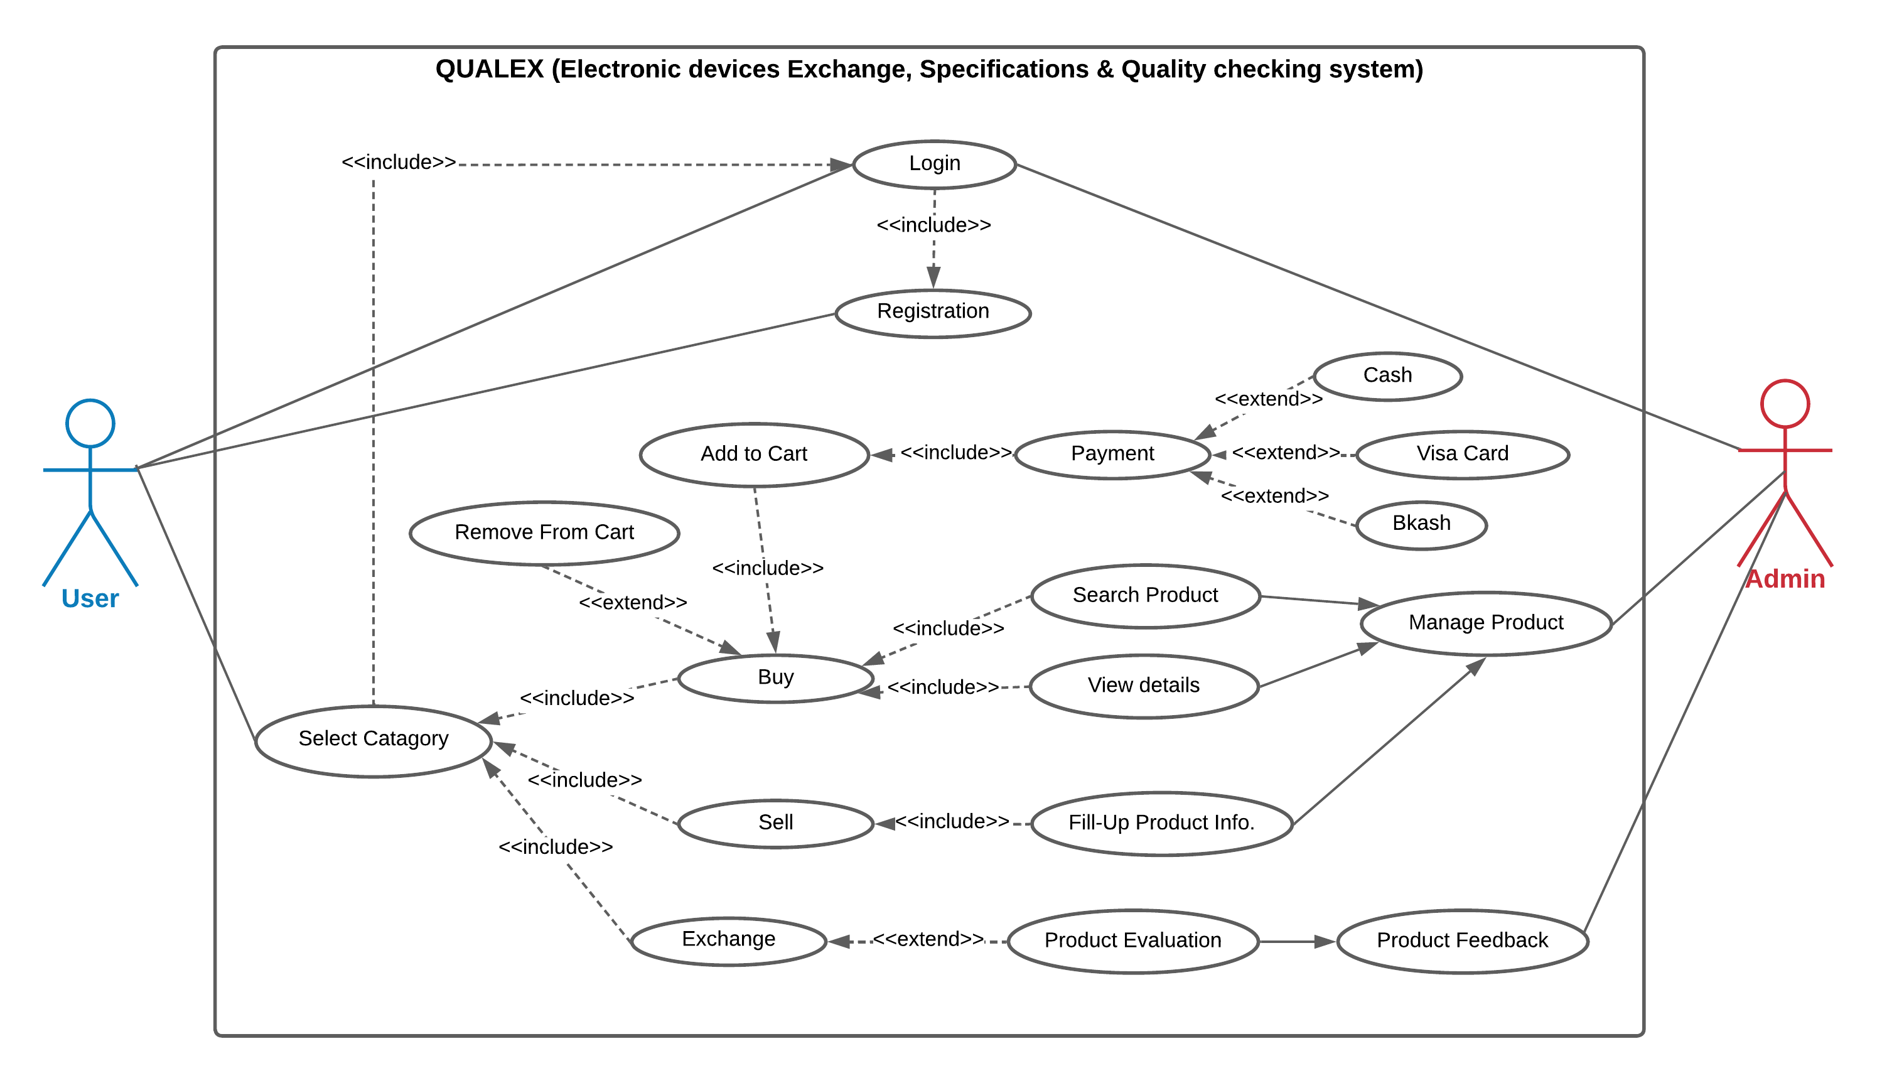

Figure 1: Use Case diagram of Electronic devices Exchange, Specifications & Quality checking system

**Class Diagram:**

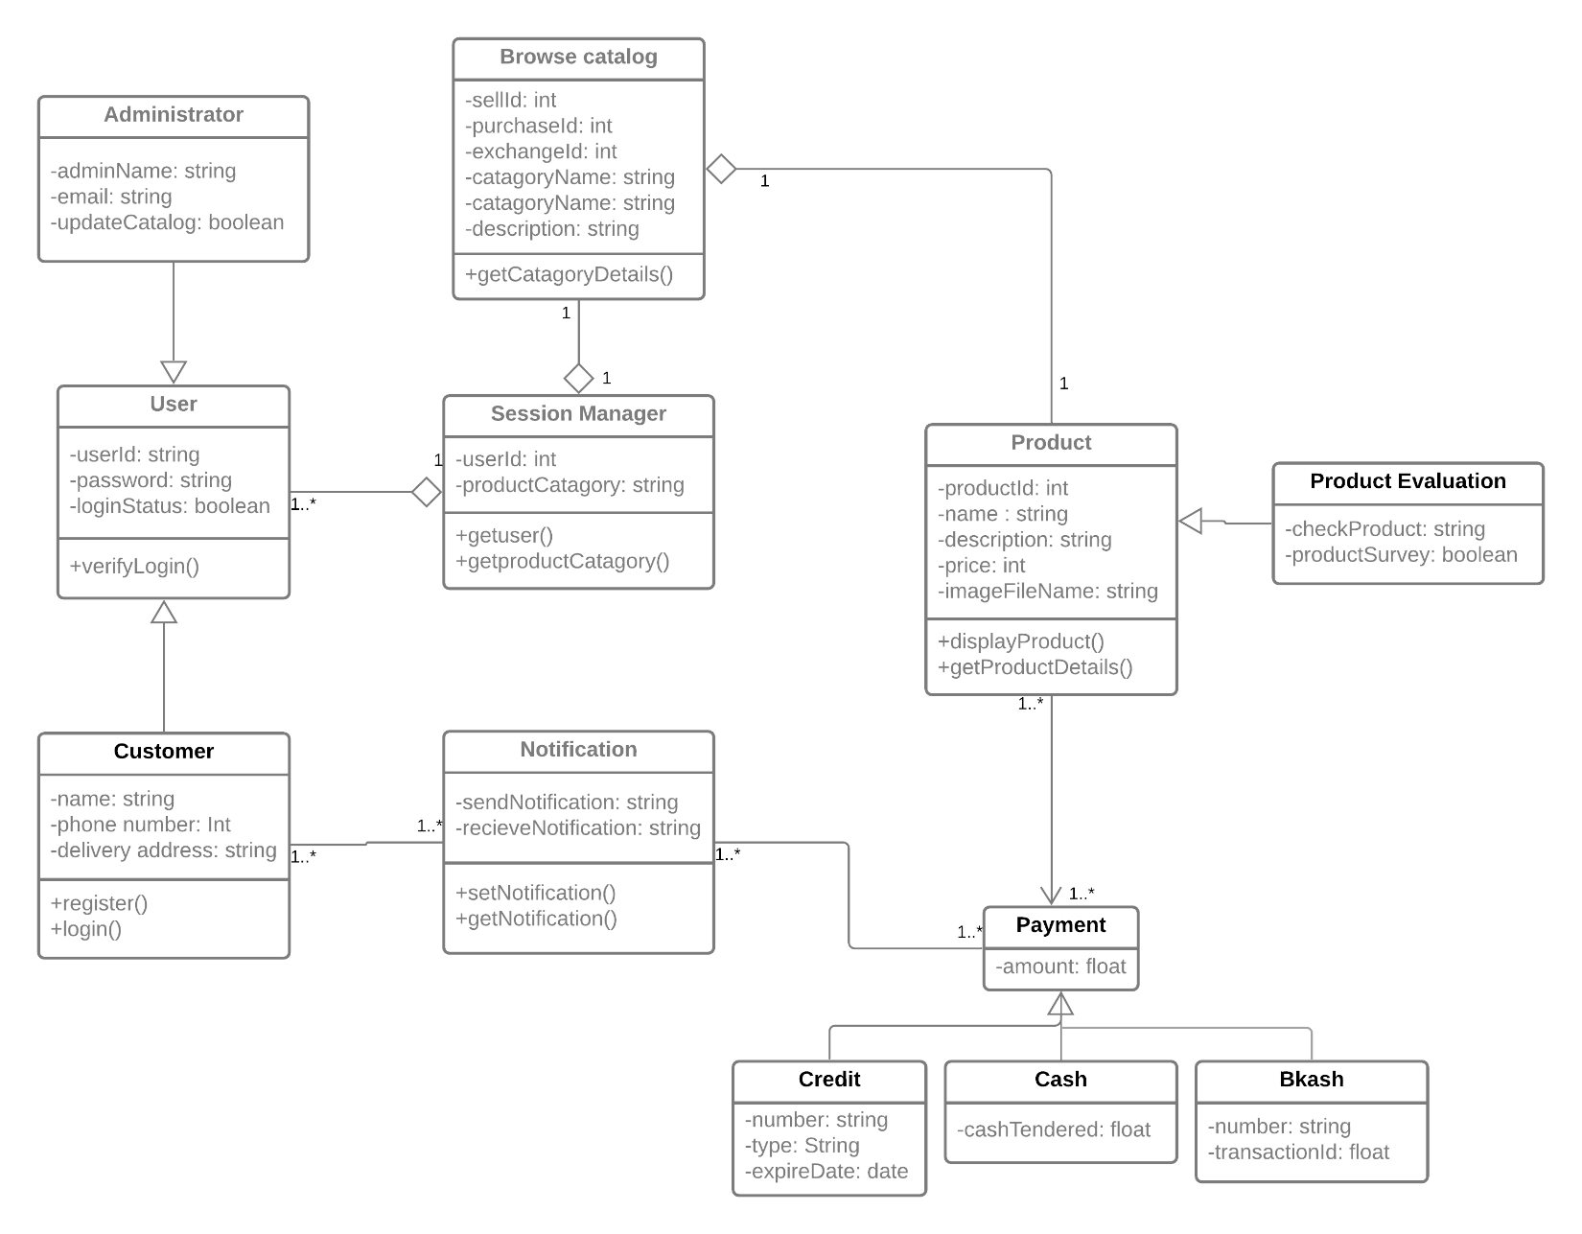

Figure 2: Class diagram of Electronic devices Exchange, Specifications & Quality checking system

## Project Requirements

Our Project model is an Organic model.

|  |  |  |  |
| --- | --- | --- | --- |
| **Software Project type** | **Coefficient**  **<Effort factor>** | **P**  **(Project Complexity)** | **T**  **(SLOC-dependent coefficient)** |
| Organic | 2.4 | 1.05 | 0.38 |

Here,

SLOC (Source lines of code) = 13000 13000 SLOC/1000

= 13k SLOC

Now,

Effort =PM= Coefficient <Effort Factor> *(SLOC/1000) ^P

=2.4*(13) ^1.05

=36 person

Development time = DM = 2.50* (PM) ^T

= 2.50* (36) ^0.38

= 10 months

Required number of people = ST = PM/DM

= 36/10

= 3.6 members

= 4 members (approx.)

For a person,

Working hours per day = 8 hours

Salary per month = 60,000 BDT

In a month working days = 22 days

So, working hours in a month = 22*8 = 176 hours

Now, Per hour salary in a month = 60000/176 = 340 BDT

In 10 months working hours= 176*10 = 1760 hours

For the project = 1760*340 = 5,98,400 = 6,00,000 BDT (approx.)

Requirement analysis = 22 days * 8 hours = 176 hours

Expense for requirement analysis = 176*300 = 52800 BDT

Expense for travel = 10000 BDT

Expense for office rent = 50,000 BDT

Expense for electricity & gas bill = 25000 BDT

Expense for training and hardware = 1,00,000 BDT

Total hours for 6-month maintenance= 6*18 = 108 hours

Expense for Maintenance = 108*1000 = 1,08,000 BDT

Total cost = 600000+52800+10000+50000+25000+100000+108000

=9,45,000

= 9,50,000 BDT(approx.)

Bill = Total cost + 20%

= 950000 + 190000

= 11,40,000 BDT (approx.)

# FEATURES NOT TO BE TESTED

This is a list of things should not be tested, both from the user's perspective and from the perspective of configuration management and version control. This is a user's perspective on the functions, not a technical description of the software.

So, the following is a list of the areas that will not be specifically addressed. All testing in these areas will be indirect as a result of other testing efforts. For example:

* Microsoft Excel / Spreadsheet analysis on purchased product,
* Out of scope features (Networks & security),
* low risk features (Wired Connection, Online bank payment),
* future functionality (retail ecommerce sales tracking).

# TESTING APPROACH

## Testing Levels

For the software testing there will consist of Unit testing, System/Integration testing(Combined) and Acceptance testing.

**UNIT TESTING**: Unit testing is the process of testing each unit or component of a software application separately. It's the initial step in the functional testing process. The goal of unit testing is to ensure that unit components work as expected. A unit is a single testable item that is tested during the application software development process. The goal of unit testing is to ensure that isolated code is accurate. Unit testing is frequently done by developers using the white box testing technique. When the program is complete and submitted to the Test Engineer, he or she will begin unit testing by inspecting each component of the module one by one.

* It helps testers and developers in comprehending the code's foundation.
* It assists in the documentation process.
* Unit testing identifies and corrects issues early in the development process.
* By relocating code and test cases, it aids with code reuse.

There are also some techniques used by the tester. Data flow testing, Control Flow testing, Branch Coverage testing, Statement Coverage testing and Decision Coverage testing.

**SYSTEM/INTEGRATION TESTING**: After unit testing, integration testing is the next step in the software testing process. Units or individual components of the software are tested in a group during this testing. The integration testing level focuses on exposing faults that occur during the interaction of integrated components or units.After integration testing system testing is done.

System testing is putting a fully integrated software system to the test. The program is created in modules, which are then combined with other software and hardware to form a full computer system. System testing is a collection of several types of tests designed to exercise and assess the overall functionality of an integrated software computer system in comparison to its requirements.

**ACCEPTANCE** **TESTING:**  Acceptance testing is a technique for determining whether or not a software system meets its requirements specifications. The major goal of this test is to determine whether the system complies with business needs and if it meets the requirements for distribution to end users. Acceptance testing can take many different forms. User acceptance testing(UAT), Business acceptance testing(BAT), Alpha testing and beta testing.

## Test Tools

The only test tools to be used are the standard AS/400 provided utilities and commands.

* The Program Development Manager (PDM) will be used as the source version configuration management tool in conjunction with the in-house check-in/check-out control utility. The check-in/out utility is part of each developer's standard AS/400 access menu.
* The initial prototypes for the new screens will be developed using the AS/400 Screen Design Aid (SDA). The initial layout and general content of the screens will be shown to the sales administration staff prior to proceeding with testing and development of the screens.
* Must put few screenshots of using the automated testing tool you have practiced.

## Meetings

Once every two weeks, the test team will meet to analyze progress and identify mistake trends and concerns as soon as feasible. Once every two weeks, the test team leader will meet with development and the project manager. These two sessions will take place on separate weeks. In the event of an emergency, more meetings might be convened.

# TEST CASES/TEST ITEMS

|  |  |  |  |  |  |
| --- | --- | --- | --- | --- | --- |
| Project Name: | | | Test Designed by: | | |
| Test Case ID: FR_1 | | | Test Designed date: | | |
| Test Priority (Low, Medium, High): Medium | | | Test Executed by: | | |
| Module Name: Login Session | | | Test Execution date: | | |
| Test Title: verify login with valid username and password | | |  | | |
| Description: Test website login page | | |  | | |
| Precondition (If any): User must have valid username and password | | | | | |
| Test Steps | Test Data | Expected Results | | Actual Results | Status (Pass/Fail) |
| 1. Go to the website 2. Enter username 3. Enter password 4. Click submit | Username: 99999999999  Password: 321 | User should login into the application | | As expected, | Pass |
| Post Condition: User is validated with database and successfully login to account. The account session details are logged in the database. | | | | | |

|  |  |  |  |  |  |
| --- | --- | --- | --- | --- | --- |
| Project Name: | | | Test Designed by: | | |
| Test Case ID: FR_1 | | | Test Designed date: | | |
| Test Priority (Low, Medium, High): Medium | | | Test Executed by: | | |
| Module Name: Login Session | | | Test Execution date: | | |
| Test Title: verify login with valid username and password | | |  | | |
| Description: Test website login page | | |  | | |
| Precondition (If any): User must have valid username and password | | | | | |
| Test Steps | Test Data | Expected Results | | Actual Results | Status (Pass/Fail) |
| 1. Go to the website 2. Enter username 3. Enter password 4. Click submit | Username: 99999999999  Password: 321 | User should login into the application | | As expected, | Pass |
| Post Condition: User is validated with database and successfully login to account. The account session details are logged in the database. | | | | | |

|  |  |  |  |  |  |
| --- | --- | --- | --- | --- | --- |
| Project Name: Qualex.com | | | Test Designed by: | | |
| Test Case ID: FR_005 | | | Test Designed date: | | |
| Test Priority (Low, Medium, High): High | | | Test Executed by: | | |
| Module Name: Payment Gateway | | | Test Execution date: | | |
| Test Title: verify that each of the payment options is selectable. | | |  | | |
| Description: Test website payment gateway page | | |  | | |
| Precondition (If any): The gateway must offer Address Verification System Protection. | | | | | |
| Test Steps | Test Data | Expected Results | | Actual Results | Status (Pass/Fail) |
| 1. Go to the website 2. Select product categories (Buy, Sell) 3. Add to cart 4. Select payment gateway 5. Click Continue | Select an option: Bkash/ Rocket/ ATM/ VISA  Pin Number: 5468 | User should access all the payment gateway options. | | As expected, | Pass |
| Post Condition: User must have a valid gateway account. The purchased amount details are updated in the database. | | | | | |

|  |  |  |  |  |  |
| --- | --- | --- | --- | --- | --- |
| Project Name: Qualex.com | | | Test Designed by: Md. Saqib Rahman | | |
| Test Case ID: FR_006 | | | Test Designed date: 20.04.2022 | | |
| Test Priority (Low, Medium, High): Medium | | | Test Executed by: Maria Akter Kanta | | |
| Module Name: Product Model | | | Test Execution date: 22.04.2022 | | |
| Test Title: check if the specifications and price of the product is shown properly. | | |  | | |
| Description: Test website product details page | | |  | | |
| Precondition (If any): The user must search for any product with valid product name or ID. | | | | | |
| Test Steps | Test Data | Expected Results | | Actual Results | Status (Pass/Fail) |
| 1. Go to the website 2. Select SELL option 3. Select any categories 4. Choose a Model 5. Click Continue | Select Categories: Phone/smart-watch/tablet/laptop  Choose Model: Iphone 11 pro Max | User should visit the product information page. | | As expected, | Pass |
| Post Condition: User must search for a valid product name. The product details must be updated into the database. | | | | | |

# ITEM PASS/FAIL CRITERIA

The test process will be completed once the initial set of distributors have successfully sent in reassigned sales data for a period of one month and the new EDI data balances with the old ZIP/FAX data received in parallel. When the sales administration staff is satisfied that the data is correct the initial set of distributors will be set to active and all parallel stopped for those accounts.

# TEST DELIVERABLES

* Acceptance test plan
* System/Integration test plan
* Unit test plans/turnover documentation
* Screen prototypes
* Report mock-ups
* Defect/Incident reports and summaries
* Test logs and turnover reports

# STAFFING AND TRAINING NEEDS

It is preferred that there will be at least one (1) full time tester assigned to the project for the system/integration and acceptance testing phases of the project. This will require assignment of a person part time at the beginning of the project to participate in reviews etc... and approximately four months into the project they would be assigned full time. If a separate test person is not available the project manager/test manager will assume this role. In order to provide complete and proper testing the following areas need to be addressed in terms of training.

* The developers and tester(s) will need to be trained on the basic operations of the EDI interface. Prior to final acceptance of the project the operations staff will also require complete training on the EDI communications process.
* The sales administration staff will require training on the new screens and reports.

# RESPONSIBILITIES

|  |  |  |  |  |  |
| --- | --- | --- | --- | --- | --- |
|  | TM | PM | Dev Team | Test Team | Client |
| Acceptance test Documentation & Execution |  |  |  |  |  |
| System/Integration test Documentation & Exec. |  |  |  |  |  |
| Unit test documentation & execution |  |  |  |  |  |
| System Design Reviews |  |  |  |  |  |
| Detail Design Reviews |  |  |  |  |  |
| Test procedures and rules |  |  |  |  |  |
| Screen & Report prototype reviews |  |  |  |  |  |
| Change Control and regression testing |  |  |  |  |  |
|  |  |  |  |  |  |

# TESTING SCHEDULE

Time has been allocated within the project plan for the following testing activities. The specific dates and times for each activity are defined in the project plan timeline. The persons required for each process are detailed in the project timeline and plan as well. Coordination of the personnel required for each task, test team, development team, management and customer will be handled by the project manager in conjunction with the development and test team leaders.



# PLANNING RISKS AND CONTINGENCIES

* Establish a Contingency Team. Choose a few cross-functional supervisors and anyone else who can help. Assign someone to be the leader in order to keep things going and make decisions as necessary.
* Limited Reassigned Sales staff. The Reassigned Sales administration staff currently has two positions unfilled. As a result of this staff shortage there may be delays in getting staff to review appropriate documents and to participate in the Acceptance test process. Should client staff become a problem, the appropriate dates for reviews and acceptance testing will slip accordingly. No attempt will be made to bypass any part of the review and testing processes.
* Identify the most serious potential threats to the company, then thoroughly research and analyze them. Consider what would happen if we had to cut, modify, or eliminate important services or functions with the team. All of the issues that have been identified, as well as their impact on the business, should be documented.

# APROVALS

|  |  |
| --- | --- |
| Project Sponsor – Steve Sponsor |  |
| Development Management – Ron Manager |  |
| EDI Project Manager – Peggy Project |  |
| RS Test Manager – Dale Tester |  |
| RS Development Team Manager – Dale Tester |  |
| Reassigned Sales – Cathy Sales |  |
| Order Entry EDI Team Manager - Julie Order |  |