CALIFORNIA STATE POLYTECHNIC UNIVERSITY
Department of Computer Science
CS 2600
Tic-Tac-Toe N.D.

Description
This assignment will utilize the MQTT protocol from your last project. The MQTT broker should be running on your GCP instance.

In this assignment you will create a Tic-Tac-Toe game that will run on your GCP. You will be able to play the game in either 1 payer mode or 2 player mode. The human players will play the game from a laptop or the ESP32. There will be a third player that is only used in 1 player mode to play against a human player. It will be a bash script you run and it will randomly guess available spaces.

STEPS
To help you walk through the steps I recommend working in the following order:
- In the Freenova Ultimate Starter Kit folder open the C_tutorial chapter 20, LCD, and walk through the setup. This will validate the ESP32 and LCD are connected and working properly.
- Create a two player, X and O, Tic-Tac-Toe game on your GCP that will allow you to enter moves from keyboard validating game works.
- Now that you have validated the game works and everything on your ESP32 is working. Modify the game to receive/send data about player requested positions and game progress using MQTT.
  - First modify game to allow player input from ESP32
  - Next modify to display information on ESP32 about status and available positions to play. (You can scroll the screen as available positions might be larger then text available)

- Create the BASH script running on your GCP. Note the scripts should be using the same MQTT topics you created earlier. Verify it works in 1 player mode.
- Finally, create the GUI on your laptop utilizing the same implementation for the mqtt topics as you did for for the ESP32.

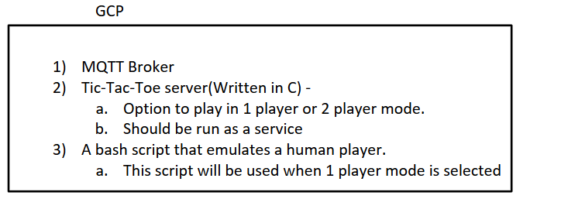
Laptop
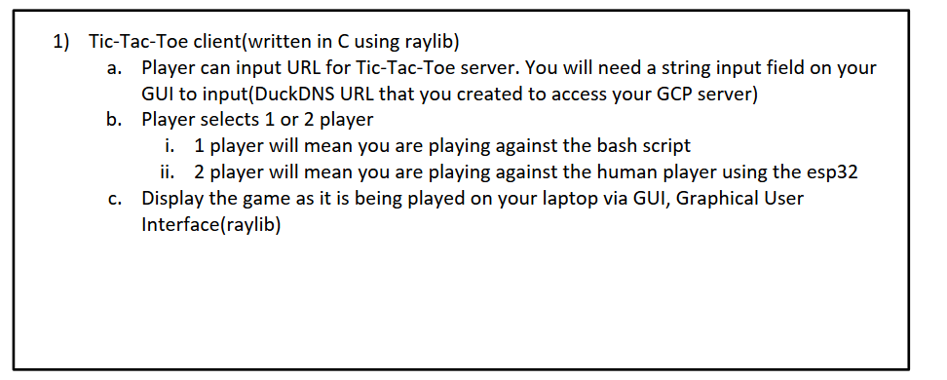

ESP32
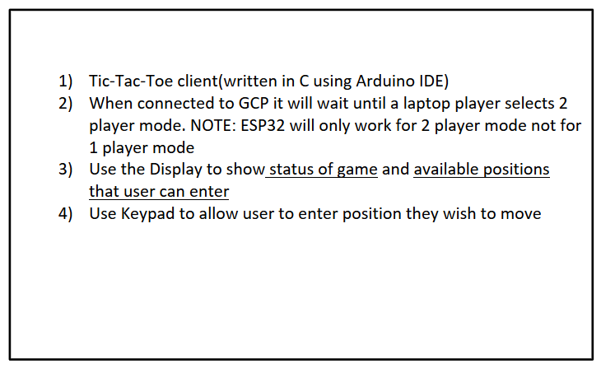

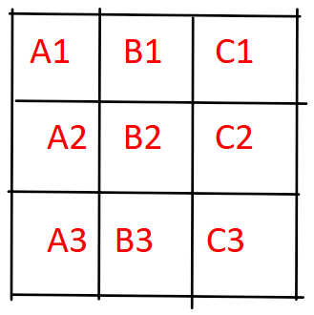
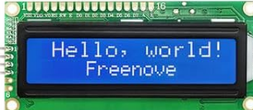
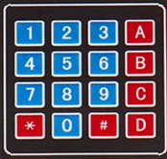

Demo
- In order to receive credit, you will need to demonstrate everything working in class!
- Show the game progress on the LCD screen and the file on your GCP as well as the SCRIPTS.

WHAT TO SUBMIT:
A doc or pdf that should include:
1) Your github link - everything should be included in this repo
2) Printout of source code for Tic-Toc-Toe(GCP)
3) Printout of script that automates player 2 if human does not play (BASH SCRIPT)
4) Printout of ESP32 source code
5) YouTube link or video demo

