|  |  |  |
| --- | --- | --- |
| G:\nsu-logo.png  **North South University**  Department of Electrical & Computer Engineering    **LAB REPORT**  Course Name:CSE231L  Section: 01  Experiment Number: 01,02,03     |  | | --- | | Experiment Name: Experiment 1- Introduction to Basic Logic Gates.  Experiment 2- Constructing 3-input AND & OR gates from 2-input AND & OR gates.  Experiment 3- Implementation of Boolean Functions. |     Experiment Date: 28/02/2021  Report Submission Date: 07/03/2021  Group Number: | |
| Student Name: Ishrat Jahan | Score |
| Student ID:1921909042 |  |
| Remarks: |

**Digital Logic Gates and Boolean Functions**

**Objectives:** Studying basic logic gates- AND, OR, NOT, NAND, NOR, XOR and utilizing them to draw truth tables and circuits for two and three inputs. Understanding a Boolean Equation and getting acquainted with Boolean algebra along with its laws and learning about Boolean Functions and using them to complete truth tables for logic diagrams with given Boolean Functions.

**Theory:** We learned how to use Logisim and the functions of all the tools in the software along with how to draw a circuit and the do’s and don’ts in it. Explanation’s on what are data bits, facing and how to change the number of inputs and valuable information’s like how the input and output bits must always be same. Then we proceeded on learning how to draw the truth tables of all the basic logic gates with two inputs 0 and 1. Next we used all these knowledge and conducted Experiment-1 where we drew all the basic logic gates with two inputs and one LED as output in the software. We varied the input with combinations 00,01,10,11 and drew truth table for each of them. After that we learned about circuits with three inputs and conducted Experiment- 2, with 3 inputs with combinations 000,001,010,011,100,101,110,111 and drew their respective truth tables for the circuits given in lab manual. Along with that we studied representing the gates in operators. For example : (+) is the OR gate and ( .) is the AND gate and complement stands for NOT gate in a Boolean equation. Moreover, we learned about Boolean algebra, the branch that deals with the relation between variable which takes truth values true (1) or false (0) and what are Boolean functions. A brief discussion on the laws of Boolean algebra, the postulates and theorem and working out proofs of each law. For example: A+A’=1 ;( If we consider A=0 and A’=1;0+1=1, or if A=1 and A’=0;1+0=1, as a result the following law is proved).Simultaneously, we learned to write the possible functions of a gate and what is combinational logic and how to understand and write it. Lastly, we conducted Experiment-3 where we were given Logic diagram with a Boolean function and we had to complete the truth table given for that Boolean function by varying the inputs.

**Circuit Diagrams:**

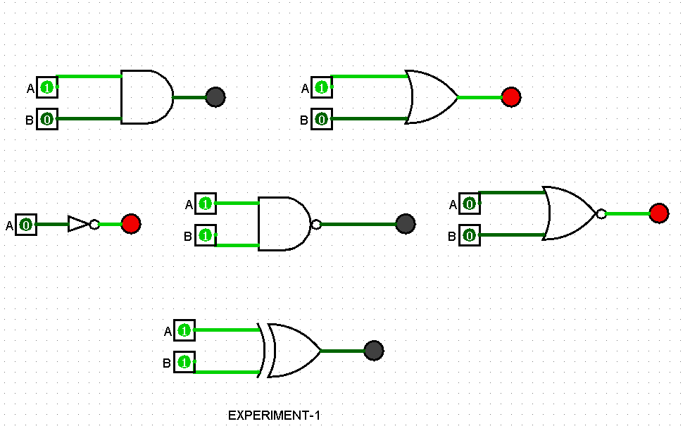

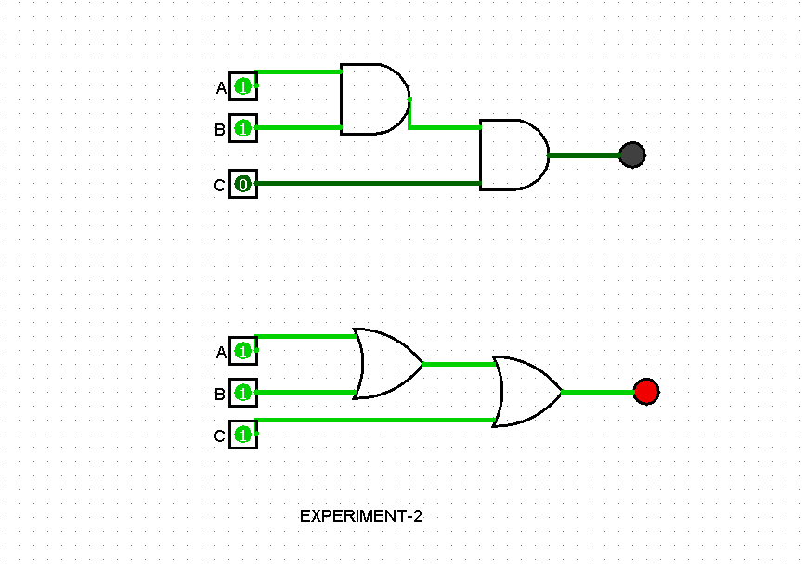

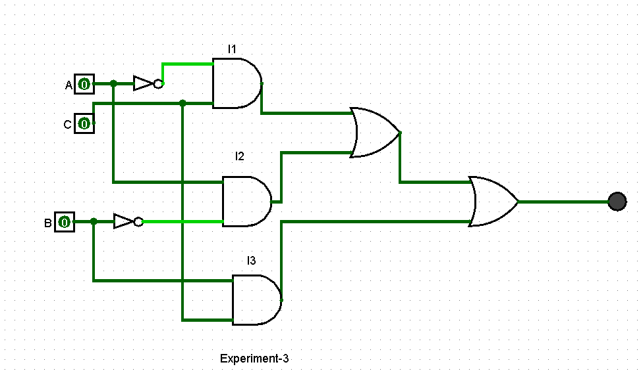

**Truth Tables:**

Experiment-1

|  |  |  |  |  |  |
| --- | --- | --- | --- | --- | --- |
| **Input**  **A B** | **AND**  **F=A.B** | **OR**  **F=A+B** | **NAND**  **F=A.B** | **XOR**  **F=A⊕B** | **NOR**  **F=A+B** |
| 00 | 0 | 0 | 1 | 0 | 1 |
| 01 | 0 | 1 | 1 | 1 | 0 |
| 10 | 0 | 1 | 1 | 1 | 0 |
| 11 | 1 | 1 | 0 | 0 | 0 |

|  |  |
| --- | --- |
| **Input**  **A** | **NOT**  **F=A** |
| 0 | 1 |
| 1 | 0 |

Experiment-2

|  |  |  |
| --- | --- | --- |
| **ABC** | **F=ABC** | **F=A+B+C** |
| 000 | 0 | 0 |
| 001 | 0 | 1 |
| 010 | 0 | 1 |
| 011 | 0 | 1 |
| 100 | 0 | 1 |
| 101 | 0 | 1 |
| 110 | 0 | 1 |
| 111 | 1 | 1 |

|  |
| --- |
| F=ABC=(AB)C |
| F=A+B+C=(A+B)+C |

Experiment-3

|  |  |  |  |  |
| --- | --- | --- | --- | --- |
| **ABC** | **I1=A’C** | **I2=AB’** | **I3=BC** | **F=I1+I2+13** |
| 000 | 0 | 0 | 0 | 0 |
| 001 | 0 | 1 | 0 | 1 |
| 010 | 0 | 0 | 1 | 0 |
| 011 | 0 | 1 | 1 | 1 |
| 100 | 1 | 0 | 0 | 1 |
| 101 | 1 | 1 | 0 | 1 |
| 110 | 1 | 0 | 1 | 0 |
| 111 | 1 | 1 | 1 | 1 |

**Discussion:** The lecture consisted of providing us knowledge on the software we will be using, which was Logisim.We were taught about the uses of every tools present on the software. At first we were taught how to create a new file. Secondly we were taught what the following tools in the toolbar does-

* The simulation tool: shaped like a hand, it is used to alter the inputs between 0 and 1.
* The design tool: pointer shaped ,it is used to select while designing a circuit.
* The input pin: green circle surrounded by square box, it is used for taking the inputs in a circuit 1or 0.We can also change the number of bits, facing and other attributes from the attribute table on the left.
* The output pin: green circle surrounded by a circular shape, which is used to determine the output.

Thirdly, we were given a brief knowledge on the list of things on the Explorer Pane. For example Spitter-which is used to increase bit width,Fanout-which helps us to make choice of divisions we want from the input data as output, Tunnel-which we can use for complex circuit and transfer data without wire, Clock-which we will use for sequential circuit, Buffer gate-to increase signal and Plexer-which we use to vary the input and where the left dot is input, down dot should be selected and enable attribute should be changed to no and a bit of explanations on the rest other components that are available.

Our first discussion was on Logic Gates. In these topic we were taught about the basic logic gates-AND, OR, NAND, NOT, NOR, XOR, a brief discussion on each of their description and their respective symbols. Alongside it, we studied the truth table, how to draw them, every possible combination of two and three bit inputs and how to use the formula Output=2^ (Input bits) to find the number of output logic levels of a logic circuit. Next we were introduced to a new topic, Boolean algebra, a branch that deals with relation between variable that take binary values true(1) and false(0).Postulates and Theorems of Boolean algebra were also explained one by one and each of them were proved with binary numbers. For example: A+0=A ;( If we consider A=0;0+0=0, or if A=1;1+0=1, as a result the following law is proved).

Our last topic was combinational logic. We studied how to represent the logic gates in operators like (+) and ( .)and what does complement stands for in a Boolean equation. For example: + stands for OR gate, . for AND gate and complement for NOT gate. Moreover, we figured out to write a gate in possible functions and then find its combinational logic. For example: AND=A’.B’, A’.B, A.B’, A.B (Possible functions)

AND=A’.B’ + A’.B +A.B’ +A.B (Combinational logic)

Lastly we performed three experiments from the lab manual using Logisim. In Experiment-1, we drew all the basic logic gates with two inputs and one LED as output. We varied the input with combinations 00,01,10,11 and drew truth table for each of them. In Experiment- 2, we varied the inputs for 3-input AND & OR gates for the circuits given in lab manual with combinations 000,001,010,011,100,101,110,111 and drew their respective truth tables. In Experiment-3 where we were given Logic diagram for a given Boolean function and we had to complete the truth table given for that Boolean function with combinations 000,001,010,011,100,101,110,111.Everything we learned in theory we saw in practice.

The only limitation faced during conducting these experiments was, the course as its name suggests” **Digital Logic**” was supposed to be a hardware course but it was conducted as software based. As most experiments was practical based, it limited our practical-learning to an extent. We didn’t get the opportunity to see and identify basic to advanced equipment’s used in building circuits which might be a problem for us when we will do advanced level hardware courses. Moreover, building circuits in software and in practical are two complete different things. We are not practicing them with equipment’s so it might result in not getting a good hand in building complex circuits in future. Overall, if we could’ve conducted the experiments in a lab rather than software it would’ve been better for us.