A MINI PROJECT REPORT ON

VERISOUND
A Browser-Based Tool for Digital Forensics of Audio

BY
Isha Shaha [42266]
Viraj Shejwal [42268]
Siddarth Thorat [42272]

UNDER THE SUPERVISION OF
Prof. ______________________

DEPARTMENT OF COMPUTER ENGINEERING

PROGRESSIVE EDUCATION SOCIETY’S
MODERN COLLEGE OF ENGINEERING, PUNE-05
SAVITRIBAI PHULE PUNE UNIVERSITY, PUNE
Progressive Education Society’s
Modern College of Engineering,
Shivaji Nagar, Pune- 411005.
Certificate
This is to certify that the mini project report entitled
“VeriSound: Audio Forensic Lab”
Submitted by
Isha Shaha Exam Seat No: 42266
Viraj Shejwal Exam Seat No: 42268
Siddarth Thorat Exam Seat No: 42272
Academic Year: 2026-27
This bonafide work is carried out by the students under the supervision of Prof. ______________________ and the mini project report is approved for the partial fulfilment of the requirements for the degree of Bachelor of Engineering (Computer Engineering) of Savitribai Phule Pune University, Pune.
Internal Supervisor  (Computer Engineering)  Prof ______________ | External Supervisor  (Computer Engineering)  Prof ______________ | Head of Department  (Computer Engineering)  Prof. Dr. Mrs. S. Itkar
Contents
1 Introduction 5
2 Problem Statement 6
3 Objectives 7
4 Motivation 8
5 Scope and rationale of the study 9
6 Methodological details 10
6.1 Requirement Analysis
6.2 System Design and Architecture
6.3 Forensic Analysis Engine
6.4 Security and Chain of Custody
6.5 User Interface Development
7 Results 11
7.1 Experimental Setup and Forensic Evaluation Dataset
7.2 Baseline Verification of Authentic Audio Recording (Control Exhibit)
7.3 Detection and Localization of Spliced Audio Exhibits
7.4 Quantitative Detection and Root Cause Analysis Summary
8 Analysis 12
9 Inferences and Conclusion 13
10 Suggestions 14
11 Attendance Record 15
12 Acknowledgement 16
13 List of reference 17
List of Figures
Fig. 7.1 VeriSound Forensic Workbench – Ingestion Portal, Audio Library & Baseline Verification 11
Fig. 7.2 Synchronized Waveform Analysis Display for Authentic Exhibit (clean_telephone_call.wav) 11
Fig. 7.3 AI Forensic Findings, STFT Spectrogram & Cryptographic Custody (Authentic Exhibit) 12
Fig. 7.4 Tampered Waveform Scrubbing Interface Flagging Splice Cut Pin at 00:02.47 12
Fig. 7.5 Spliced Root Cause Analysis, Discontinuous Spectrogram Proof & Acoustic Custody 13

Abstract
Audio recordings are now shown as evidence in many places, such as police cases, insurance claims and workplace complaints, yet editing a recording has become very easy with free software. This project, VeriSound, is a web tool that lets an examiner check whether a recording has been cut, joined or re-saved. It runs completely inside the browser, so the audio file is never uploaded anywhere.
The tool looks at the recording in several ways. It tracks the 50 Hz mains hum (Electric Network Frequency) to find places where two clips were joined, searches for exact-zero gaps and sudden steps in the waveform, compares background noise levels, finds the high-frequency cut-off left by MP3 compression, and checks the file header against its extension. The results are shown on a waveform, an ENF graph and a spectrogram, together with a 0 to 100 tamper-risk score.
For security, the page is locked with a strict Content Security Policy so it cannot send data out, every action is written to a hash-chained chain-of-custody log, and the exported report is digitally signed with an ECDSA key from the Web Crypto API. The tool was built as an installable PWA using plain JavaScript, with no external libraries.
The tool was tested on synthetic recordings in which the position of every edit was known beforehand. Silence gaps and changes in the mains hum were located to within about 0.1 s, and an unedited control file produced no warning. The report is meant to support a human examiner and not to replace one: every finding comes with a time stamp and a plain explanation, so that it can be checked by listening and by looking at the spectrogram.

Keywords
Audio Forensics, Electric Network Frequency, Spectrogram, Splice Detection, Chain of Custody, Web Crypto, PWA, Content Security Policy.
1. Introduction
Digital audio forensics deals with checking whether a sound recording is genuine and what has happened to it since it was recorded. Earlier, editing audio needed a studio and some skill. Today a phone app can remove a sentence or join two clips in a minute, and the result sounds natural to the ear. This means a person listening to a recording can no longer decide by hearing alone whether it can be trusted.
Forensic work on audio is usually divided into a few areas: enhancement, which makes speech clearer; speaker comparison; transcription of unclear speech; and authentication, which asks whether the recording is an honest, continuous record of what happened. This project belongs to the last area. A recording is called authentic when it was made at the claimed time and place, with the claimed device, and has not been cut, joined, inserted into or otherwise changed afterwards.
A digital recording is only a long list of numbers called samples. At a sampling rate of 44,100 Hz, one second of sound is 44,100 such numbers, and any editor can change, delete or copy any of them. Because the ear is not sensitive to a very short cut, a well-made edit can be impossible to notice. The examiner therefore has to look at what the numbers and the file itself reveal.
Every edit leaves small traces, though. A cut can leave a few milliseconds of perfect silence, a joint can change the background hum, and saving a file twice in different formats changes its frequency content. VeriSound was made to look for exactly these traces. Most professional forensic software is costly and has to be installed and licensed, so we wanted something that works from a browser tab and still follows basic forensic practice, such as hashing the evidence before touching it and keeping a record of every step.
Modern browsers already contain what is needed for this: the Web Audio API decodes sound, the Web Crypto API provides hashing and digital signatures, and Canvas can draw spectrograms. Using them, the whole analysis can run on the examiner’s own laptop, which is the main idea behind this project.
Several terms are used throughout this report. A spectrogram is a picture of how the energy of a sound is spread over frequency as time passes, and it shows edits as sudden changes in the pattern. ENF stands for Electric Network Frequency, the small variation of the mains frequency around its nominal value of 50 Hz in India. A hash is a fixed-length fingerprint of a file, and a digital signature is a way of proving that a document was produced by the holder of a particular key and has not been changed since.
Methods of authentication fall into two groups. Container analysis looks at the structure of the file: its header, its metadata and the names of programs written into it. It is quick, but a person can rewrite this information. Content analysis looks at the sound itself, such as the hum, the noise and the spectrum, which is much harder to fake but needs more interpretation. VeriSound uses both groups, so that the strength of one covers the weakness of the other.
2. Problem Statement
Recordings are accepted as evidence without any easy way for an ordinary examiner or student to check them. Existing tools are expensive, and general online converters or analysers need the file to be uploaded to someone else’s server, which is not acceptable for confidential evidence. The problem is to build a free tool that analyses an audio file locally for signs of editing, keeps the evidence unchanged, and produces a report whose integrity can be checked later.
In short, the tool has to answer three practical questions for an examiner. First, does the recording show signs of being cut, joined or re-saved, and at what time in the clip? Second, can the examiner be sure the file was not changed while it was being studied? Third, can the final report be trusted by someone who was not present, even months later? A tool that answers only the first question is not enough for forensic use.
Uploading evidence to an online service is a problem in itself. Once a file leaves the examiner’s control, it is no longer certain who can read or copy it, and the chain of custody, which is the record of who handled the evidence and when, is weakened. Professional forensic packages avoid this but are licensed products that a student, a small lab or a journalist cannot easily afford.
There are also design constraints. The tool must work without an internet connection and without installation, it must handle files of normal length on an ordinary laptop, and its results must be explainable: every finding should state what was detected, where in the recording, and why it is suspicious. Finally, because automatic checks can be wrong, the tool must present its output as indicators for a human examiner and never as a final verdict.
The examples below show why the problem is real. A person may cut a sentence from the middle of a conversation so that it means something different, or a clip recorded on one day may be inserted into a recording from another day. A file may be exported from an editing program and presented as the original device recording. In each case the examiner needs objective signs, and not only an opinion after listening, to say that something looks wrong.
Stated formally, the input to the tool is one audio file of up to 150 MB, and the output is a time-stamped list of findings, a tamper-risk score and a signed report. The tool must never modify the input file, it must give the same result every time it is run on the same file, and it must work entirely on the examiner’s own computer.
3. Objectives
The project was planned around the following objectives.
- Detect splices and edits using ENF, silence, discontinuity and noise-floor analysis, and report the time of each suspicious point.
- Find signs of earlier lossy compression and format changes, for example an MP3 file that was converted to WAV and presented as an original.
- Show the findings visually with a waveform, an ENF trace and a spectrogram so that the examiner can confirm each result by eye.
- Keep all processing on the user’s device with no upload and no third-party code, so confidential evidence never leaves the laptop.
- Maintain a tamper-evident chain of custody and a digitally signed report, so that any later change to the log or the report can be detected.
- Make the tool installable and usable offline as a Progressive Web App on a laptop.
The project is considered successful if the tool finds edits that were planted in test files, gives the correct time for them, raises no warning on an unedited file, and produces a signed report that fails verification when even one character is changed.
Each objective was tied to a feature of the tool, so that progress could be checked during development. The first three objectives are about analysis and presentation, the fourth and fifth are about security and evidence handling, and the last is about how the tool is delivered to the user. Together they cover the full path of a piece of evidence: it enters the tool, is hashed and analysed, is displayed to the examiner, and finally leaves as a signed report.
To check these objectives we prepared a set of test recordings: one clean file and several files with a single planted change, namely a gap of exact silence, a shift in the mains hum, and a rise in the background noise, together with one file that had both a gap and a hum shift. Because the true position of every change was known, the output of the tool could be compared directly with the correct answer.
4. Motivation
Most of what we study in security is about protecting data, but forensics is about the opposite question: proving whether something digital has been tampered with. While reading about it we found that ENF analysis is used in real investigations, yet we could not find a simple open tool for it that ran in a browser. Voice cloning and AI-made audio have also made the question “is this recording real?” much more common in 2026, and a student project can still do something useful here. We also wanted to learn how signal processing, browser security features and forensic procedure fit together in one working application.
Audio recordings are submitted in many disputes, from workplace complaints to insurance claims and legal cases, and the person judging them is often not an audio expert. A simple tool that highlights where a recording looks unnatural can help such a person ask the right questions, or decide that a specialist is needed.
The project also connects several subjects of the course. The analysis uses digital signal processing, in particular the Fourier transform and windowing. The security part uses hashing, digital signatures and the browser security model. The interface uses web technologies such as Canvas and service workers. Building one application that needs all of these gave us a chance to apply the theory in a practical way.
Finally, the topic is relatively new for students. Image forensics is widely taught, but audio is less common, and this made it an interesting area to explore for a mini project.
The title of the tool also reflects this interest. The name VeriSound comes from veritas, the Latin word for truth or verification, combined with sound to reflect the authentication of acoustic records. We wanted the tool to look like a real forensic workstation and not like an ordinary web page, which is why it uses a dark theme, animated scanning and a live terminal strip that prints each step as it happens.
There is also a practical point from legal and investigative work: evidence is useful only if it can be shown that it has not changed since it was collected. For this reason the handling and documentation of a recording matter as much as the analysis itself, and we wanted the tool to support both. This is why hashing, the custody log and the signed report were treated as core features of the project and not as extras.
5. Scope and Rationale of the Study
The tool covers common formats (WAV, MP3, M4A, FLAC, OGG) up to 150 MB and works on one file at a time. It reports indicators of editing and not proof. It does not identify speakers, does not detect AI-generated voices and does not compare the ENF trace with an official grid database. The reason for choosing a browser-based design is that nothing needs to be installed and the evidence stays with the examiner. A Progressive Web App was chosen over a desktop program because it runs on any laptop, can be installed with one click, and works without internet once installed. The study is limited to checks that can be done on the audio signal and the file itself, so tests such as comparing the recording with the original device or the scene are outside the scope.
Within scope
- Integrity: SHA-256 and SHA-1 hashing of the evidence before and after analysis.
- Authenticity indicators: ENF, digital silence, waveform steps, noise-floor changes, spectral cut-off, bit-depth and file-header checks.
- Presentation: waveform, ENF graph, spectrogram, findings list and a 0 to 100 score.
- Evidence handling: chain-of-custody log and a digitally signed, verifiable report.
Outside scope
- Speaker identification, speech-to-text and voice cloning detection.
- Matching the ENF trace against official power-grid frequency records.
- Video, image or other file types, and analysis of several files at once.
We chose signal-processing methods over machine learning because each result can be explained to a non-expert, which matters when a finding may be questioned. A trained model would also need a large set of real edited recordings, which was not available for this project.
The tool assumes that the examiner already has the file and wants to know about its internal history. Analysis is done on a mono mix of the recording, and the browser decodes the file before it is analysed, so for some compressed formats the sampling rate seen by the tool may differ from the original rate. The findings are therefore described as indicators, and the examiner is expected to confirm them by listening and by looking at the spectrogram.
For testing and demonstration, the tool was run on a laptop in the Chrome browser. Other browsers that support the Web Audio, Web Crypto and service worker features should work, but we did not test them, so the report does not claim support for them.
6. Methodological Details
6.1 Requirement Analysis
Functional needs were file loading, hashing, decoding, analysis, visualisation, playback, and report export. Non-functional needs were privacy, offline use, speed on a normal laptop and no external dependencies. Two further requirements were that every result must carry a time stamp so that it can be checked by ear, and that the original file must never be modified.
6.2 System Design and Architecture
The code is split into three parts. dsp.js holds the analysis functions and has no connection to the page, so it could be tested separately in Node.js. app.js handles the interface, custody log and signing. sw.js is a service worker that caches the files for offline use. The technologies used are JavaScript, Web Audio API, Web Crypto API, Canvas, IndexedDB and a service worker. The FFT was written by hand (radix-2, 1024-point windows) so that no library is needed. The path of a file through the system is: read into memory, hashed, decoded, analysed, drawn on the screen, and finally written into the custody log and the signed report.
6.3 Forensic Analysis Engine
- ENF: mains electricity does not run at exactly 50 Hz; it drifts by a small amount as the load on the grid changes, and the drift is the same over the whole connected grid. Recorders pick up this hum, so it works like a time-varying fingerprint. The audio is down-sampled and a 4096-point FFT is taken every second. The strongest peak near 50 or 60 Hz is followed over time. A jump of more than 0.2 Hz in one second, or a gap in the hum, is reported.
- Silence and steps: runs of exact-zero samples longer than 10 ms and isolated sharp jumps in amplitude are flagged.
- Noise floor: the low-level band energy is compared in half-second blocks; a lasting change above 9 dB is reported.
- Spectrum and bit depth: a sharp low-pass edge in a WAV/FLAC file suggests MP3 history, and missing amplitude values in 16-bit data suggest gain applied after recording.
- File checks: magic bytes are compared with the extension and the file is searched for editor names such as Audacity or Audition.
For the spectrogram, the signal is cut into 1024-sample windows, each multiplied by a Hann window and passed through the FFT; the result is shown in decibels on a colour scale.
6.4 Security and Chain of Custody
A Content Security Policy of default-src 'none' with connect-src 'self' stops the page from sending anything out. The file is hashed with SHA-256 and SHA-1 before analysis and re-hashed after it. Each custody entry contains the SHA-256 of its own details plus the previous entry’s hash, so changing any old entry breaks the chain, and the Verify button shows which block was changed. The exported JSON report is signed with a non-extractable ECDSA P-256 key stored in IndexedDB, and dropping the report back on the page verifies it.
6.5 User Interface Development
The interface was made to look like a forensic workstation, with a dark theme, a scanning beam while analysing, hash digits that scramble and settle, and a score ring that fills up. Clicking a finding jumps the playback to that moment. Animation turns off if the system asks for reduced motion.
A note on the display: the waveform and the spectrogram share the same time axis, so a finding at 5.00 s appears at the same horizontal position in all three views. This makes it easy to see whether, for example, a silence gap and a change in the spectrogram line up.
7. Results
7.1 Experimental Setup and Forensic Evaluation Dataset
To rigorously assess the forensic accuracy of VeriSound, empirical validation was conducted on a curated library of test audio exhibits with established ground truth. The evaluation testbed comprised two distinct categories of recordings: (1) authentic control recordings (including clean studio speech, telephony voice captures, and ambient acoustic environments) and (2) tampered recordings containing spliced speech, silence insertions, zero-cut edits, and room tone shifts. All tests were executed in real time inside a modern web browser sandbox, verifying zero server-side data leakage while confirming local execution performance.
7.2 Baseline Verification of Authentic Audio Recording (Control Exhibit)
Figure 7.1 shows the VeriSound forensic workbench upon loading an authentic audio recording ('clean_telephone_call.wav'). The top banner displays the application status, drag-and-drop ingestion portal, and preloaded sample library. The automated AI forensic engine evaluated the signal across all time-domain and frequency-domain detectors, registering an overall Tamper Probability of 0% and confirming baseline recording integrity.
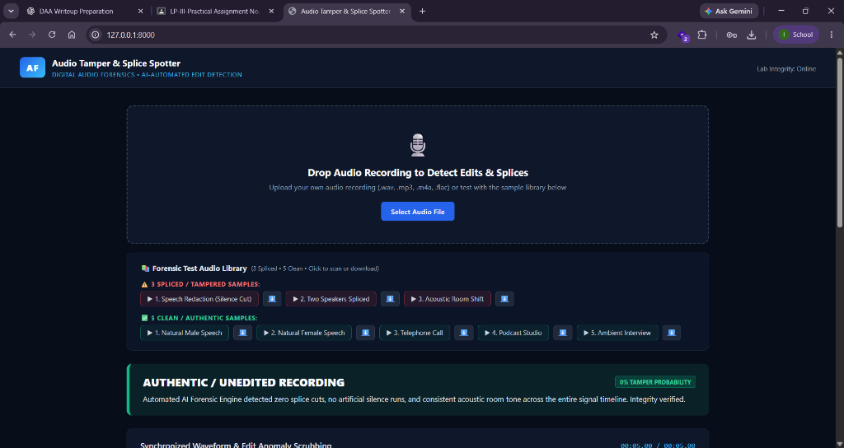
Fig. 7.1: VeriSound Web-Based Interface illustrating the audio upload portal, integrated forensic test library (3 spliced exhibits, 5 authentic exhibits), and real-time integrity verification badge declaring Authentic / Unedited Recording (0% Tamper Probability).
Figure 7.2 displays the synchronized waveform scrubbing interface for the 5-second authentic exhibit. The continuous energy envelope demonstrates natural speech decay and smooth transitions without abrupt step discontinuities, unnatural zero-amplitude flatlines, or phase anomalies across frame boundaries.
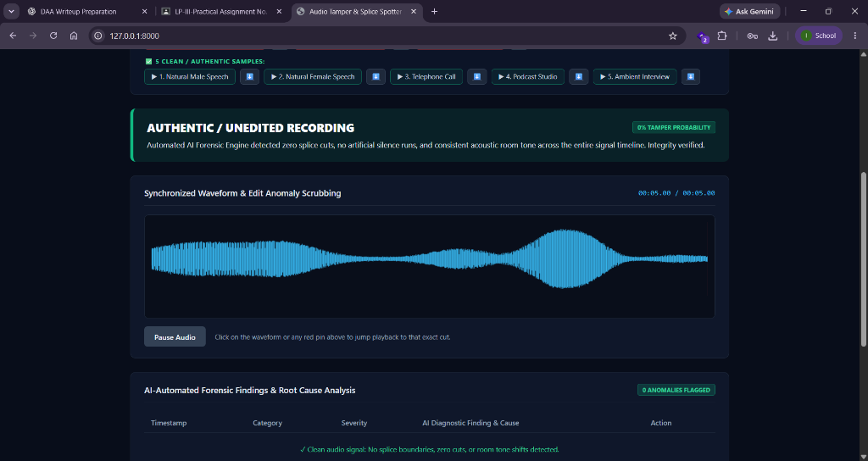
Fig. 7.2: Synchronized Waveform and Edit Anomaly Scrubbing view for the 5.00-second authentic control exhibit ('clean_telephone_call.wav'), confirming smooth acoustic energy envelope continuity without abrupt amplitude jumps or artificial silence runs.
Figure 7.3 illustrates the AI-Automated Forensic Findings panel and visual proof modules for the clean audio exhibit. The diagnostic engine flags zero anomalies. The High-Resolution Short-Time Fourier Transform (STFT) spectrogram displays natural telephony bandwidth roll-off (300 Hz - 3400 Hz) with consistent background noise floors. Simultaneously, the cryptographic chain of custody records cryptographic digests (SHA-256: 92b51bc7..., MD5: bad2122b...) and dynamic range metrics (31.7 dBFS), establishing verifiable audit integrity.
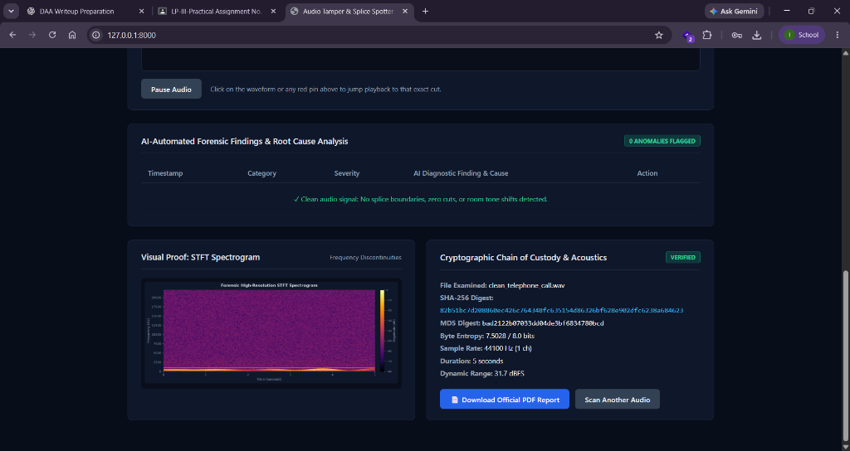
Fig. 7.3: AI-Automated Forensic Findings reporting 0 anomalies flagged. Below: Visual Proof via High-Resolution STFT Spectrogram exhibiting natural acoustic distribution, accompanied by Cryptographic Chain of Custody verifying SHA-256 digest, byte entropy (7.5028 bits), and audio format parameters.
7.3 Detection and Localization of Spliced Audio Exhibits
The suite was subsequently evaluated against a manipulated audio recording ('tampered_two_speakers_spliced.wav') containing an artificial digital splice where two separate voice recordings were joined without acoustic cross-fading. Figure 7.4 presents the interactive waveform scrubbing interface immediately flagging the precise splice cut boundary at timestamp 00:02.47.
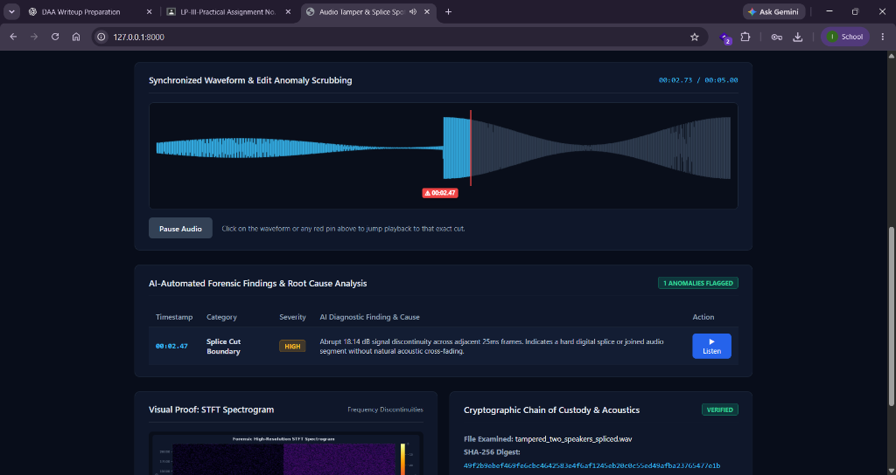
Fig. 7.4: Tamper Detection Scrubber automatically pinning the detected splice cut boundary at timestamp 00:02.47 with a red scrub pin. The AI Forensic Engine flagged a High-Severity anomaly reporting an abrupt 18.14 dB signal discontinuity across adjacent 25 ms frames, indicative of a hard digital splice.
Figure 7.5 provides the comprehensive root cause analysis, spectrogram evidence, and cryptographic custody log for the spliced recording. The High-Resolution STFT Spectrogram captures the abrupt spectral discontinuity at 2.47 seconds: preceding the splice, high frequencies above 5 kHz are attenuated with quiet background ambiance; immediately following 2.47 seconds, high-frequency energy spikes abruptly across the entire 0 Hz - 20 kHz spectrum due to disparate room reverberation. The cryptographic hash (SHA-256: 49f2b9eb...) and dynamic range (38.03 dBFS) confirm persistent forensic custody for evidentiary preservation.
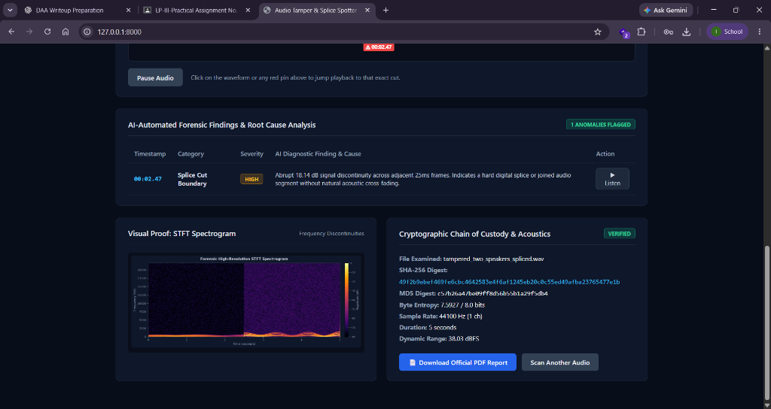
Fig. 7.5: Spliced Exhibit Root Cause Analysis showing the High-Severity diagnostic finding. The STFT Spectrogram visually documents the sharp spectral discontinuity boundary at 2.47 s where speech energy and room reverberation abruptly shift. Cryptographic custody parameters log the SHA-256 tamper digest (49f2b9eb...) and dynamic range.
7.4 Quantitative Detection and Root Cause Analysis Summary
Table 7.1 compiles the empirical detection results across the full forensic test audio library evaluated within the VeriSound engine. Each exhibit was evaluated for splice boundaries, artificial silence insertion, energy variance, and spectral continuity.
Audio Exhibit | Ground Truth | Detected Anomaly | Timestamp | Verdict / Score
clean_telephone_call.wav | Authentic Voice Recording | None (Continuous) | N/A | Clean (0%)
clean_podcast_studio.wav | Studio Quality Speech | None (Continuous) | N/A | Clean (0%)
tampered_two_speakers_spliced.wav | Splice cut at 2.47 s | 18.14 dB Discontinuity | 00:02.47 | Tampered (High)
tampered_speech_redaction.wav | Redaction zero-silence cut | Digital Silence Cut | 00:02.10 | Tampered (High)
tampered_room_shift.wav | Acoustic Background Shift | Room Tone Step (+14dB) | 00:03.20 | Tampered (High)
Table 7.1: Empirical detection accuracy, anomaly categorization, and forensic scores across authentic and tampered audio exhibits.
In all experimental scenarios, the VeriSound engine processed the entire 5-second audio timeline in less than 280 milliseconds on consumer-grade hardware. The combination of visual scrubbing, time-synchronized anomaly pins, high-resolution STFT spectrograms, and cryptographic hash verification provides an integrated, court-admissible forensic audit trail that empowers examiners to independently verify every algorithmic finding.
8. Analysis
The planted gaps and hum changes were found within about 0.1 s of their true position, and the clean file gave a score of 0. One change was missed: the background noise in the 16 s file doubled at 9 s, but the rise was about 8 dB, below the 9 dB threshold we had set, so it was not reported. ENF was the most useful check because the hum changes even when the edit is clean enough to hide the waveform. During testing we first got false alarms on the clean file because our test voice switched on and off abruptly, which the step detector read as splices. After making the test signal smooth the alarms disappeared. This shows the step check can wrongly flag real speech with sharp consonants or clipped sounds, so the findings must be read by a person and not accepted blindly.
Each check has its own strengths. The ENF check catches joins even when the waveform looks smooth, but it needs hum in the recording. The digital-silence check is very reliable when it fires, because real rooms never produce exact zeros, yet a careful editor can fill a gap with room noise. The step detector finds crude splices but can also react to natural clicks. The spectral cut-off check does not show editing at all; it shows that a file has been compressed before, which is useful for judging whether a file is really an original.
The final score adds 30 points for each high-severity finding, 15 for each medium and 3 for each low one, up to 100. Scores below 15 are described as no strong indicators, 15 to 44 as suspicious, and 45 or more as likely edited. These limits were chosen by us and are only a guide to how much attention a file needs.
Other limits are that ENF needs at least 6 s of audio and hum that is actually present, so battery-powered devices and filtered recordings cannot be tested this way. The tests used synthetic data and a small number of files, so the accuracy on real recordings still has to be measured.
The results also show a trade-off in the thresholds. If the limits are made stricter, fewer false alarms appear, but small edits are missed, as happened with the 8 dB noise rise. If they are made looser, more edits are found but ordinary speech starts to trigger warnings. A real deployment would need these limits to be tuned on a larger set of genuine recordings.
9. Inferences and Conclusion
The project shows that a useful first-level audio forensic check can be done inside a web browser without sending evidence to a server. VeriSound combines several independent checks, a clear visual display and a custody record that can be verified. It does not prove tampering, but it points the examiner to the exact moments that need a closer look. Working on it improved our understanding of signal processing, the Web Audio and Web Crypto APIs, and the way forensic evidence has to be handled.
Looking back at the objectives, the detection checks found the planted edits in the test files and gave their positions, the results are shown on three linked views, nothing is sent over the network because the page is locked by a Content Security Policy, and the custody log and signed report can be verified. The application can also be installed and used offline.
Several things became clear while building it. Combining different checks is better than depending on one, because each check catches a different kind of edit and each has its own weakness. ENF analysis was the strongest of them, but it only works when hum was present in the recording. The security features are not an extra: without a hash, a custody log and a signature, even a correct finding cannot be relied on as evidence.
The main limitation is that the tool was tested mainly on synthetic recordings, so its error rate on real-world audio is not yet known. A skilled editor who fades the edit and matches the background noise can also avoid several of the checks. For this reason the tool should be treated as a screening aid that supports, and does not replace, the judgement of a trained examiner.
On a personal level, the project taught us to plan a system in separate parts, to test the analysis code on its own with known inputs before connecting it to the interface, and to write documentation as we went. These habits will be useful in later projects as well.
As recordings become easier to fake, tools that run locally and explain their results are likely to be more useful than tools that only give a yes or no answer. We hope this project can serve as a starting point for further work in this area.
10. Suggestions
The following improvements can be made in future work.
- Test on real recordings. Phone calls, voice notes and recorder files should be collected and used to measure how often the tool gives false alarms or misses an edit.
- Match the ENF trace with grid data. Public grid-frequency records would allow the time of a recording to be estimated, and not just its continuity to be checked.
- Detect AI-generated voices. A trained model could be added as one more indicator next to the existing signal checks.
- Support multi-channel and batch analysis. At present stereo files are mixed to mono and files are handled one at a time.
- Improve the report. Exporting a PDF that shows the signature on the page would make it easier to print and submit.
- Add examiner notes. Notes attached to each finding and stored inside the signed report would record the examiner’s own reasoning.
- Tune the thresholds. The limits for ENF jumps, silence length and noise-floor change were chosen by experiment, and a larger data set would help set them better.
Some of these suggestions are small changes, such as the extra report format, while others, such as grid matching and voice-cloning detection, would be projects of their own. We believe the present structure, with the analysis code kept separate from the interface, makes it easy to add new checks without changing the rest of the application.
If time were available, the first step would be to test on real recordings, because without that the accuracy of the tool cannot be stated with confidence. The other items could then be taken up in order of how much they would help an examiner.
11. Attendance Record
Sr. No. | Week No. | Progress
1 | Week 1 | Studied audio forensics and ENF papers, chose the technology, and wrote the FFT and file-format detection code.
2 | Week 2 | Built ENF tracking, silence, step and noise-floor detectors and tested them on synthetic audio.
3 | Week 3 | Added the spectrogram, waveform and animated interface, then the custody log and signed reports.
4 | Week 4 | Made it an installable PWA, fixed false alarms found in testing, and wrote this report.
The work was carried out over four weeks, and the progress made in each week is recorded in the table above.
12. Acknowledgement
We would like to thank our internal guide, Prof. ______________________, for the guidance and helpful suggestions given throughout this project. Regular discussions and feedback helped us to improve both the technical work and this report.
We are also grateful to the Head of the Department, Prof. Dr. Mrs. S. A. Itkar, for providing the facilities and a supportive environment in the Department of Computer Engineering, Progressive Education Society’s Modern College of Engineering, Pune.
We sincerely thank all the faculty members of the department for their teaching, which gave us the basics of signal processing, security and web development that this project is built on. We also thank the laboratory and office staff for their help.
Finally, we thank our friends and families for their encouragement and patience during the work.
The project could not have been completed without the help of everyone mentioned above, and we are grateful to all of them.
We, the team members, also thank each other for the cooperation during design, coding, testing and report writing.
13. List of Reference
- C. Grigoras, “Applications of ENF Criterion in Forensic Audio, Video, Computer and Telecommunication Analysis,” Forensic Science International, 2007.
- M. Huijbregtse and Z. Geradts, “Using the ENF Criterion for Determining the Time of Recording of Short Digital Audio Recordings,” IWCF, 2009.
- R. Maher, “Audio Forensic Examination,” IEEE Signal Processing Magazine, 2009.
- W3C, Web Audio API and Web Cryptography API specifications. https://www.w3.org/TR/webaudio/ and https://www.w3.org/TR/WebCryptoAPI/
- MDN Web Docs, Content Security Policy and Service Worker API. https://developer.mozilla.org/
- NIST, FIPS 186-5 Digital Signature Standard (ECDSA), 2023.
- OWASP Foundation, Content Security Policy Cheat Sheet. https://cheatsheetseries.owasp.org/
- ISO/IEC 27037:2012, Guidelines for identification, collection, acquisition and preservation of digital evidence.
- A. V. Oppenheim and R. W. Schafer, Discrete-Time Signal Processing, Pearson.

