**DAA Practical 5**

**Name: Ishita Premchandani**

**Roll no: 08**

**Section: A3**

**Batch: B1**

**TASK 1:**

**Aim: Implement a dynamic algorithm for Longest Common Subsequence (LCS) to find the**

**length and LCS for DNA sequences.**

**Problem Statement:**

**(i) DNA sequences can be viewed as strings of A, C, G, and T characters, which**

**represent nucleotides. Finding the similarities between two DNA sequences are an**

**important computation performed in bioinformatics.**

**[Note that a subsequence might not include consecutive elements of the original sequence.]**

**TASK 1: Find the similarity between the given X and Y sequence.**

**X=AGCCCTAAGGGCTACCTAGCTT**

**Y= GACAGCCTACAAGCGTTAGCTTG**

**Output: Cost matrix with all costs and direction, final cost of LCS and the LCS.**

**Length of LCS=16**

**CODE:**

#include <stdio.h>

#include <string.h>

#define MAX 100

void LCS(char X[], char Y[]) {

int m = strlen(X);

int n = strlen(Y);

int C[MAX][MAX];

char LCS[MAX];

int i, j;

for (i = 0; i <= m; i++)

C[i][0] = 0;

for (j = 0; j <= n; j++)

C[0][j] = 0;

for (i = 1; i <= m; i++) {

for (j = 1; j <= n; j++) {

if (X[i - 1] == Y[j - 1])

C[i][j] = C[i - 1][j - 1] + 1;

else if (C[i - 1][j] >= C[i][j - 1])

C[i][j] = C[i - 1][j];

else

C[i][j] = C[i][j - 1];

}

}

int index = C[m][n];

LCS[index] = '\0';

i = m;

j = n;

while (i > 0 && j > 0) {

if (X[i - 1] == Y[j - 1]) {

LCS[index - 1] = X[i - 1];

i--;

j--;

index--;

} else if (C[i - 1][j] > C[i][j - 1])

i--;

else

j--;

}

printf("Length of LCS = %d\n", C[m][n]);

printf("LCS = %s\n", LCS);

}

int main() {

char X[] = "AGCCCTAAGGGCTACCTAGCTT";

char Y[] = "GACAGCCTACAAGCGTTAGCTTG";

LCS(X, Y);

return 0;

}

Output:

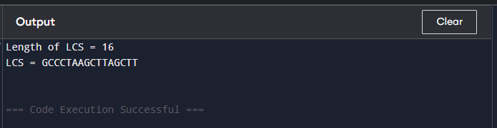

**TASK-2: Find the longest repeating subsequence (LRS). Consider it as a variation of the**

**longest common subsequence (LCS) problem.**

**Let the given string be S. You need to find the LRS within S. To use the LCS framework, you**

**effectively compare S with itself. So, consider string1 = S and string2 = S.**

**Example:**

**AABCBDC**

**LRS= ABC or ABD**

**CODE:**

#include <stdio.h>

#include <string.h>

int max(int a, int b) { return a > b ? a : b; }

void LRS(char *str) {

int n = strlen(str);

int dp[n+1][n+1];

for (int i = 0; i <= n; i++)

for (int j = 0; j <= n; j++)

if (i == 0 || j == 0)

dp[i][j] = 0;

else if (str[i-1] == str[j-1] && i != j)

dp[i][j] = dp[i-1][j-1] + 1;

else

dp[i][j] = max(dp[i-1][j], dp[i][j-1]);

int i = n, j = n, k = dp[n][n];

char lrs[k+1];

lrs[k] = '\0';

while (i > 0 && j > 0) {

if (str[i-1] == str[j-1] && i != j) {

lrs[--k] = str[i-1];

i--; j--;

} else if (dp[i-1][j] > dp[i][j-1])

i--;

else

j--;

}

printf("LRS Length: %d\n", dp[n][n]);

printf("LRS: %s\n", lrs);

}

int main() {

char S[] = "AABCBDC";

LRS(S);

return 0;

}

**Output:**

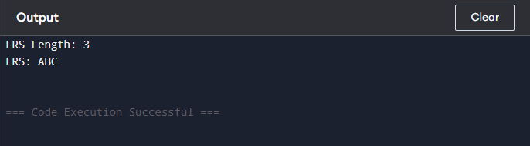

**LEET CODE:**

<https://leetcode.com/problems/longest-common-subsequence/description/>

**CODE:**

int longestCommonSubsequence(char *text1, char *text2) {

    int m = strlen(text1);

    int n = strlen(text2);

    int dp[m + 1][n + 1];

    for (int i = 0; i <= m; i++)

        for (int j = 0; j <= n; j++)

            if (i == 0 || j == 0)

                dp[i][j] = 0;

            else if (text1[i - 1] == text2[j - 1])

                dp[i][j] = dp[i - 1][j - 1] + 1;

            else

                dp[i][j] = dp[i - 1][j] > dp[i][j - 1] ? dp[i - 1][j] : dp[i][j - 1];

    return dp[m][n];

}

**Output:**

