Tools used:

Python-3.6   
Django  
PyGithub module  
Json

The Gitmining web application takes 3 inputs as request parameters   
1.Name of the organisation  
2.Number of top repositories  
3.Number of top committers

Here is a sample screenshot of a request made to the web application.

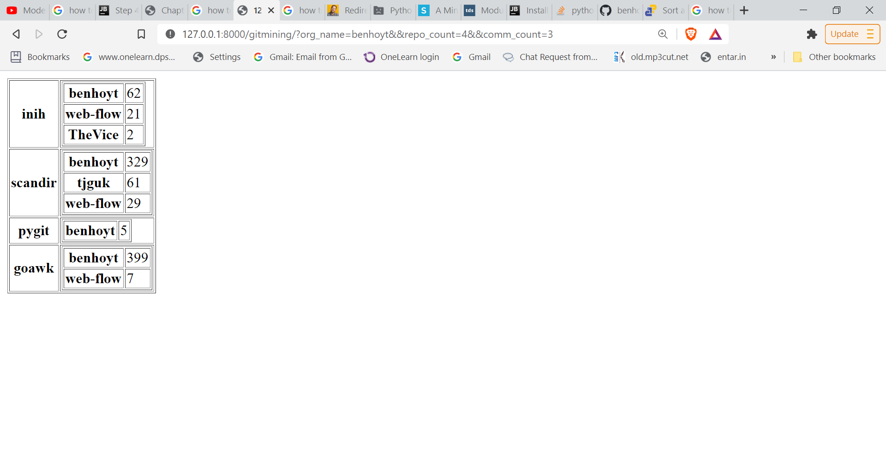

Current Limitations:

1.The application is processing the GitHub repositories in a serial fashion so the time taken is more , hence repositories which have high number of commits cannot be processed in a timely manner .   
Given more time, these issues can be addressed.

2.Also, the code is not very well structured and commented but could be done if more time had been provided.