Tools used:
Python-3.6
Django
PyGithub module
Json
The Gitmining web application takes 3 inputs as request parameters
1.Name of the organisation
2.Number of top repositories
3.Number of top committers

Here is a sample screenshot of a request made to the web application.
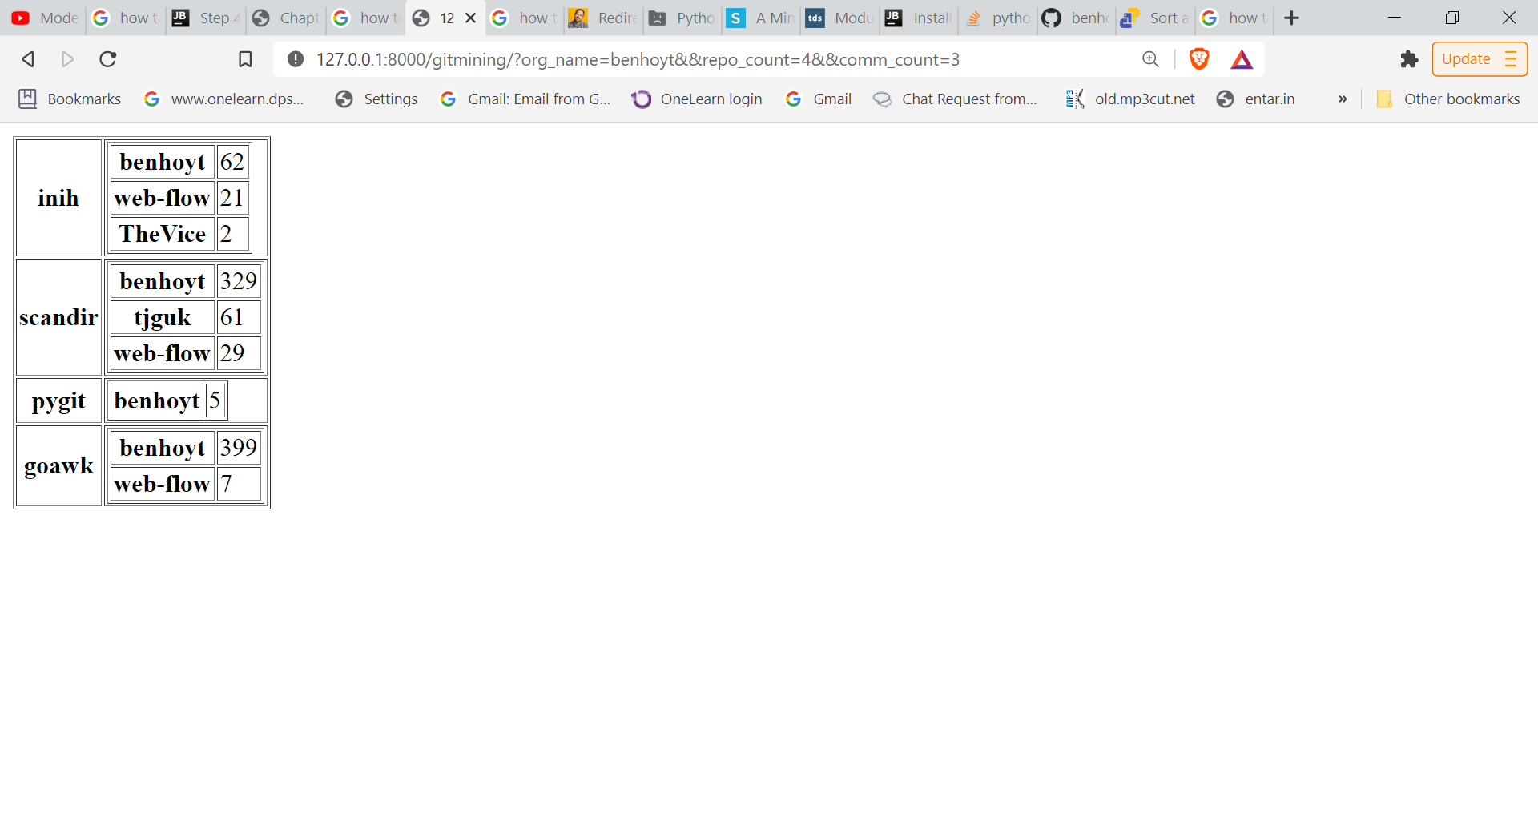
Current Limitations:
1.The application is processing the GitHub repositories in a serial fashion so the time taken is more , hence repositories which have high number of commits cannot be processed in a timely manner .
Given more time, these issues can be addressed.
2.Also, the code is not very well structured and commented but could be done if more time had been provided.

