DVT Project

Isha Shukla

16 June 2024

# Problem 1

Consider that you are a Lead Data Analyst at an Insurance Claims company that has provided you with the Car Insurance Claims dataset. You have been given a task to explore the data, create different plots and interpret useful insights/findings. Your end goal here will be to create a storyboard that you have to present to the Senior Management and the story has to have an end objective and should follow a logical flow to display that you are heading towards achieving the end objective. This will help the Senior Management in taking some decisive actions on the current claims system in place. This storyboard will be an open-ended story for you to explore various different features in the data and try to showcase different plots. Make sure to have minimum clutter in the plots, follow a consistent color scheme across all the plots, and use proper colors to highlight a specific insight. Moreover, your plots on all the dashboards should be interactive and responsive. *There should be 1 dashboard that should cover the summary of the story as well as your recommendations.*

**Storyboard Link** - <https://public.tableau.com/shared/5F93FTYH6?:display_count=n&:origin=viz_share_link>

Age Group calculated field

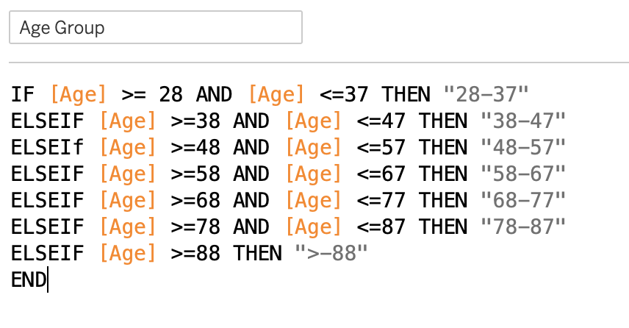

Age of Car

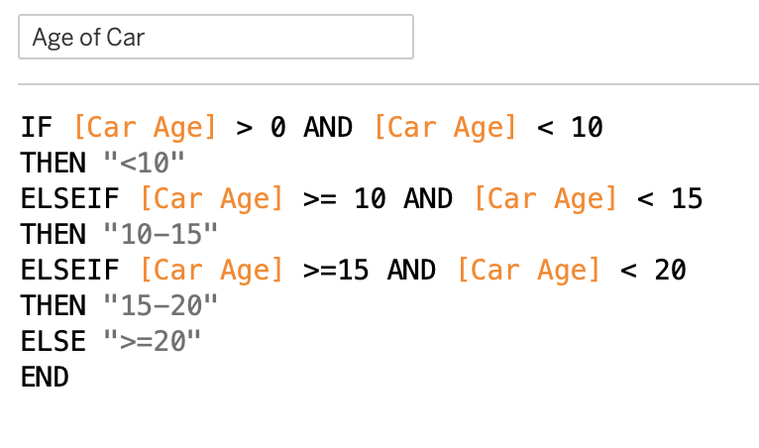

Multi Select Criteria

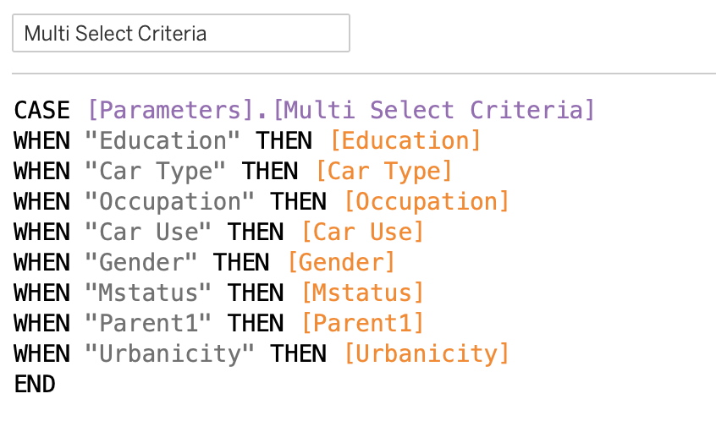

Income Value

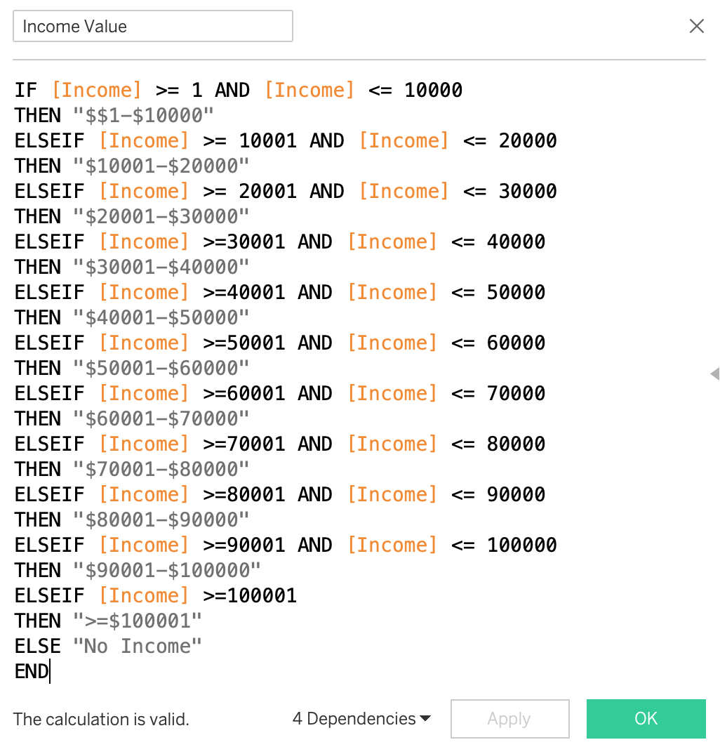

Number of Records

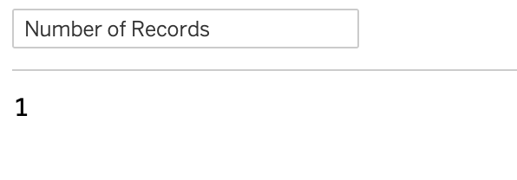

Home Value

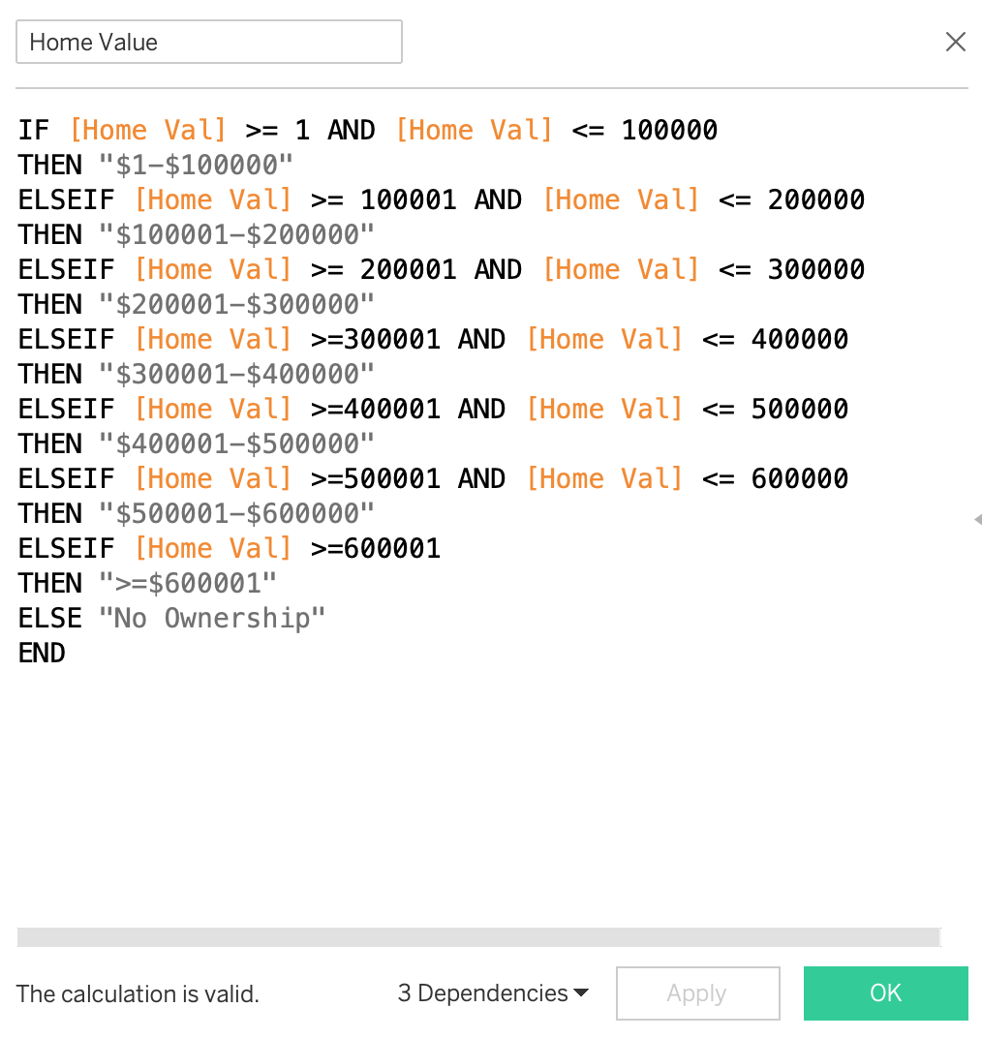

Parameters

