**Social Media Project**

**Steps to achieve the output has been mentioned in the comments along with the code.**

***PROBLEM1 –TOP 10 MOST COMMONLY USED TAGS IN THE DATASET.***

**SOLUTION CODE:**

/*Step -1 Loaded Social Media comma seperated file*/

StackEx_file = LOAD '/samples/Social_Media.csv' USING org.apache.pig.piggybank.storage.CSVExcelStorage(',', 'NO_MULTILINE', 'NOCHANGE', 'SKIP_INPUT_HEADER') AS (uid:int, qid:int, i:int, qs:int, qt:chararray, tags:chararray, qvc:int, qac:int, aid:int, j:int, as:int, at:chararray);

/*Step -2 For each record in file selected only "tag" column*/

qus_tags = FOREACH StackEx_file GENERATE tags;

/*Step 3 Since each qid has multiple tags associated with it, For each record in step 2 I have splitted/tokenized the tags*/

split_tags = FOREACH qus_tags GENERATE FLATTEN(TOKENIZE(tags)) as splittag;

/*Step 4 Grouped the data in step 3 using each tag as key*/

grouped_tags = GROUP split_tags BY splittag;

/*step 5: For each key in step 4 counted number of tags associated with it*/

tag_count = FOREACH grouped_tags GENERATE group,COUNT(split_tags) as tot_tag;

/*Step 6 Sorted data of step 5 in desc order */

sort_tag = ORDER tag_count BY tot_tag DESC;

/*Step 7 Selected only top 10 records from Step 6*/

top_10_tag = limit sort_tag 10;

/*Stored the output in file*/

store top_10_tag into '/samples/output/solution1.txt';

**Output Screenshot:**

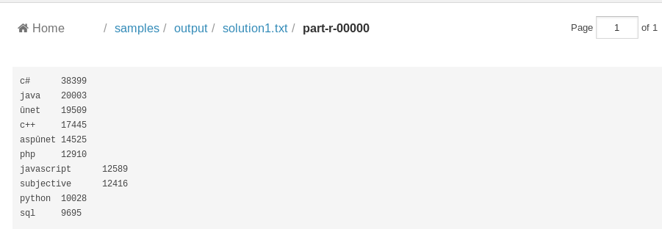

**Output:**

c# 38399

java 20003

ûnet 19509

c++ 17445

aspûnet 14525

php 12910

javascript 12589

subjective 12416

python 10028

sql 9695

***PROBLEM 2: Average time to answer questions***

**SOLUTION CODE :**

/*Step 1 - Loaded the file as a comma seperated values*/

StackEx_file = LOAD '/samples/Social_Media.csv' USING org.apache.pig.piggybank.storage.CSVExcelStorage(',', 'NO_MULTILINE', 'NOCHANGE', 'SKIP_INPUT_HEADER') AS (uid:int, qid:int, i:int, qs:int, qt:long, tags:chararray, qvc:int, qac:int, aid:int, j:int, as:int, at:long);

/*Step 2 - for each record in step 1 calculated the difference between the time at which question was posted and time at which it was answered for the first time */

ans_time = FOREACH StackEx_file GENERATE at-qt as timediff;

/*Grouped the data in step 2 under 1 key and calculated the average using avg function in pig*/

avg_time = FOREACH (GROUP ans_time ALL) GENERATE AVG(ans_time.timediff);

/*Stored the output in a file. Since epoch time is in seconds the final answer is in seconds*/

store avg_time into '/samples/output/solution2';store avg_time into '/samples/output/solution2';

**Output Screenshot.**

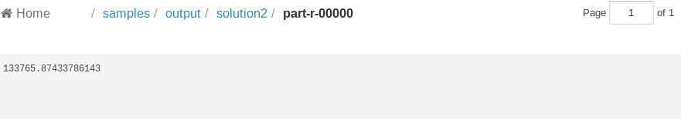

**Output:**

133765.87433786143

**PROBLEM 3: NUMBER OF QUESTIONS WHICH GOT ANSWERED WITHIN ONE HOUR**

**SOLUTION CODE:**

/*Step 1: Loaded the file as csv*/

StackEx_file = LOAD '/samples/Social_Media.csv' USINGorg.apache.pig.piggybank.storage.CSVExcelStorage(',', 'NO_MULTILINE', 'NOCHANGE', 'SKIP_INPUT_HEADER') AS (uid:int, qid:int, i:int, qs:int, qt:long, tags:chararray, qvc:int, qac:int, aid:int, j:int, as:int, at:long);

/*Step 2:Filtered records from the file where the time difference between question posted and answer time was less than or equal to 1 hr. Since epoch time is in seconds i have compared with 3600 sec which is equivalent to 1 hr.*/

flt_rec = FILTER StackEx_file BY (at-qt) <= 3600;

/* step 3: Grouped the records in step 2 by question id*/

grp_rec = GROUP flt_rec BY qid;

/*Step 4: In step 3 we might get duplicates as there can be multiple answers given for a single question within an hour. Hence selecting only 1 record for each qid.*/

rem_dup = FOREACH grp_rec { top_rec = LIMIT flt_rec 1;

GENERATE flatten(top_rec); };

/*Step 5: Counted number of records in step 4*/

count_rec = FOREACH (GROUP rem_dup ALL) GENERATE COUNT(rem_dup.qid) ;

/*Step 6: stored the output in a file*/

store count_rec into '/samples/output/solution3';

**Output Screenshot:**

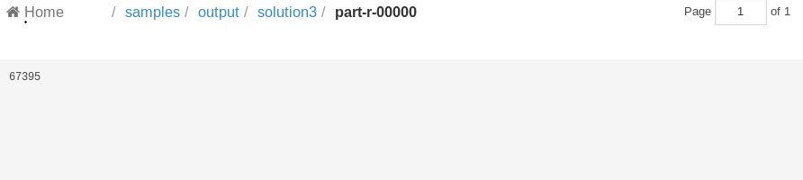

**Output:**

67395

***PROBLEM 4: TAGS OF QUESTIONS THAT GOT ANSWERED WITHIN AN HOUR.***

**SOLUTION CODE:**

/*Step 1: Loaded the file as csv*/

StackEx_file = LOAD '/samples/Social_Media.csv' USING org.apache.pig.piggybank.storage.CSVExcelStorage(',', 'NO_MULTILINE', 'NOCHANGE', 'SKIP_INPUT_HEADER')

AS (uid:int, qid:int, i:int, qs:int, qt:long, tags:chararray, qvc:int, qac:int, aid:int, j:int, as:int, at:long);

/*Step 2: Filtered records from the file where the time difference between question posted and answer time was less than or equal to 1 hr. Since epoch time is in seconds i have compared with 3600 sec which is equivalent to 1 hr.*/

flt_rec = FILTER StackEx_file BY (at-qt) <= 3600;

/* step 3: Grouped the records in step 2 by question id*/

grp_rec = GROUP flt_rec BY qid;

/*Step 4: In step 3 we might get duplicates as there can be multiple answers given for a single question within an hour. Hence selecting only 1 record for each qid.*/

rem_dup = FOREACH grp_rec {

top_rec = LIMIT flt_rec 1;

GENERATE flatten(top_rec);

};

/*For each record in step 4 i have selected qid and tags associated with that question*/

tag_rec = FOREACH rem_dup GENERATE qid,tags;

/*stored the output in a file*/

store tag_rec into '/samples/output/solution4';

**Output Screesnhot:**

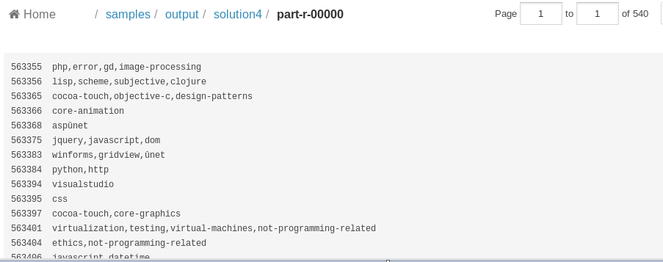

**Since the output is big I have attached the output file below:**

