Practical 1 : Markov Chain Text Generator
Name: Isha Ghorpade
PNR: 22420020

Objective
To build a simple text generator using Markov Chains.

Theory
A Markov Chain is a stochastic model where the next state depends only on the current state. In text generation, each word is treated as a state, and transitions between words are learned from input text.

Methodology
1. Take input text.
2. Build a Markov Chain mapping each word to possible next words.
3. Randomly select a starting word.
4. Generate text by selecting next words based on the chain.

Code Explanation
The program constructs a dictionary where each word maps to a list of possible next words. Text is generated by randomly selecting the next word from this list.
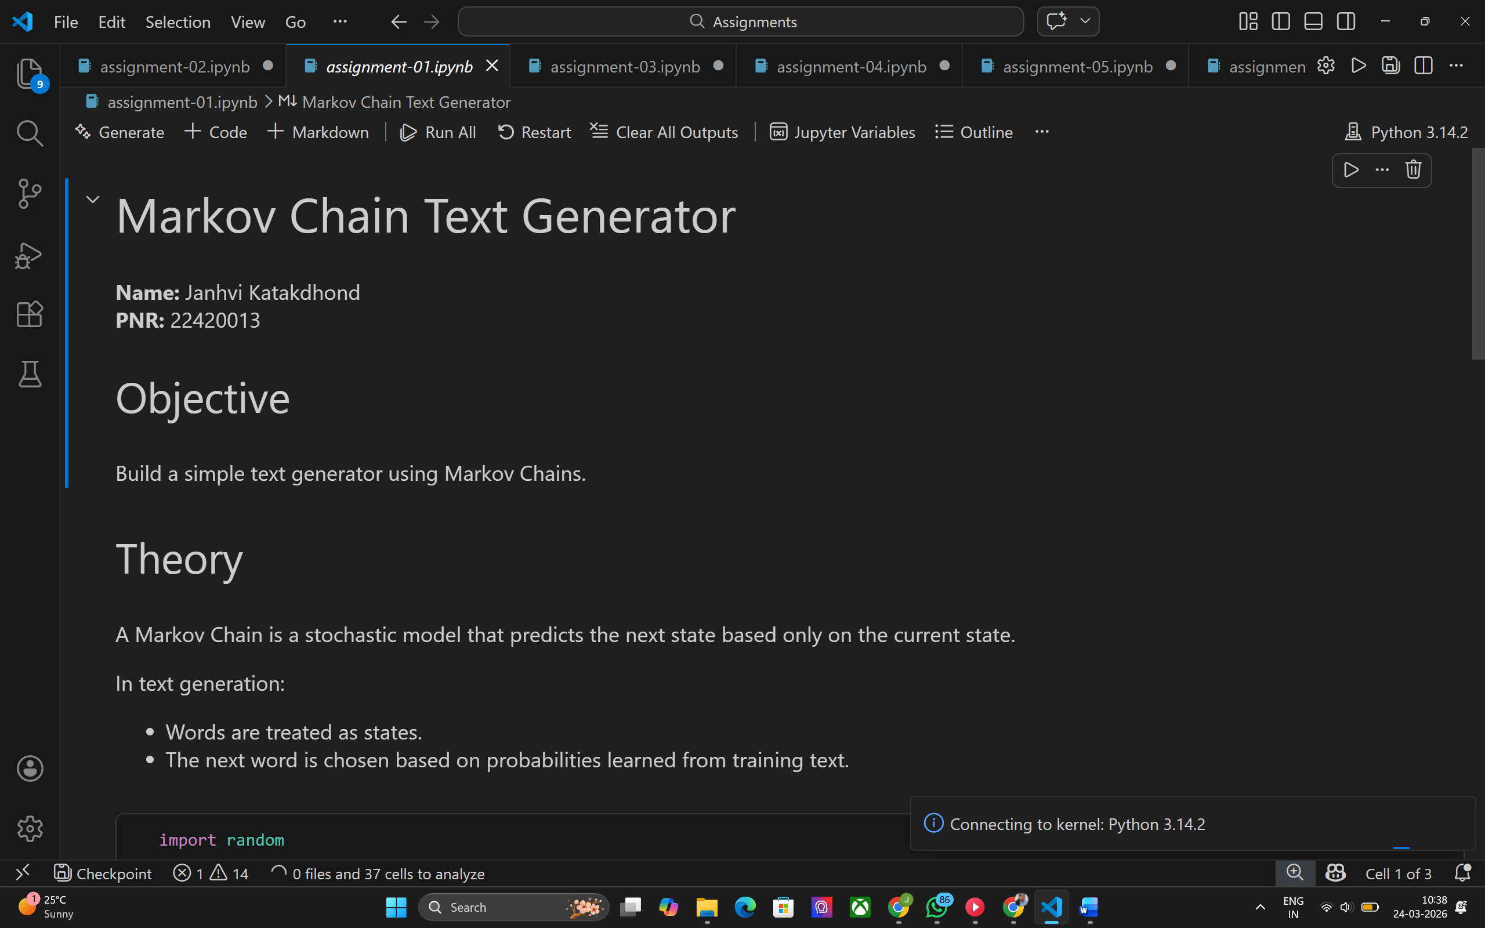
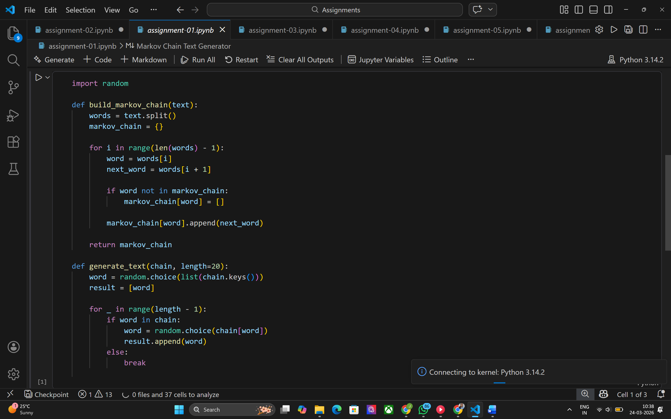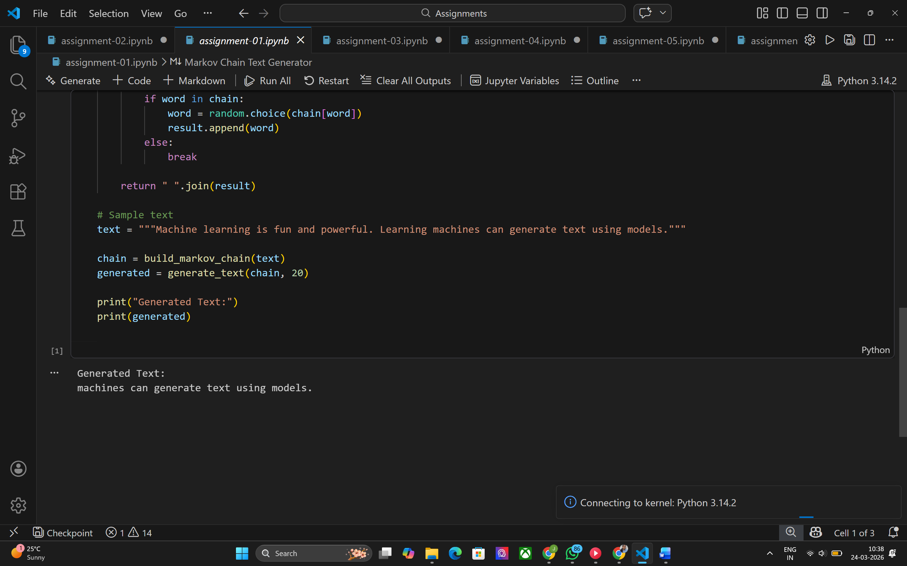

Conclusion
Markov Chains provide a simple yet effective way to generate text. Though basic, they demonstrate core ideas behind probabilistic language models.

