Practical 2 : Prompt Engineering Approaches
Name: Isha Ghorpade
PNR: 22420020

Objective
To implement and compare various prompt engineering techniques.

Techniques
1. Zero-shot Prompting
2. Few-shot Prompting
3. Chain of Thought
4. Tree of Thought
5. Interview Approach

Analysis
Zero-shot is simple but less accurate. Few-shot improves performance by providing examples. Chain of Thought enhances reasoning. Tree of Thought explores multiple solutions. Interview approach is useful for refining user requirements.
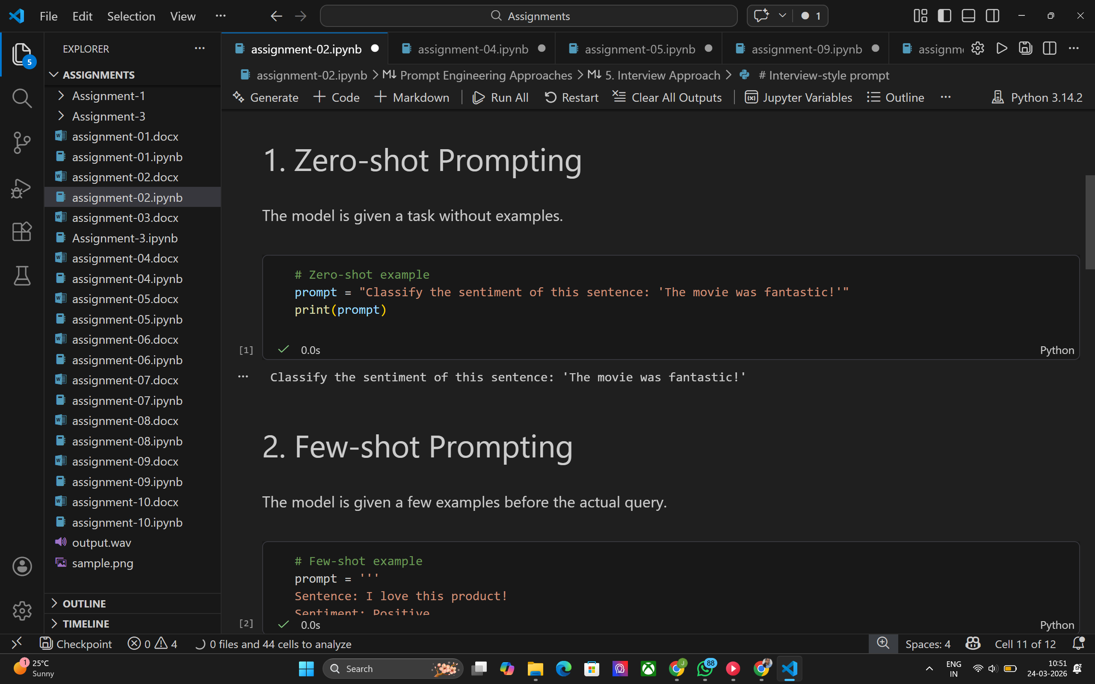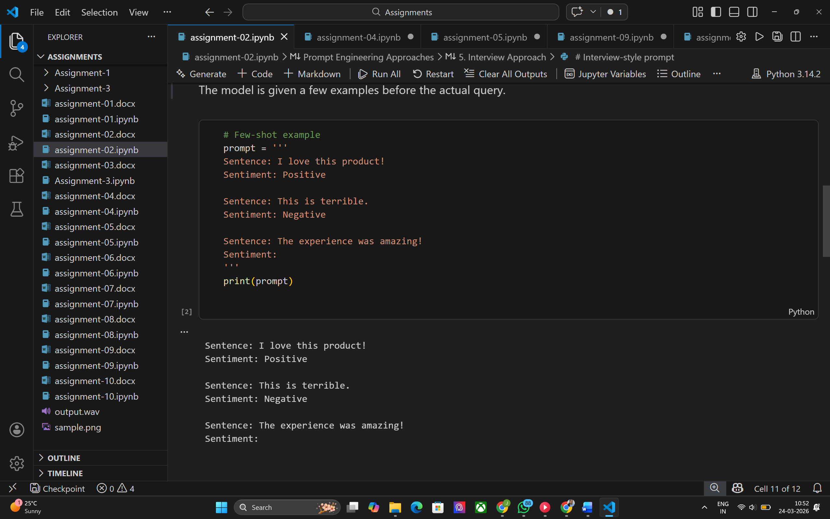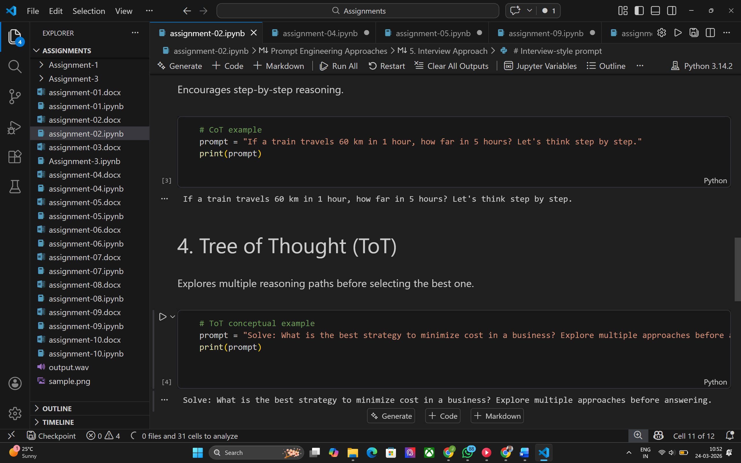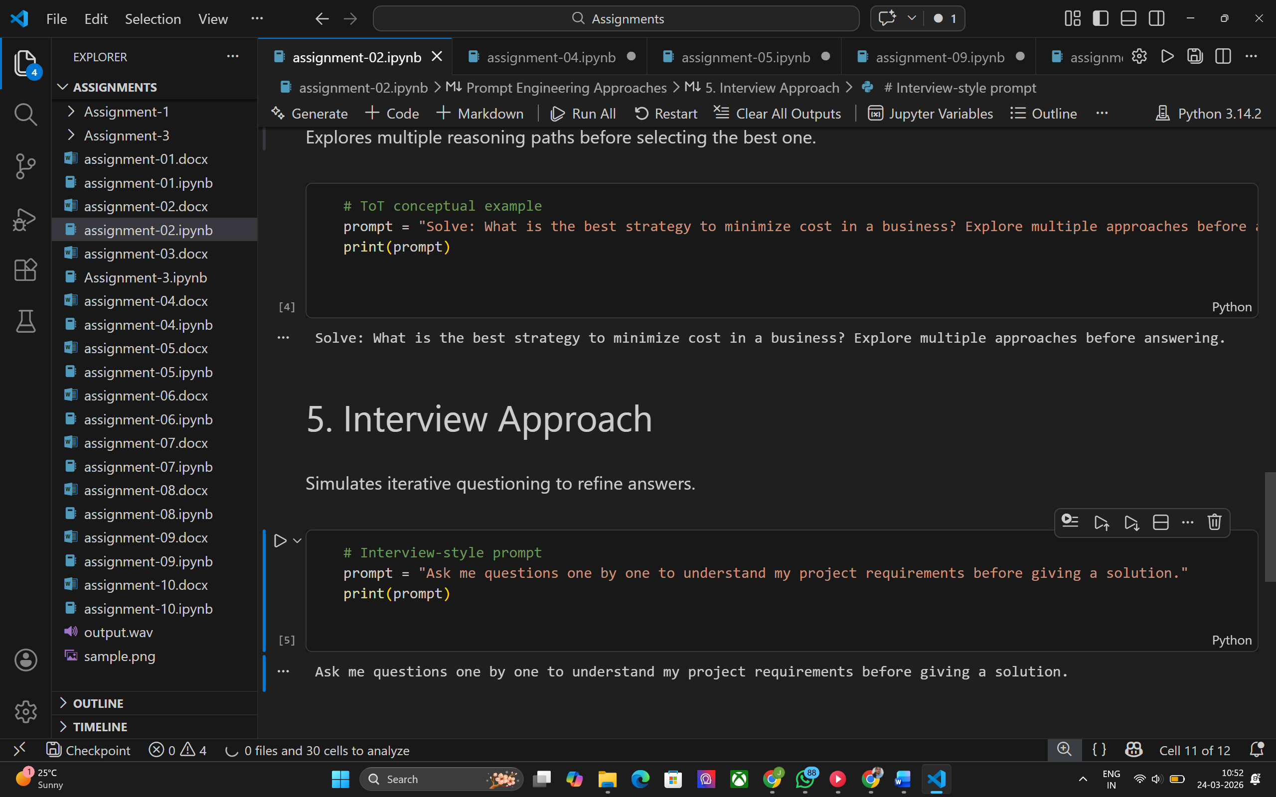

Comparison
Few-shot outperforms zero-shot in structured tasks. CoT and ToT are better for complex reasoning problems. Interview approach is best suited for interactive systems.

Conclusion
Different prompt engineering techniques serve different purposes. Choosing the right method depends on task complexity.

