Practical 3 : Fine-Tuning GPT-2 for Creative Story Generation
Name: Isha Ghorpade
PNR: 22420020

Objective
To fine-tune GPT-2 for generating creative stories.

Methodology
1. Load a dataset of story text.
2. Use GPT-2 tokenizer.
3. Fine-tune GPT-2 model using Trainer API.
4. Generate stories using trained model.

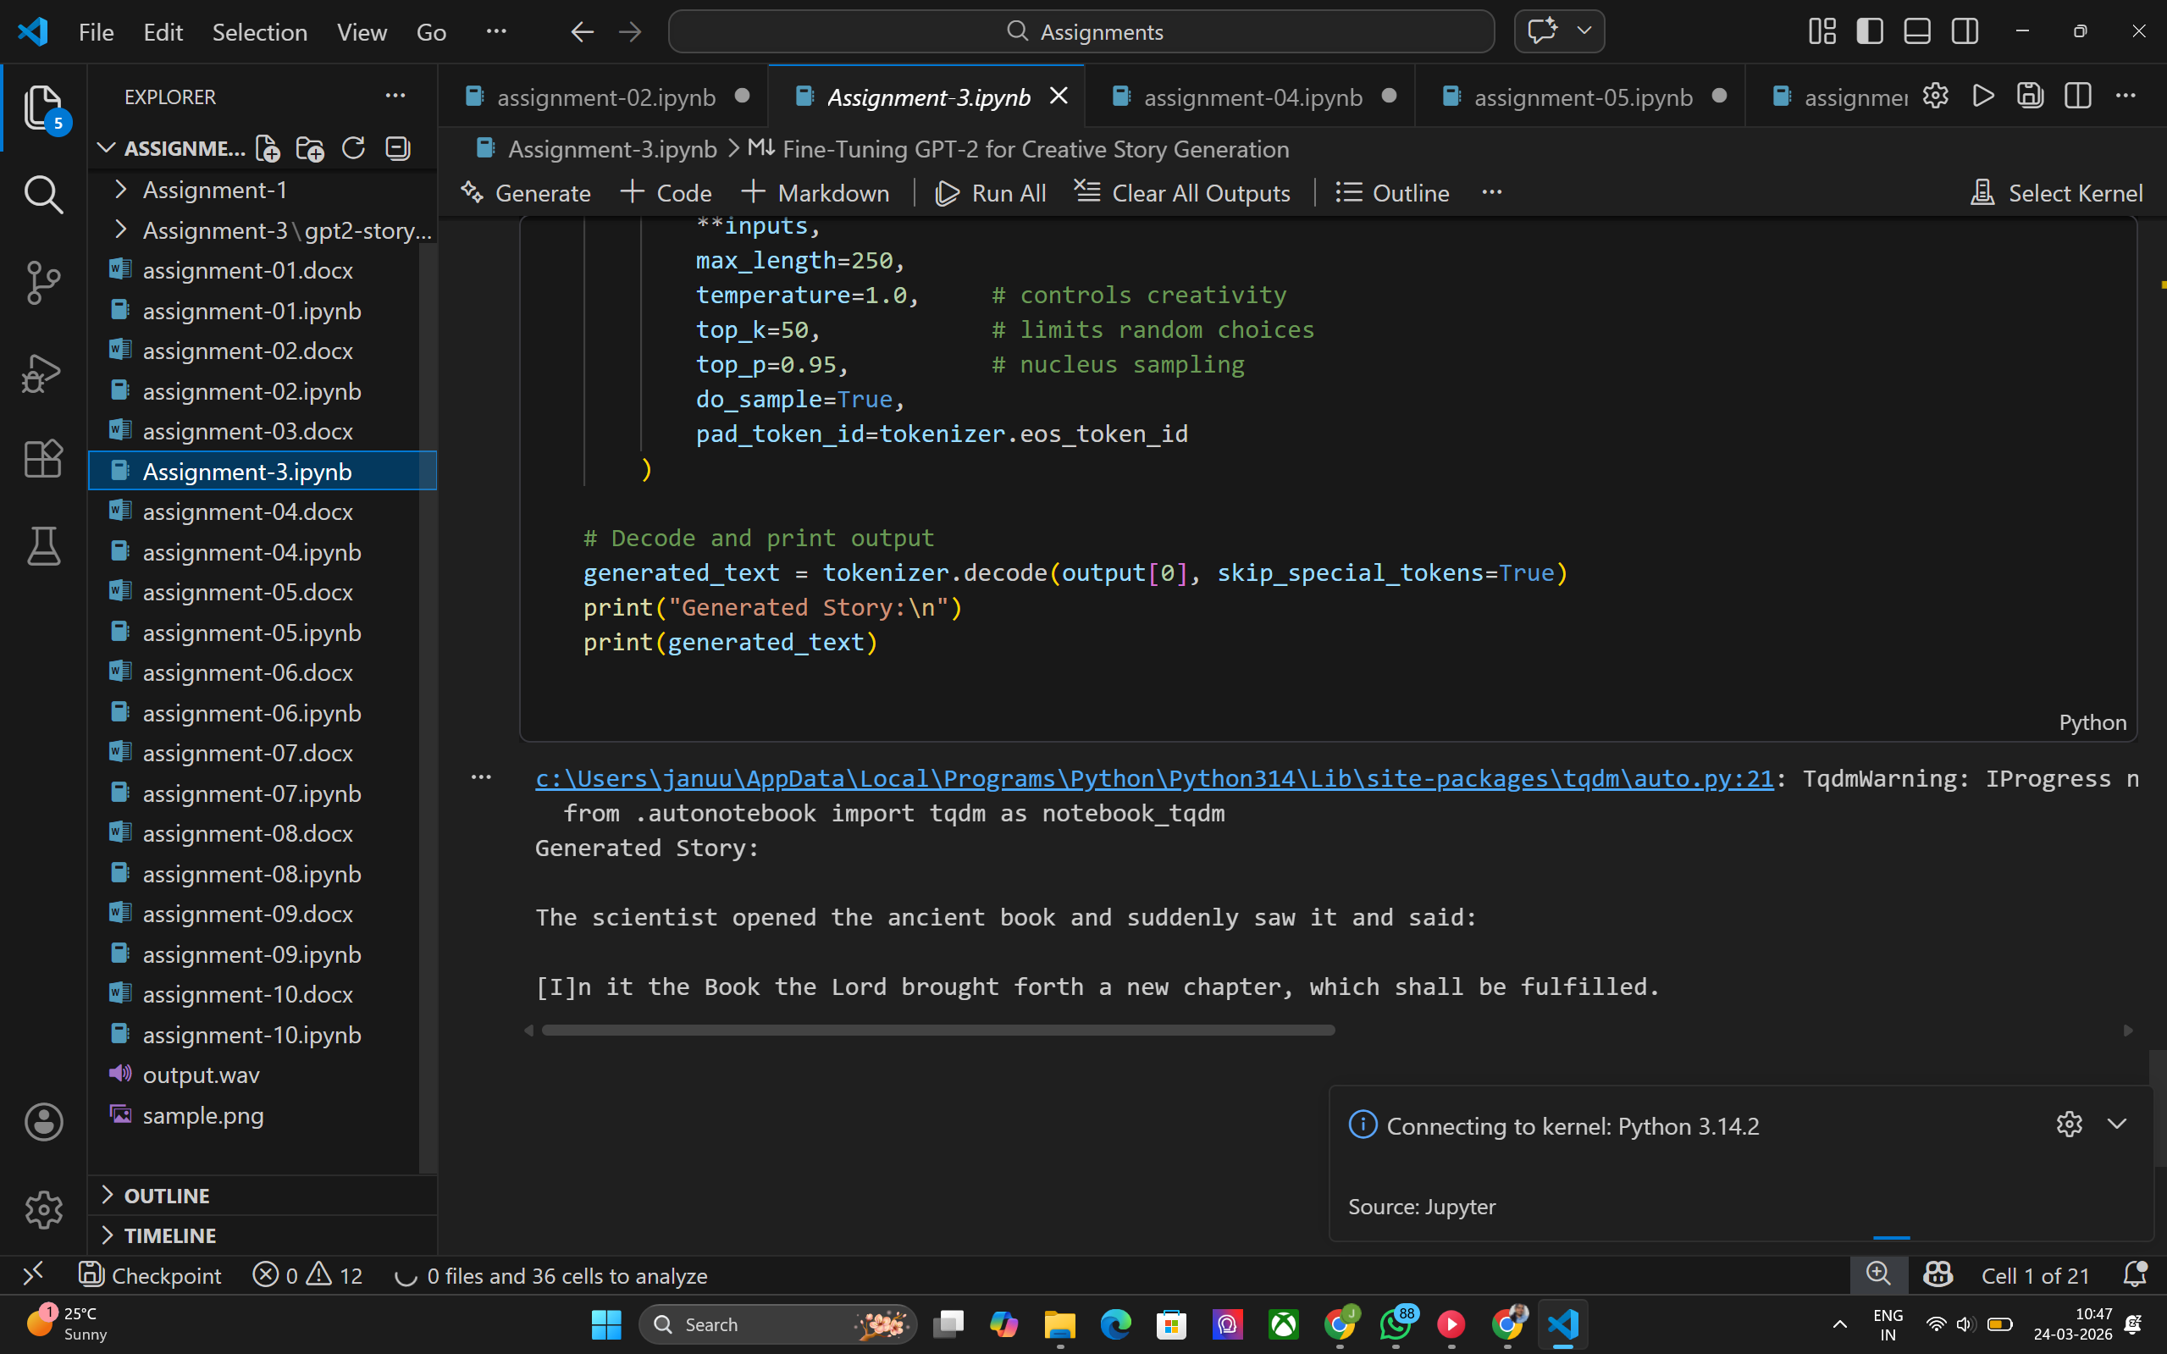

Tools Used
Transformers, PyTorch, Datasets library.

Conclusion
Fine-tuning GPT-2 improves its ability to generate domain-specific creative text.

