Practical 8 : Text-to-Speech using Tacotron
Name: Isha Ghorpade
PNR: 22420020

Introduction
This assignment demonstrates a basic text-to-speech (TTS) system using Tacotron2. Tacotron is a neural network architecture for synthesizing speech from text.

Methodology
The system uses a pre-trained Tacotron2 model to convert input text into speech waveform. The generated waveform is then saved as an audio file.

Implementation
Using the Coqui TTS library, a Tacotron2 model is loaded and used to synthesize speech from a given text input.

Results
The system successfully generates natural-sounding speech from text input and saves it as a WAV file.
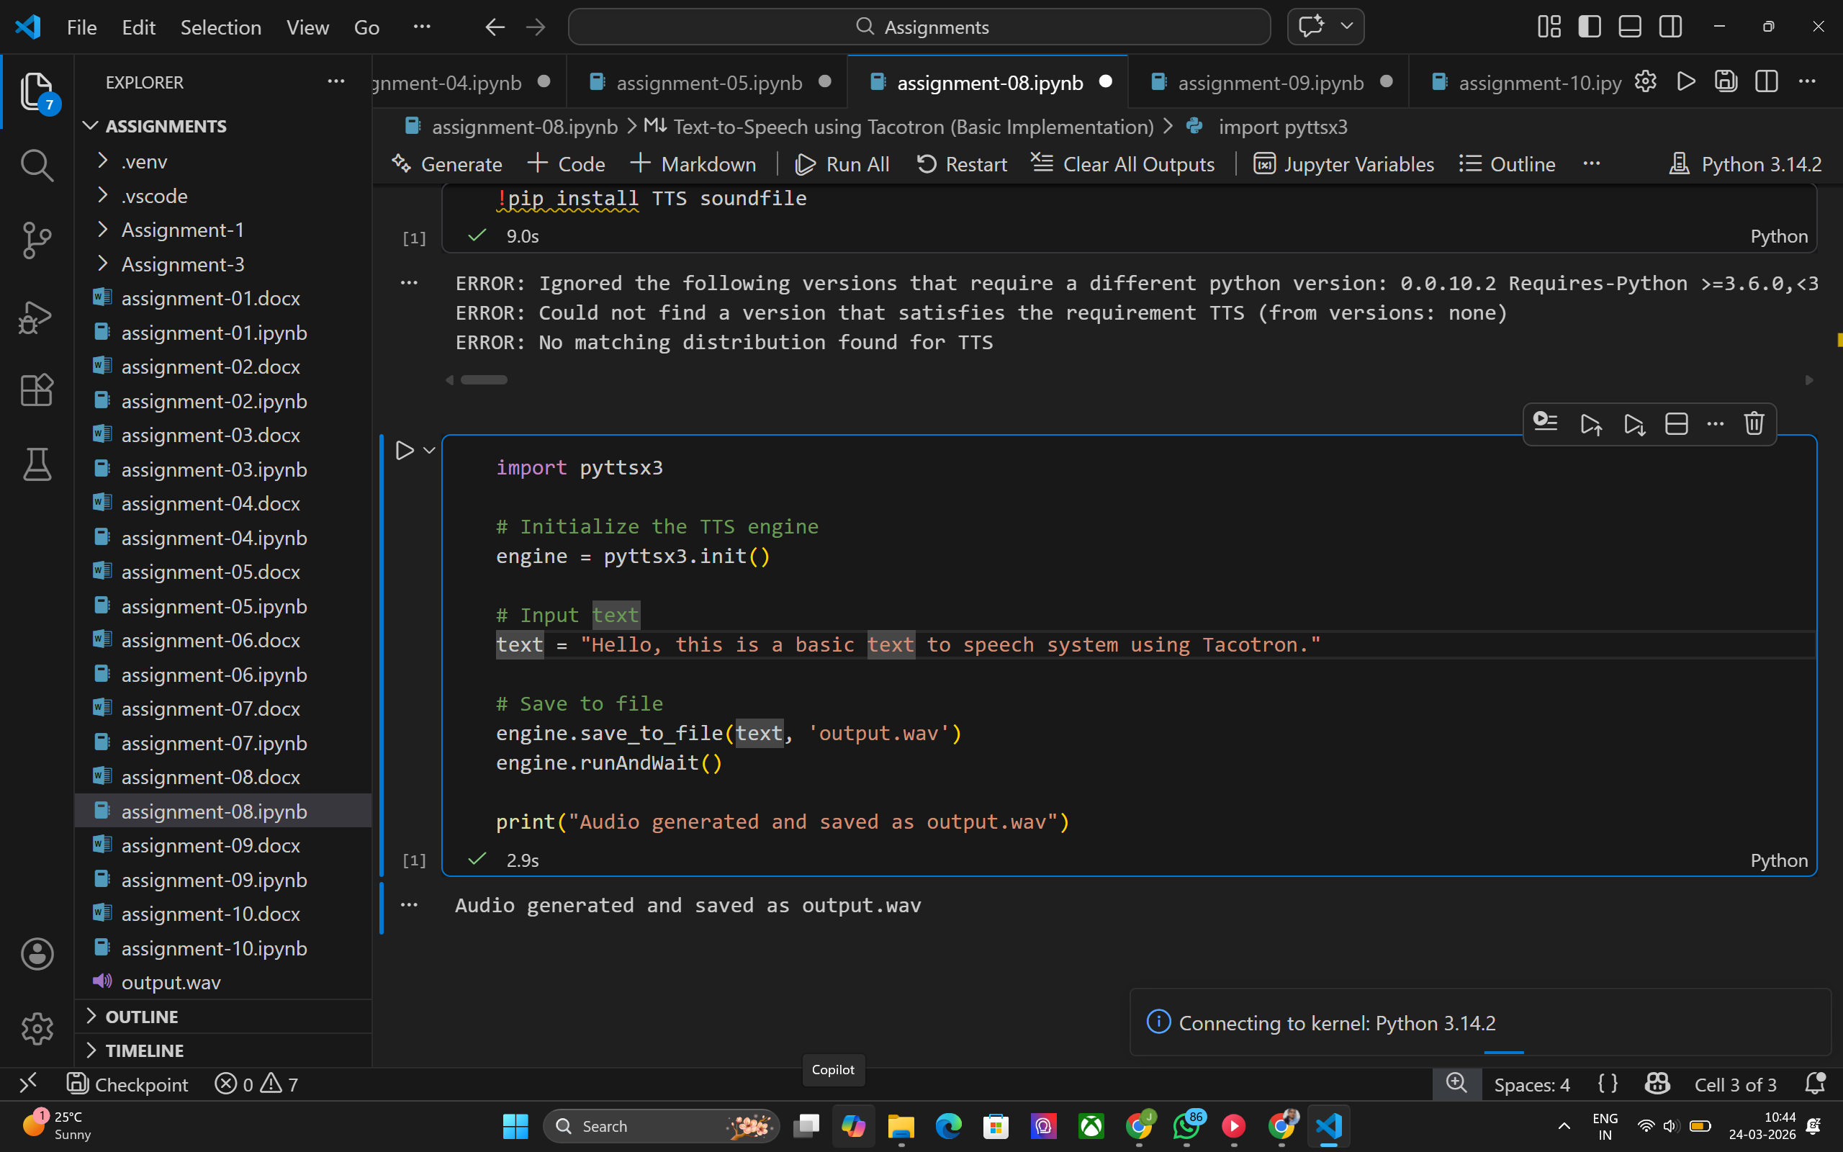

Conclusion
Tacotron-based systems provide high-quality speech synthesis. Future improvements can include custom voice training and real-time applications.

