**Name:** Isha Ghorpade

**Roll no:** 281066

**Batch:** A3

**Assignment 5: Data Visualization**

**Problem Statement:**

Visualize the dataset provided for Assignment No. 1 and 2 using either R/Python or Tableau. Select a suitable dataset for visualization.

a) Using R/Python:

- Utilize Scatter plot, bar plot, Box plot, and Histogram to visualize the dataset effectively.

OR

b) Using Tableau:

- Perform data visualization operations using Tableau for the provided dataset.

**Libraries Used:**

1. NumPy (np)

2.Pandas (pd)

3.Matplotlib (plt)

4.Seaborn (sns)

**Theory:**

**1) Methodology:**

Data visualization using Google Colab involves the use of various Python libraries such as Matplotlib, Seaborn, Pandas, and NumPy. These libraries provide a comprehensive set of tools to create a wide range of visualizations including scatter plots, bar plots, box plots, histograms, and more.

The methodology typically involves the following steps:

* Data Importing: Importing the dataset into the Colab environment using Pandas or accessing data from other sources such as Google Drive.
* Data Preprocessing: Preprocessing the data if necessary, including handling missing values, data cleaning, and feature engineering.
* Visualization: Using Matplotlib and Seaborn to create visualizations based on the requirements of the assignment. This may include choosing appropriate plot types, customizing plot aesthetics, and adding necessary annotations.
* Interactivity: Enhancing visualizations with interactive features using libraries like Plotly, if required.
* Presentation: Presenting the visualizations in the notebook along with appropriate titles, labels, and legends to convey the insights effectively.

**2)Advantages:**

* **Enhanced Data Interpretation**: Visualizing data through different plots allows for a more intuitive understanding of patterns, trends, and relationships within the dataset.
* **Effective Communication:** Visualizations serve as powerful tools for conveying complex information in a clear and concise manner, facilitating communication of insights to stakeholders.
* **Decision Making Support:** By providing visual representations of data, decision-makers can make informed decisions based on a deeper understanding of the underlying trends and patterns.

**3)Disadvantages:**

* **Subjectivity:** Interpretation of visualizations can be subjective, leading to potential misinterpretation of data if not communicated effectively.
* **Limited Representation:** Certain types of data may not be effectively represented through standard visualization techniques, potentially leading to oversimplification or loss of important details.
* **Technical Challenges:** Generating complex visualizations or handling large datasets may pose technical challenges, requiring advanced skills and computational resources.

**4)Applications:**

* **Business Analytics:** Data visualization is widely used in business analytics for market analysis, performance tracking, and decision-making support.
* **Scientific Research:** Visualization techniques play a crucial role in scientific research for data exploration, hypothesis testing, and result presentation.
* **Healthcare:** In healthcare, visualizations are used for patient monitoring, disease analysis, and medical imaging interpretation.
* **Finance:** Financial analysts utilize visualizations for risk assessment, portfolio management, and trend analysis in stock markets and investment strategies.

**5)Examples:**

* Creating a sales dashboard to monitor revenue trends and performance metrics.
* Visualizing customer segmentation for targeted marketing strategies.
* Analyzing website traffic patterns and user behavior through interactive dashboards.

**Screenshots of the Output:**

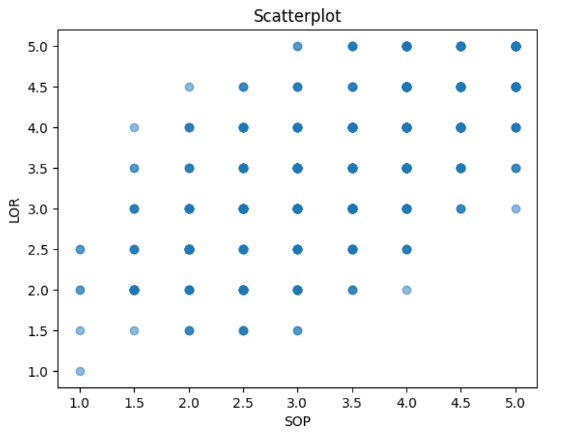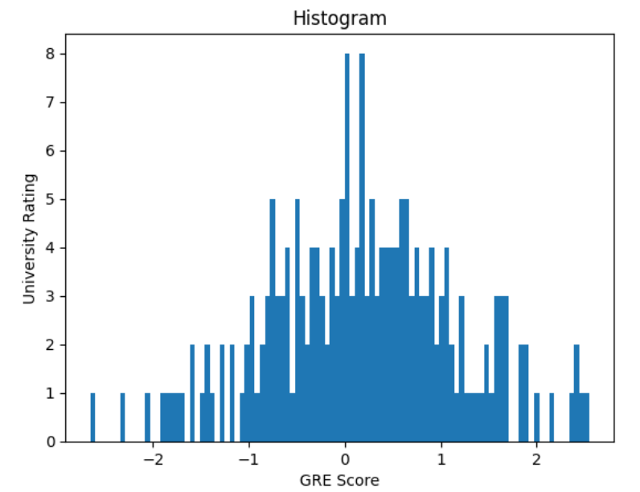

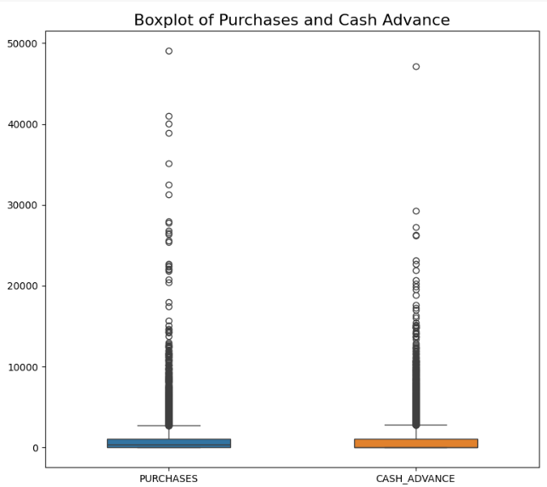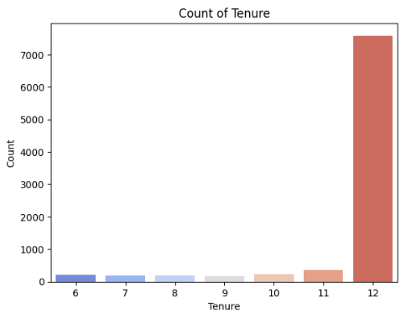

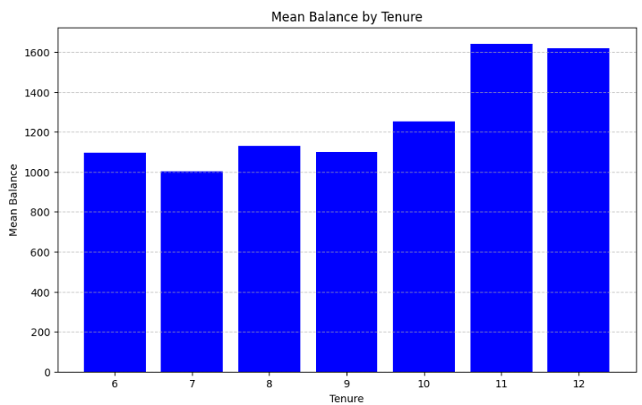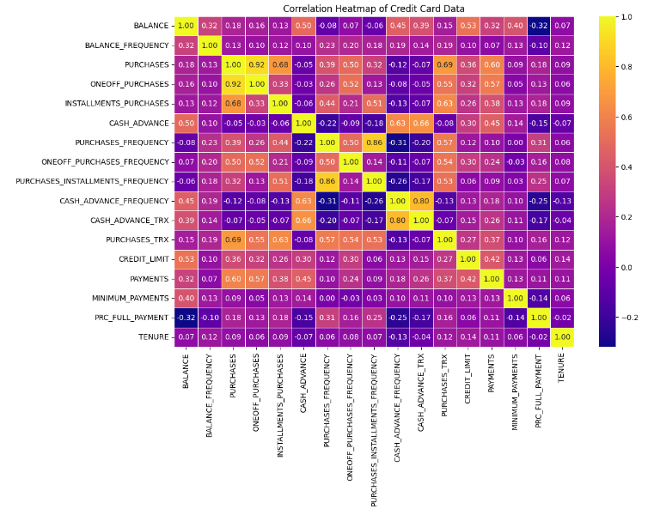

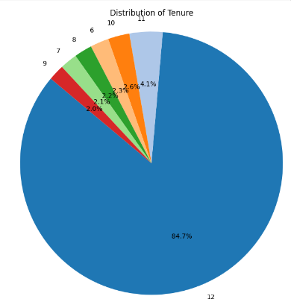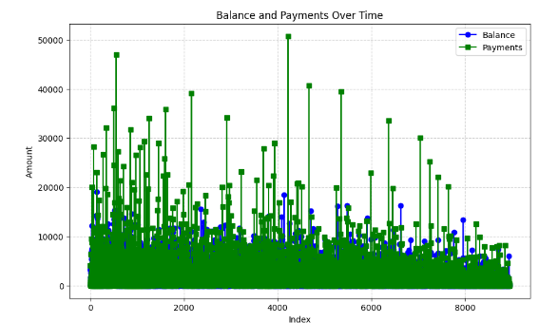

**-**

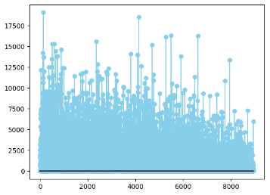

**Conclusion:**

In conclusion, the methodology outlined for data visualization using Google Colab, alongside Python libraries such as Matplotlib, Seaborn, Pandas, and NumPy, provides a robust framework for exploring and interpreting the university dataset. By following the steps of data importing, preprocessing, visualization, interactivity, and presentation, we have effectively leveraged these tools to gain insights into various aspects of university data.The visualizations generated, including scatter plots, bar plots, box plots, and histograms, have enabled us to uncover patterns, trends, and relationships within the dataset. Through interactive features, stakeholders can dynamically explore the data, gaining deeper insights and making more informed decisions.