**Name : Isha Dave A.**

**Enroll : 202400819010016**

**Assignment – 1**

**Set 1: Student Registration Form**

* Welcome.blade.php :

<link rel="stylesheet" href="css/style.css">

<h1> WelCome to Student Registration Site </h1>

<div style="text-align: center">

<a href="/registration"> Click here to Register </a>

<div>

* registration.blade.php :

<link rel="stylesheet" href="css/style.css">

<form method="post" action="/registration">

@csrf

<table>

<tr>

<td>Full Name : </td>

<td>

<input type="text" name="FullName:" required>

</td>

</tr>

<tr>

<td>Email : </td>

<td>

<input type="email" name="Email:" required>

</td>

</tr>

<tr>

<td>Phone Number : </td>

<td>

<input type="tel" name="PhoneNo:" required pattern="[0-9]{10}" title="Please enter exactly 10 digits">

</td>

</tr>

<tr>

<td>Course : </td>

<td>

<select name="Course:">

<option>Msc IT</option>

<option>MCA</option>

<option>BCA</option>

<option>Bsc IT</option>

</select>

</td>

</tr>

</table>

<nav>

<button type="submit" >Submit</button>

</nav>

</form>

* show.blade.php :

<link rel="stylesheet" href="css/style.css">

<table>

@foreach($data as $key => $value)

@if($key !== '_token')

<tr>

<td>{{ $key }}</td>

<td>{{ $value }}</td>

</tr>

@endif

@endforeach

</table>

* web.php :

use App\Http\Controllers\student;

Route::get('/',[student::class,'index']);

Route::get('/registration',[student::class,'registration']);

Route::get('/show',[student::class,'show']);

Route::post('/registration',[student::class,'submit']);

* student.php :

class student extends Controller

{

public function index(){

return view('/welcome');

}

public function registration(){

return view('/registration');

}

public function show(){

return view('/show');

}

public function submit(Request $request){

$data = $request -> all();

return view ('/show',compact('data'));

}

}

* OUTPUT :

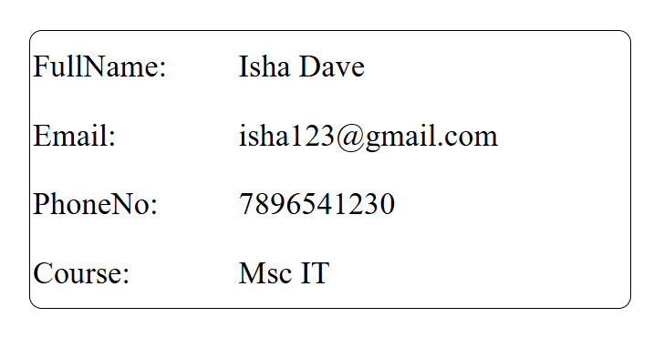

**Set 2: Product Management System**

* product.blade.php :

<link rel="stylesheet" href="css/style.css">

<form method="post" action="/product">

@csrf

<table>

<tr>

<td>Product Name : </td>

<td>

<input type="text" name="Product Name:" required>

</td>

</tr>

<tr>

<td>Category : </td>

<td>

<select name="Category:">

<option>Makeup kit</option>

<option>Perfume</option>

<option>Purse</option>

<option>Watch</option>

</select>

</td>

</tr>

<tr>

<td>Price : </td>

<td>

<input type="number" name="Price:" required min="0" title="you can not enter negative number">

</td>

</tr>

<tr>

<td>Stock Quantity : </td>

<td>

<input type="number" name="Stock:" min="1" required title="Minimum quantity should be 1">

</td>

</tr>

</table>

<nav>

<button type="submit" >Submit</button>

</nav>

</form>

* show.blade.php :

<link rel="stylesheet" href="css/style.css">

<table>

@foreach($data as $key => $value)

@if($key !== '_token')

<tr>

<td>{{ $key }}</td>

<td>{{ $value }}</td>

</tr>

@endif

@endforeach

</table>

* web.php :

Route::get('/',[product::class,'index']);

Route::get('/product',[product::class,'product']);

Route::get('/show',[product::class,'show']);

Route::post('/product',[product::class,'submit']);

* product.php :

class product extends Controller

{

public function index(){

return view('/welcome');

}

public function product(){

return view('/product');

}

public function show(){

return view('/show');

}

public function submit(Request $request){

$data = $request -> all();

return view ('/show',compact('data'));

}

}

* OUTPUT :

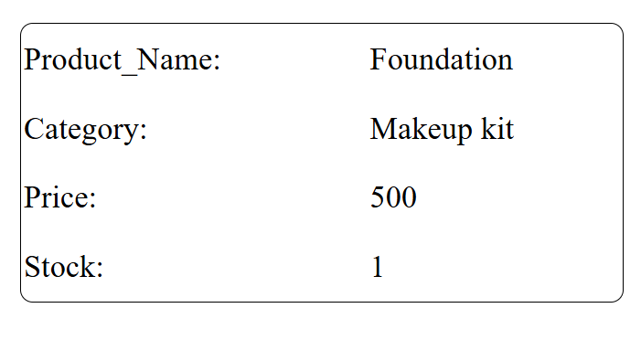

**Set 3: Job Application Form**

* Job_form.blade.php

<link rel="stylesheet" href="css/style.css">

<form method="post" action="/job_form">

@csrf

<table>

<tr>

<td>Full Name : </td>

<td>

<input type="text" name="FullName:" required>

</td>

</tr>

<tr>

<td>Email : </td>

<td>

<input type="email" name="Email:" required>

</td>

</tr>

<tr>

<td>Phone Number : </td>

<td>

<input type="tel" name="PhoneNo:" required >

</td>

</tr>

<tr>

<td>Position : </td>

<td>

<select name="Position:">

<option>Developer</option>

<option>Manager</option>

<option>Team Lead</option>

<option>CEO</option>

</select>

</td>

</tr>

</table>

<nav>

<button type="submit" >Submit</button>

</nav>

</form>

* Web.php

Route::get('/',[job::class,'index']);

Route::get('/ job_form',[ job::class,' job_form']);

Route::get('/show',[ job::class,'show']);

Route::post('/ job_form ',[ job::class,'submit']);

* job.php :

class job extends Controller

{

public function index(){

return view('/welcome');

}

public function job_form(){

return view('/ job_form ');

}

public function show(){

return view('/show');

}

public function submit(Request $request){

$data = $request -> all();

return view ('/show',compact('data'));

}

}

* OUTPUT :

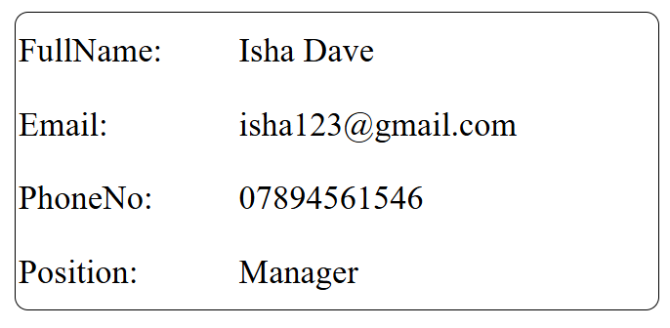

**Set 4.Library Management**

* checkout.blade.php

<form method="POST" action="{{ route('submitCheckout') }}">

@csrf

<table class="table table-bordered table-striped">

<tbody>

<tr>

<th><label for="firstName">First Name:</label></th>

<td><input type="text" name="firstName" class="form-control" required></td>

</tr>

<tr>

<th><label for="email">Email:</label></th>

<td><input type="email" name="email" class="form-control" required></td>

</tr>

<tr>

<th><label for="contact">Contact Number:</label></th>

<td><input type="text" name="contact" class="form-control" required></td>

</tr>

<tr>

<th><label for="position">Position:</label></th>

<td><textarea name="position" class="form-control" rows="3" required></textarea></td>

</tr>

</tbody>

</table>

<div class="text-center">

<button type="submit" class="btn btn-primary">Submit</button>

</div>

</form

* we.php

Route::get('/', [LibraryController::class, 'home'])->name('home');

Route::get('/about', [LibraryController::class, 'about'])->name('about');

Route::get('/shop', [LibraryController::class, 'shop'])->name('shop');

Route::get('/contact', [LibraryController::class, 'contact'])->name('contact');

Route::get('/checkout', [LibraryController::class, 'checkout'])->name('checkout');

Route::post('/checkout', [LibraryController::class, 'submitCheckout'])->name('submitCheckout');

* Library.php

class LibraryController extends Controller

{

public function home()

{

return view('home');

}

public function about()

{

return view('about');

}

public function shop()

{

return view('shop');

}

public function contact()

{

return view('contact');

}

public function checkout()

{

return view('checkout');

}

public function submitCheckout(Request $request)

{

$data = $request->all();

return view('checkout-summary', compact('data'));

}

}

**Set 5: Hotel Booking System**

* Checkout.blade.php

<form method="POST" action="{{ route('submitCheckout') }}">

@csrf

<table class="table table-bordered table-striped">

<tbody>

<tr>

<th><label for="customername">Customer Name:</label></th>

<td><input type="text" name="customername"

class="form-control" required></td>

</tr>

<tr>

<th><label for="email">Email:</label></th>

<td><input type="email" name="email" class="form-control"

required></td>

</tr>

<tr>

<th><label for="checkindate">Check-in Date:</label></th>

<td><input type="text" name="checkindate"

class="form-control" required></td>

</tr>

<tr>

<th><label for="checkoutdate">Check-out Date:</label></th>

<td><input type="text" name="checkoutdate"

class="form-control" required></td>

</tr>

</tbody>

</table>

<div class="text-center">

<button type="submit" class="btn btn-primary">Submit</button>

</div>

</form>

* Web.php

Route::get('/', [BookingController::class, 'home'])->name('home');

Route::get('/about', [BookingController::class, 'about'])->name('about');

Route::get('/contact', [BookingController::class, 'contact'])->name('contact');

Route::get('/checkout', [BookingController::class, 'checkout'])->name('checkout');

Route::post('/checkout', [BookingController::class, 'submitCheckout'])->name('submitCheckout');

* Booking.php

class BookingController extends Controller

{

public function home()

{

return view('home');

}

public function about()

{

return view('about');

}

public function contact()

{

return view('contact');

}

public function checkout()

{

return view('checkout');

}

public function submitCheckout(Request $request)

{

$data = $request->all();

return view('checkout-summary', compact('data'));

}

}

**Set 6: Event Registration System**

* EventRegistration.blade.php

@extends('→ layout.blade.php')

@section('content')

<h1 class="text-center mb-4">Checkout</h1>

<form method="POST" action="{{ route('submitCheckout') }}">

@csrf

<table class="table table-bordered table-striped">

<tbody>

<tr>

<th><label for="participantname">Participant

Name:</label></th>

<td><input type="text" name="participantname"

class="form-control" required></td>

</tr>

<tr>

<th><label for="email">Email:</label></th>

<td><input type="email" name="email" class="form-control"

required></td>

</tr>

<tr>

<th><label for="eventtype">Event Type:</label></th>

<td><input type="text" name="eventtype"

class="form-control" required></td>

</tr>

<tr>

<th><label for="numberofattendees"> Number of

Attendees:</label></th>

<td><input type="text" name="numberofattendees"

class="form-control" required></td>

</tr>

</tbody>

</table>

<div class="text-center">

<button type="submit" class="btn btn-primary">Submit</button>

</div>

</form>

* Web.php

class EventController extends Controller

{

public function home()

{

return view('home');

}

public function about()

{

return view('about');

}

public function contact()

{

return view('contact');

}

public function checkout()

{

return view('checkout');

}

public function submitCheckout(Request $request)

{

$data = $request->all();

return view('checkout-summary', compact('data'));

}

}

* Event.php

Route::get('/', [EventController::class, 'home'])->name('home');

Route::get('/about', [EventController::class, 'about'])->name('about');

Route::get('/contact', [EventController::class, 'contact'])->name('contact');

Route::get('/checkout', [EventController::class, 'checkout'])->name('checkout');

Route::post('/checkout', [EventController::class, 'submitCheckout'])->name('submitCheckout');

**Set 7.Employee Registration Form**

* Registration.blade.php

<form method="POST" action="{{ route('submitCheckout') }}">

@csrf

<table class="table table-bordered table-striped">

<tbody>

<tr>

<th><label for="fullname">Full Name:</label></th>

<td><input type="text" name="fullname" class="form-control" required></td>

</tr>

<tr>

<th><label for="email">Email:</label></th>

<td><input type="email" name="email" class="form-control" required></td>

</tr>

<tr>

<th><label for="phonenumber">Phone Number:</label></th>

<td><input type="email" name="phonenumber" class="form-control" required></td>

</tr>

<tr>

<th><label for="department">Department:</label></th>

<td><input type="text" name="department" class="form-control" required ></td>

</tr>

</tbody>

</table>

<div class="text-center">

<button type="submit" class="btn btn-primary">Submit</button>

</div>

</form>

* Web.php

Route::get('/', [EmployeeController::class, 'home'])->name('home');

Route::get('/about', [EmployeeController::class, 'about'])->name('about');

Route::get('/contact', [EmployeeController::class, 'contact'])->name('contact');

Route::get('/checkout', [EmployeeController::class, 'checkout'])->name('checkout');

Route::post('/checkout', [EmployeeController::class, 'submitCheckout'])->name('submitCheckout');

* Employee.php

class EmployeeController extends Controller

{

public function home()

{

return view('home');

}

public function about()

{

return view('about');

}

public function contact()

{

return view('contact');

}

public function checkout()

{

return view('checkout');

}

public function submitCheckout(Request $request)

{

$data = $request->all();

return view('checkout-summary', compact('data'));

}

}

**8.Online Course Enrollment**

* OnlineCourseRegistration.blade.php
* <form method="POST" action="{{ route('submitCheckout') }}">
* @csrf
* <table class="table table-bordered table-striped">
* <tbody>
* <tr>
* <th><label for="StudentName">Student Name:</label></th>
* <td><input type="text" name="StudentName" class="form-control" required></td>
* </tr>
* <tr>
* <th><label for="email">Email:</label></th>
* <td><input type="email" name="email" class="form-control" required></td>
* </tr>
* <tr>
* <th><label for="coursename">Course Name:</label></th>
* <td><input type="text" name="coursename" class="form-control" required></td>
* </tr>
* <tr>
* <th><label for="duration">Duration(in month):</label></th>
* <td><input type="text" name="duration" class="form-control" rows="3" required></td>
* </tr>

* </tbody>
* </table>
* <div class="text-center">
* <button type="submit" class="btn btn-primary">Submit</button>
* </div>
* </form>
* Web.php

Route::get('/', [CourseController::class, 'home'])->name('home');

Route::get('/about', [CourseController::class, 'about'])->name('about');

Route::get('/shop', [CourseController::class, 'shop'])->name('shop');

Route::get('/contact', [CourseController::class, 'contact'])->name('contact');

Route::get('/checkout', [CourseController::class, 'checkout'])->name('checkout');

Route::post('/checkout', [CourseController::class, 'submitCheckout'])->name('submitCheckout');

* OnlineCourse.php
* class CourseController extends Controller
* {
* public function home()
* {

return view('home');

* }
* public function about()
* {
* return view('about');
* }
* public function shop()
* {
* return view('shop');
* }
* public function contact()
* {
* return view('contact');
* }
* public function checkout()
* {
* return view('checkout');
* }
* public function submitCheckout(Request $request)
* {
* $data = $request->all();
* return view('checkout-summary', compact('data'));
* }
* }

**9.Customer Feedback Form**

* CustomerFeedback.blade.php
* <form method="POST" action="{{ route('submitCheckout') }}">
* @csrf
* <table class="table table-bordered table-striped">
* <tbody>
* <tr>
* <th><label for="customerName">Cuestomer Name:</label></th>
* <td><input type="text" name="customerName" class="form-control" required></td>
* </tr>
* <tr>
* <th><label for="email">Email:</label></th>
* <td><input type="email" name="email" class="form-control" required></td>
* </tr>
* <tr>
* <td><label for="rating">Rating (1-5):</label></td>
* <td>
* <select id="rating" name="rating" required>
* <option value="1">1</option>
* <option value="2">2</option>
* <option value="3">3</option>
* <option value="4">4</option>
* <option value="5">5</option>
* </select>
* </td>
* </tr>
* <tr>
* <th><label for="comments">Comments:</label></th>
* <td><textarea name="comments" class="form-control" rows="3" required></textarea></td>
* </tr>

* </tbody>
* </table>
* <div class="text-center">
* <button type="submit" class="btn btn-primary">Submit</button>
* </div>
* </form>
* Web.php

use App\Http\Controllers\FeedbackController;

Route::get('/', [FeedbackController::class, 'home'])->name('home');

Route::get('/about', [FeedbackController::class, 'about'])->name('about');

Route::get('/shop', [FeedbackController::class, 'shop'])->name('shop');

Route::get('/contact', [FeedbackController::class, 'contact'])->name('contact');

Route::get('/checkout', [FeedbackController::class, 'checkout'])->name('checkout');

Route::post('/checkout', [FeedbackController::class, 'submitCheckout'])->name('submitCheckout');

* Feedback.php
* class FeedbackController extends Controller
* {
* public function home()
* {
* return view('home');
* }
* public function about()
* {
* return view('about');
* }
* public function shop()
* {
* return view('shop');
* }
* public function contact()
* {
* return view('contact');
* }
* public function checkout()
* {
* return view('checkout');
* }
* public function submitCheckout(Request $request)
* {
* $data = $request->all();
* return view('checkout-summary', compact('data'));
* }
* }

**10.Bus Ticket Booking System**

* TicketBooking.blade.php
* <form method="POST" action="{{ route('submitCheckout') }}">
* @csrf
* <table class="table table-bordered table-striped">
* <tbody>
* <tr>
* <th><label for="passangerName">Passenger Name:</label></th>
* <td><input type="text" name="passangerName" class="form-control" required></td>
* </tr>
* <tr>
* <th><label for="email">Email:</label></th>
* <td><input type="email" name="email" class="form-control" required></td>
* </tr>
* <tr>
* <th><label for="source">Source:</label></th>
* <td><input type="text" name="source" class="form-control" required></td>
* </tr>
* <tr>
* <th><label for="destination">Destination:</label></th>
* <td><input type="text" name="destination" class="form-control" required></td>
* </tr>
* <tr>
* <th><label for="date">Traveldate:</label></th>
* <td><input type="text" name="date" class="form-control" required></td>
* </tr>

* </tbody>
* </table>
* <div class="text-center">
* <button type="submit" class="btn btn-primary">Submit</button>
* </div>
* </form>
* Web.php

Route::get('/', [TicketController::class, 'home'])->name('home');

Route::get('/about', [TicketController::class, 'about'])->name('about');

Route::get('/shop', [TicketController::class, 'shop'])->name('shop');

Route::get('/contact', [TicketController::class, 'contact'])->name('contact');

Route::get('/checkout', [TicketController::class, 'checkout'])->name('checkout');

Route::post('/checkout', [TicketController::class, 'submitCheckout'])->name('submitCheckout');

* BusTicket.php
* class TicketController extends Controller
* {
* public function home()
* {
* return view('home');
* }
* public function about()
* {
* return view('about');
* }
* public function shop()
* {
* return view('shop');
* }
* public function contact()
* {
* return view('contact');
* }
* public function checkout()
* {
* return view('checkout');
* }
* public function submitCheckout(Request $request)
* {
* $data = $request->all();
* return view('checkout-summary', compact('data'));
* }
* }

**Set 11: Medical Appointment System**

* AppointmentForm.blade.php

<link rel="stylesheet" href="css/style.css">

    <script>

        // Function to set the minimum date to today

        function setMinDate() {

            const today = new Date();

            const dd = String(today.getDate()).padStart(2, '0');

            const mm = String(today.getMonth() + 1).padStart(2, '0'); // January is 0!

            const yyyy = today.getFullYear();

            const formattedDate = yyyy + '-' + mm + '-' + dd; // Format: YYYY-MM-DD

            document.getElementById("AppointmentDate").setAttribute("min", formattedDate);

        }

        // Call the function when the page loads

        window.onload = setMinDate;

    </script>

* Web.php

use App\Http\Controllers\Appointment;

// Route::get('/', function () {

// return view('welcome');

// });

Route::get('/',[Appointment::class,'index']);

Route::get('/registration',[Appointment::class,'AppointmentForm']);

Route::get('/show',[Appointment::class,'show']);

Route::post('/registration',[Appointment::class,'submit']);

* Appointment.php

public function index(){

return view('/welcome');

}

public function AppointmentForm(){

return view('/AppointmentForm');

}

public function show(){

return view('/show');

}

public function submit(Request $request){

$data = $request -> all();

return view ('/show',compact('data'));

}

**Set 12:** **Car Rental System**

* CarBookingForm.blade.php

<form method="post" action="/registration" >

@csrf

<table>

<tr>

<td>Customer Name : </td>

<td>

<input type="text" name="CustomerName:" required>

</td>

</tr>

<tr>

<td>Email : </td>

<td>

<input type="email" name="Email:" required>

</td>

</tr>

<tr>

<td>Car Model : </td>

<td>

<input type="tel" name="CarModel:" required>

</td>

</tr>

<tr>

<td>Rental Duration : </td>

<td>

<input type="number" name="RentalDuration:" min="1" required>

</td>

</tr>

</table>

<nav>

<button type="submit" >Submit</button>

</nav>

</form>

* Web.php

use App\Http\Controllers\CarRental;

Route::get('/',[CarRental::class,'index']);

Route::get('/registration',[CarRental::class,'CarBookingForm']);

Route::get('/show',[CarRental::class,'show']);

Route::post('/registration',[CarRental::class,'submit']);

* CarRental.php

public function index(){

return view('/welcome');

}

public function CarBookingForm(){

return view('/CarBookingForm');

}

public function show(){

return view('/show');

}

public function submit(Request $request){

$data = $request -> all();

return view ('/show',compact('data'));

}

}

**Set 13:** **Restaurant Table** **Reservation**

* TableBookingForm.blade.php

<form method="post" action="/registration" >

@csrf

<table>

<tr>

<td>Customer Name : </td>

<td>

<input type="text" name="CustomerName:" required>

</td>

</tr>

<tr>

<td>Email : </td>

<td>

<input type="email" name="Email:" required>

</td>

</tr>

<tr>

<td>Number Of Guests : </td>

<td>

<input type="number" name="NoOfGuest:" min="1" required>

</td>

</tr>

<tr>

<td>Resarvation Date : </td>

<td>

<input type="date" name="ResarvationDate:" required>

</td>

</tr>

</table>

<nav>

<button type="submit" >Submit</button>

</nav>

</form>

* Web.php

use App\Http\Controllers\Resarvation;

Route::get('/',[Resarvation::class,'index']);

Route::get('/registration',[Resarvation::class,'TableBookingForm']);

Route::get('/show',[Resarvation::class,'show']);

Route::post('/registration',[Resarvation::class,'submit']);

* Resarvation.php

public function index(){

return view('/welcome');

}

public function TableBookingForm(){

return view('/TableBookingForm');

}

public function show(){

return view('/show');

}

public function submit(Request $request){

$data = $request -> all();

return view ('/show',compact('data'));

}

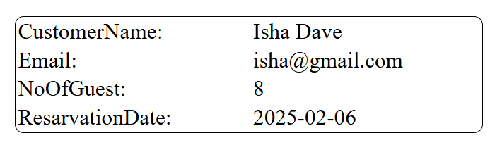

**Set 14:** **Gym Membership Registration**

* Membershipform.blade.php

<form method="post" action="/registration" >

@csrf

<table>

<tr>

<td>Full Name : </td>

<td>

<input type="text" name="FullName:" required>

</td>

</tr>

<tr>

<td>Email : </td>

<td>

<input type="email" name="Email:" required>

</td>

</tr>

<tr>

<td>Membership Type : </td>

<td>

<select name="MembershipType:">

<option>Basic</option>

<option>Premium</option>

<option>VIP</option>

</select>

</td>

</tr>

<tr>

<td>Duration: </td>

<td>

<input type="number" name="Duration:" min="1" required>

</td>

</tr>

</table>

<nav>

<button type="submit" >Submit</button>

</nav>

</form>

* Web.php

use App\Http\Controllers\gym;

Route::get('/',[gym::class,'index']);

Route::get('/registration',[gym::class,'MembershipForm']);

Route::get('/show',[gym::class,'show']);

Route::post('/registration',[gym::class,'submit']);

* Gym.php

public function index(){

return view('/welcome');

}

public function MembershipForm(){

return view('/MembershipForm');

}

public function show(){

return view('/show');

}

public function submit(Request $request){

$data = $request -> all();

return view ('/show',compact('data'));

}

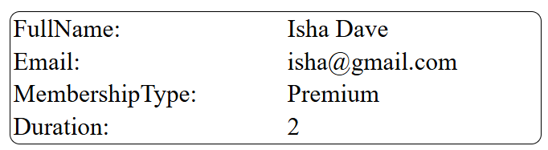

**Set 15:** **Electricity Bill Payment System**

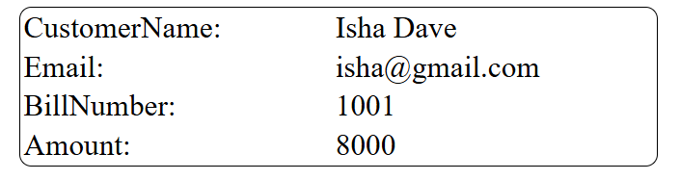

* BillPaymentForm.blade.php

<form method="post" action="/registration" >

@csrf

<table>

<tr>

<td>Customer Name : </td>

<td>

<input type="text" name="CustomerName:" required>

</td>

</tr>

<tr>

<td>Email : </td>

<td>

<input type="email" name="Email:" required>

</td>

</tr>

<tr>

<td>Bill Number : </td>

<td>

<input type="text" name="BillNumber:" required>

</td>

</tr>

<tr>

<td>Amount: </td>

<td>

<input type="number" name="Amount:" step="0.01" required>

</td>

</tr>

</table>

<nav>

<button type="submit" >Submit</button>

</nav>

</form>

* Web.php

use App\Http\Controllers\Bill;

Route::get('/',[Bill::class,'index']);

Route::get('/registration',[Bill::class,'BillPaymentForm']);

Route::get('/show',[Bill::class,'show']);

Route::post('/registration',[Bill::class,'submit']);

* Bill.php

public function index(){

return view('/welcome');

}

public function BillPaymentForm(){

return view('/BillPaymentForm');

}

public function show(){

return view('/show');

}

public function submit(Request $request){

$data = $request -> all();

return view ('/show',compact('data'));

}

**Set 16: College Admission Form**

* AdmissionForm.blade.php

<form method="post" action="/registration" >

@csrf

<table>

<tr>

<td>Student Name : </td>

<td>

<input type="text" name="StudentName:" required>

</td>

</tr>

<tr>

<td>Email : </td>

<td>

<input type="email" name="Email:" required>

</td>

</tr>

<tr>

<td>Course Name : </td>

<td>

<select name="Course Name:">

<option>Msc IT</option>

<option>MCA</option>

<option>BCA</option>

<option>Bsc IT</option>

<option>MBA</option>

<option>BBA</option>

<option>IMBA</option>

</select>

</td>

</tr>

<tr>

<td>Privious Qualification: </td>

<td>

<input type="text" name="PreQua:" required>

</td>

</tr>

</table>

<nav>

<button type="submit" >Submit</button>

</nav>

</form>

* Web.php

use App\Http\Controllers\Admission;

Route::get('/',[Admission::class,'index']);

Route::get('/registration',[Admission::class,'AdmissionForm']);

Route::get('/show',[Admission::class,'show']);

Route::post('/registration',[Admission::class,'submit']);

* Admission.php

public function index(){

return view('/welcome');

}

public function AdmissionForm(){

return view('/AdmissionForm');

}

public function show(){

return view('/show');

}

public function submit(Request $request){

$data = $request -> all();

return view ('/show',compact('data'));

}

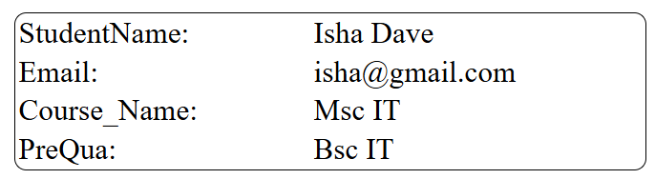

**Set 17: Travel Package Booking**

* PackageBookingForm.blade.php

<link rel="stylesheet" href="css/style.css">

<script>

// Function to set the minimum date to today

function setMinDate() {

const today = new Date();

const dd = String(today.getDate()).padStart(2, '0');

const mm = String(today.getMonth() + 1).padStart(2, '0'); // January is 0!

const yyyy = today.getFullYear();

const formattedDate = yyyy + '-' + mm + '-' + dd; // Format: YYYY-MM-DD

document.getElementById("TravelDate").setAttribute("min", formattedDate);

}

// Call the function when the page loads

window.onload = setMinDate;

</script>

</head>

<body>

<form method="post" action="/registration" >

@csrf

<table>

<tr>

<td>Traveller Name : </td>

<td>

<input type="text" name="TravellerName:" required>

</td>

</tr>

<tr>

<td>Email : </td>

<td>

<input type="email" name="Email:" required>

</td>

</tr>

<tr>

<td>Destination : </td>

<td><input type="text" name="Destination:" required></td>

</tr>

<tr>

<td>Travel Date: </td>

<td>

<input type="date" name="TravelDate:" required>

</td>

</tr>

</table>

<nav>

<button type="submit" >Submit</button>

</nav>

</form>

</body>

* Web.php

use App\Http\Controllers\Travel;

Route::get('/',[Travel::class,'index']);

Route::get('/registration',[Travel::class,'PackageBookingForm']);

Route::get('/show',[Travel::class,'show']);

Route::post('/registration',[Travel::class,'submit']);

* Travel.php

public function index(){

return view('/welcome');

}

public function PackageBookingForm(){

return view('/PackageBookingForm');

}

public function show(){

return view('/show');

}

public function submit(Request $request){

$data = $request -> all();

return view ('/show',compact('data'));

}

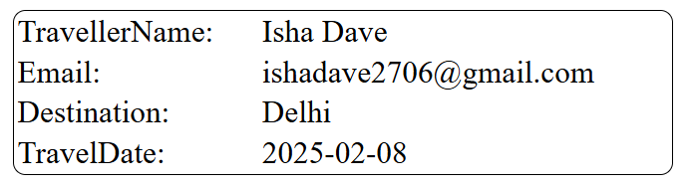

**Set 18: Water Supply Connection Request**

* ConnectionReqquestForm.blade.php

<form method="post" action="/registration" >

@csrf

<table>

<tr>

<td>Customer Name : </td>

<td>

<input type="text" name="CustomerName:" required>

</td>

</tr>

<tr>

<td>Email : </td>

<td>

<input type="email" name="Email:" required>

</td>

</tr>

<tr>

<td>Address : </td>

<td><textarea name="Address" max=225></textarea></td>

</tr>

<tr>

<td>Connection Type: </td>

<td>

<input type="text" name="ConnectionType:" required>

</td>

</tr>

</table>

<nav>

<button type="submit" >Submit</button>

</nav>

</form>

* Web.php

use App\Http\Controllers\WaterSupply;

Route::get('/',[WaterSupply::class,'index']);

Route::get('/registration',[WaterSupply::class,'ConnectionRequestForm']);

Route::get('/show',[WaterSupply::class,'show']);

Route::post('/registration',[WaterSupply::class,'submit']);

* WaterSupply.php

public function index(){

return view('/welcome');

}

public function ConnectionRequestForm(){

return view('/ConnectionRequestForm');

}

public function show(){

return view('/show');

}

public function submit(Request $request){

$data = $request -> all();

return view ('/show',compact('data'));

}

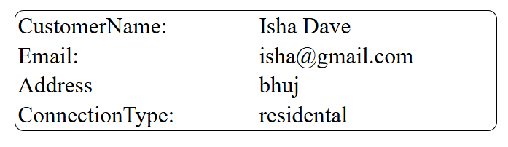

**Set 19: Insurance Policy Registration**

* policyRegistrationForm.blade.php

<form method="post" action="/registration" >

@csrf

<table>

<tr>

<td>Customer Name : </td>

<td>

<input type="text" name="CustomerName:" required>

</td>

</tr>

<tr>

<td>Email : </td>

<td>

<input type="email" name="Email:" required>

</td>

</tr>

<tr>

<td>Pplicy Type : </td>

<td><select name="Policytype:">

<option>Life Insurance</option>

<option>Health Insurance</option>

<option>Car Insurance</option>

<option>Home Insurance</option>

</select>

</td>

</tr>

<tr>

<td>Premium Amount: </td>

<td>

<input type="number" name="PrimiumAmount:" min="1" required>

</td>

</tr>

</table>

<nav>

<button type="submit" >Submit</button>

</nav>

</form>

* web.php

use App\Http\Controllers\Insurance;

Route::get('/',[Insurance::class,'index']);

Route::get('/registration',[Insurance::class,'PolicyRegistrationForm']);

Route::get('/show',[Insurance::class,'show']);

Route::post('/registration',[Insurance::class,'submit']);

* Insurance.php

public function index(){

return view('/welcome');

}

public function PolicyRegistrationForm(){

return view('/PolicyRegistrationForm');

}

public function show(){

return view('/show');

}

public function submit(Request $request){

$data = $request -> all();

return view ('/show',compact('data'));

}

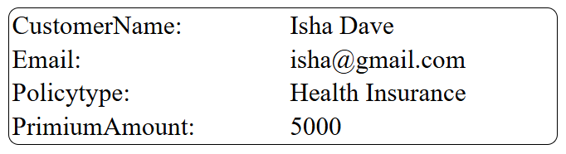

**Set 20: Movie Ticket Booking System**

>>form

@extends('→ layout.blade.php')

@section('content')

<h1 class="text-center mb-4"> Movie Ticket Booking System Form</h1>

<form method="POST" action="{{ route('submitCheckout') }}">

@csrf

<table class="table table-bordered table-striped">

<tbody>

<tr>

<th><label for="customername">Customer Name:</label></th>

<td><input type="text" name="customername" class="form-control" required></td>

</tr>

<tr>

<th><label for="email">Email:</label></th>

<td><input type="email" name="email" class="form-control" required></td>

</tr>

<tr>

<th><label for="moviename">Movie Name:</label></th>

<td><input type="email" name="moviename" class="form-control" required></td>

</tr>

<tr>

<th><label for="ticket">Number Of Tickets:</label></th>

<td><input type="number" name="ticket" class="form-control" required min="1" ></td>

</tr>

</tbody>

</table>

<div class="text-center">

<button type="submit" class="btn btn-primary">Submit</button>

</div>

</form>

@endsection

>>controller

<?php

namespace App\Http\Controllers;

use Illuminate\Http\Request;

class MovieController extends Controller

{

public function home()

{

return view('home');

}

public function about()

{

return view('about');

}

public function contact()

{

return view('contact');

}

public function checkout()

{

return view('checkout');

}

public function submitCheckout(Request $request)

{

$data = $request->all();

return view('checkout-summary', compact('data'));

}

}

>>→web.php

<?php

use Illuminate\Support\Facades\Route;

use App\Http\Controllers\MovieController;

Route::get('/', [MovieController::class, 'home'])->name('home');

Route::get('/about', [MovieController::class, 'about'])->name('about');

Route::get('/contact', [MovieController::class, 'contact'])->name('contact');

Route::get('/checkout', [MovieController::class, 'checkout'])->name('checkout');

Route::post('/checkout', [MovieController::class, 'submitCheckout'])->name('submitCheckout');