**Feynn lab : Solo Project**

**Name : Isha Mistry**

**Project Idea : Handwritten Equation Solver Using CNN**

**Github Link :<https://github.com/IsHa0211/Handwritten-equation-solver-using-cnn>**

**1.Problem statement**

🡪 Handwritten mathematical expression recognition is still a most challenging job to do in the area of computer vision. Due to the two dimensional nesting assembly and different sizes, the correction rate of symbol segmentation and recognition still cannot achieve its actual requirements.

**🡪**The primary task for the recognition of mathematical expression is to segment the character and then classify those characters. Convolutional neural network (CNN) is one of the mostly used classification model in computer vision area.

🡪To solve this problem we apply Convolutional neural network which doesn‟t required any predefined feature for classification of specific character. We use smallest number of hidden layer in order to reduce the training time with tolerable error rate.

**2.Assessment**

🡪Using CNN to create a robust handwritten equation solver is a difficult task in image processing. One of the most difficult challenges in computer vision research is handwritten mathematical expression recognition. The work is made more difficult by the fact that certain characters are segmented and classified. a collection ofquadratic equations created by hand This study looks at quadratic equations as well as a single quadratic equation. These equations must be recognised and solved.Horizontal compactprojectionanalysis is used for segmentation. We use both connected component analysis and integrated connected component analysis methodologies. ConvolutionalNeuralNetworks Characters are classified using a network. Each appropriate is required for the solution ofthe problem. Character string operationis used for detection. Finally, the results of the experiment show that the strategy we've described is quite effective. The goal of this project is to create a handwritten alphabet. Equation solver capable of dealing with a wide range of mathematical equations.

**3.Target Specifications and Characterization**

🡪Convolutional layer, pooling layer, completely connected input layer, fully connected layer, and fully connected

🡪Output layer are all layers in the CNN design.

**1. Convolutional layer**: The backbone of any CNN working model is the convolutional layer. This layer is where the images are scanned pixel by pixel and a feature map is created to define future classifications.

**2. Layer for pooling:** Pooling is also known as data down sampling, in which the total dimensions of the photos are reduced. Each feature's information from each convolutional layer is condensed to only include the most essential data. The creation of convolutional layers and the use of pooling is a continuous process that may require multiple iterations.

**3. Fully connected input layer:** The flattening of the images is also known as the fully linked input layer. The

previous layer's outputs are flattened into a single vector.

**4. Fully connected layer:** When it's time to compute after the feature analysis, this layer applies random weights to the inputs andpredicts a suitable label. Fully connected

**5. Output layer:** The CNN model's final layer stores the results of the labels determined for classification and assigns a class to the images.

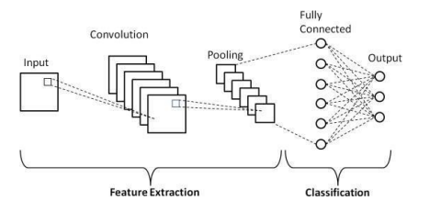

**4.Applicable Patents**

**4.1 Methodologies Explanation:** First, noise from the original input image is reduced using our proposed method by binarizing it. Then, from the input image, we utilize compact horizontal projection to segment each line of equation. Then, for subsequent processing, we treat each segment of thesegmented image as a full image. We then look for certain characteristics in the form of related components for each line of equation image. After that, each segmented character is fed into a convolutional neural network model for character categorization. The resulting character, which is CNN's output, is then utilized to create a character string that looks like the original equation.

**4.2 Dataset preparation** The preparation of the dataset is the most important aspect of this project. The borders of characters like the English numeral, alphabet, and mathematical symbol can all be accurately defined. As a result, we begin by preparing the dataset with the highest priority given to its edges, i.e., illumine the edges. We created our own datasets and used a modified version of the NIST dataset for digits, which is similar to the popular MINIST dataset. For the training of the network, we use 2000 data items for each category. And in the majority of cases, our network training was accurate to the tune of 98.5 percent. We used a 32x32 grey level image in our dataset.

**4.3 Pre-processing** The procedure of changing and modifying the input image to make it suitable for recognition is known as preprocessing. Image enhancing techniques include the ones listed below.

1) Conversion of RGB to Gray-Scale Because character detection on a colored image is more difficultthanona grayscale image, this colored image is first turned into a conventional gray-scale image and represented through a single matrix. If the grey bitmap is Y and the color bitmaps areR, G, andB,the formula is Y = 0.299R + 0.587G+0.114B.

2) Binarization Binarization is the process of converting pixel data into 0s and 1s by selecting a threshold value. In this study, 1s indicate black pixels and 0s represent white pixels in the horizontal projection computation. Binarization thresholds can be approved in two ways: overall threshold and partial threshold. Otsu's method is based on picture statistical properties and is 11 an overall threshold method. This strategy allows the computer to choose a threshold on its own.

3) Noise Reduction Noise refers to the presence of too many pixels in an image. Salt and pepper noise and Gaussian noise are two types of noise. Low pass filtering is used to remove Gaussian noise from the image, and Salt and Pepper noise does not need to be filtered because it is relatively low in comparison to Gaussian noise. For the sake of simplicity, we deleted all components that are less than 5 pixels in our proposed solution.

**4.4 Segmentation** Image processing and computer vision applications frequently use segmentation to identify objects or other key information in digital images. Which is the division of one image into several parts. In our proposed method, segmentation is divided into two parts.

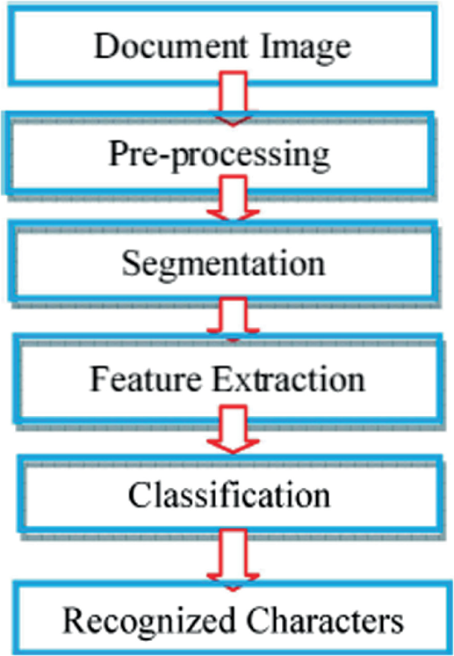

**5.Concept Generation**

🡪Arithmetic is utilized in basically every part of science, including physical science, designing, medication, and financial aspects. The investigation and perception of advanced archives is a critical scholastic subject today. OCR (optical person acknowledgment) can give further developed acknowledgment precision to English characters and digits in electronic books. In the field of PC vision, transcribed numerical articulation acknowledgment stays a troublesome assignment. Convolutional Neural Network (CNN) inclining has exhibited brilliant execution in the fields of picture grouping, AI, and normal language handling lately.

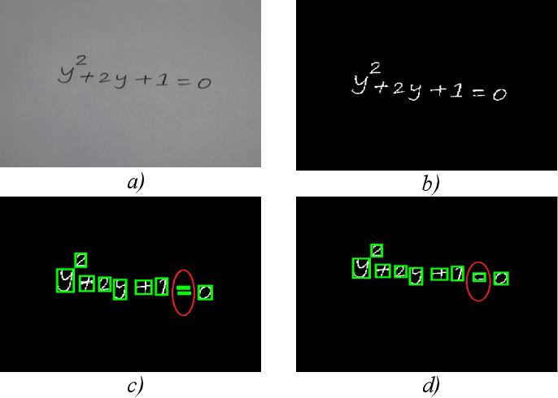

**6.Concept Development**

1. To build a user interface for entering the object image that is straightforward to use.

2. The system should be able to process the mathematical expression in advance.

3. The system should be able to recognize text in the image as well as mathematical symbols.

4. The system should extract text from the image and display the mathematical expression's solution.

5. The primary goal is to learn how to create a CNN model for Mathematical Expression.

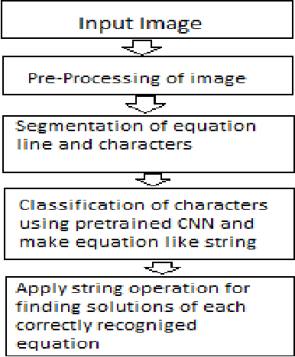

**7.Applicable Regulations**

🡪Many various papers can be found on handwritten character segmentation. Some scheme is also working on mathematical expressions recognition “MER”. Like “Using SVM and projection histogram identification of ME”. Some are for offline printed mathematical expressions and recognition mentioned by Zanibbi et. al. (2002), “Recognition of printed mathematical symbols”, “Using SVM Mathematical symbols identification”, “Recognition of online mathematical symbols using template matching distance”, “Offline Handwritten Mathematical symbols recognition using character geometry”.

🡪An Application for Automated Recognition and Processing of Handwritten Mathematical Equations(2018).

**8.Final Product Prototype (abstract) with Schematic Diagram**

* **ABSTRACT**

Robust handwritten character recognition is a tricky job in the area of image processing. Among all the problem handwritten mathematical expression recognition is one of the complicated issue in the area of computer vision research. Segmentation and classification of specific character makes the task more difficult. In this paper a group of handwritten quadratic equation as well as a single quadratic equation are considered to recognize and make a solution for those equation. Horizontal compact projection analysis and combined connected component analysis methods are used for segmentation. For classification of specific character we apply Convolutional Neural Network. Each of the correct detection, character string operation is used for the solution of the equation. Finally the experimental results shows the great effectiveness of our proposed system.

* **Schematic Diagram :**

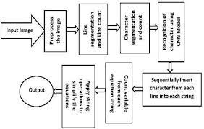

**9.Product details**

**🡪How does it work?**

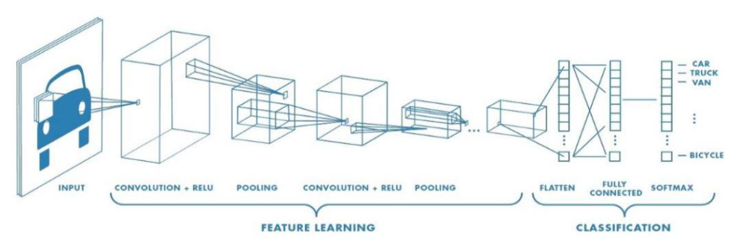

**10.Code Implementation/Validation**

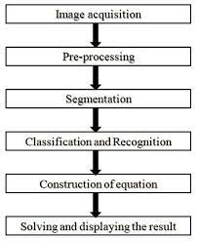

**Github Link :<https://github.com/IsHa0211/Handwritten-equation-solver-using-cnn>**

**11.Conclusion**

🡪The focal point of this review was on perceiving manually written numerical quadratics. For acknowledgment, we think about single quadratics just as series of quadratics. Examine projections Each line of quadratics is fragmented utilizing a particular minimized flat projection. For character division, an associated part with a high achievement rate is utilized. For image acknowledgment like '=,' which is a solitary image blended in with two separate associated parts,a further developed form of associated part is used. The most troublesome part of arrangement is highlight extraction. Besides, penmanship is more diligently to recognize on the grounds that to a few preset highlights. After effectively perceiving quadratics in any mix, we process the found condition to get the quadratics' answer. We usea string activity way to deal with get the worth of a, b, and c of every quadratic of the structure ay2+by+c=0 in this segment. At long last, we accomplished best in class execution in both the discovery and arrangement stages.

**12.References**

1. Chuangxia, H.; Liu, B. New studies on dynamic analysis of inertial neural networks involving nonreduced order method. Neurocomputing 2019, 325, 283– 287.

2. Alvear-Sandoval, R.; Figueiras-Vidal, A. On building ensembles of stacked denoising autoencoding classifiers and their further improvement. Inf. Fusion 2018, 39, 41–52.

3. Cai, Z.W.; Li-Hong, H. Finite-time synchronization by switching state-feedback control for discontinuous Cohen– Grossberg neural networks with mixed delays. Int. J. Mach. Learn. Cybern. 2018, 9, 1683– 1695.

4. Zeng, D.; Dai, Y.; Li, F.; Sherratt, R.S.; Wang, J. Adversarial learning for distant supervised relation extraction. Comput. Mater. Contin. 2018, 55, 121– 136.

5. Xiang, L.; Li, Y.; Hao, W.; Yang, P.; Shen, X. Reversible natural language watermarking using synonym substitution and arithmetic coding. Comput. Mater. Contin. 2018, 55, 541– 559.