Network Devices:

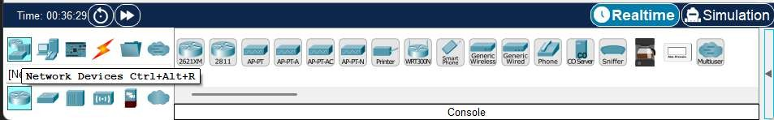

Demonstrate How to simulate it:

Step-1:- Take One Networking Device (Router):



Step-2 :- Take Network End Point (Computer):



Step – 3 :- Take Switches to Connected The End Points with Each Other



Step – 4 :- Connect all the Computers with each other using switch and connect Switch Router

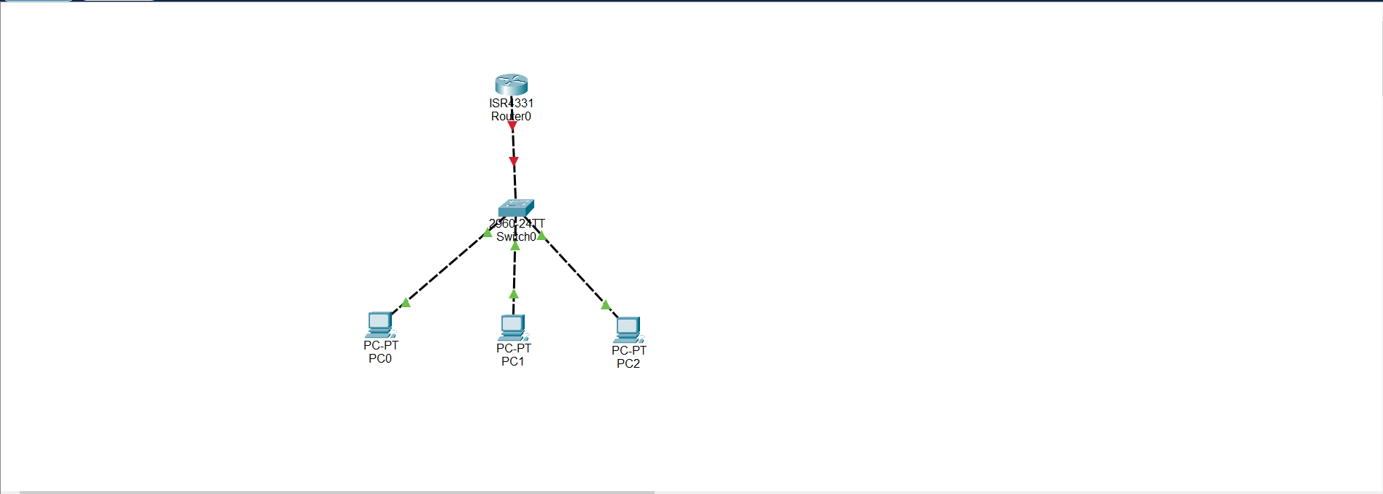

**Conclusion:-**

By Performing this Experiment , I came to Know How to Simulate and Visualize any network on Cisco Packet Tracer , and I explored Some of the basic functionalities and basic networking devices. And came to know how to connect networking devices with each other.