**Step-1:** Open Cisco Packet Tracer and take two routers, two switches, and four PCs.

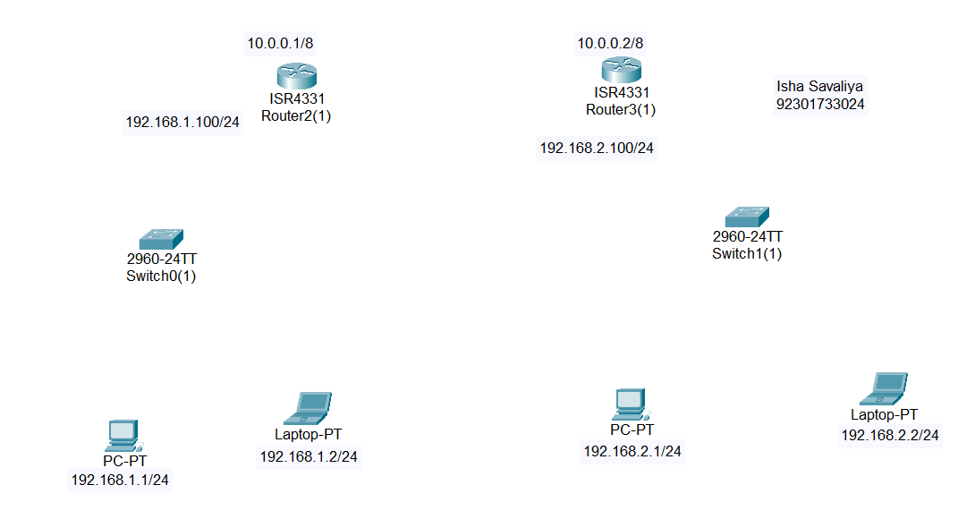

**Step-2:** For the serial port, turn off the router, drag and drop the NIM-2T module, and then turn the router back on.

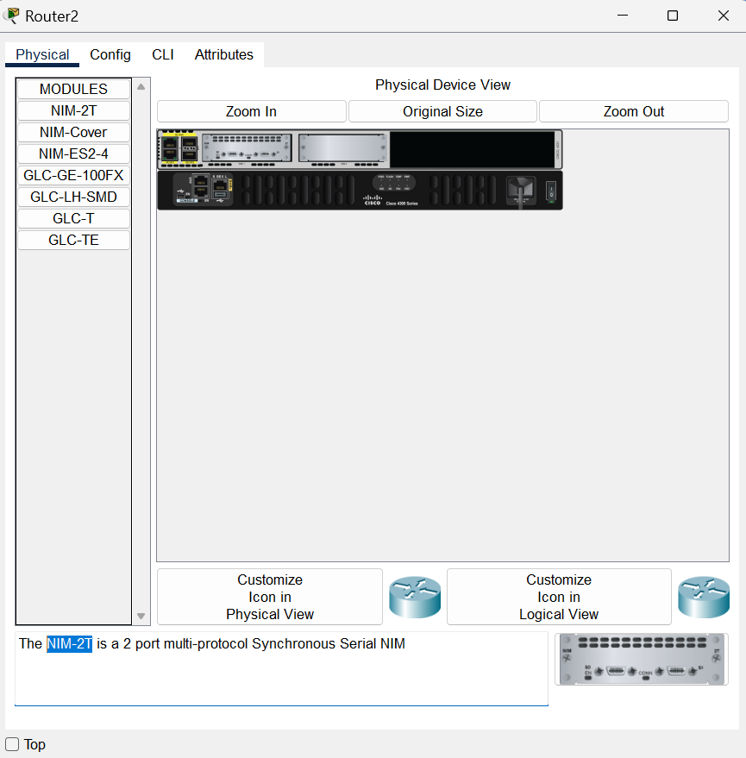

**Step-3:** Connect the two routers using a Serial DTE cable.  
 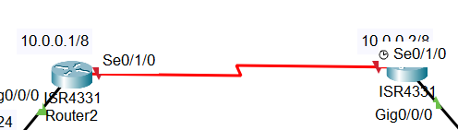

**Step-4:** Connect the switches with the routers using Copper Straight-Through cables in the GigabitEthernet ports. Also, connect the PCs with the switches using Copper Straight-Through cables.

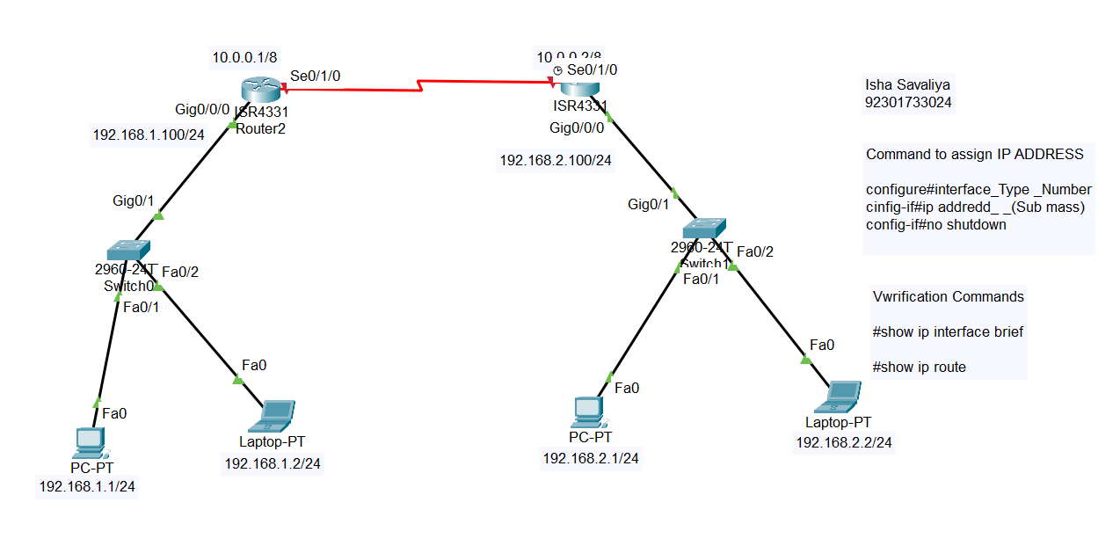

**Step-5:-**  Assign IP addresses and subnet masks to all PCs.

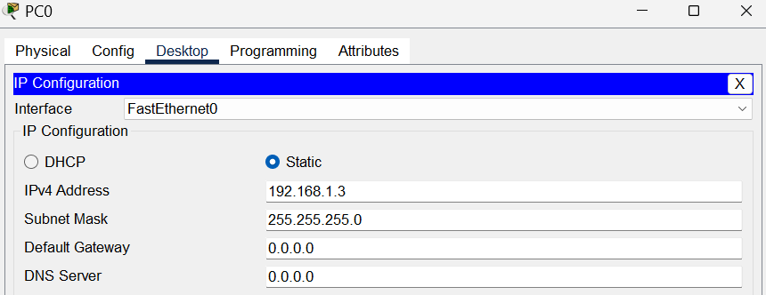

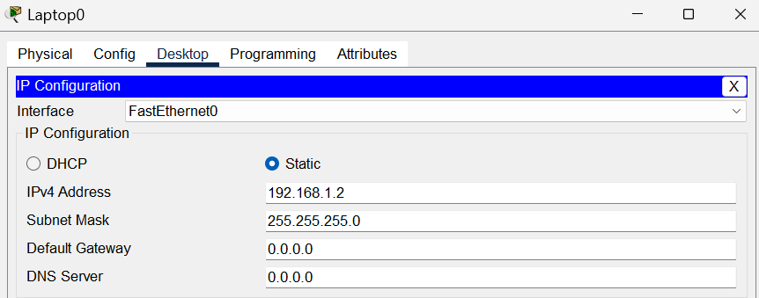

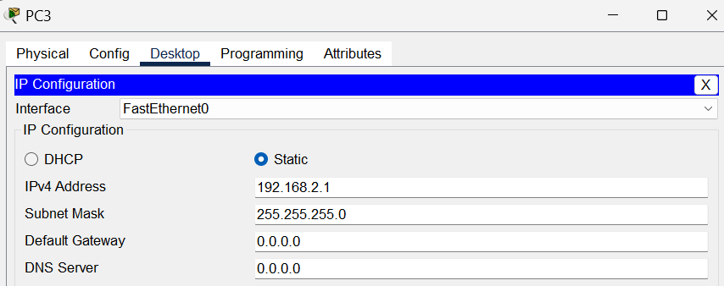

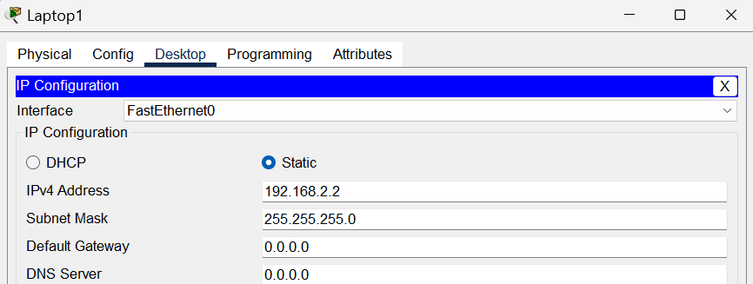

**Step-6:** Go to the Router CLI and assign IP addresses to the router interfaces.

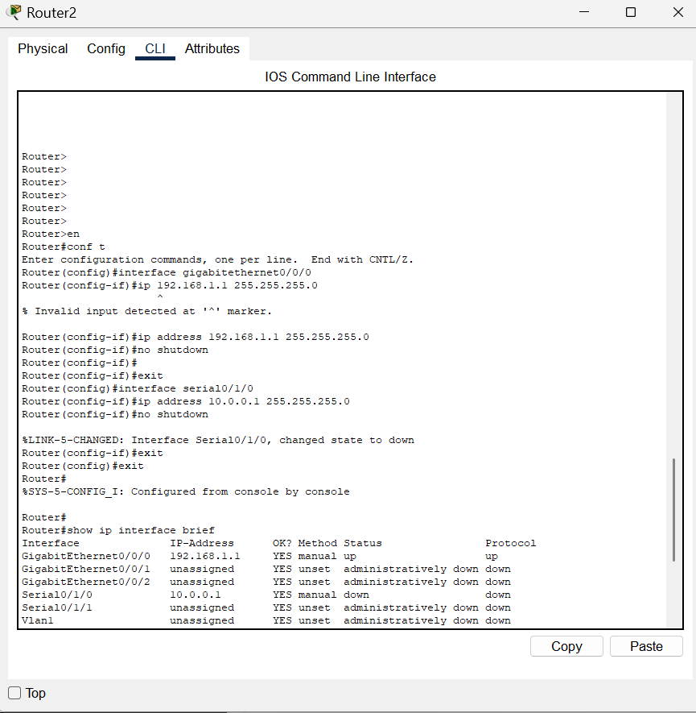

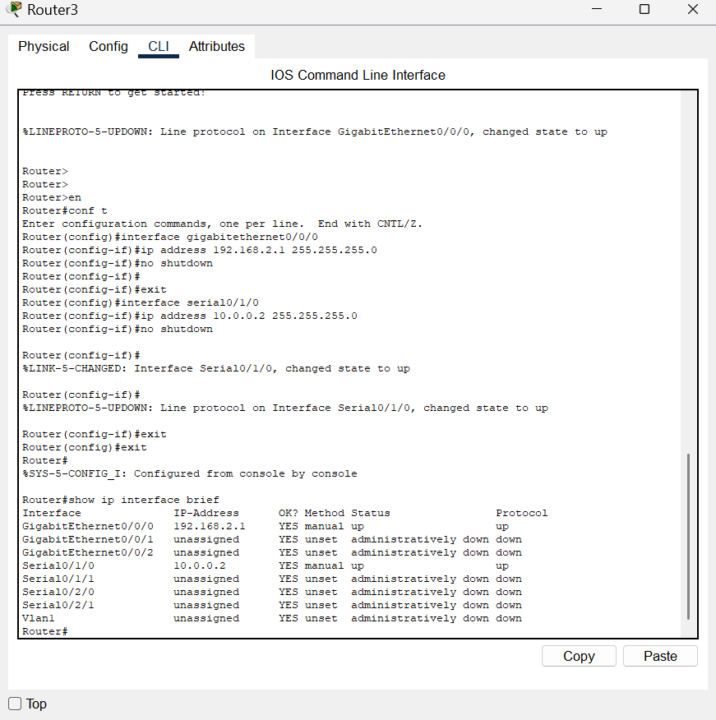

**Step -7:-** Check the network connectivity.

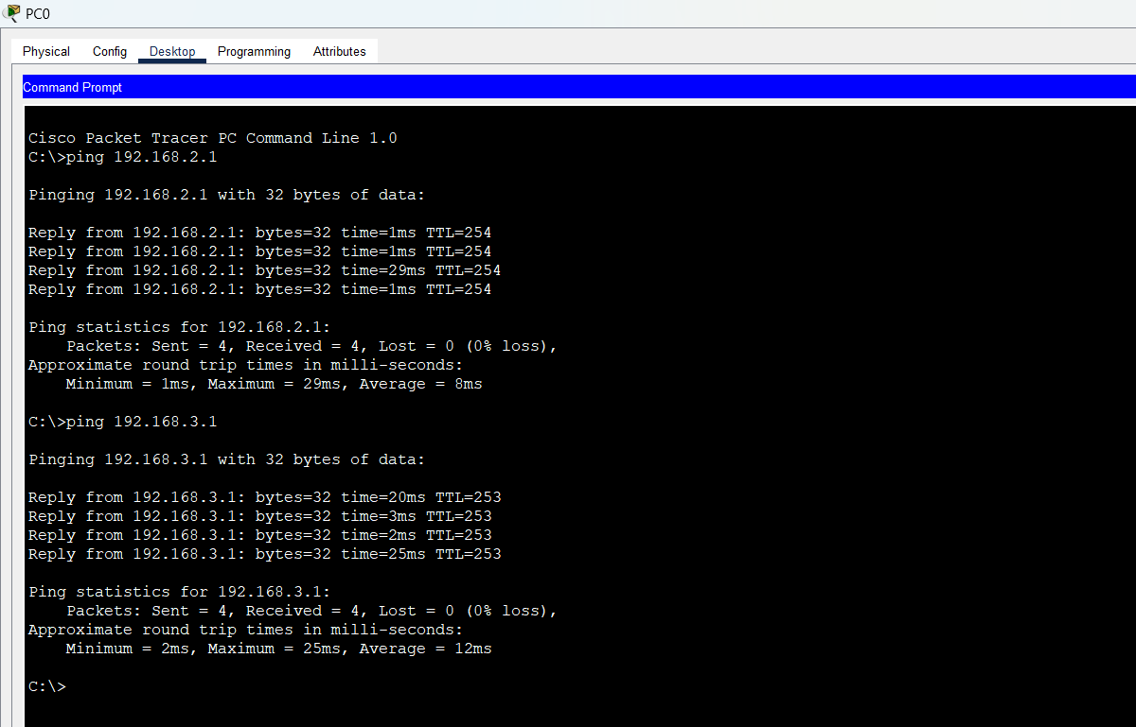

**Conclusion:**

By performing this experiment, we learned how to connect routers, switches, and PCs, assign IP addresses, and verify connectivity using static routing.