Step – 1:- Open Cisco Packet Tracer and take 2 switches and 8 PCs. Connect all the PCs to the switches using copper straight-through cables, and connect the two switches using a copper cross-over cable.

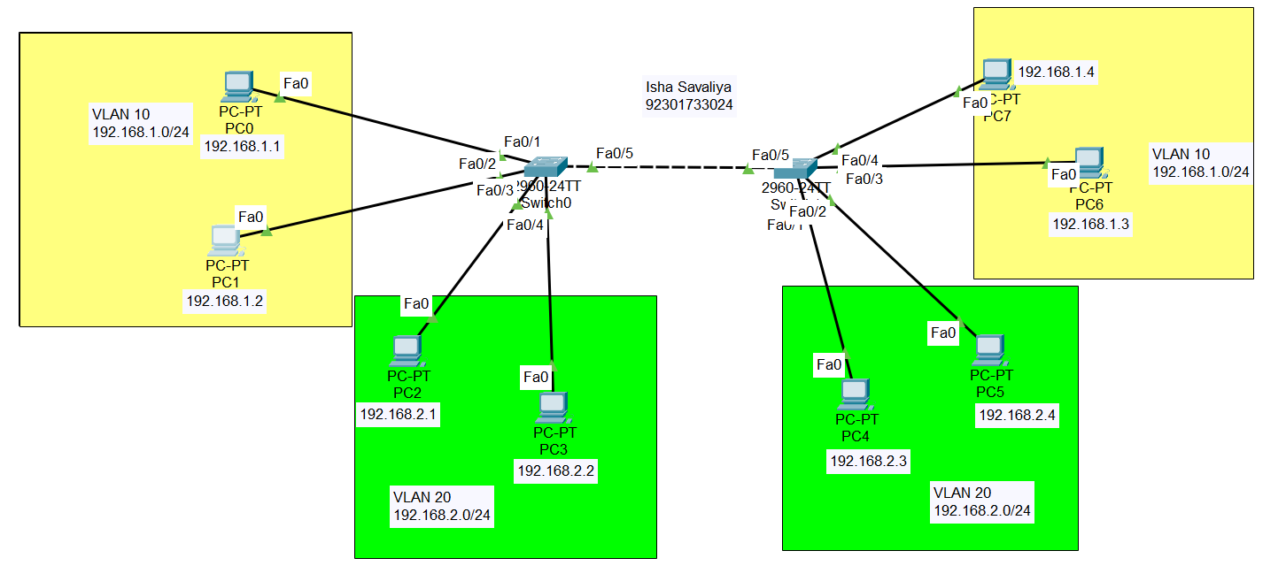

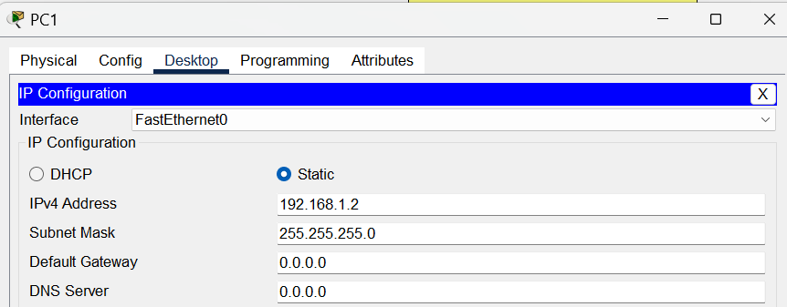
Step – 2 :- Assign IP addresses to all the PCs.
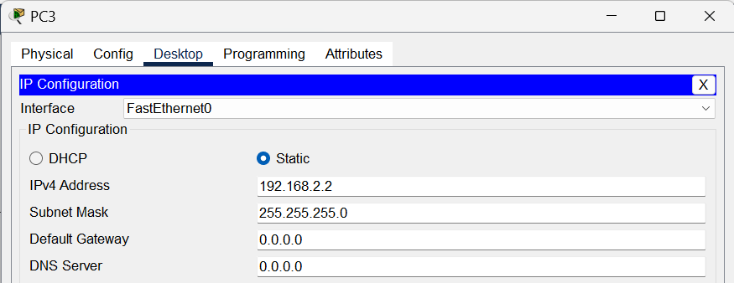
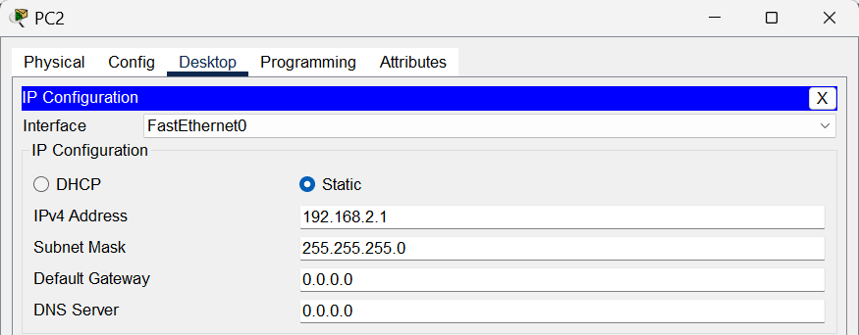
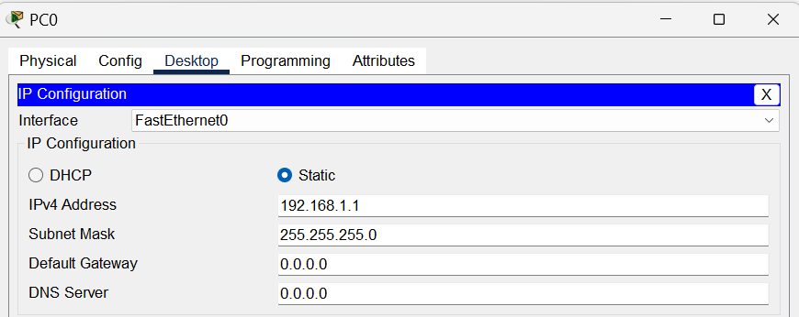

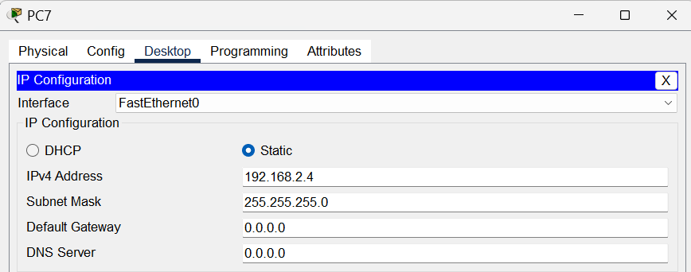
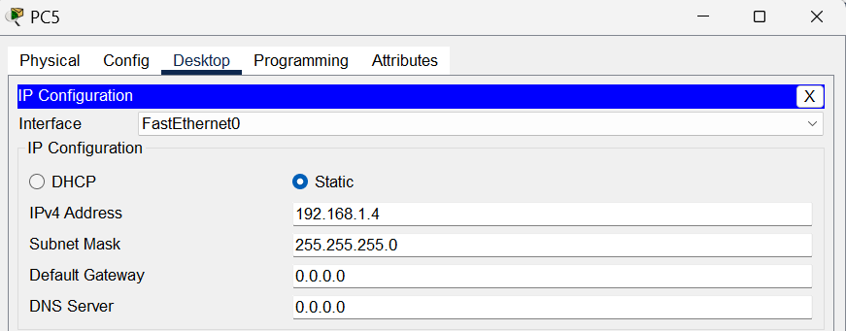
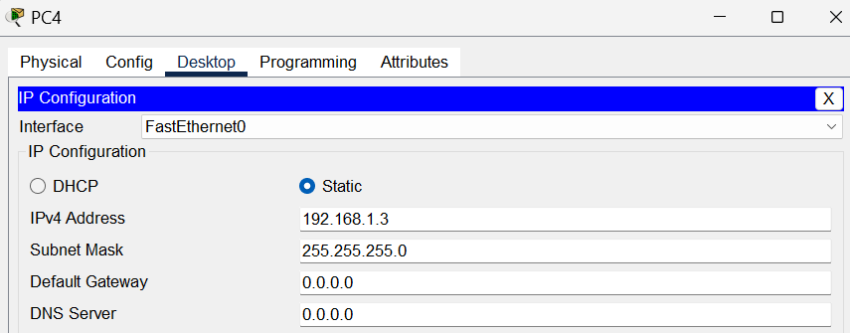
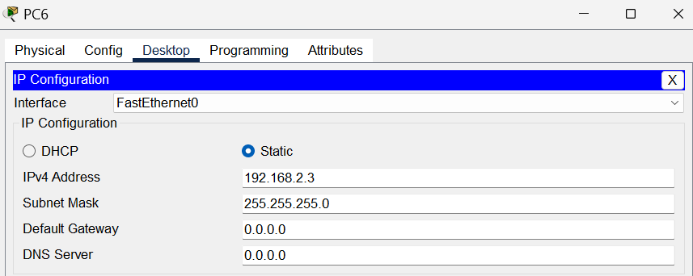

Step – 3 :- Click on switch0 and open the CLI to access the Command Line Interface of the switch.

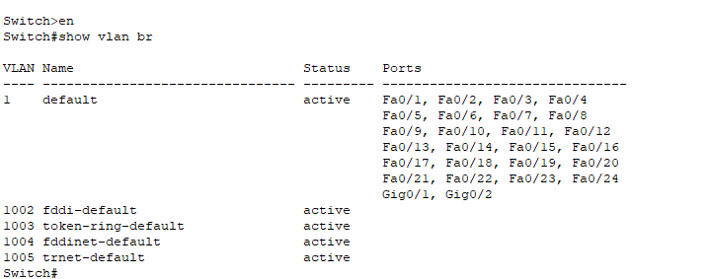

In Picture we can see that the by default one VLAN is there with name default, id 1 and access of
all ports.

Step – 4:- Now we will assign the Ports to VLAN for switch0.

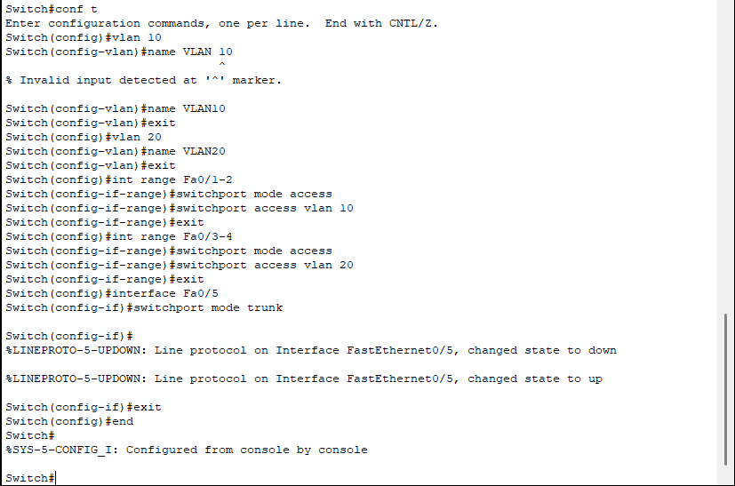
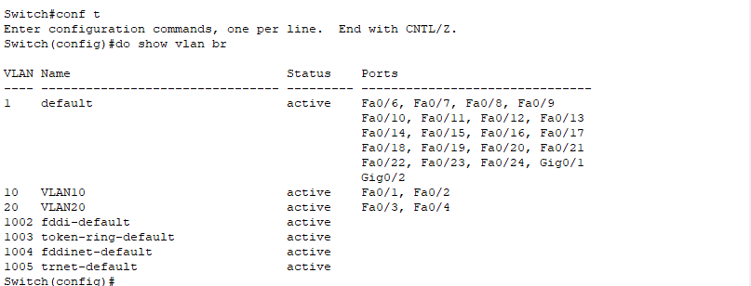

Step – 5:- Now we will assign the Ports to VLAN for switch1.

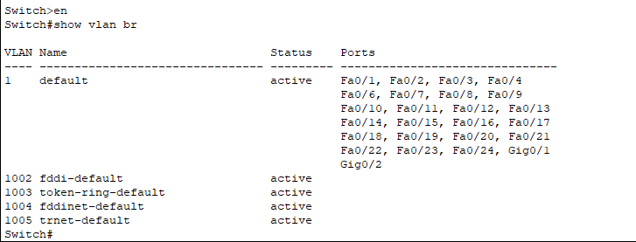
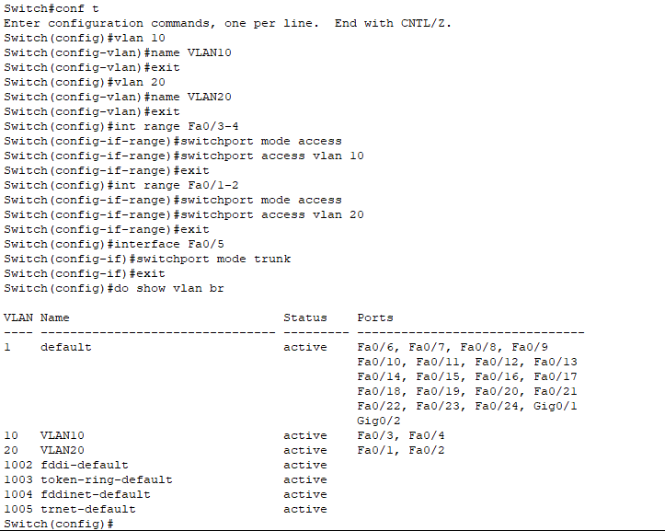

Step – 6 :- Now we will check the connectivity between the two PC’s in the same and different VLAN.

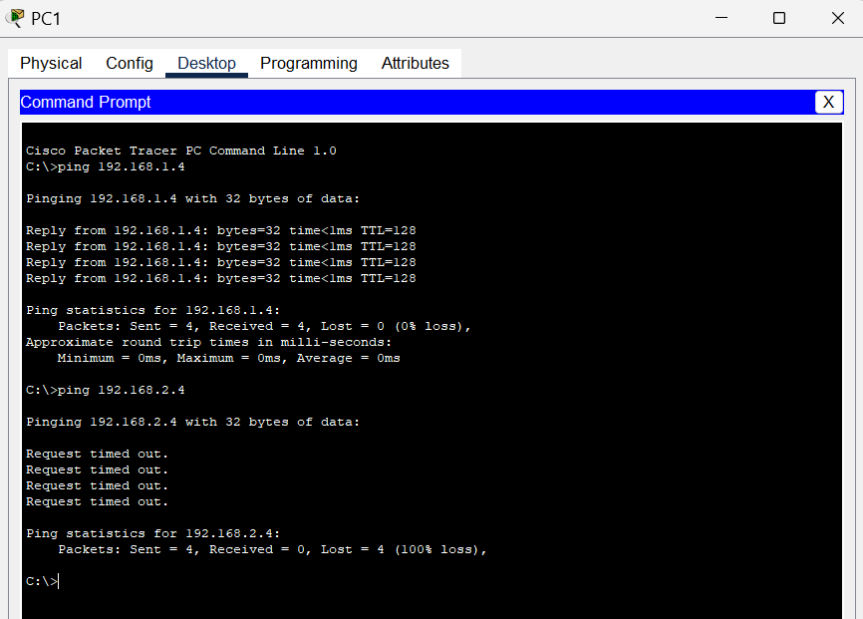

The packet is lost beacues the PC’s are not in the same VLAN.

Conclusion:-

In this experiment, We saw that computers in the same VLAN can easily communicate with each other, but those in different VLANs cannot. This shows how VLANs help in dividing a network into smaller parts to make it more organized, secure, and efficient.

