Step – 1:- Open the Cisco Packet tracer and take three routers, three switch and six PC’s.

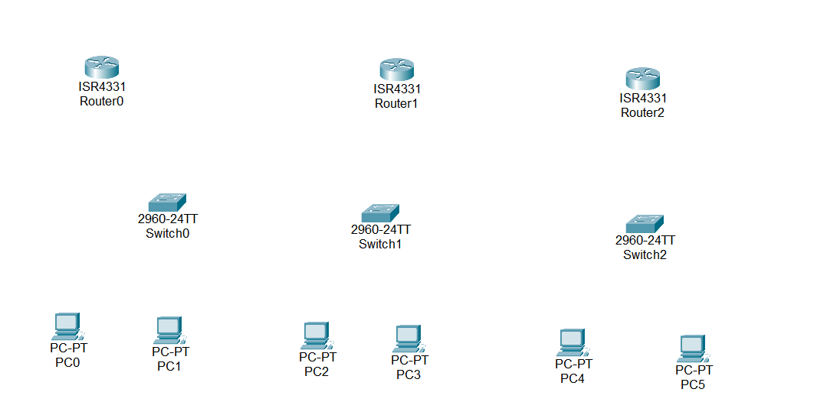

Step – 2 :- To long distance communication we need to connect router using Serial DTE cable. For the serial port we have to open router turn off it and drag and drop WIC-1T on router and turn on router.

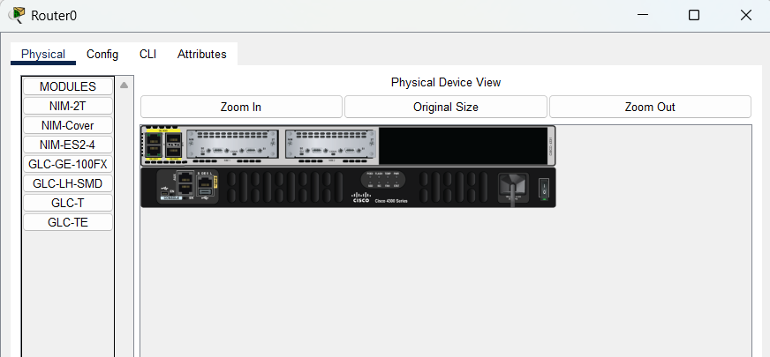

Step – 3 :- Now Connect Two Routers Using Serial DTE Cable.

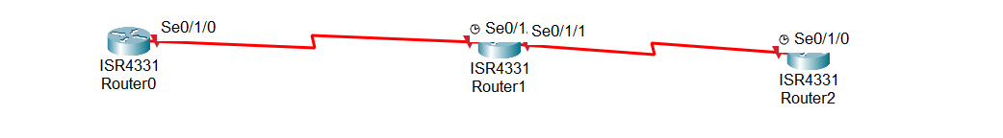

Step – 4 :- Now Connect the Switches with routers using Copper Straight through cable In GigaEthernet Port. And Connect PC’s with Switches using copper Straight through cab

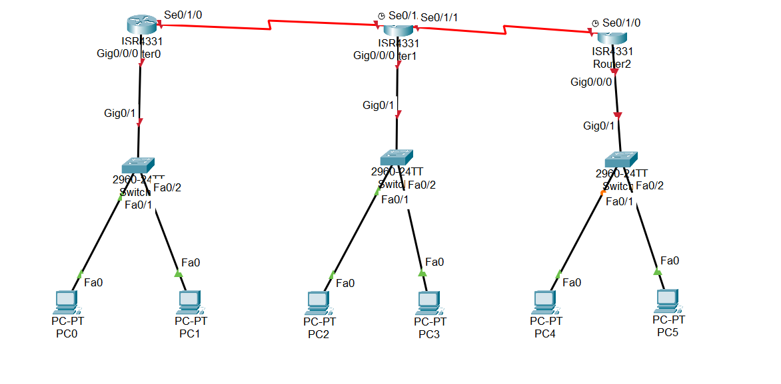

Step – 5:- Now assign the IP address And Subnet mask and Gateway to all PC’s.

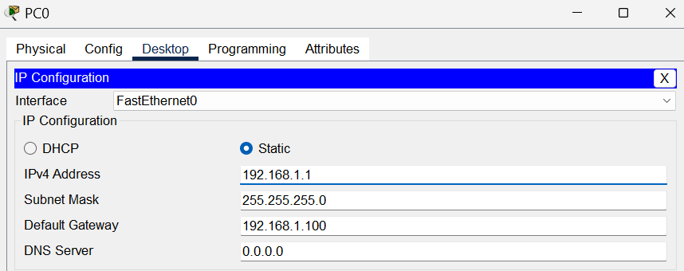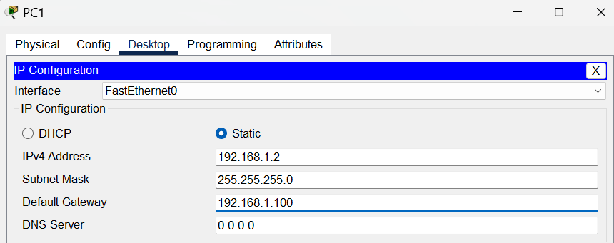

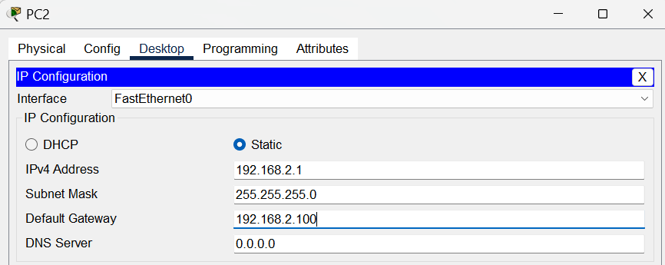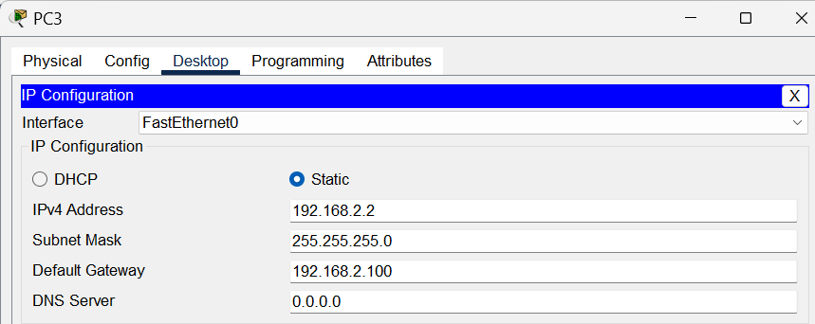

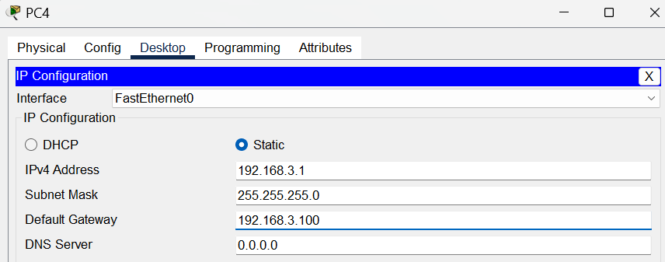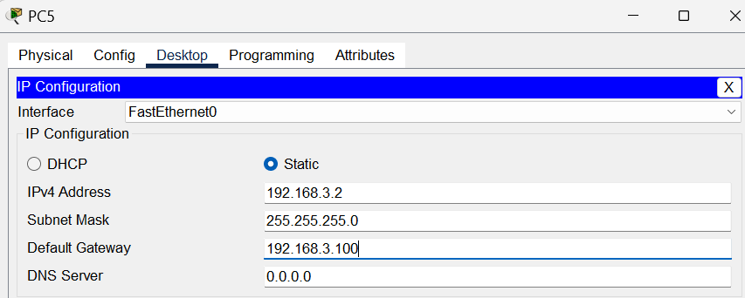
Step – 6:- Assign IP Address to Routers
Router – 0 :-
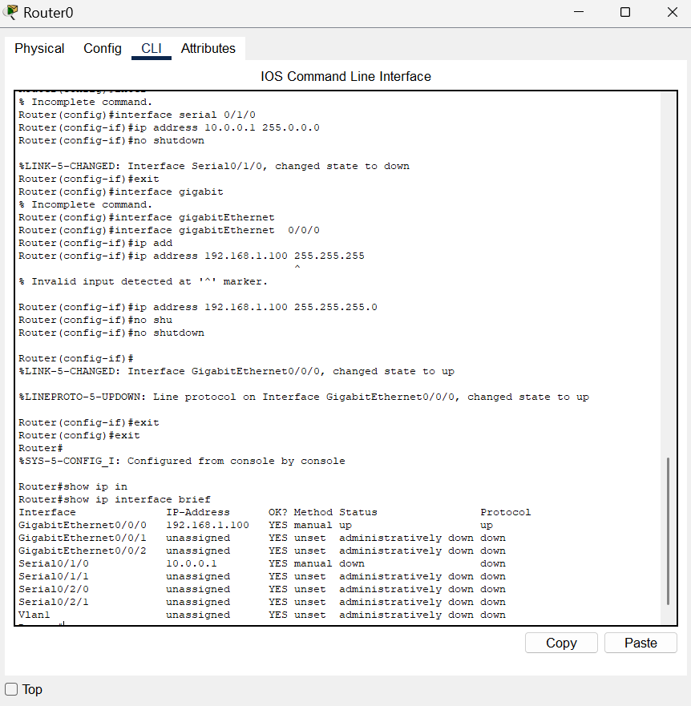

Router – 1 :-
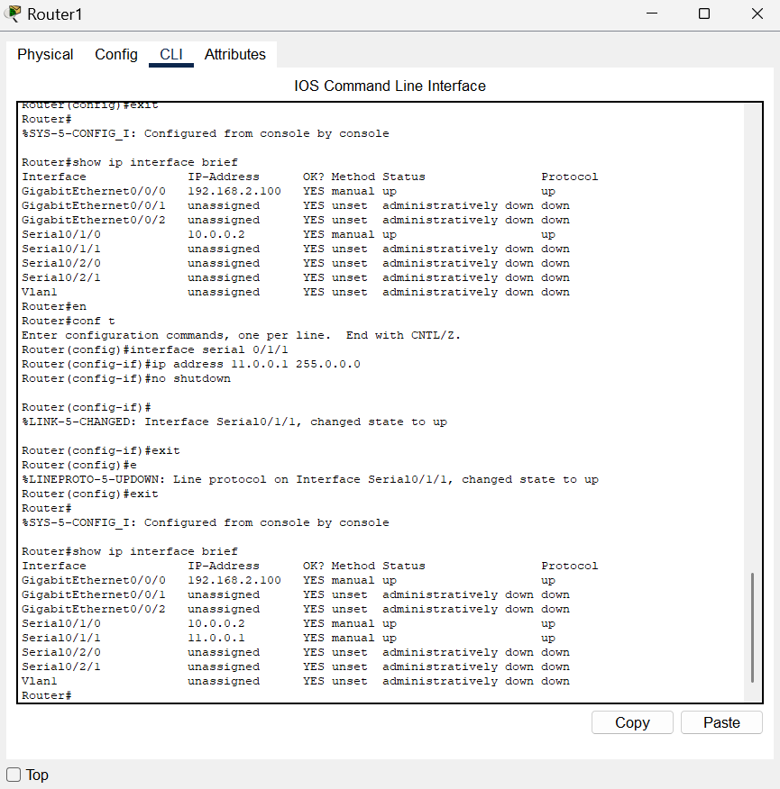

Router – 2 :-
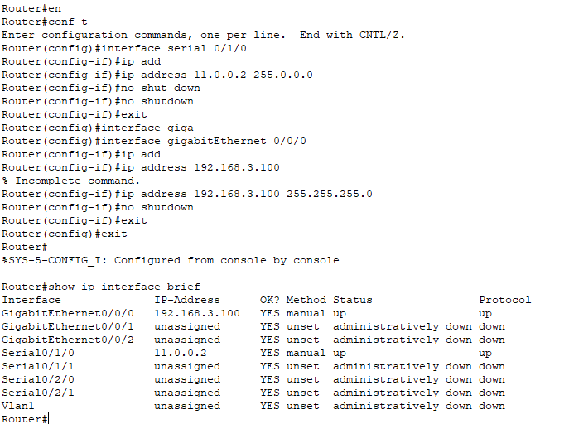

Step – 7:- now we will configure router for RIP Protocol.

Router - 0
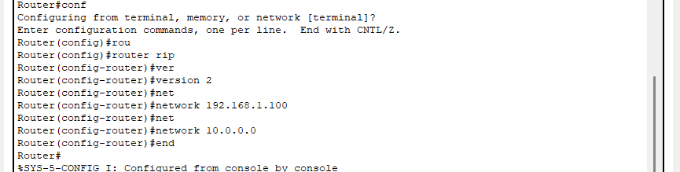

Router – 1 :-

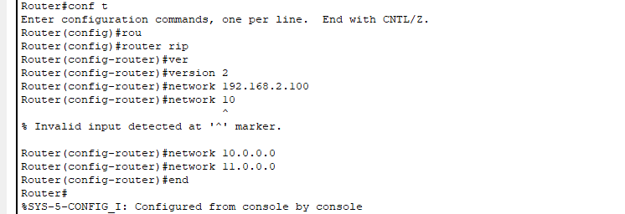

Router-2 :-

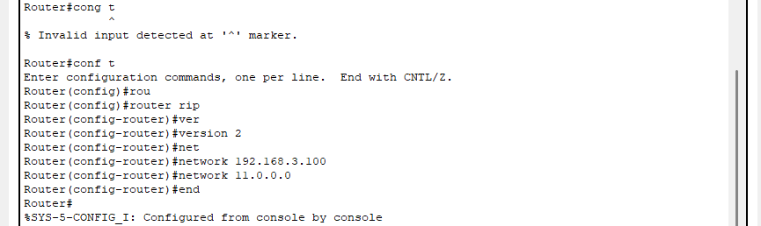

Step – 8 :- now we will check connection using ping command. And using tracert ip_add command we can check how packet will be reach at ip add.
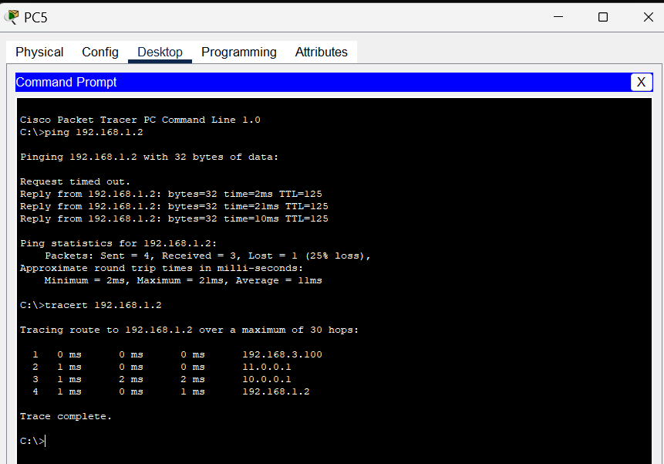

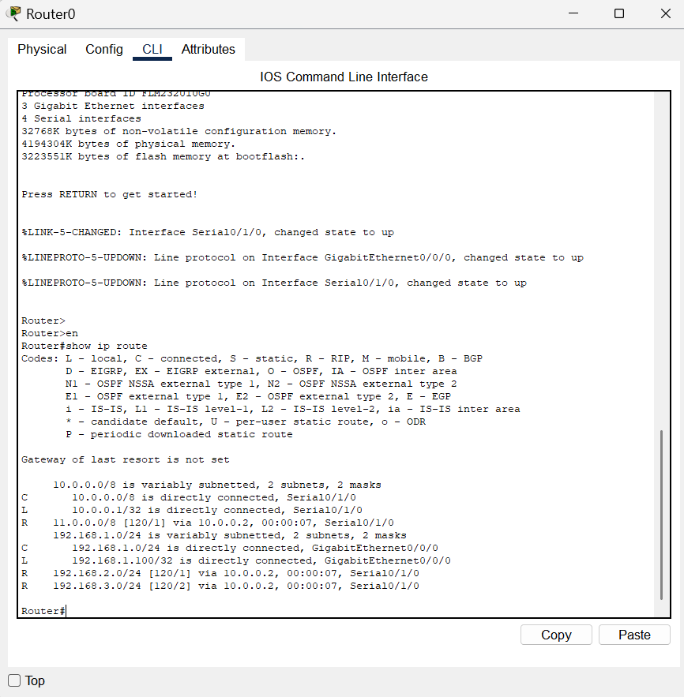

Conclusion :-

Through this experiment, I learned the importance of routing protocols in facilitating communication between different networks, specifically the Routing Information Protocol (RIP). By examining the output of the "show ip route" command.

