Step – 1:- Open the Cisco Packet tracer and take three routers, three switch and six PC’s.

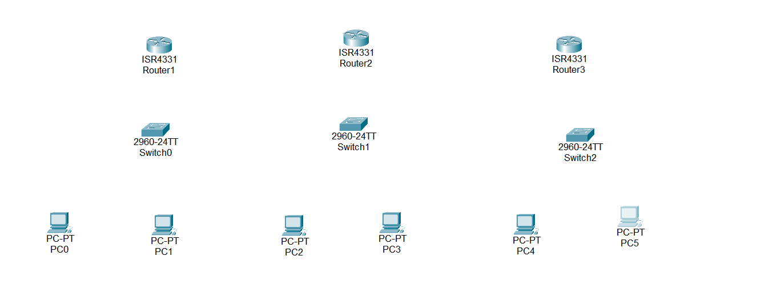

Step – 2 :- To long distance communication we need to connect router using Serial DTE cable. For the serial port we have to open router turn off it and drag and drop NIM-2T on router and turn on router.

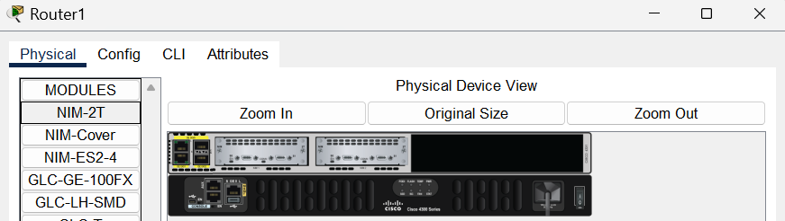

Step – 3 :- Now Connect Two Routers Using Serial DTE Cable.

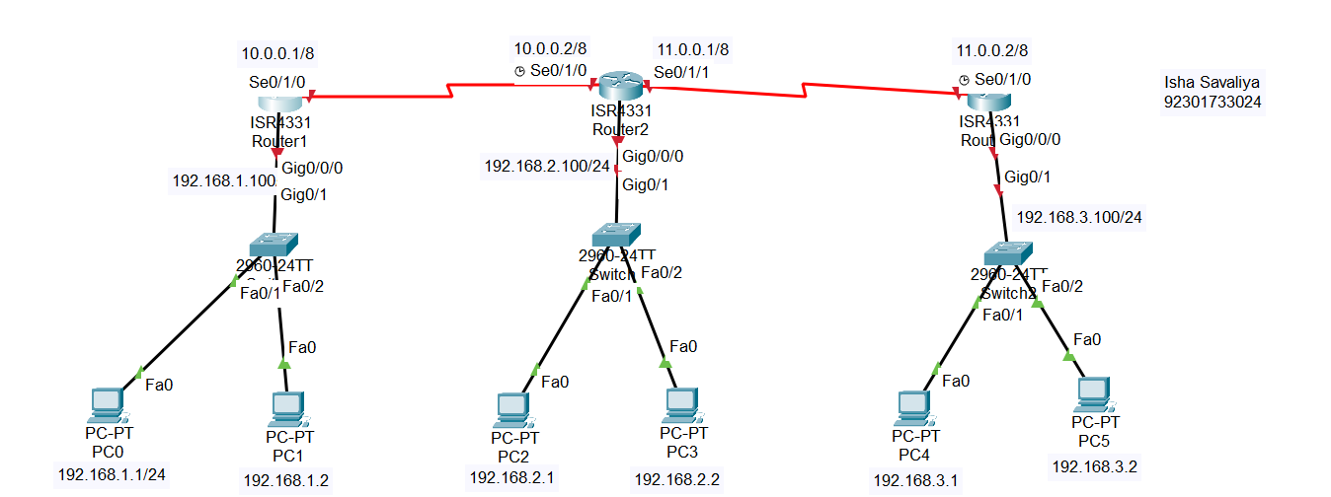

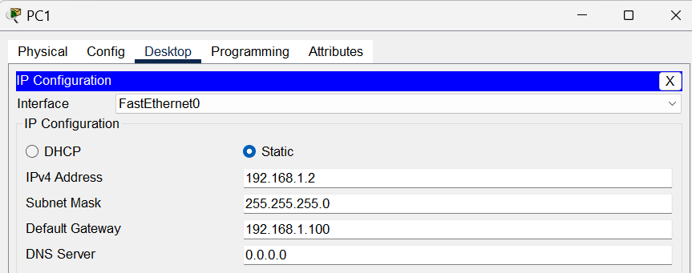
Step – 4:- Now assign the IP address And Subnet mask and Gateway to all PC’s.
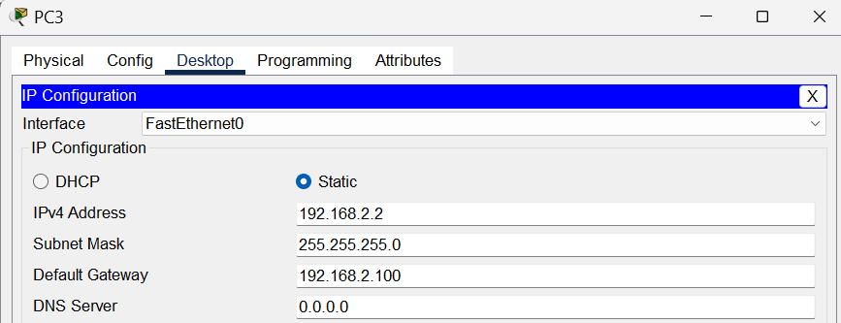
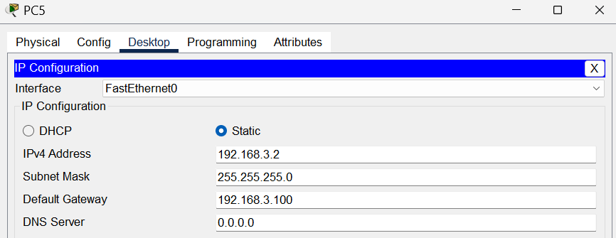
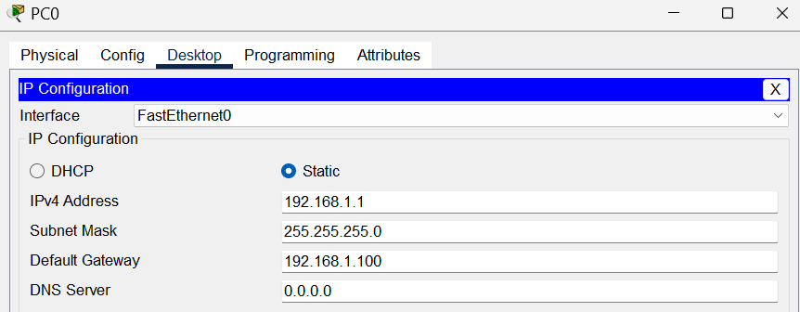
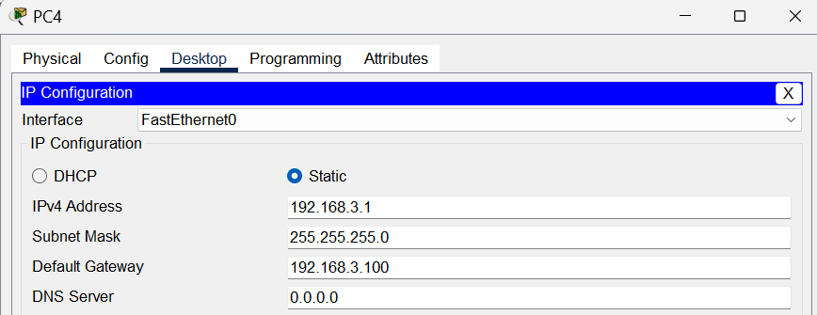
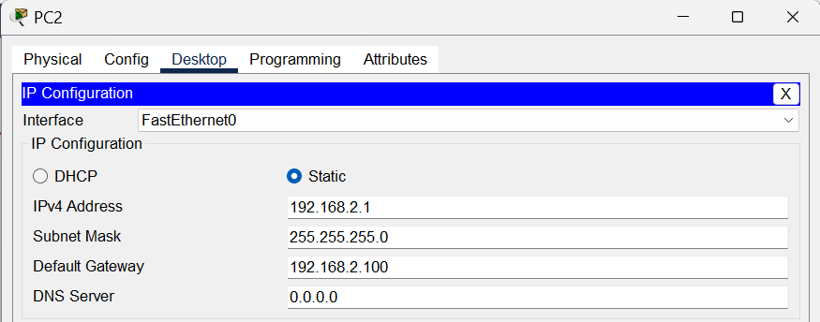

Step – 5 :- Assign IP Address to Routers

Router – 0 :-

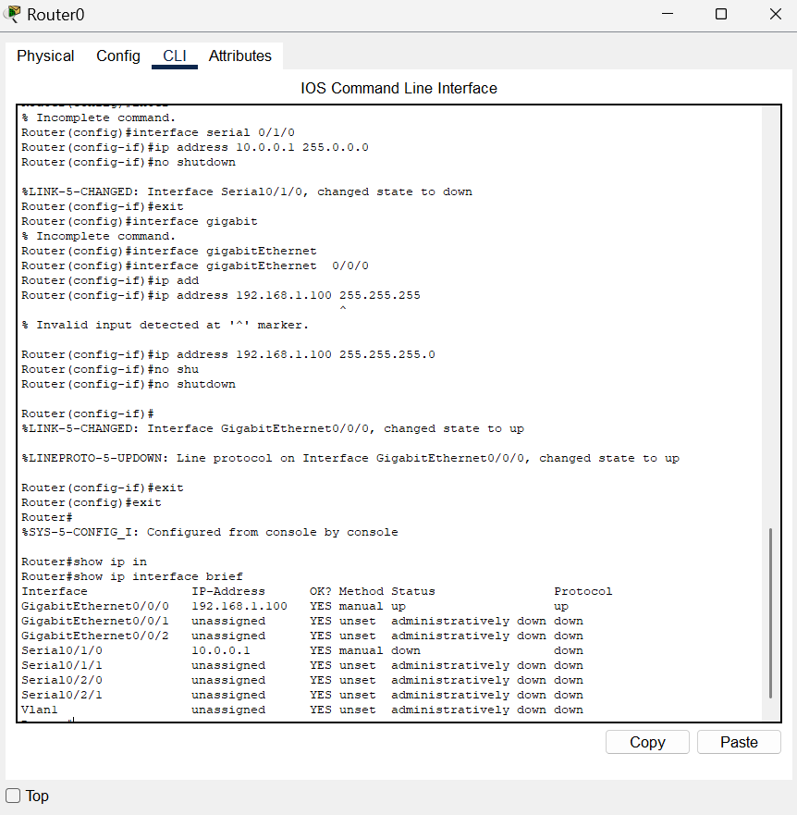
Router – 1 :-

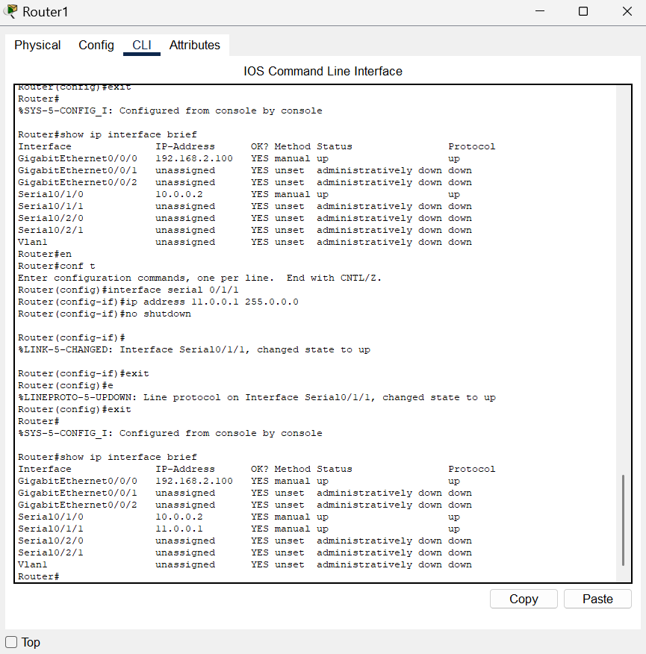

Router – 2 :-

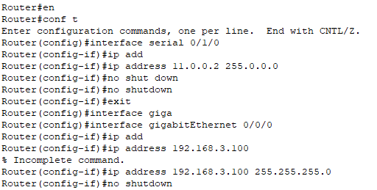

Step – 6 :- now we will configure router for OSPF Protocol.

We need to implement routing protocol onto routers so that router can find destination for another network, for that in dynamic routing protocol OSPF we have command “router ospf 1” using that we entered in routers OSPF configuration mode and then we have command “network area 0”.

Router – 0 :-
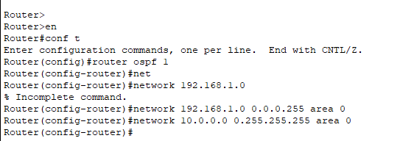

Router – 1 :-
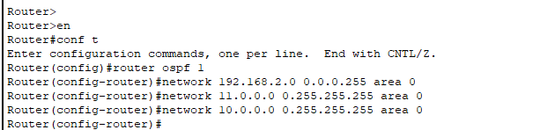

Router – 2 :-

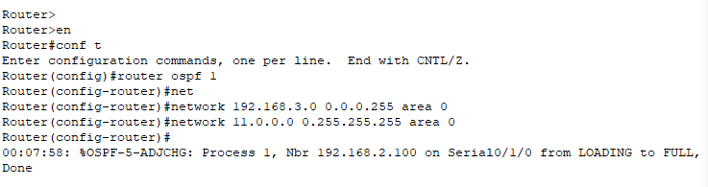

Step – 7 :- now we will check connection using ping command.

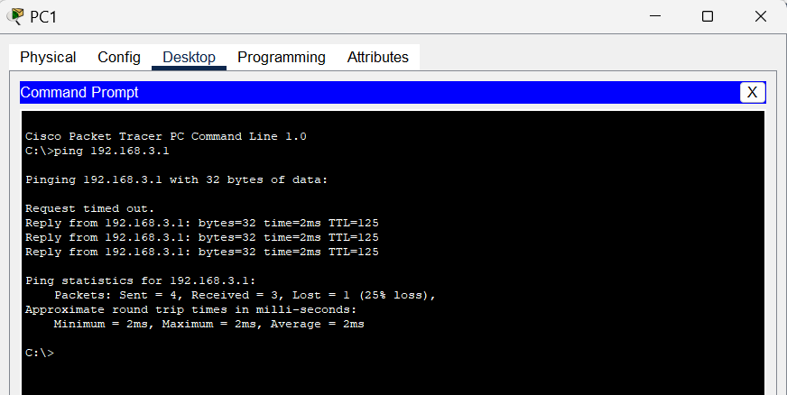

Conclusion :-

In this experiment, we implemented the OSPF dynamic routing protocol. We configured routers to share routing information and automatically update their routing tables. This allowed successful communication between different networks and demonstrated the efficiency of dynamic routing compared to static routing.

