Step – 1:- Open the Cisco Packet tracer and take three routers, two switch and four PC’s.Connect r-r
Using copper straight-through cable(gigabitethernet), Connect r-sw Using copper straight-through cable(gigabitethernet, Connect sw-pc Using copper straight-through cable(Fastethernet).

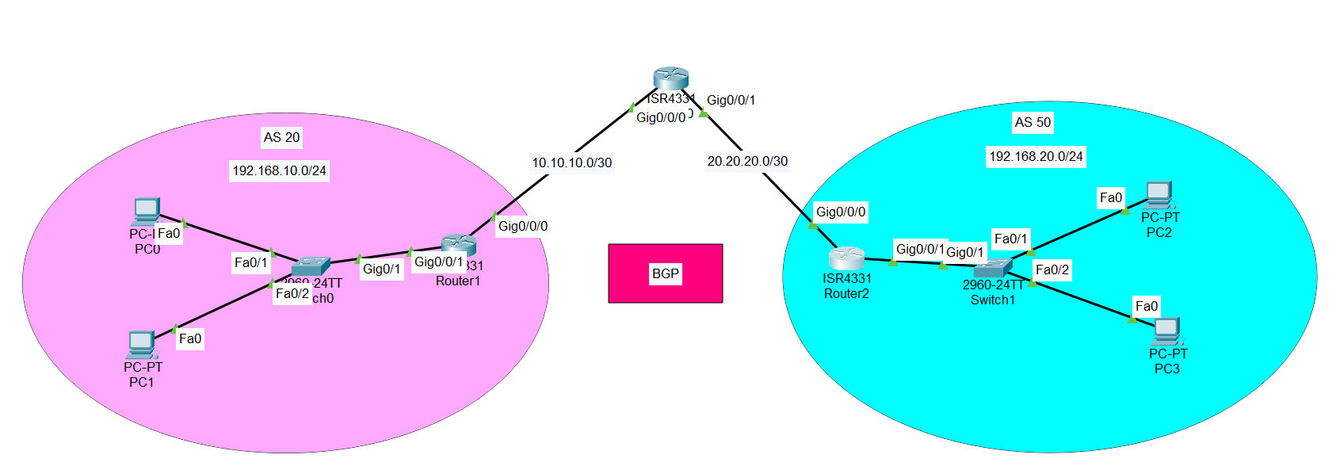

Step – 2:- Now assign the IP address And Subnet mask and Gateway to all PC’s.
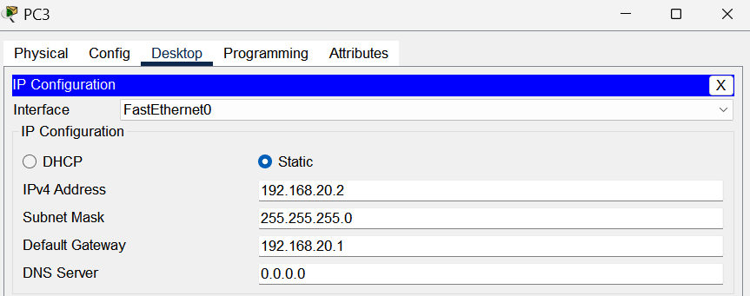
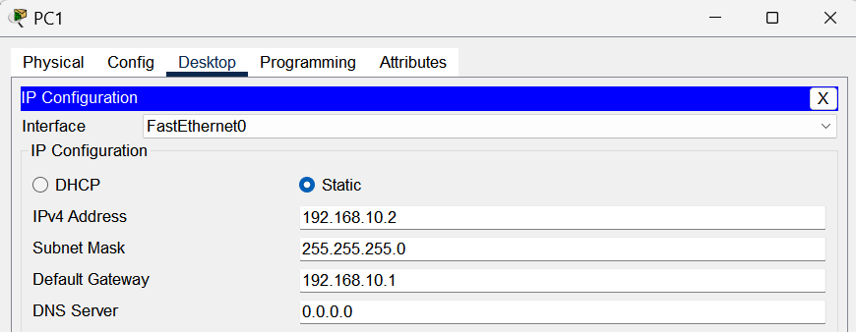
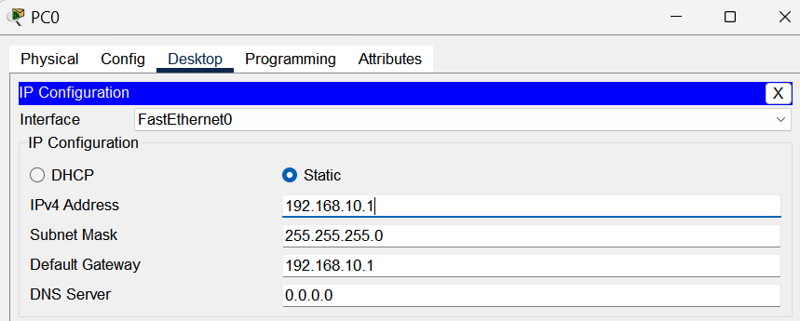

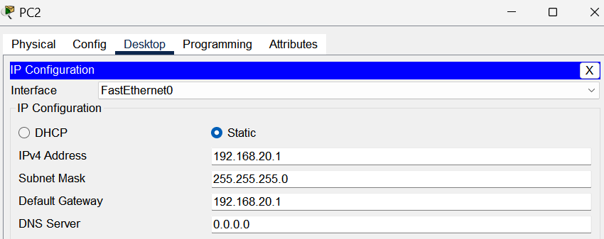

Step – 3 :- Assign IP Address to Routers

Router – 0 :-

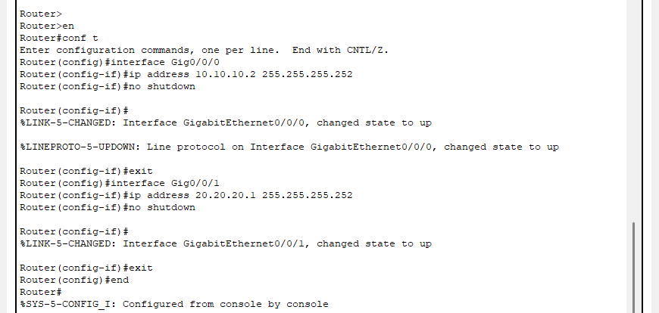

Router – 1 :-

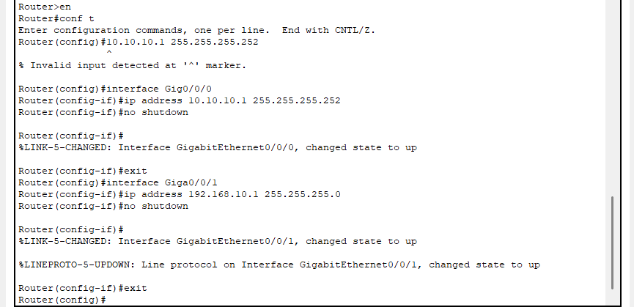

Router – 2 :-

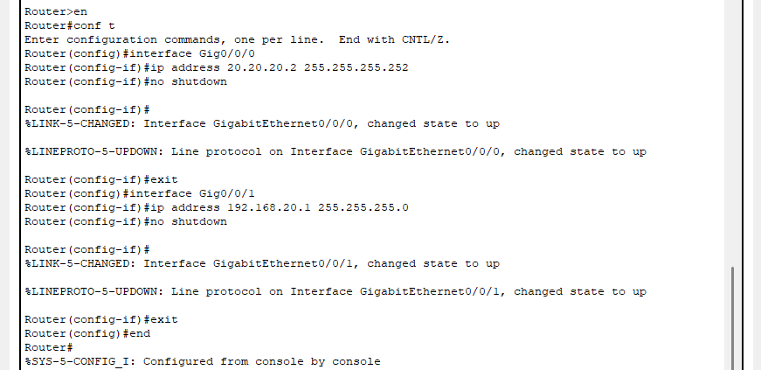

Step – 4 :- now we will configure router for BGPP Protocol.

Router – 1
enable
configure terminal
router bgp 20
bgp router-id 1.1.1.1
neighbor 10.10.10.2 remote-as 35
network 192.168.10.0 mask 255.255.255.0
network 10.10.10.0 mask 255.255.255.252
exit
end

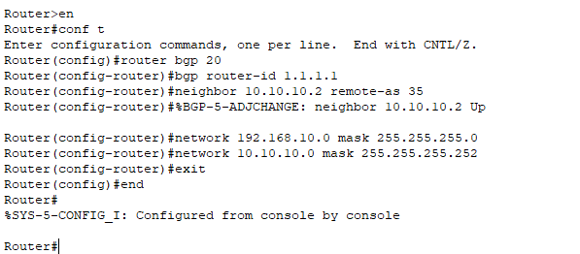

Router – 0 :-

enable
configure terminal
router bgp 35
bgp router-id 3.3.3.3
neighbor 10.10.10.1 remote-as 20
neighbor 20.20.20.2 remote-as 50
network 10.10.10.0 mask 255.255.255.252
network 20.20.20.0 mask 255.255.255.252
exit
end

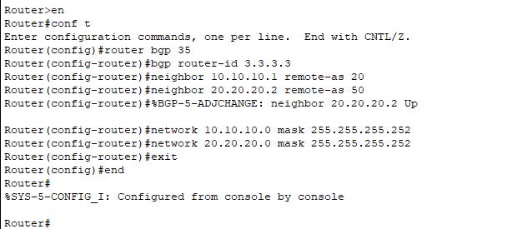

Router-2 :-
enable
configure terminal
router bgp 50
bgp router-id 2.2.2.2
neighbor 20.20.20.1 remote-as 35
network 192.168.20.0 mask 255.255.255.0
network 20.20.20.0 mask 255.255.255.252
exit
end

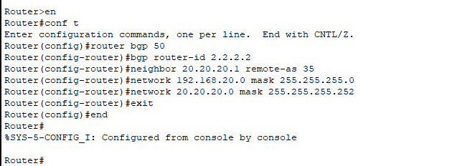

Step – 5 :- now we will check the BGP Neighbour using the command show ip bgp neighbor

Router-0 :-

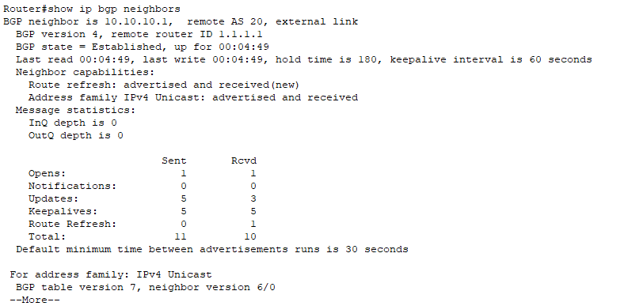

Router-1 :-

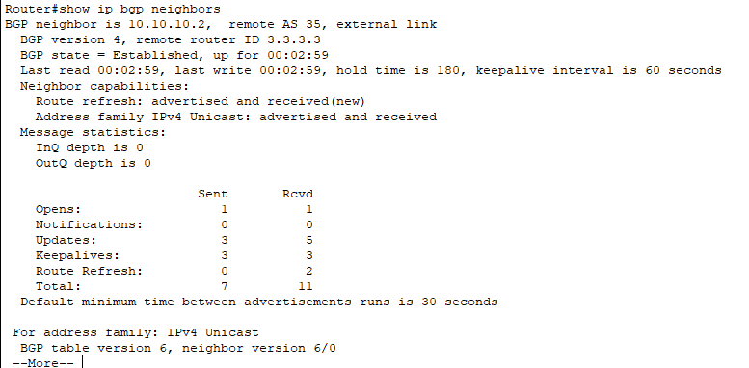

Router-2 :-

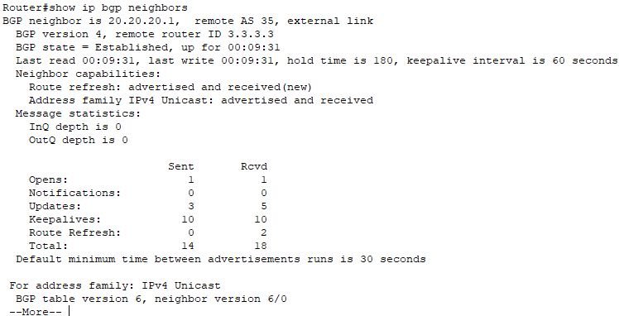

Step – 6 :- now we will check summary of bgp using the command show ip bgp summary

Router-0 :-
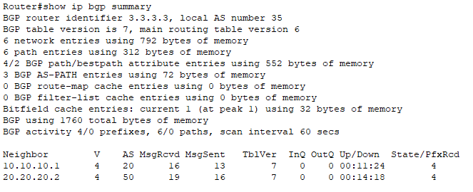

Router-1 :-

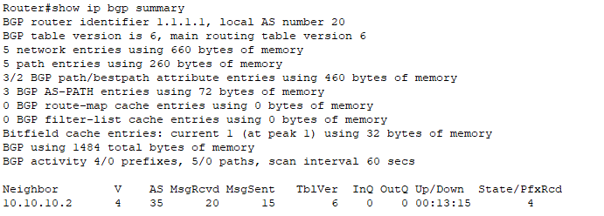

Router-2 :-

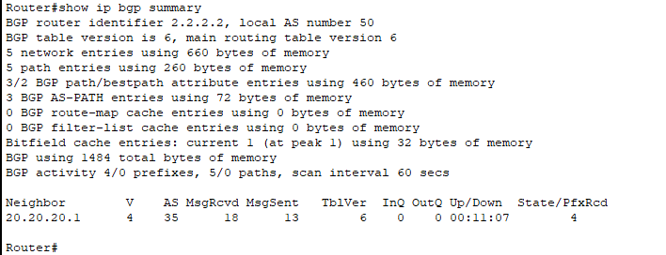

Step – 7 :- now we will check bgp using the command show ip bgp

Router-0 :-
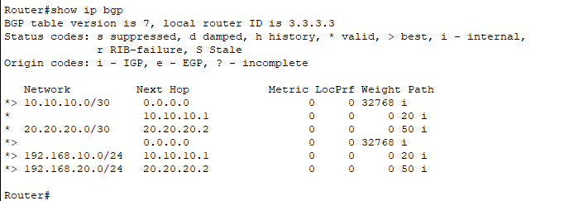

Router-1 :-
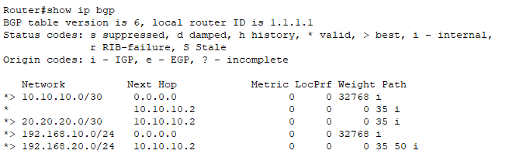

Router-2 :-

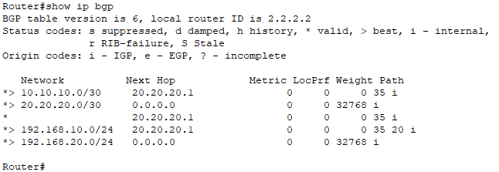

Step – 8 :- now we will check the connection using the ping dest_ip command

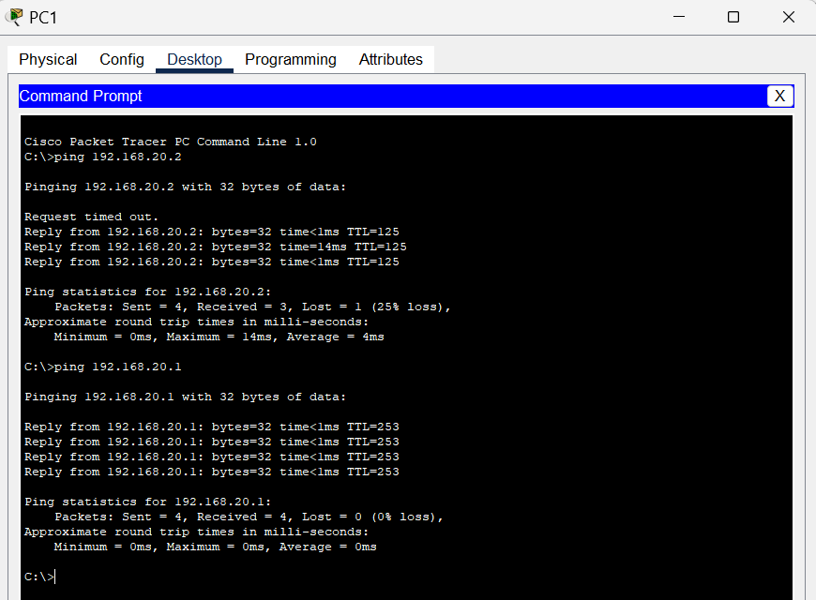

Conclusion :-

In this experiment of BGP, we connected all PCs using BGP routers from three Autonomous Systems AS20, AS35, and AS50. Each router was assigned a unique router ID for identification. AS20 was connected to AS35 via 10.10.10.1, and AS35 was connected to AS50 via 20.20.20.1. I learned new commands such as bgp router-id to assign IDs, neighbor <ip> remote-as <AS> to define neighbors, network <ip> mask <mask> to advertise networks, and verification commands like show ip bgp neighbor and show ip bgp summary to check BGP connectivity and status.

