Step – 1:- Open Cisco Packet Tracer and take one Router, one Switch, and four PCs.

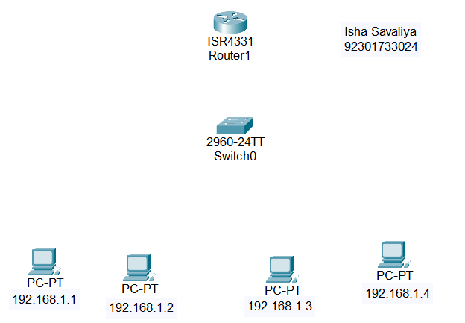

Step – 2 : Connect the PCs to the Switch (FastEthernet) and the Switch to the Router (GigabitEthernet) using copper straight-through cables.

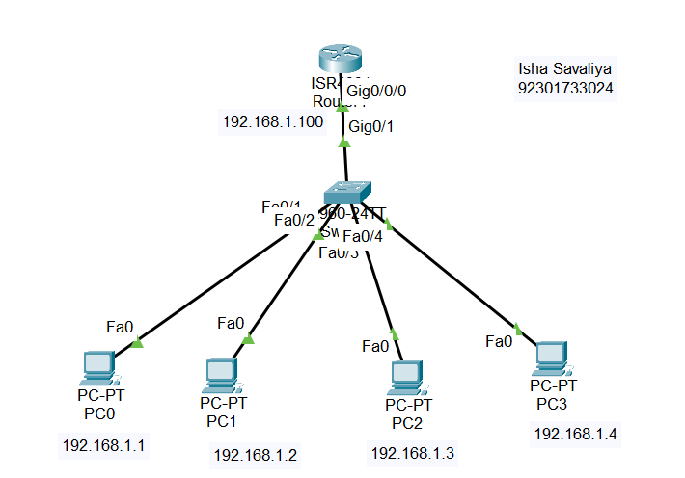

Step – 3 :- Assign the IP Address to the the Routers. Create IP DHCP Pool for network 192.168.1.0

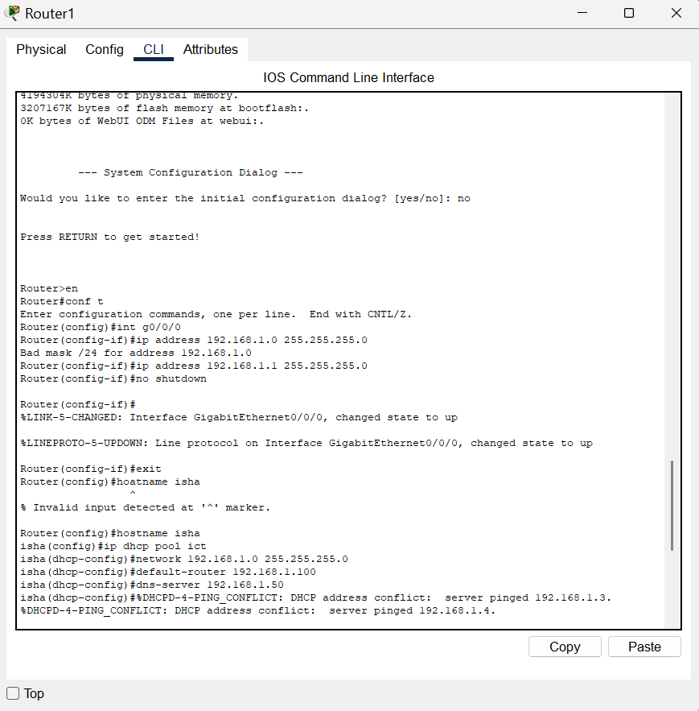

- ip dhcp pool ict:- This command creates a new DHCP pool called iict. A DHCP pool is a range of IP addresses that can be assigned dynamically to clients on the network.

- network 192.168.1.0 255.255.255.0 :- This command specifies the network address and the subnet mask for the DHCP pool. In this case, the network is 192.168.1.0 with a subnet mask of 255.255.255.0. The DHCP server has the provision to assign an IP address to any of the clients connecting to it within the range of 192.168.1.1-192.168.1.254.

- default-route 192.168.1.100 :- this command specifies the default gateway.

- dns-server 192.168.1.50 :- this will provide the address of DNS server.

Step – 9 :- Configure the PCs to obtain their IP addresses using DHCP.

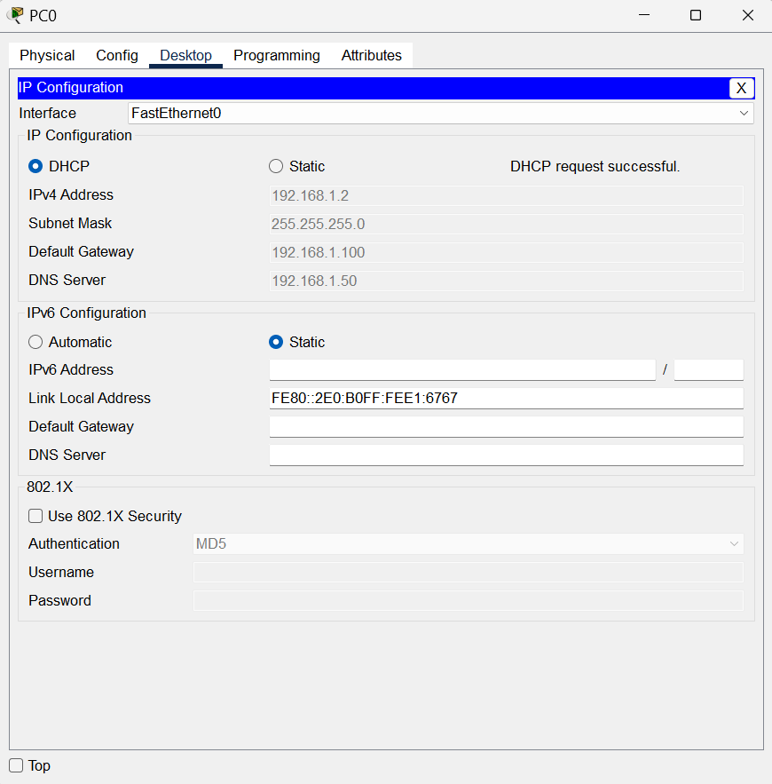

Step – 10 :- Use the release IP address command to test reassignment.

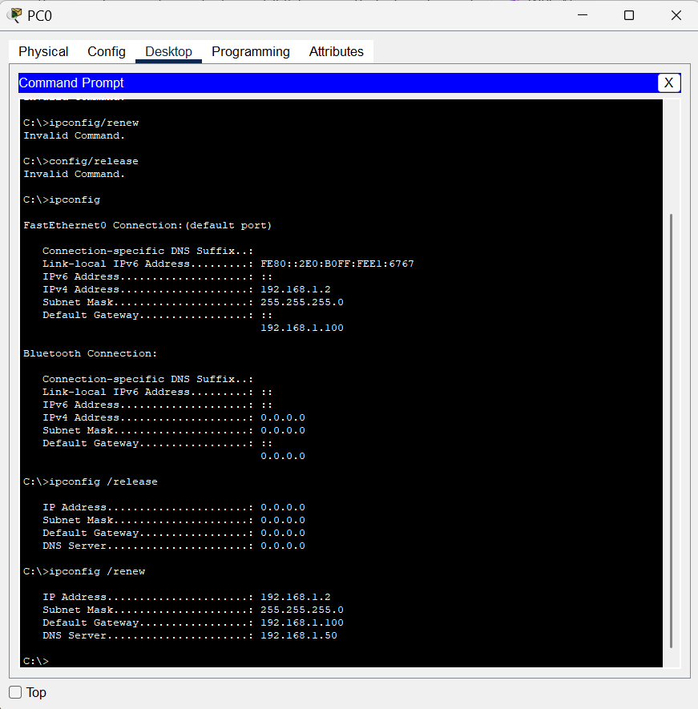

Conclusion :-
By performing this experiment,i learned how to configure a router as a DHCP server. We created an IP pool, assigned a range of IP addresses, set the DNS server address, and defined the default gateway. This helped us establish successful communication while ensuring efficient use of IP addresses and minimizing wastage.

