TCP Analysis using Wireshark,

Step – 1:- Open Wireshark

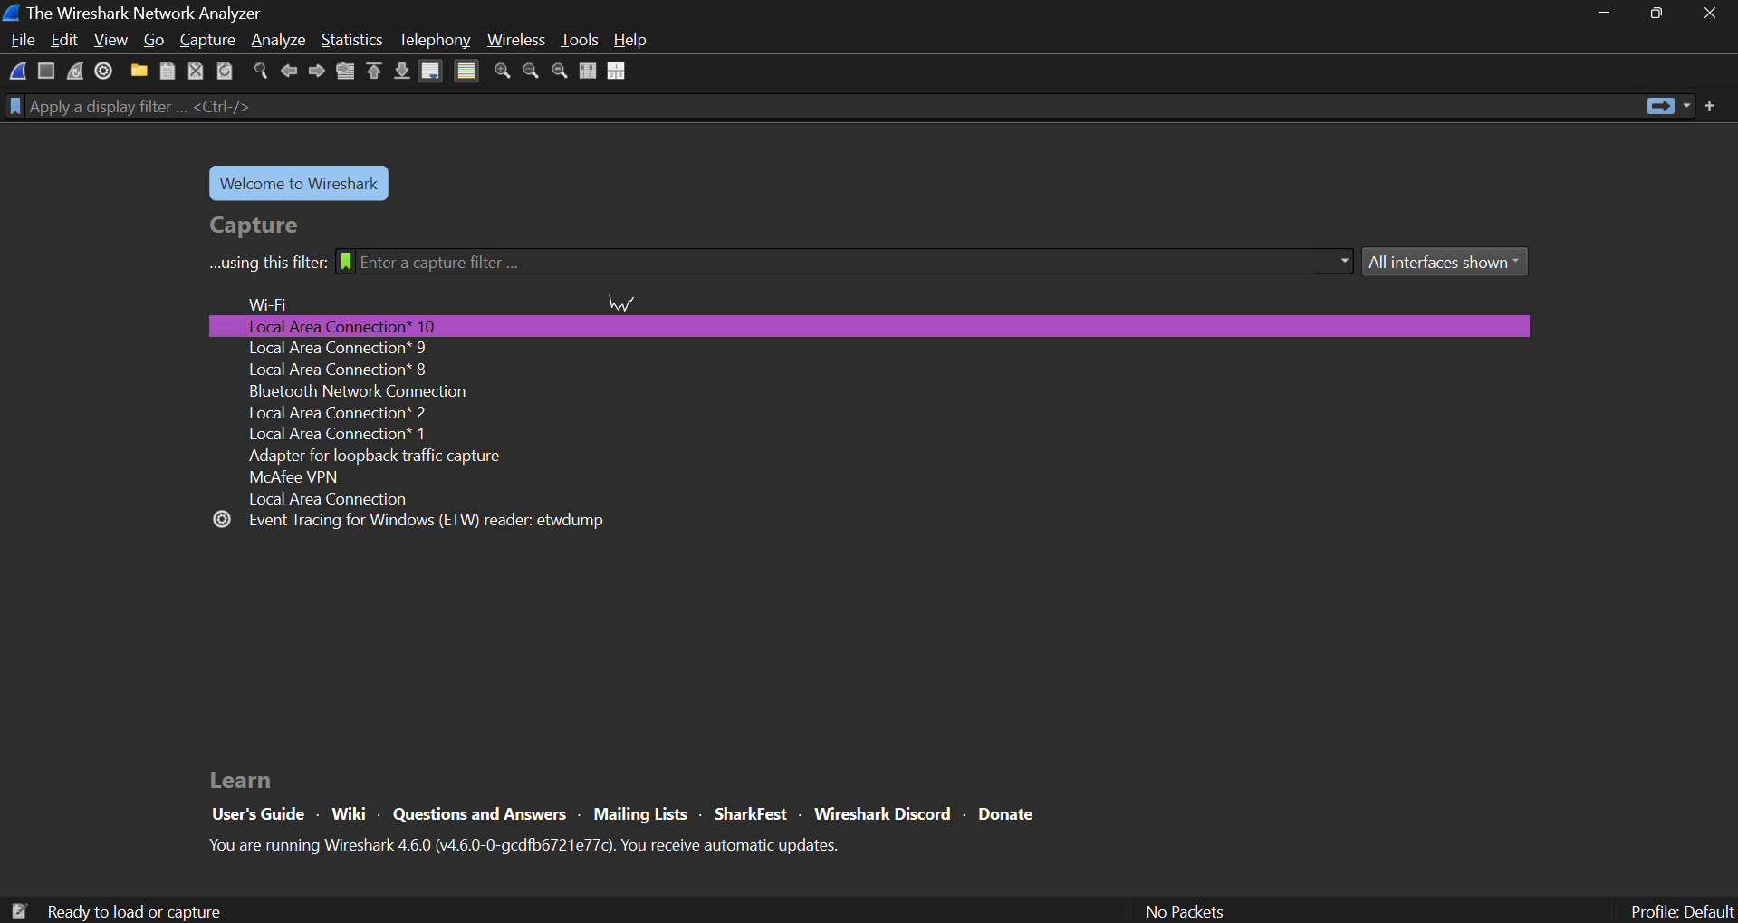

Step – 2 :- Select the Network from which you want to communicate

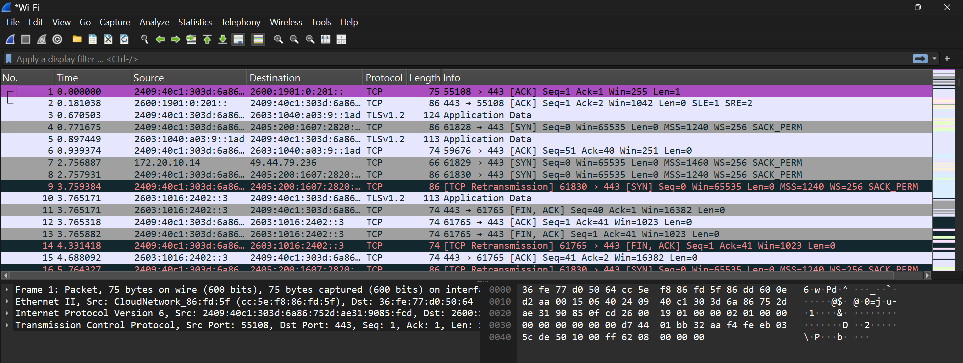

Step – 3 :- Apply Display Filters for TCP Traffic(tcp.port == 80 or tcp.port == 443)

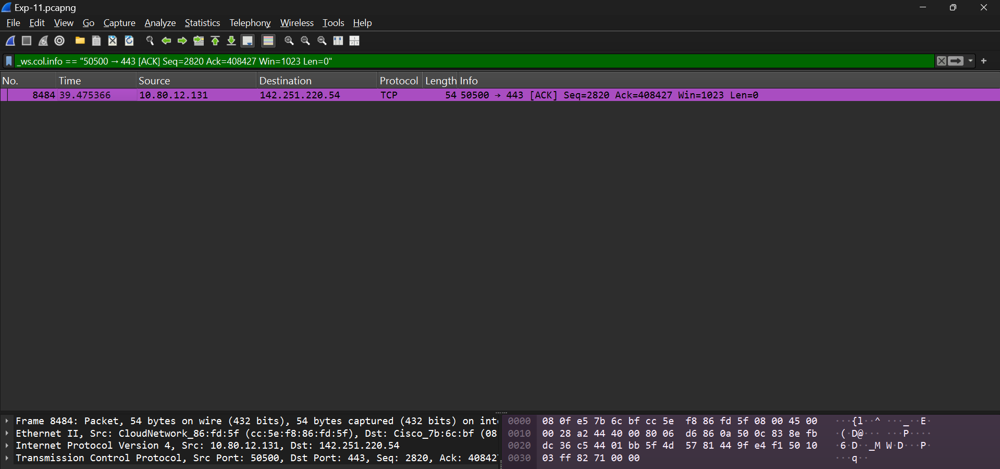

Step – 4 :- Follow a TCP Stream.

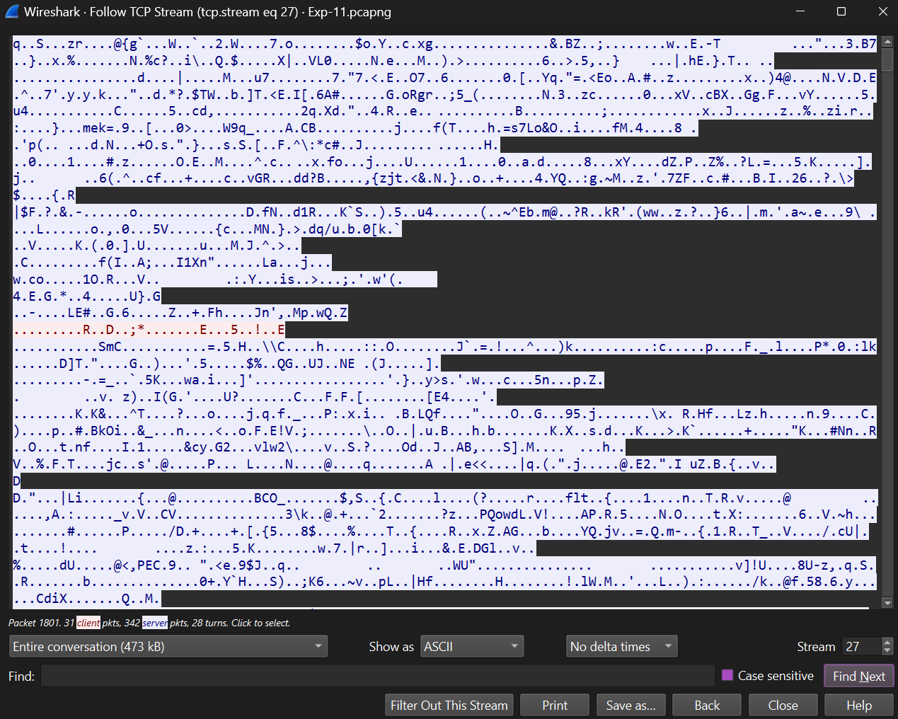
Step – 5 :- View TCP Statistics and Graphs.

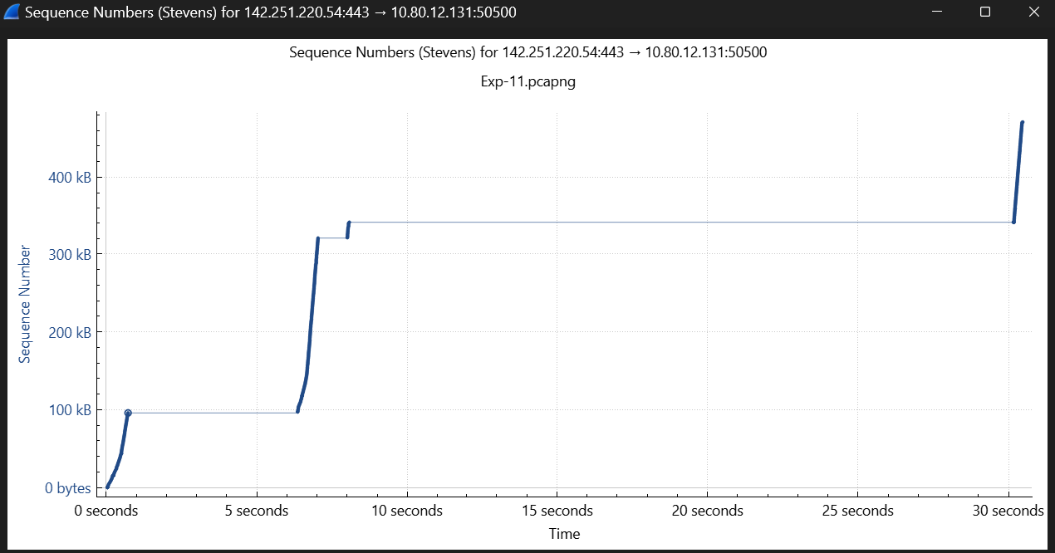

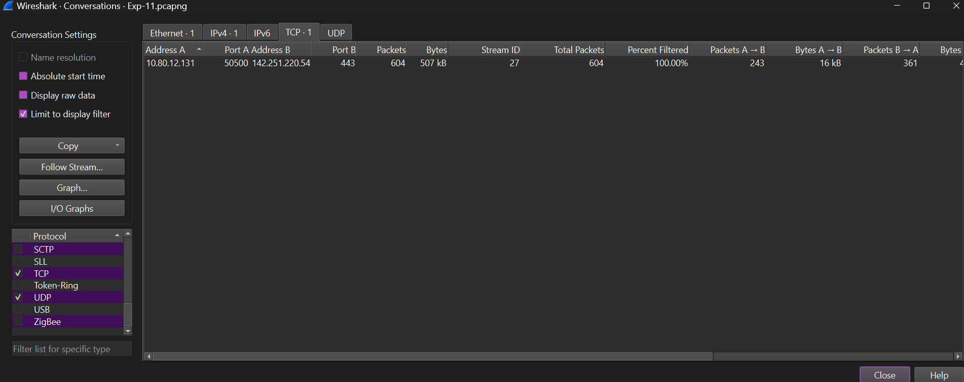

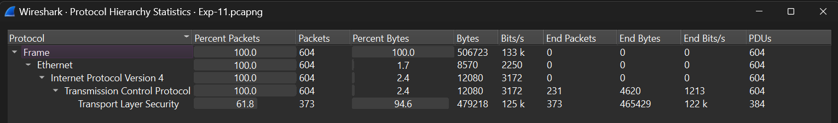

Step – 7 :- Check Expert Information for Anomalies.

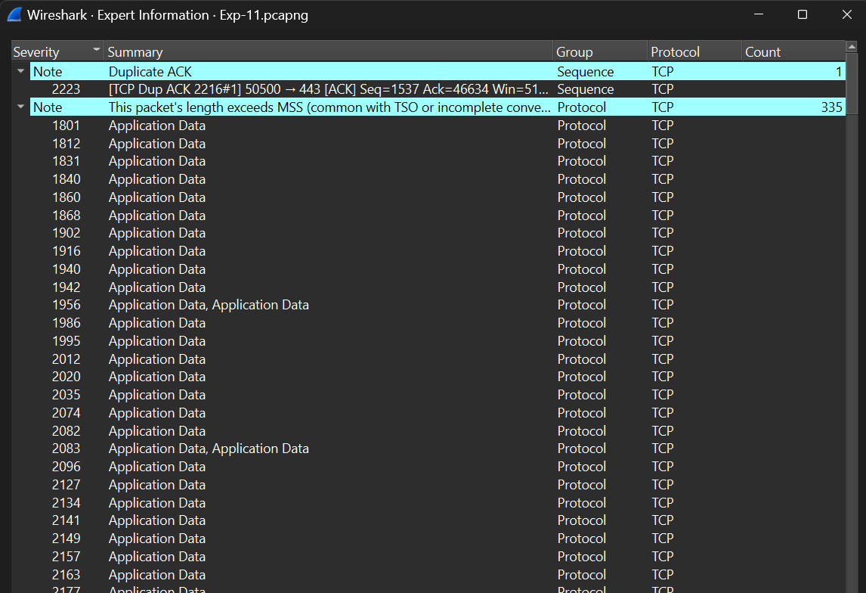

Step – 8:- Export and Report Findings.

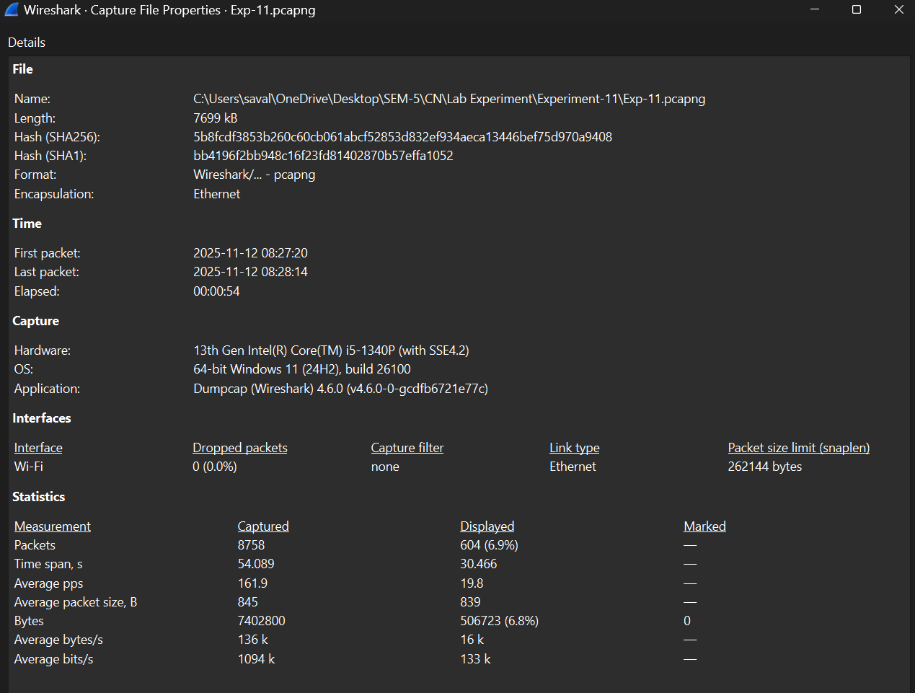

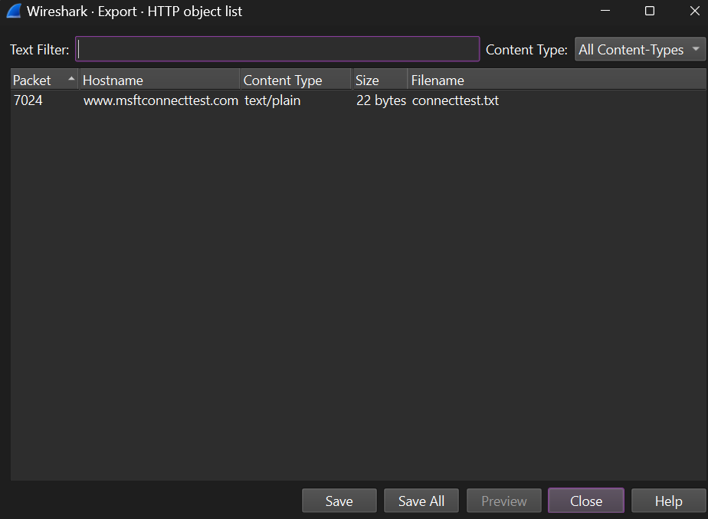

UDP (User Datagram Protocol) Analysis using Wireshark

Step-1: Start Capturing Packets
While capturing, perform a network activity to generate UDP traffic: Open Command Prompt (search "cmd" in Start menu), type "nslookup example.com" and press Enter. This sends a UDP DNS query to a server on port 53.

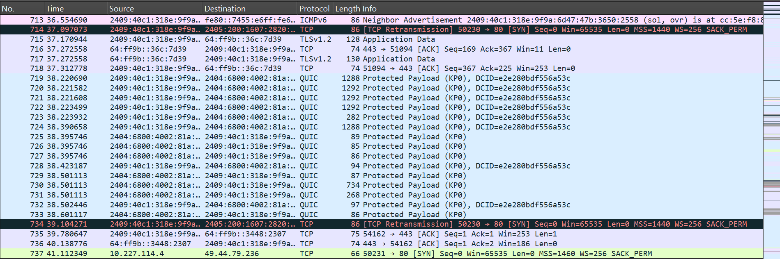

Step-2: Stop the Capture and Save the File
Go to File > Save As, choose a location (e.g., Desktop), name it (e.g., "udp_capture.pcapng"), and save in .pcapng format for full metadata.

Step-3: Apply Display Filters for UDP Traffic
- In the filter bar (green box above the packet list), type "udp" and press Enter (or Apply).
- For specifics: "udp.port == 53" for DNS, or "udp.length > 100" for larger datagrams.
- Right-click a packet > Apply as Filter > Selected to quickly filter based on a field (e.g., source IP).

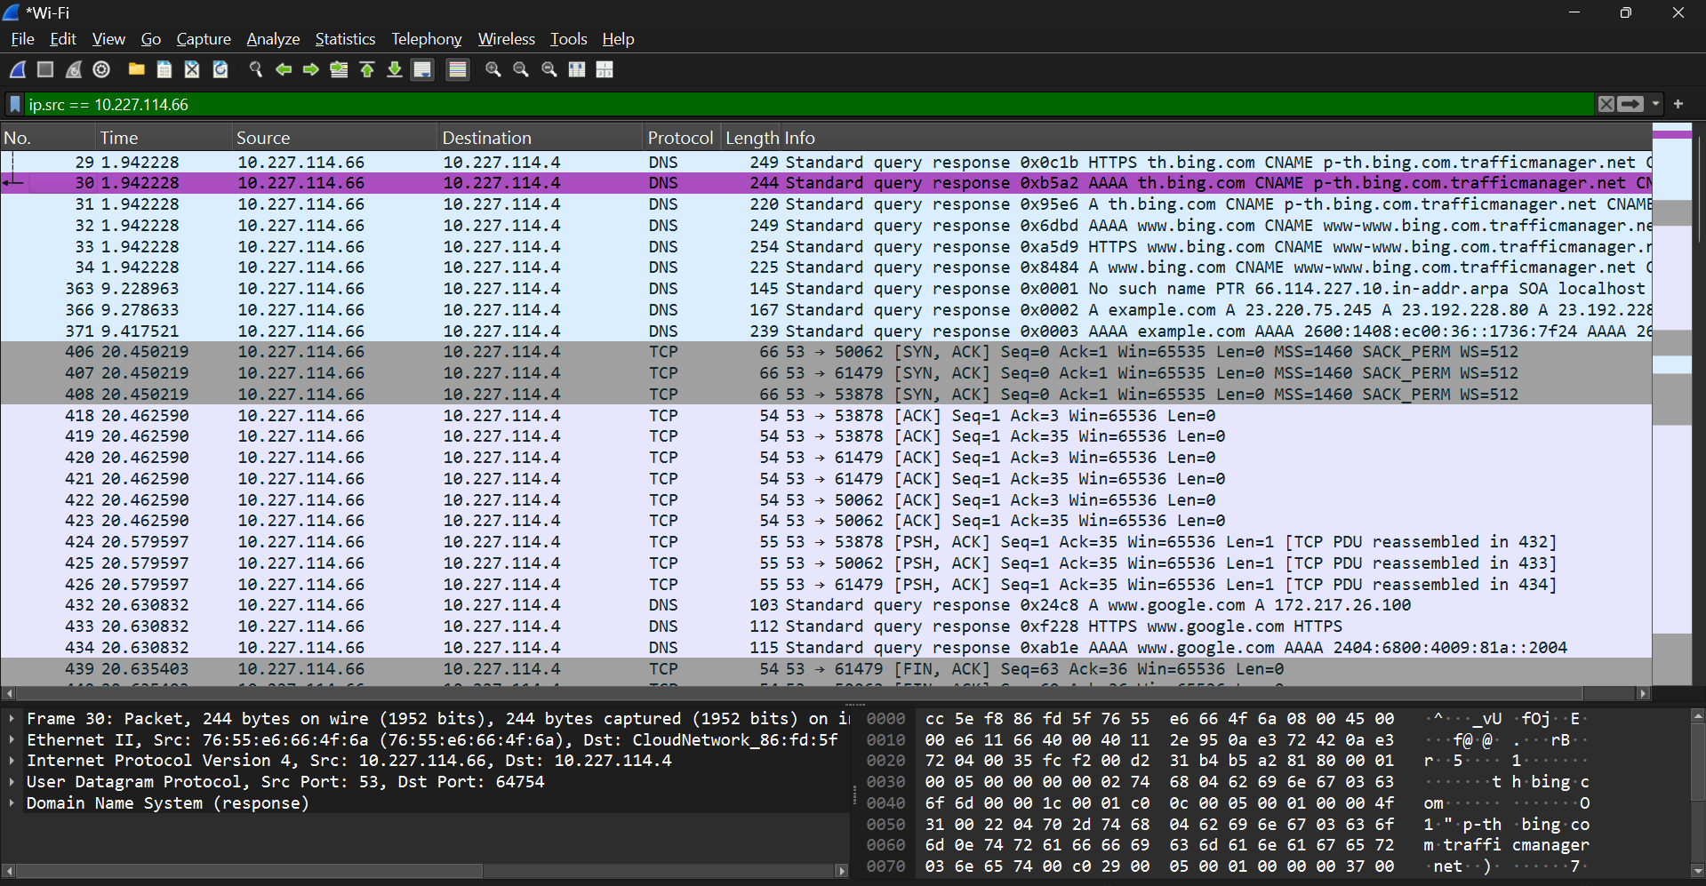

Step-4: Follow a UDP Stream
- Select a UDP packet in the list (e.g., one with DNS data).
- Right-click > Follow > UDP Stream (or Analyze > Follow > UDP Stream).
- In the stream window, switch views: "Entire conversation," "ASCII," or "Hex Dump." Click "Save As" to export the stream.

Step 7: View UDP Statistics and Graphs
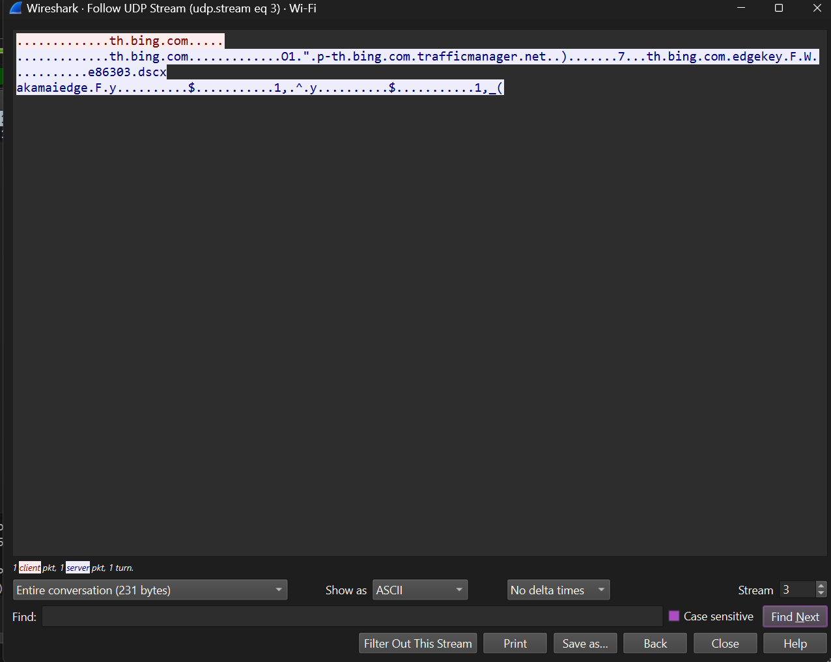

Step-5: View UDP Statistics and Graphs
- Go to Statistics > Conversations > UDP tab for endpoint summaries.
- Or Statistics > Protocol Hierarchy to see UDP percentage.
- For graphs: Statistics > IO Graphs, filter for "udp" to plot packet rates over time (no dedicated UDP stream graphs like TCP).

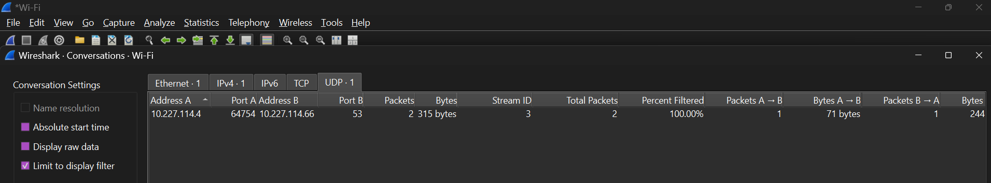
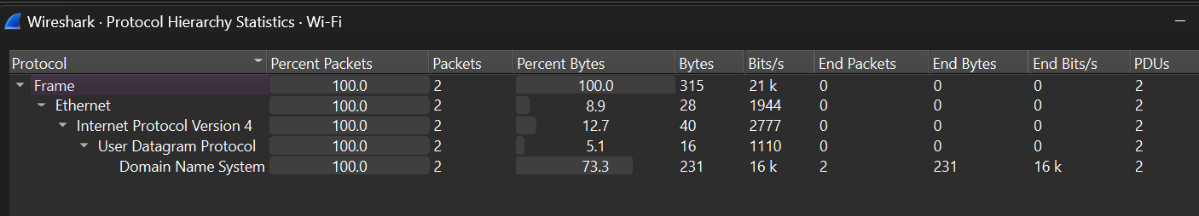

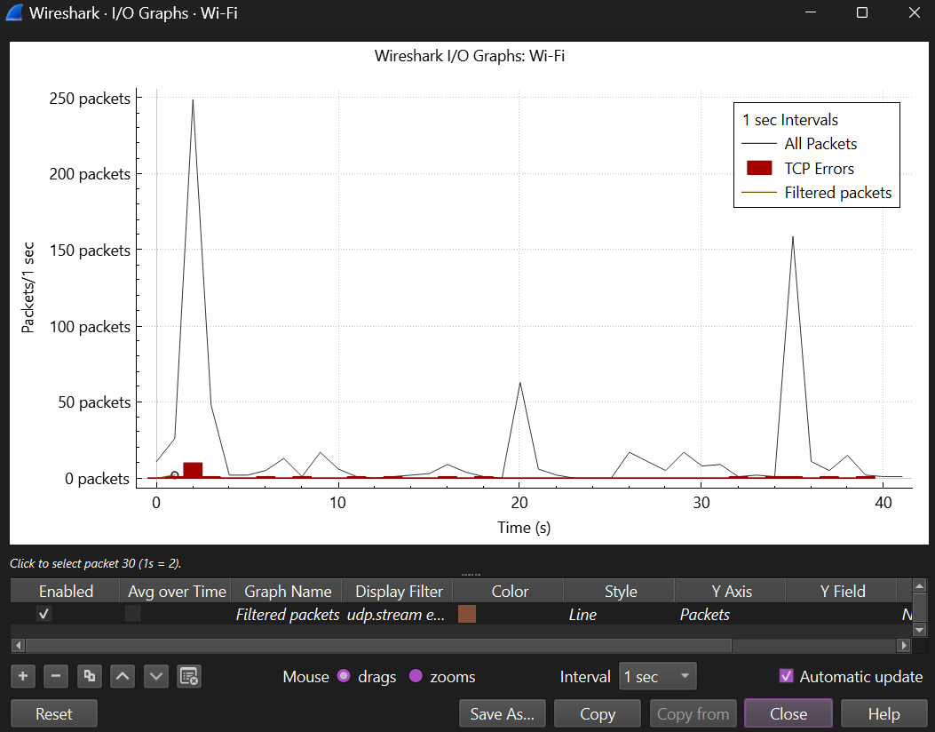

Step-6: Check Expert Information for Anomalies
- Go to Analyze > Expert Information.
- Filter by severity: Errors (red), Warnings (yellow), Notes (cyan), Chats (blue).
- Click entries to jump to packets

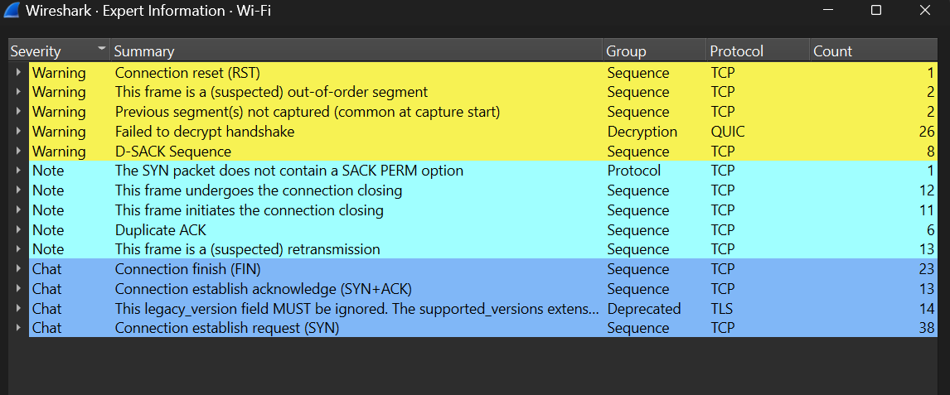

Step-7: Export and Report Findings
- For reports: Statistics > Capture File Properties > Copy to clipboard.
- Export objects: File > Export Objects > HTTP (if UDP carries HTTP-like data) or general packet bytes.
- Close Wireshark or File > Quit.

