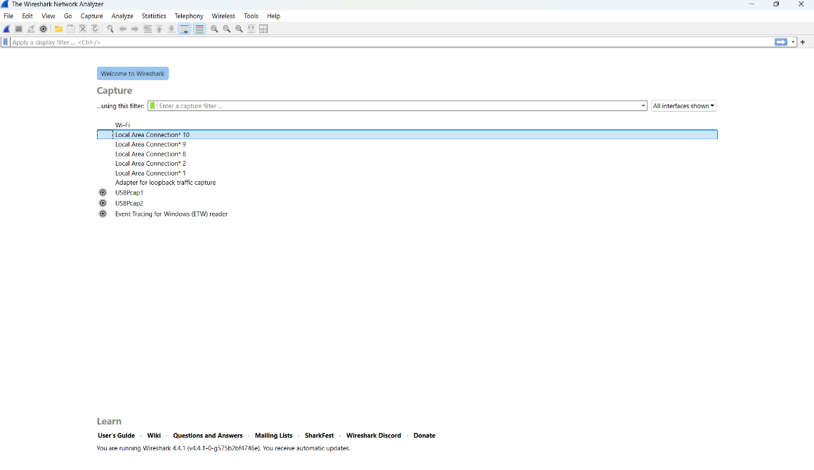
Step – 1:- Open Wireshark

Step – 2 :- Select the Network from which you want to communicate
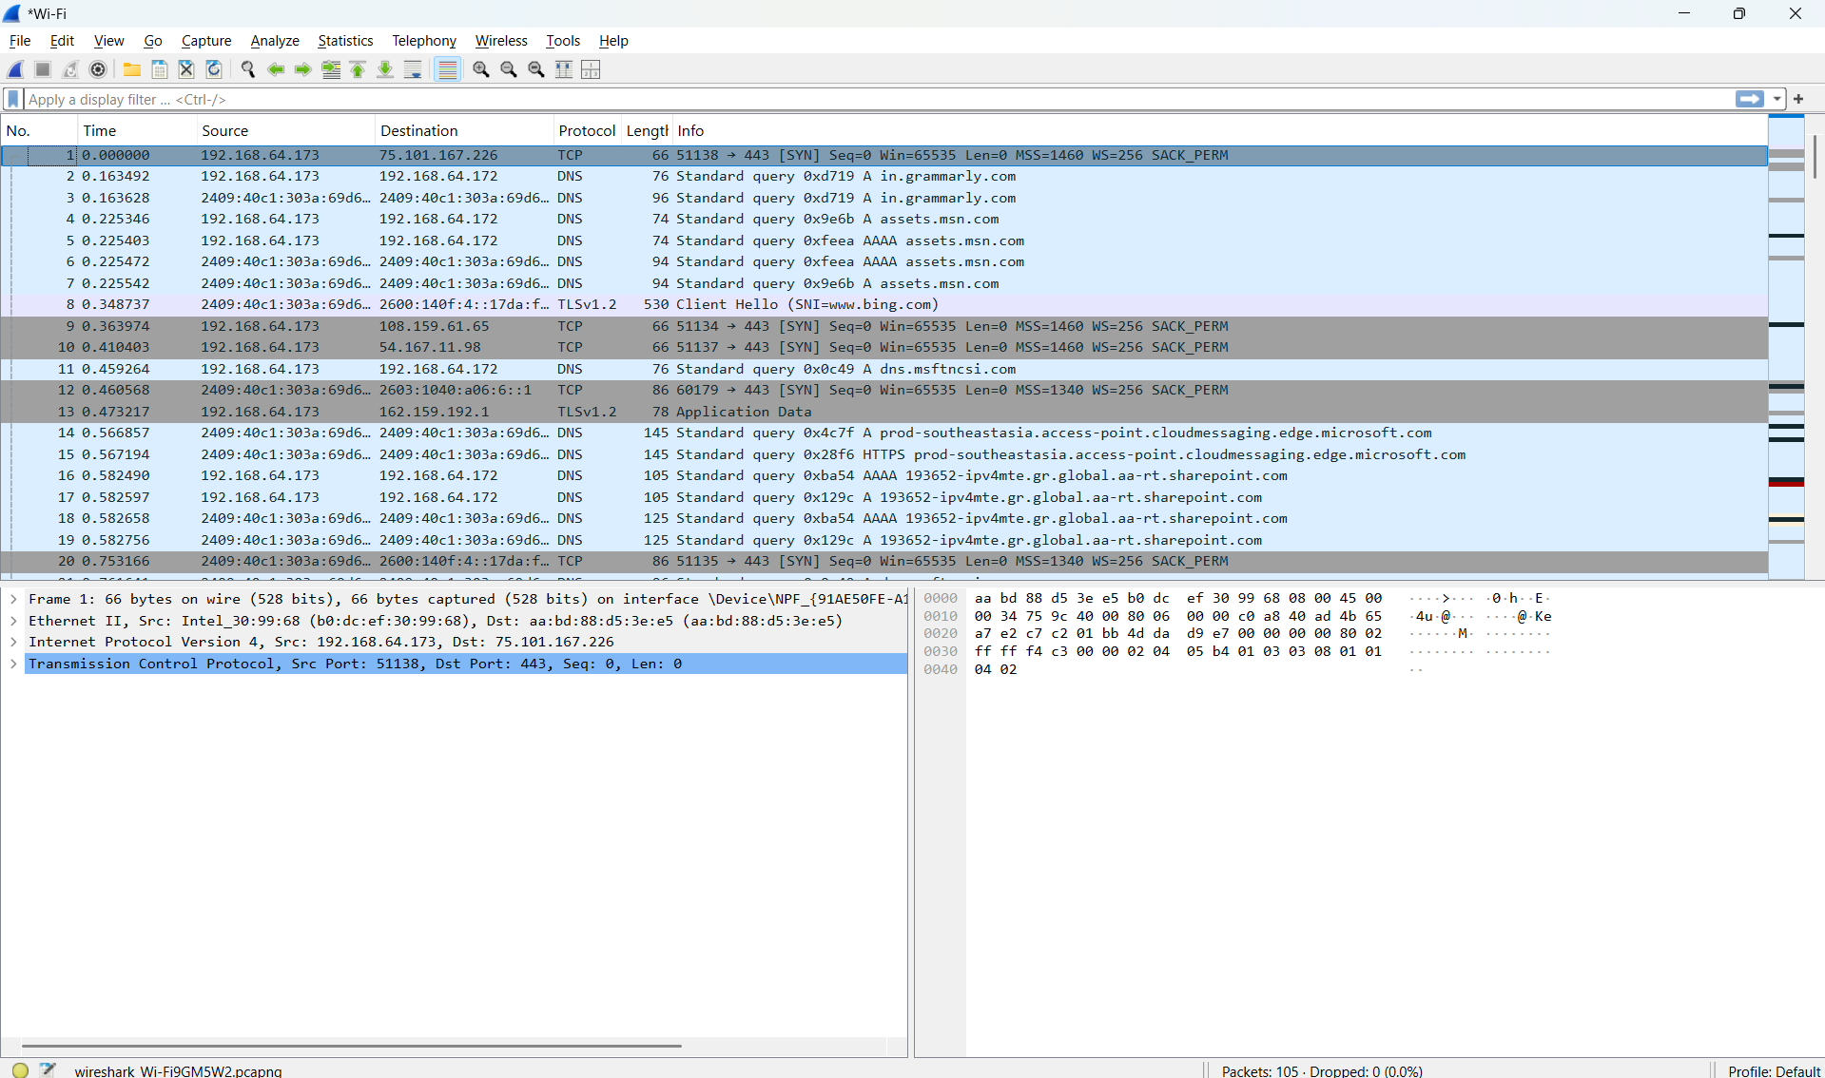

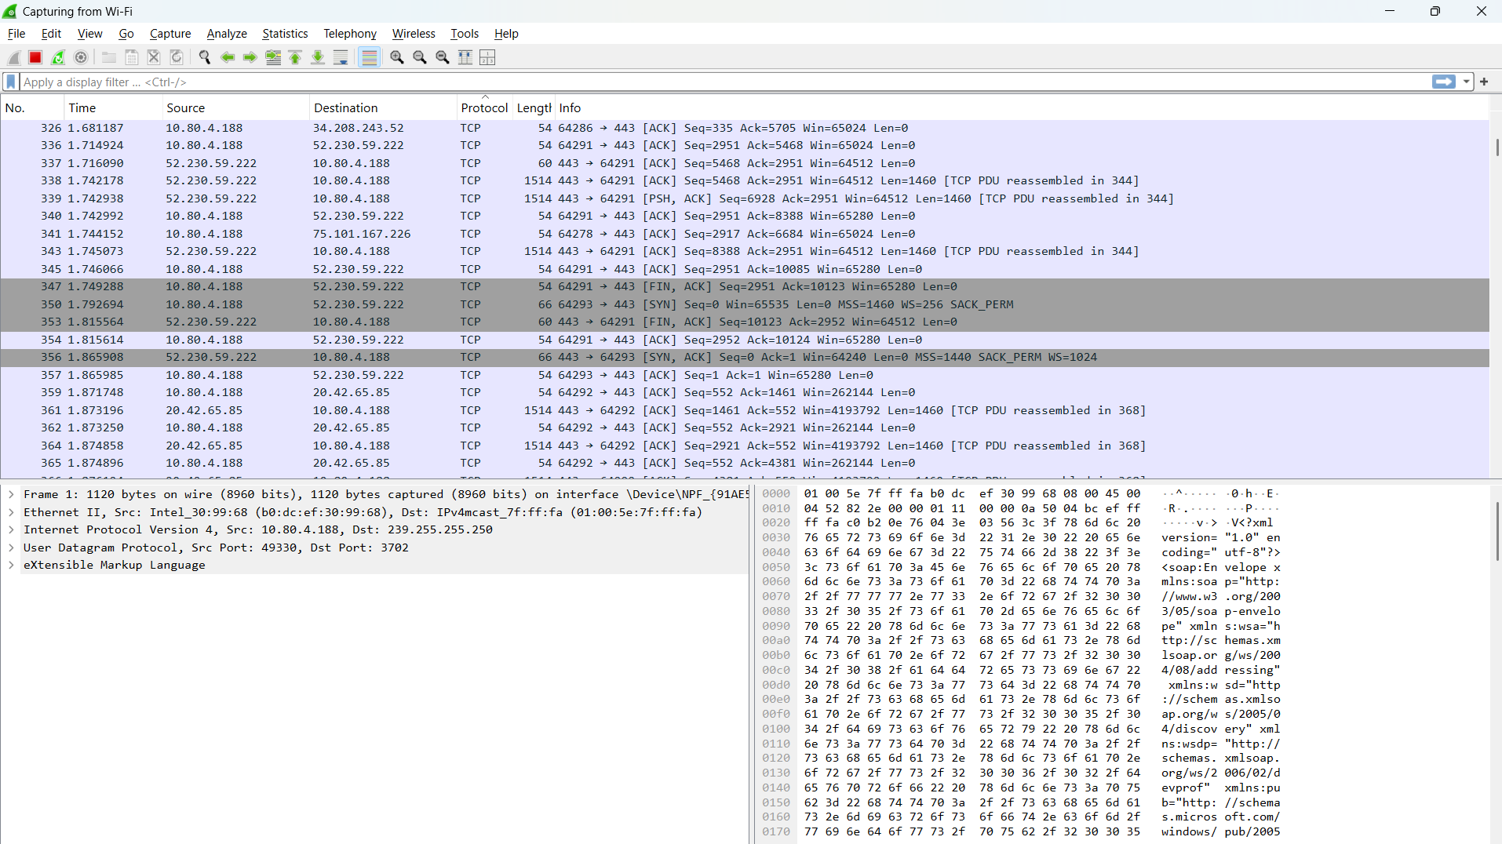
Step – 3 :- Now when we press Protocol button it will sort the packet based on protocol used.

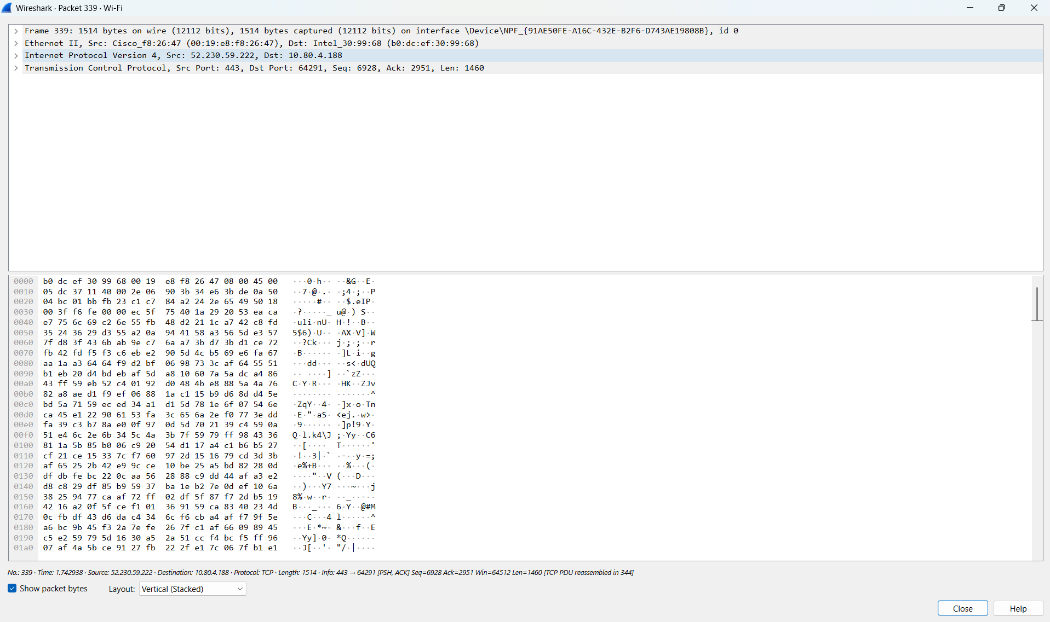
Step – 4 :- Now when we press one of the packet it will open the packet and show every detsils.

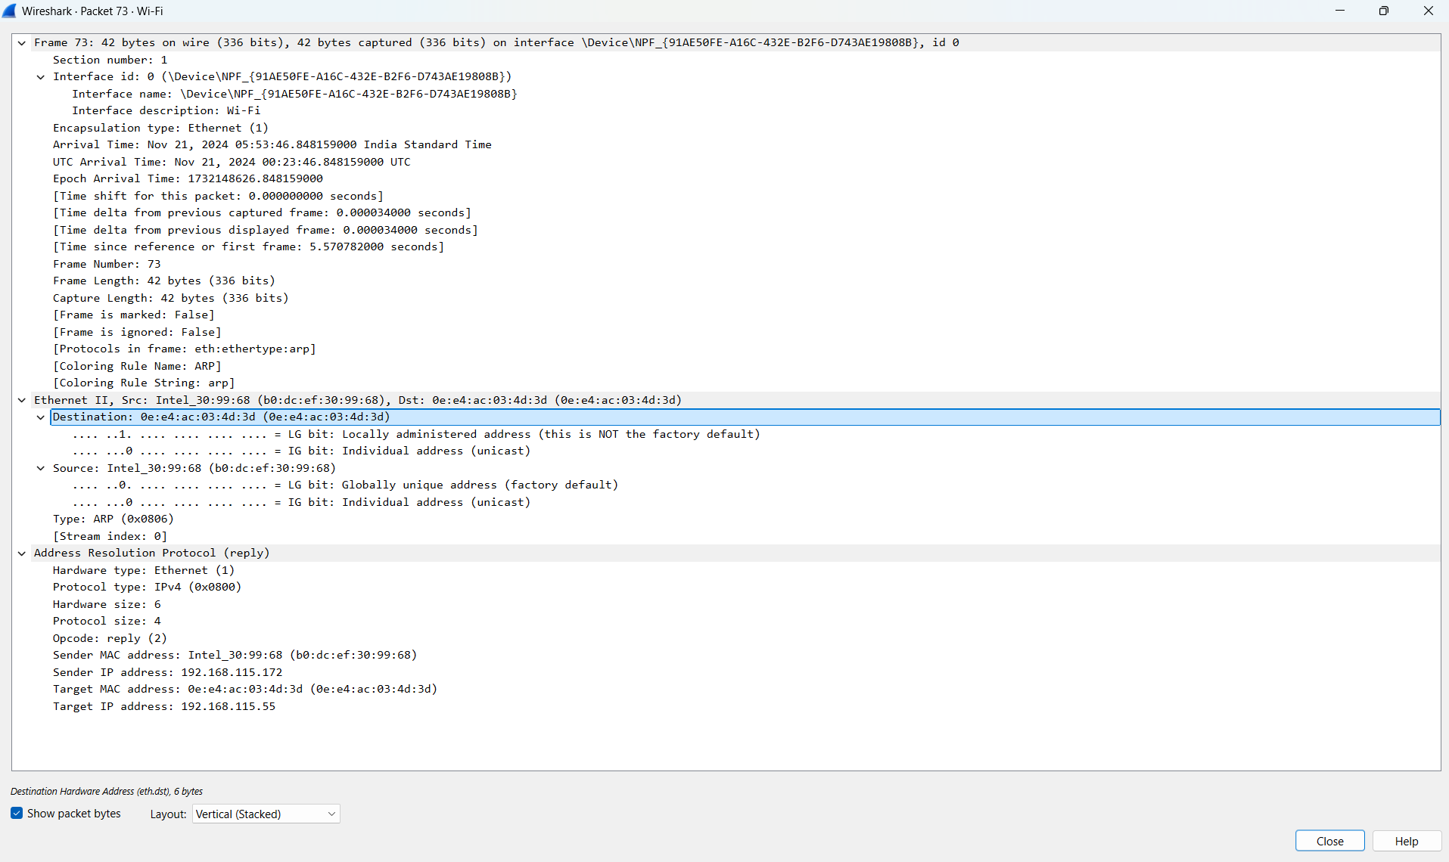
Step – 5 :- Now we will analyze one ARP Packet

Step – 7 :- Analysis of ARP Packet

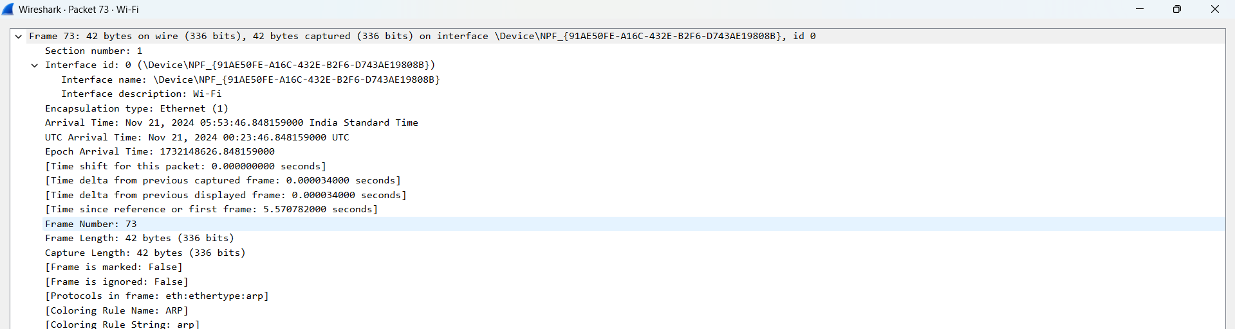

- It is the timing details and frame length and frame no.

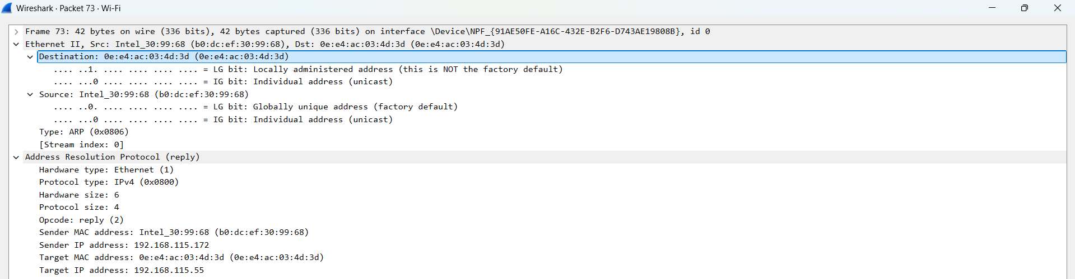
Step – 8:- It is showing the source and destination IP Address:-

Step – 9:- It is showing the TCP related details stored in the packets: like header section src and destination port no flags , checksum , length , timestamps.

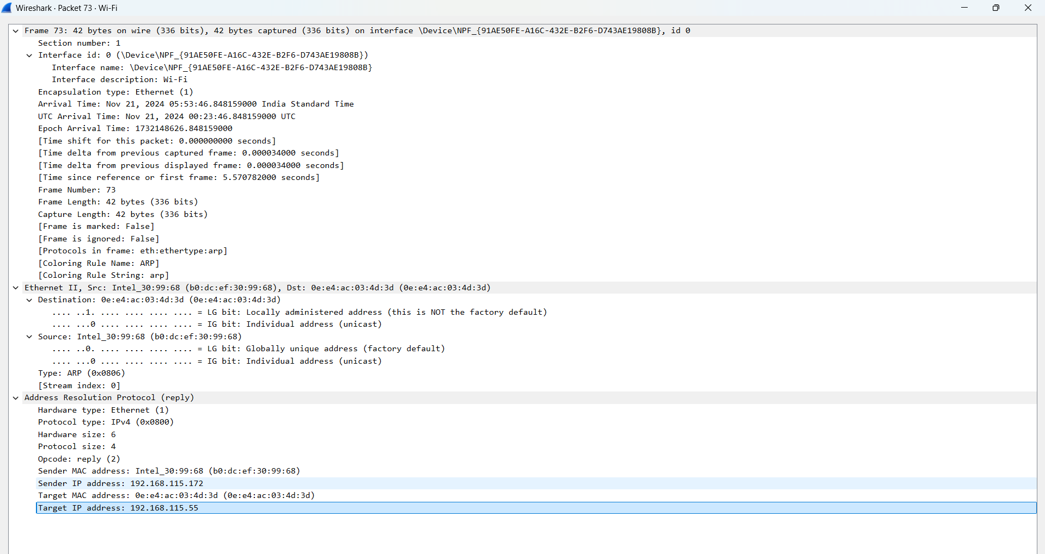

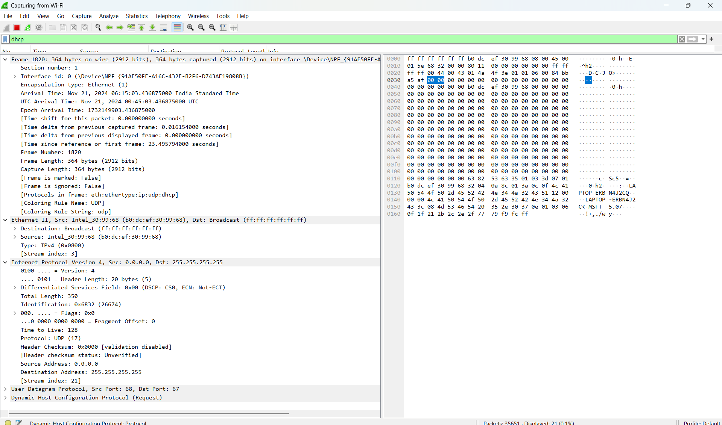
Step - 11:- now we will analyze the DHCP Packet.

Step - 12:- It us showing the timing related details of DHCP Packet.

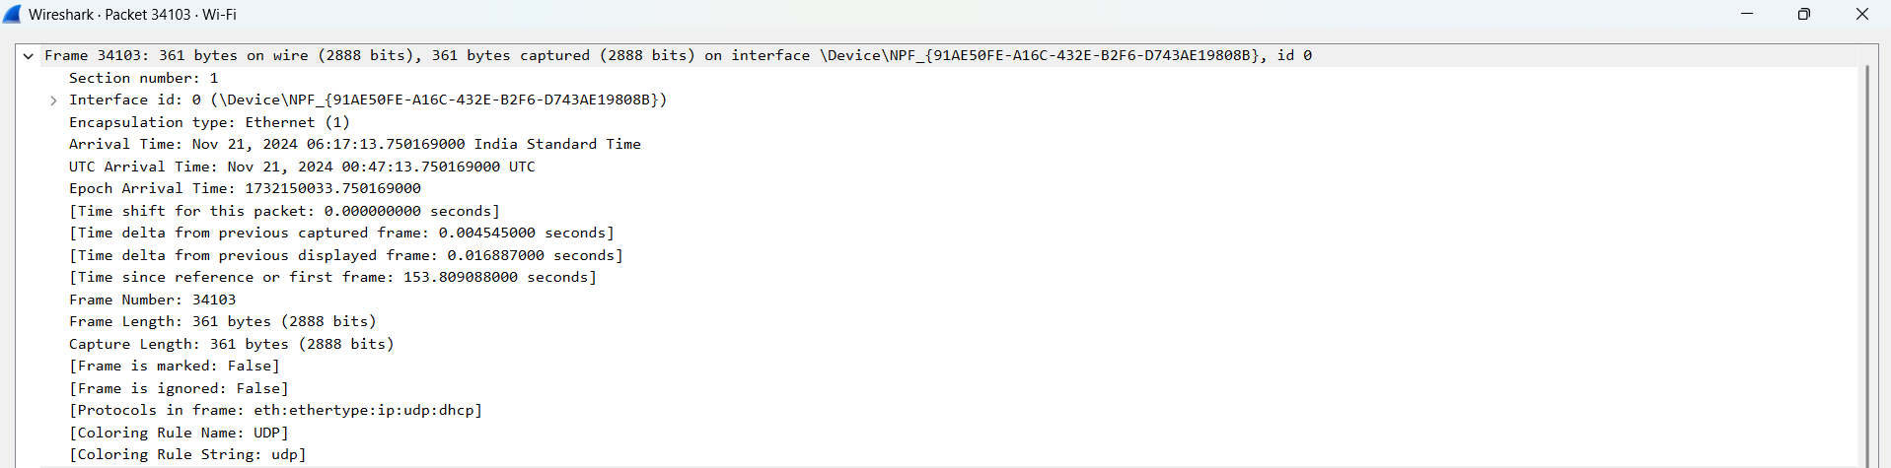

Step - 13:- It is showing the ip related details of DHCP Packet.

Step - 14:- It is showing the details about the flags of DHCP Packet.

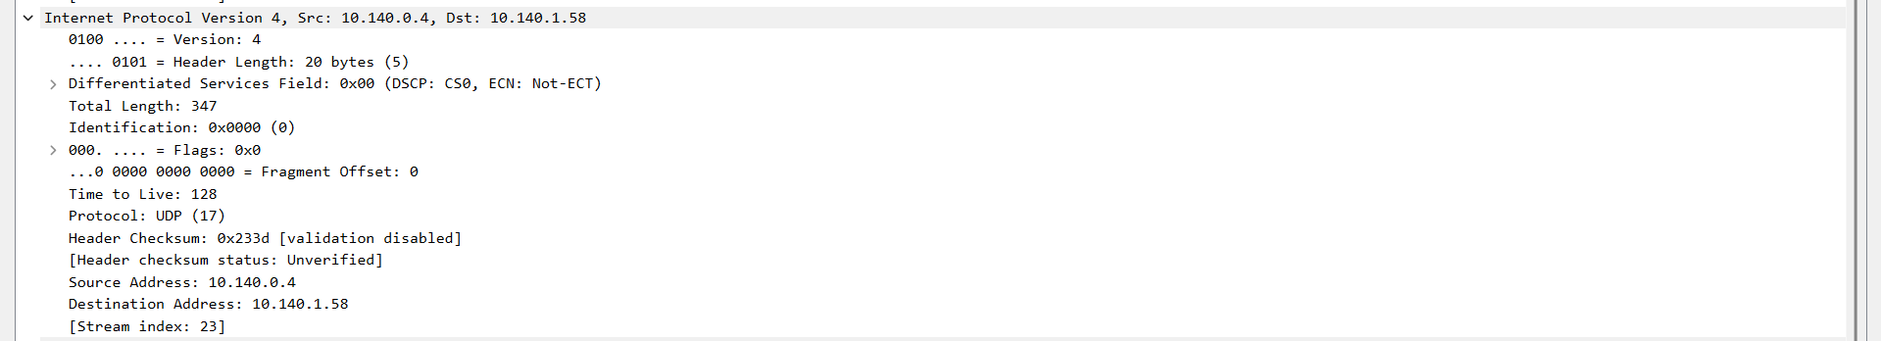

Step - 15:- It is showing the details about the header of DHCP Packet.

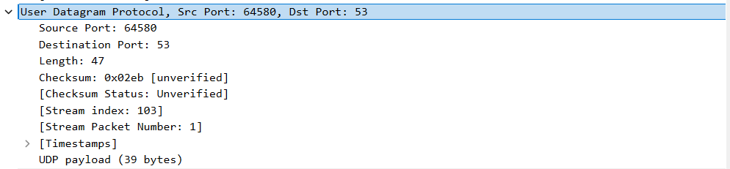

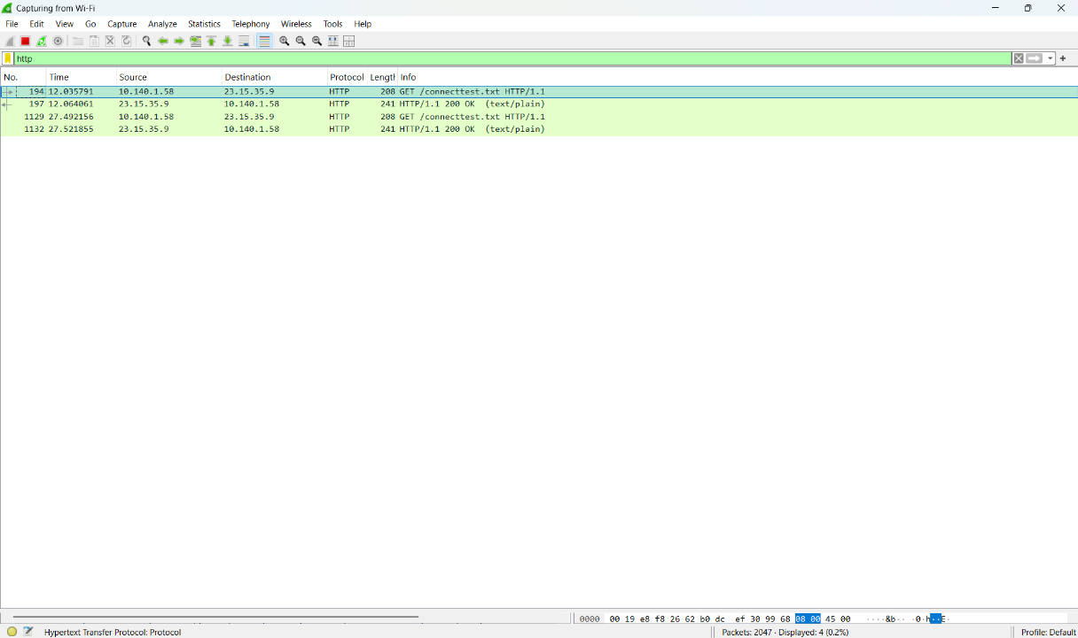
Step - 16:- Now we will analyze the HTTP Protocol.

Step - 17:- These are the timing related details of http packet
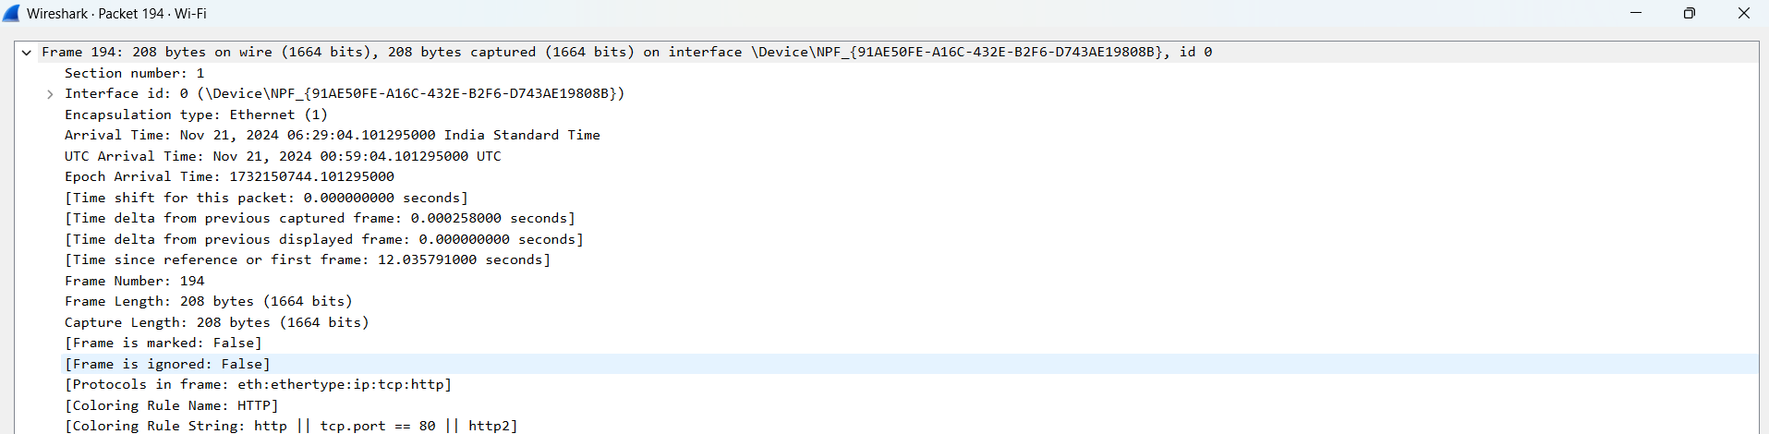

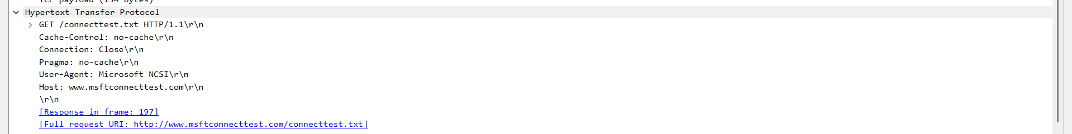
Step - 18:- these are the fields of http packets :-

