Step – 1:- Open Wireshark

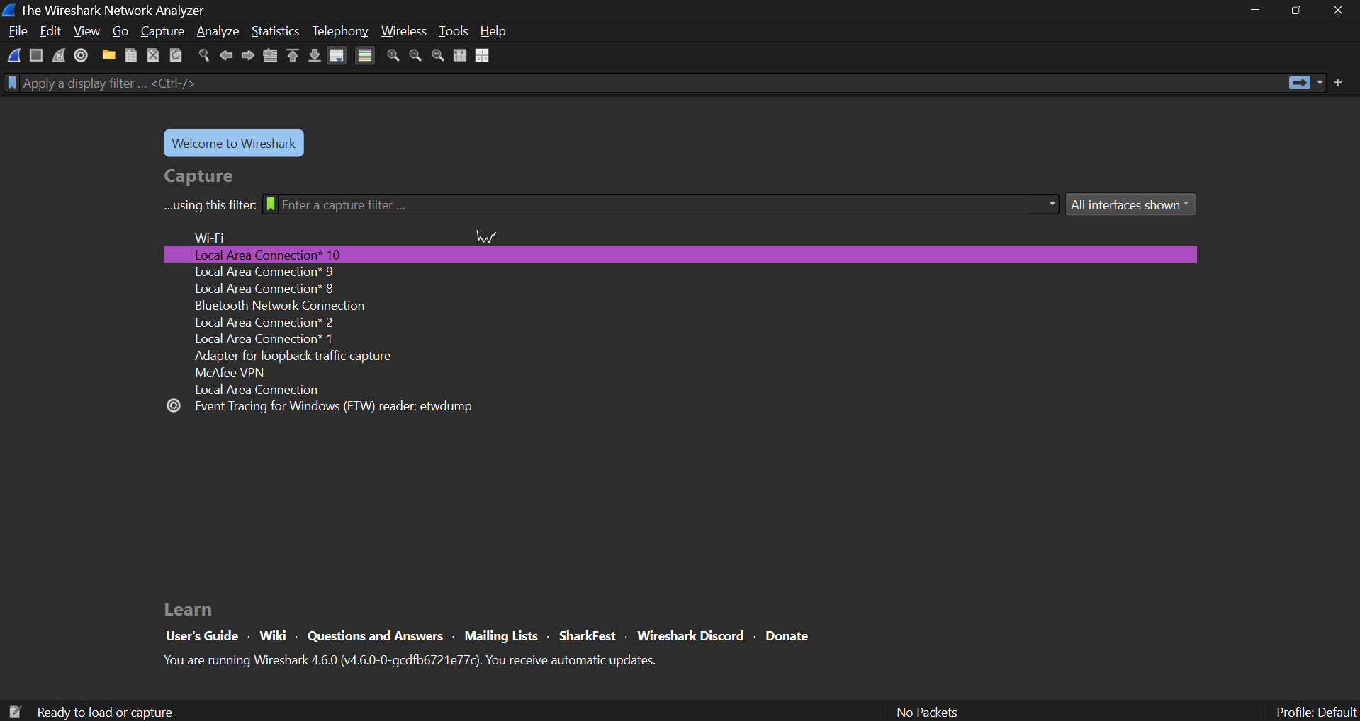

Step – 2 :- Select the Network from which you want to communicate

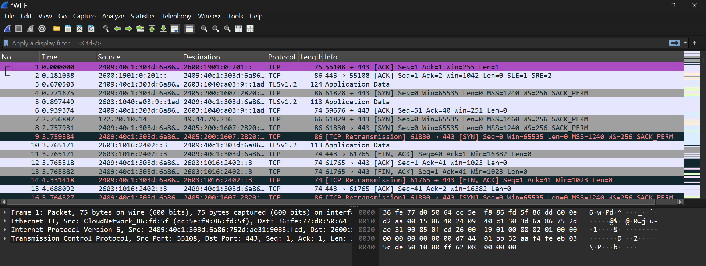

Step – 3 :- Apply Display Filters for TCP Traffic(tcp.port == 80 or tcp.port == 443)

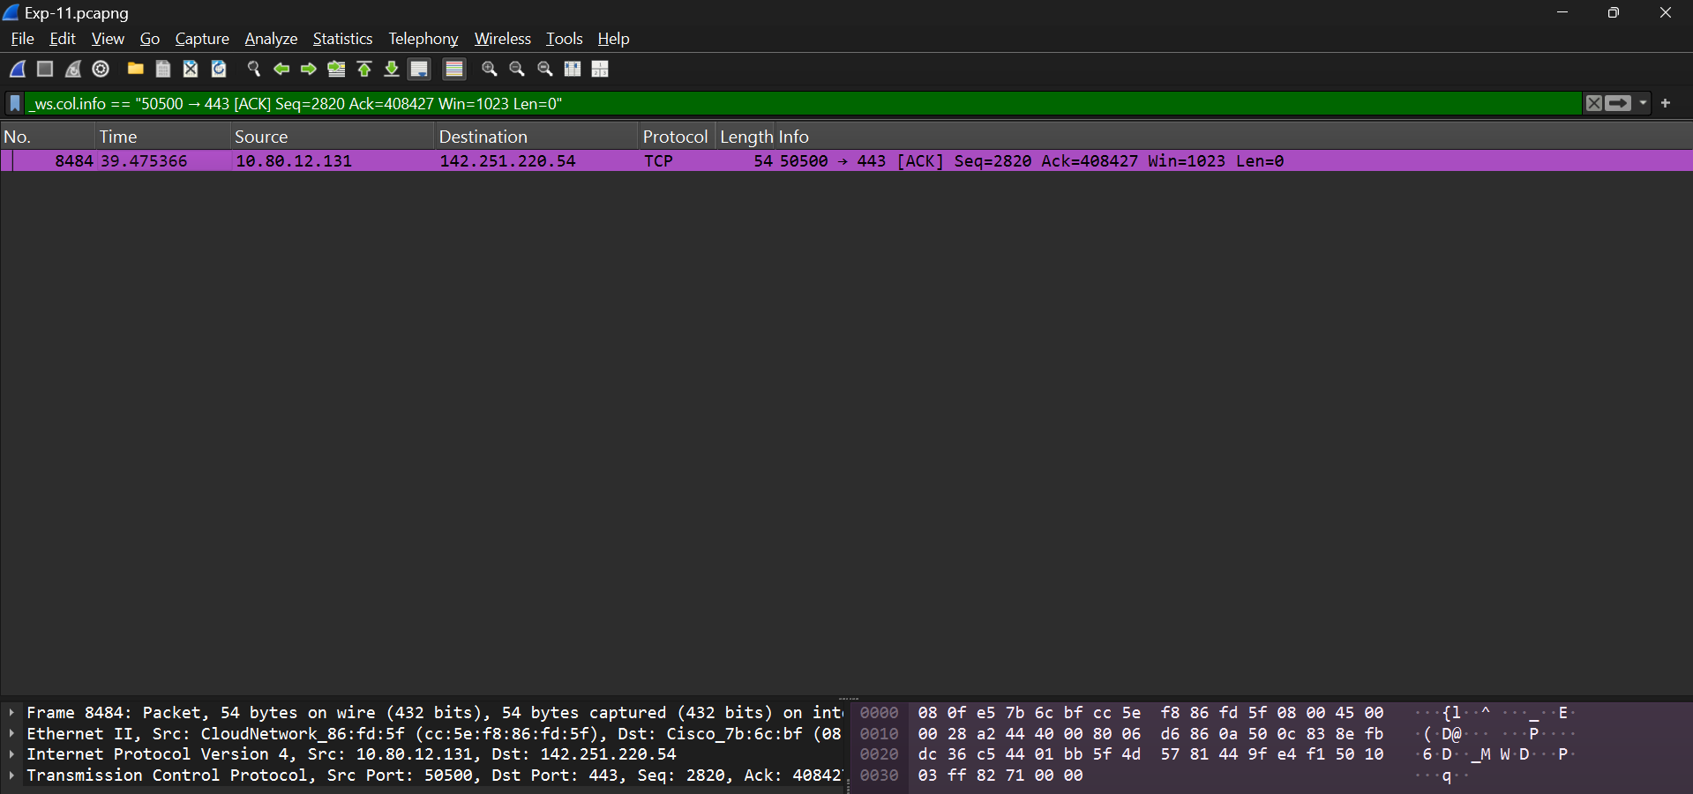

Step – 4 :- Follow a TCP Stream.

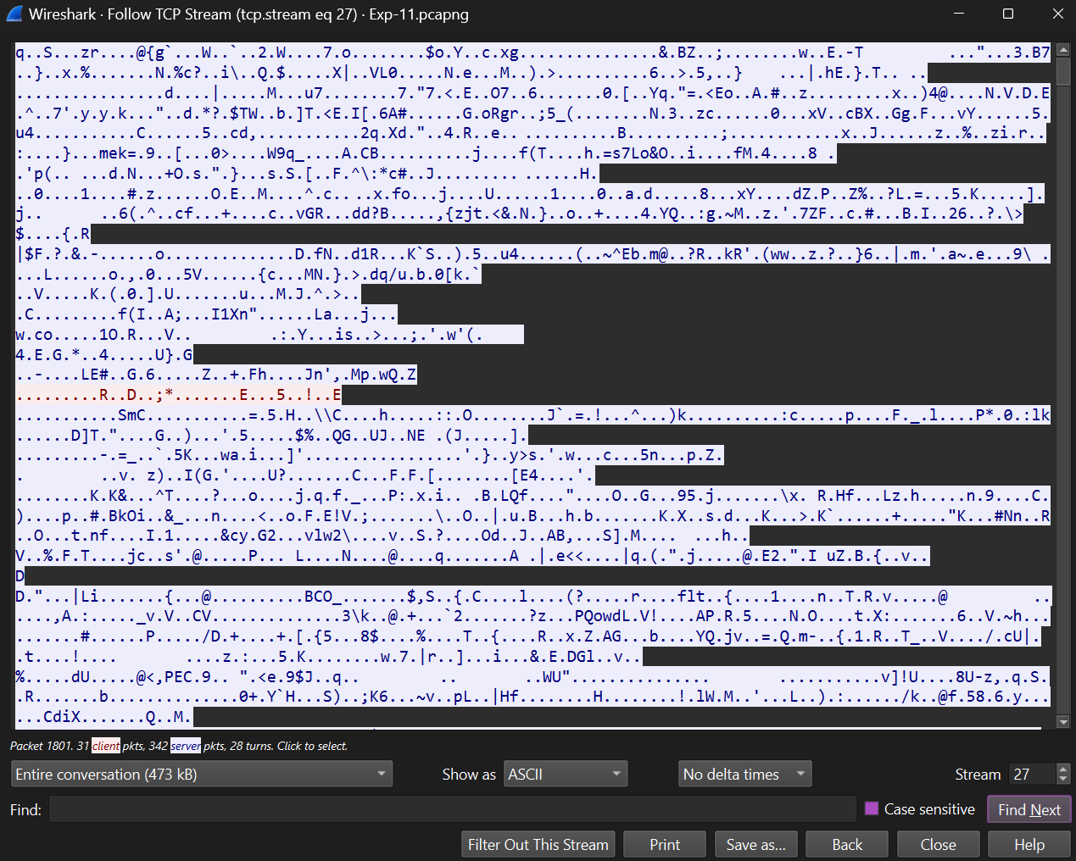

Step – 5 :- View TCP Statistics and Graphs.

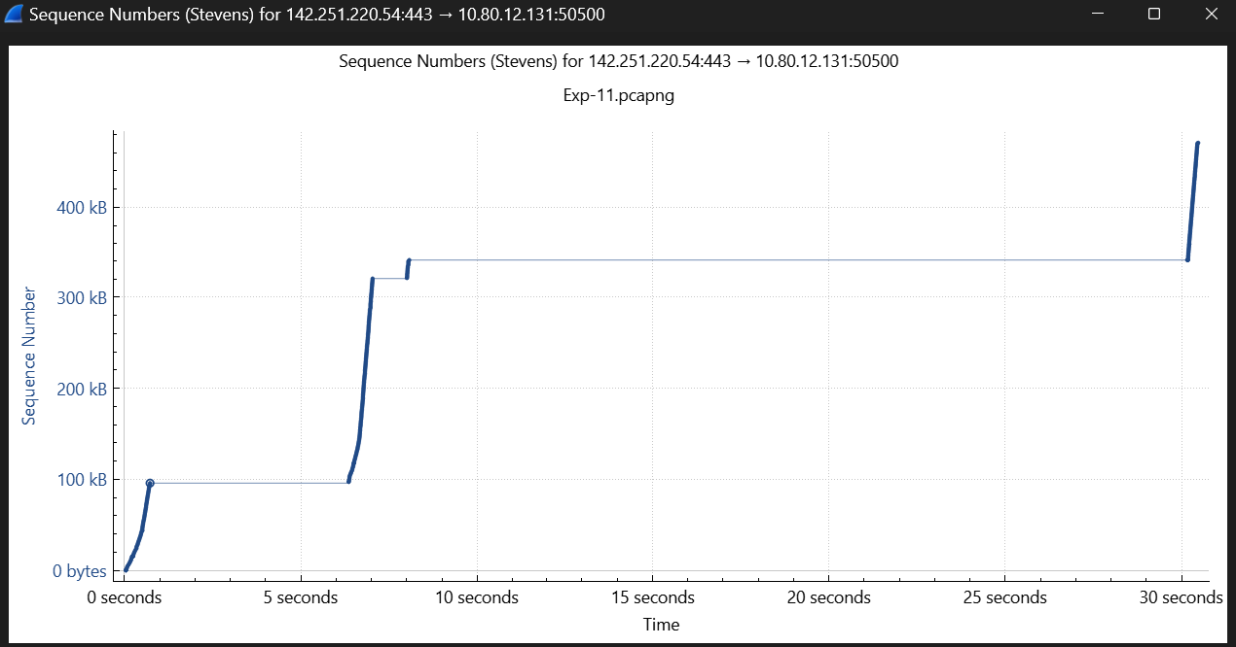

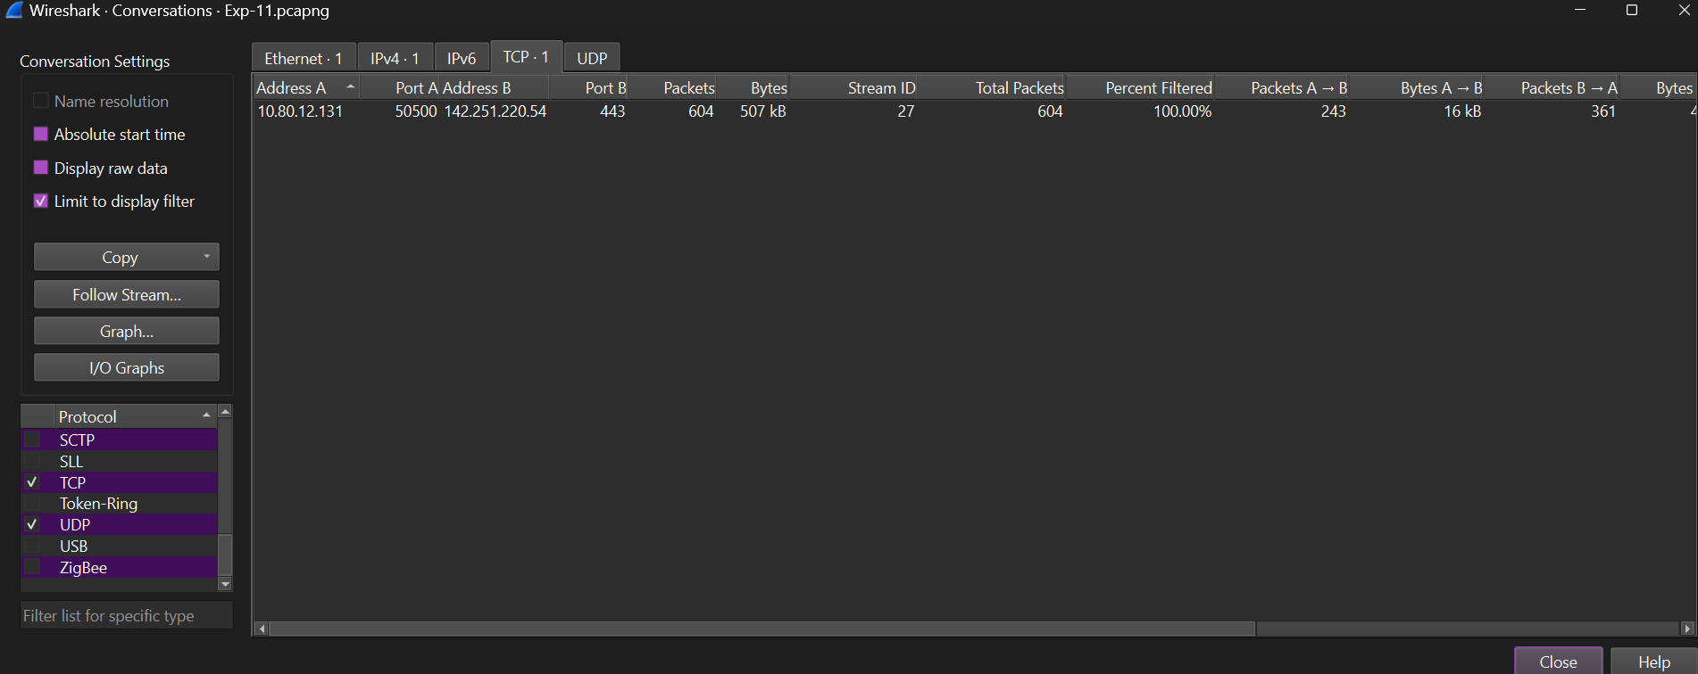

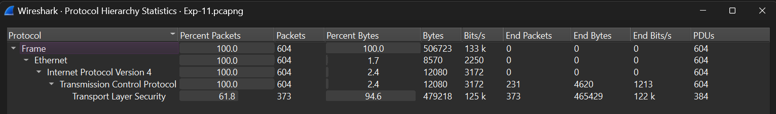

Step – 7 :- Check Expert Information for Anomalies.

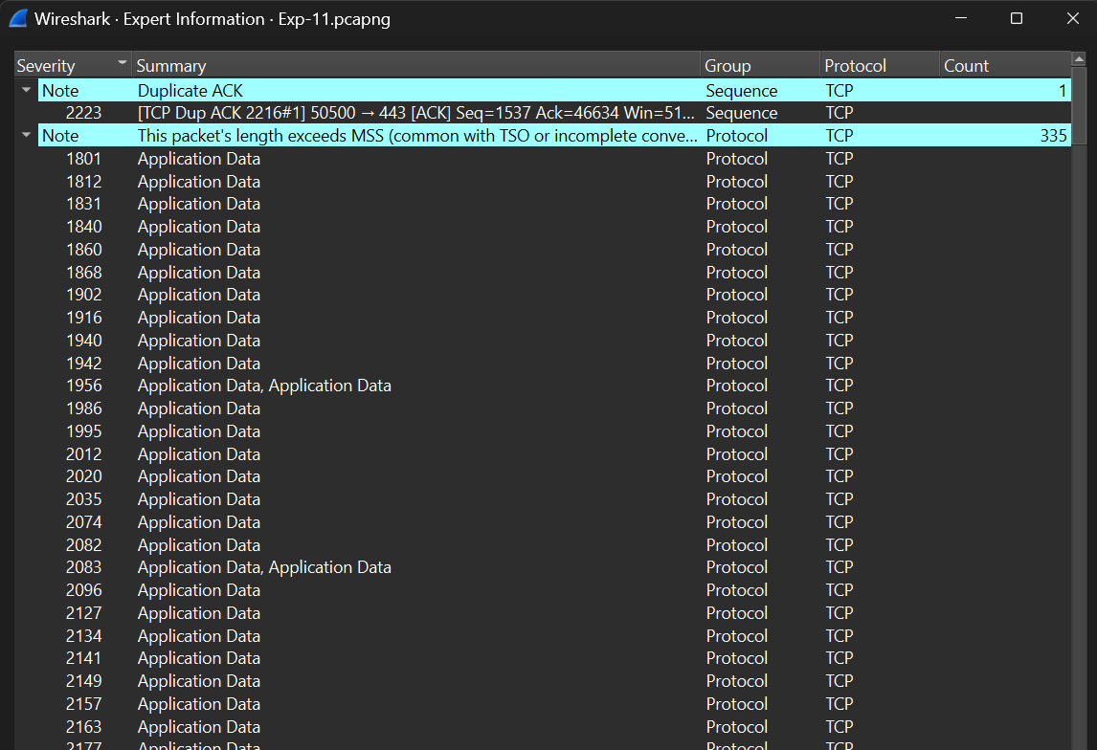

Step – 8:- Export and Report Findings.

