HACK IT-WPU’24



PLUTUS

CANDLE PROFITER: LIGHTING YOUR PATH TO PROFIT

PLUTUS

Division: Division 1 School/Department: School of Computer Science

SR. NO  . | NAME | PHONE NO | EMAIL | ROLE
1. | VARSHA SONTAKKE |  |  | Faculty Mentor
2. | AARYA SHINDE |  |  | Team Leader
3. | YASH OHARA |  |  | Team Member 1
4. | DIVYA PADUKONE |  |  | Team Member 2
5. | SIDDHESH PATIL |  |  | Team Member 3
6. | ISHAA NANGARE |  |  | Team Member 4

REPORT: Increasing Participation In The stock Market ,Pre and Post COVID-

Introduction:
The stock market has experienced significant shifts in participation, particularly among the youth, before and after the COVID-19 pandemic. This report aims to analyze the trends in stock market participation, focusing on the attraction of youth towards the stock market for quick financial gains.

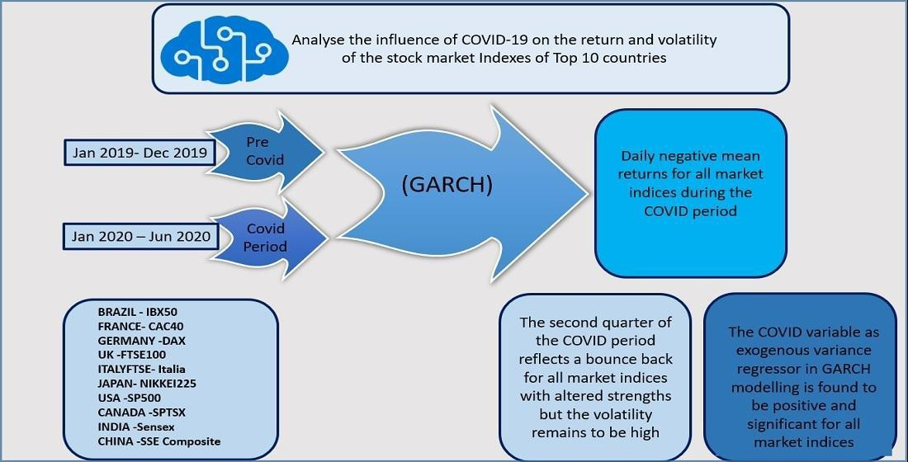

GARCH describes an approach to estimate volatility in financial markets.

Pre-COVID Trends:
Before the pandemic, stock market participation among youth was gradually increasing but remained relatively low compared to other age groups. Many young individuals were

hesitant to invest in stocks due to perceived complexity, lack of knowledge, and risk aversion.

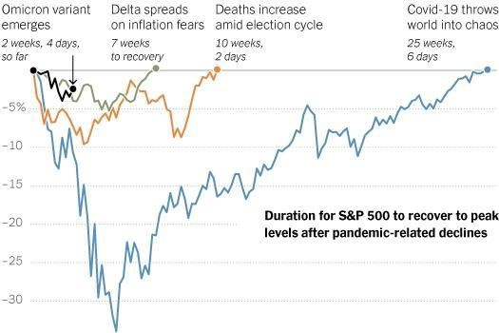

Factors Attracting Youth to the Stock Market:

- Ease of Access: Online brokerage platforms made it easier for individuals, including the youth, to access the stock market from their smartphones or computers.

- Educational Resources: Increased availability of educational resources, such as online courses, tutorials, and investment apps, helped to make the stock market and provided guidance on investing strategies much clearer and easier to understand.

- Social Media Influence: Platforms like Telegram, Twitter, and TikTok played a significant role in popularizing stock trading among the youth. The rise of social media influencers and investment communities sharing tips and success stories attracted many young investors.

- Tech Industry Boom: The rapid growth of technology companies, particularly during the pre-COVID era, fueled optimism among young investors, who saw opportunities for substantial returns in sectors like tech and renewable energy.

Post-COVID Trends:
The COVID-19 pandemic served as a catalyst for increased participation in the stock market among all age groups, including the youth.
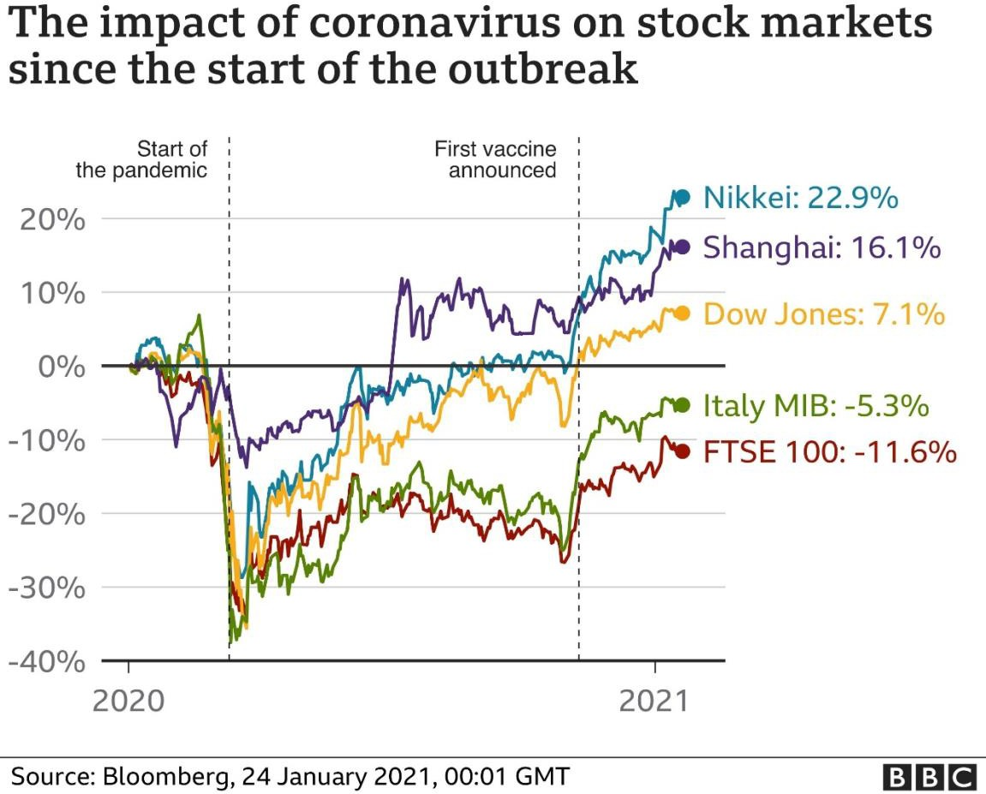

The following factors contributed to this trend:

- Remote Work and Increased Time: Lockdowns and remote work arrangements provided individuals, especially young professionals & students, with more time to explore investment opportunities and engage in stock trading.

- Market Volatility: The volatility induced by the pandemic presented both risks and opportunities for investors. Many young traders saw the market downturns as buying opportunities, while others engaged in speculative trading to capitalize on short-term price fluctuations.

- Government Stimulus: Stimulus packages and relief measures provided by governments worldwide injected into financial markets, encouraging investors to enter the stock market.

- Digital Payment Platforms: The rise of digital payment platforms and fintech innovations facilitated seamless transactions, making it easier for young investors to buy and sell stocks.

- Gamification of Investing: Some brokerage platforms introduced gamification features, such as virtual trading competitions and rewards, which appealed to the gaming-oriented mindset of many young investors.

REAL NEWS BEFORE AND AFTER PANDEMIC:
According to: THE TIMES OF INDIA
Between May 2020 and September 2021, the user base of BSE nearly doubled to over 80 million, of which the last 10 million were on-boarded only between the first week of June 2021 and the third week of September.
The online survey was conducted among 2 lakh people in the 18-50 age bracket .According to the survey carried out by an online investment platform Groww , as much as 81 per cent of the survey respondents are investing their money into stock markets followed by mutual funds etc…

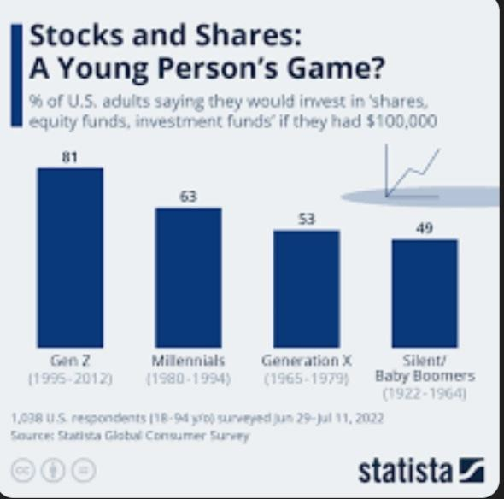

Conclusion:
The stock market has witnessed a surge in participation among the youth, driven by various factors such as technological advancements, increased access to educational resources, and the allure of quick financial gains. While this trend presents opportunities for wealth creation, it also underscores the importance of financial literacy and responsible investing practices among young investors to mitigate risks and ensure long-term financial security.

Candlestick chart:-


