Scenario 1:

Apply Discount to Interest

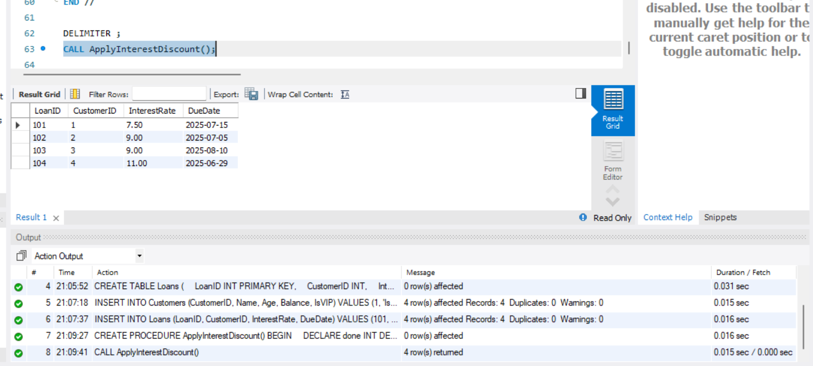

Scenario 2:

Promoting Customer to VIP

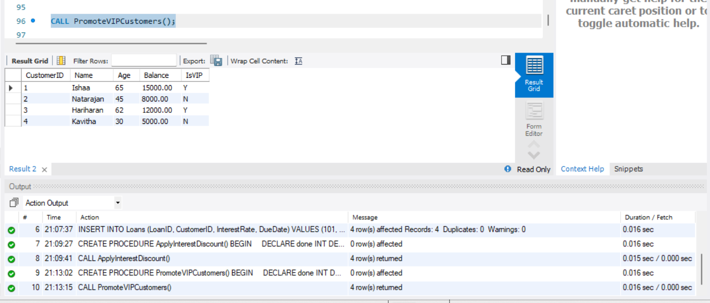

Scenario 3:

Remainders for loan dues in next 30 Days

