Agentic Browser

Table of Contents
(Table of contents will be generated when you open the document in Word)

A production-grade, Chrome-like browser with integrated AI agent capabilities. Built with Electron + React + TypeScript.

✨ Features
Feature | Description
🌐 Modern Browser | Full Chrome-like tabbed browsing experience
🤖 AI Agent | Integrated AI that can browse, search, and complete tasks autonomously
🎨 Beautiful UI | Dark/light themes with smooth Framer Motion animations
⚡ Fast | Vite-powered development, optimized production builds
🔒 Secure | Sandboxed webviews, encrypted API key storage
⌨️ Keyboard First | Full keyboard navigation with customizable shortcuts

🏗️ Architecture

High-Level System Architecture
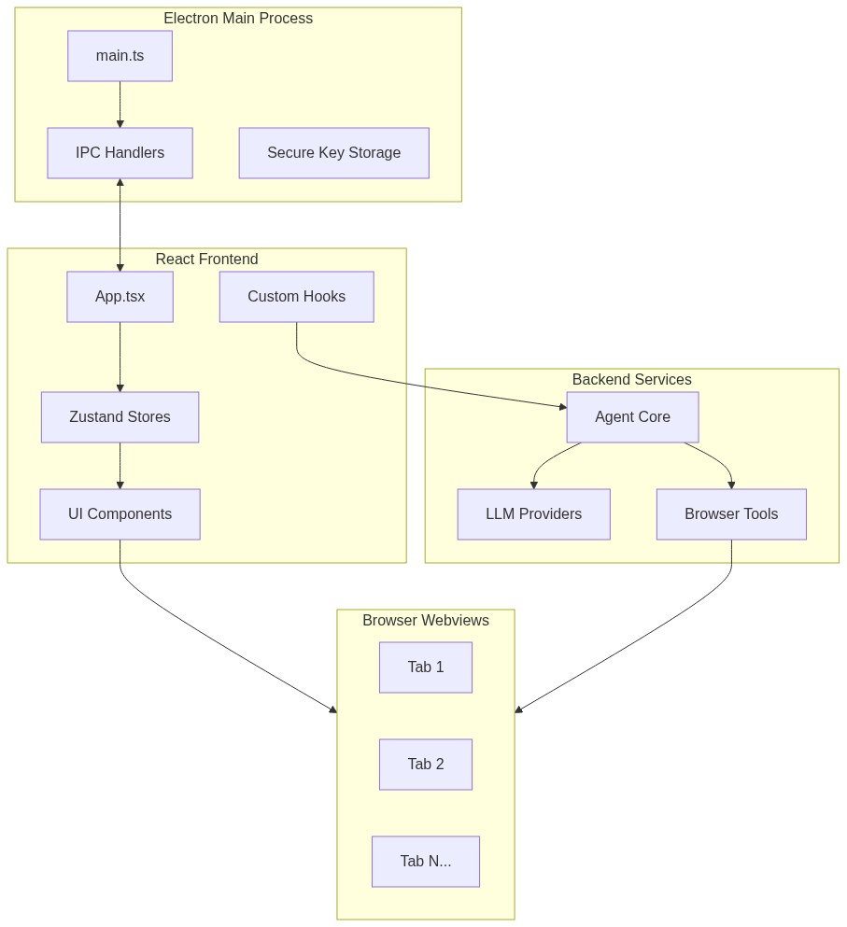
Mermaid Diagram 1

Agent Execution Flow
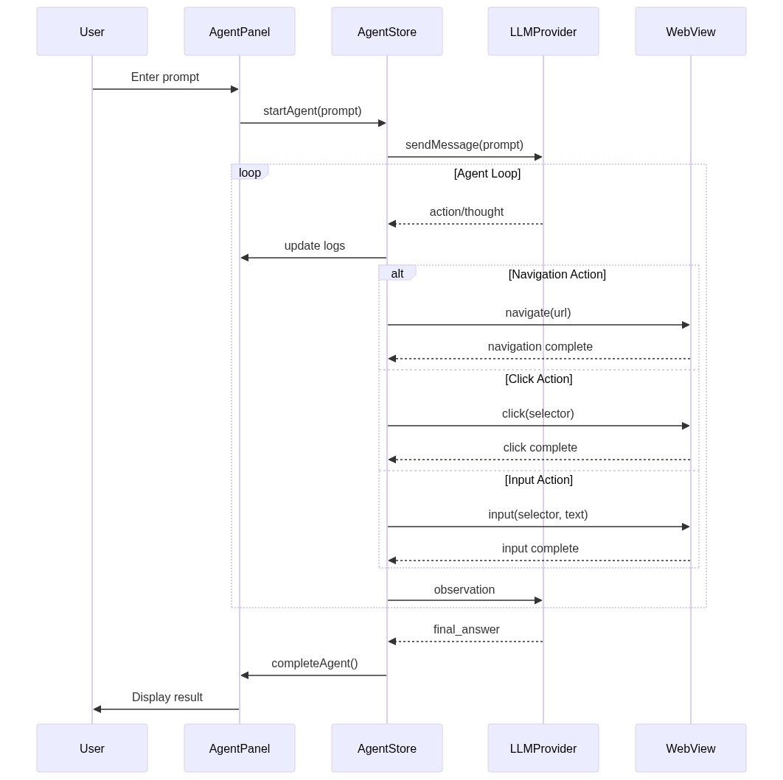
Mermaid Diagram 2

Frontend State Management
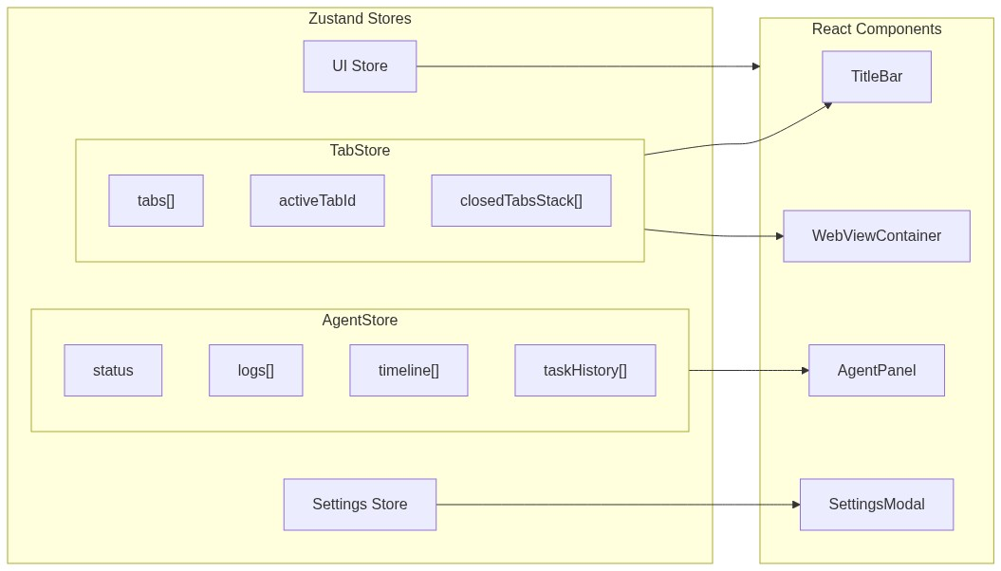
Mermaid Diagram 3

🚀 Quick Start

Prerequisites
- Node.js 18+
- npm 9+

Installation
# Clone the repository
git clone https://github.com/Kritavya/agentic-browser-electron.git
cd agentic-browser-electron
# Install dependencies
npm install
# Start development server
npm run dev

Build for Production
# Build the application
npm run build
# Package for distribution
npm run package

⌨️ Keyboard Shortcuts
Action | Shortcut
New Tab | Ctrl+T
Close Tab | Ctrl+W
Next Tab | Ctrl+Tab
Previous Tab | Ctrl+Shift+Tab
Reopen Closed Tab | Ctrl+Shift+T
New Window | Ctrl+N
Focus Address Bar | Ctrl+L
Open History | Ctrl+H
Open Downloads | Ctrl+J
Toggle Agent Panel | Ctrl+Shift+A
Open Settings | Ctrl+,
Reload Page | Ctrl+R / F5
Toggle Vertical Tabs | Ctrl+Shift+V

📁 Project Structure
agentic-browser-electron/
├── electron/ # Electron main process
│ ├── main.ts # Main entry, window management
│ └── preload.ts # Context bridge, IPC
├── frontend/ # React frontend
│ ├── app/ # Root components
│ ├── components/ # Shared UI components
│ ├── features/ # Feature modules
│ │ ├── agent/ # AI agent panel
│ │ ├── tabs/ # Tab bar system
│ │ └── history/ # History panel
│ ├── hooks/ # Custom React hooks
│ ├── store/ # Zustand state stores
│ └── theme/ # Design system
├── backend/ # Backend services
│ ├── models/ # LLM provider configs
│ └── tools/ # Agent tool definitions
└── package.json

🔧 Tech Stack
Layer | Technology
Desktop | Electron 29
Framework | React 18 + TypeScript 5
Styling | Tailwind CSS + CSS Variables
Animations | Framer Motion
State | Zustand
Icons | Lucide React
Bundler | Vite

🤖 AI Providers
Supports multiple LLM providers:
Provider | Models | Free Tier
OpenRouter | Kimi K2, Gemma 3, Qwen3, Llama 3.3 | ✅ Yes
Google | Gemini 2.5 Flash, Gemini 3 Flash/Pro | ✅ 20 req/day
Anthropic | Claude 3.5 Sonnet, Claude 4 | ❌ No
OpenAI | GPT-4o, GPT-4o-mini | ❌ No

🛡️ Security
- Sandboxed Webviews: Each tab runs in isolated sandbox
- Encrypted API Keys: Stored using Electron's safeStorage
- Context Isolation: Frontend has no direct Node.js access
- No Cloud Storage: All data stored locally

👨‍💻 Author
Kritavya Patel
📧 kritavyapatel999@gmail.com
🔗 GitHub

📄 License
MIT License - see LICENSE for details.

