Agentic Browser: A Next-Generation AI-Integrated Web Browsing Paradigm

Table of Contents
(Table of contents will be generated when you open the document in Word)

Abstract
The rapid advancement of Large Language Models (LLMs) has ushered in a new era of human-computer interaction, evolving from simple chat interfaces to autonomous agents capable of performing complex tasks. This report details the architecture, design, and implementation of the "Agentic Browser"—a production-grade, Chrome-like browser built with Electron, React, TypeScript, and Tailwind CSS. By deeply integrating an autonomous AI agent directly into the browser's core process rather than relying on fragile browser extensions, the system enables seamless web navigation, interaction, and real-time voice-driven commands. This report extensively covers the architecture, the multi-provider LLM support, and a highly optimized local voice transcription pipeline built around whisper.cpp.

1. Introduction
Traditional web browsing requires users to manually navigate, read, parse, and interact with web pages to accomplish their goals. As the web becomes more complex, the cognitive load on users increases. Agentic Browser seeks to mitigate this by embedding an AI agent directly into the browsing environment. The browser is capable of autonomous navigation, data extraction, form submission, and logical reasoning, guided by user prompts or real-time voice transcripts.
Unlike existing solutions that rely on DOM manipulation via Chrome Extensions (which are heavily restricted by Content Security Policies and extension limits), the Agentic Browser is built on the robust foundation of Electron. This provides native access to webviews, cross-platform desktop capabilities, and a modern React frontend optimized for performance and aesthetic appeal.

2. Literature Review
The development of the Agentic Browser intersects several active areas of research in Artificial Intelligence and Human-Computer Interaction:

2.1 Autonomous Web Agents
Recent research has focused heavily on LLMs acting as web agents. Frameworks like WebGPT (Nakano et al.) and AutoGPT have demonstrated that given a goal, LLMs can autonomously issue search queries, read web pages, and synthesize answers. However, most of these agents operate as headless scripts, leading to a disconnect between the user's visual context and the agent's actions. The Agentic Browser solves this by executing agent operations within visible, sandboxed web views within the user's active browsing session.

2.2 Local Inference, LLM Multi-Plexing, and Data Privacy
A critical concern in AI-assisted browsing is the privacy of user data. Sending every web page's DOM or user query to centralized cloud providers poses significant security risks. The Agentic Browser supports a hybrid multi-provider approach. It supports premium Cloud LLM providers (Anthropic Claude 3.5, OpenAI GPT-4o, Google Gemini Flash/Pro), OpenRouter integrations (Kimi K2, Gemma 3, Qwen3), alongside localized execution environments (Llama.cpp). This multiplexing ensures users can balance cost, latency, and absolute privacy.

2.3 Streaming Voice Transcriptions in Desktop Apps
Voice interfaces lower the barrier to interaction. Technologies like OpenAI's Whisper model have revolutionized Automatic Speech Recognition (ASR). Researchers have increasingly focused on streaming transcription pipelines that minimize latency. By employing whisper.cpp locally (which runs pure C/C++ inference without Python dependencies), the browser achieves continuous, non-blocking audio transcription, allowing users to issue complex agent commands conversationally and with high accuracy directly on consumer CPUs.

3. System Architecture and Component Mapping
The Agentic Browser uses a multi-process architecture inherited from Electron, enhanced by a carefully designed IPC (Inter-Process Communication) layer that connects the UI, the backend agent services (Eko), and the sandboxed web views.

3.1 High-Level Systems
The system is cleanly decoupled into four main spaces:
1. Electron Main Process: Manages windows, secure credential storage, and IPC routing.
2. React Frontend: Built with React 18 and Tailwind. Manages tabs, settings, and the Agent Control Panel.
3. Sandboxed WebViews: The actual rendering surfaces of the internet. They are dynamically attached to the Agent context.
4. Backend Services (Eko Core): Handles LLM provider routing, Tool execution (clicking, typing, navigating), and the Whisper Manager.
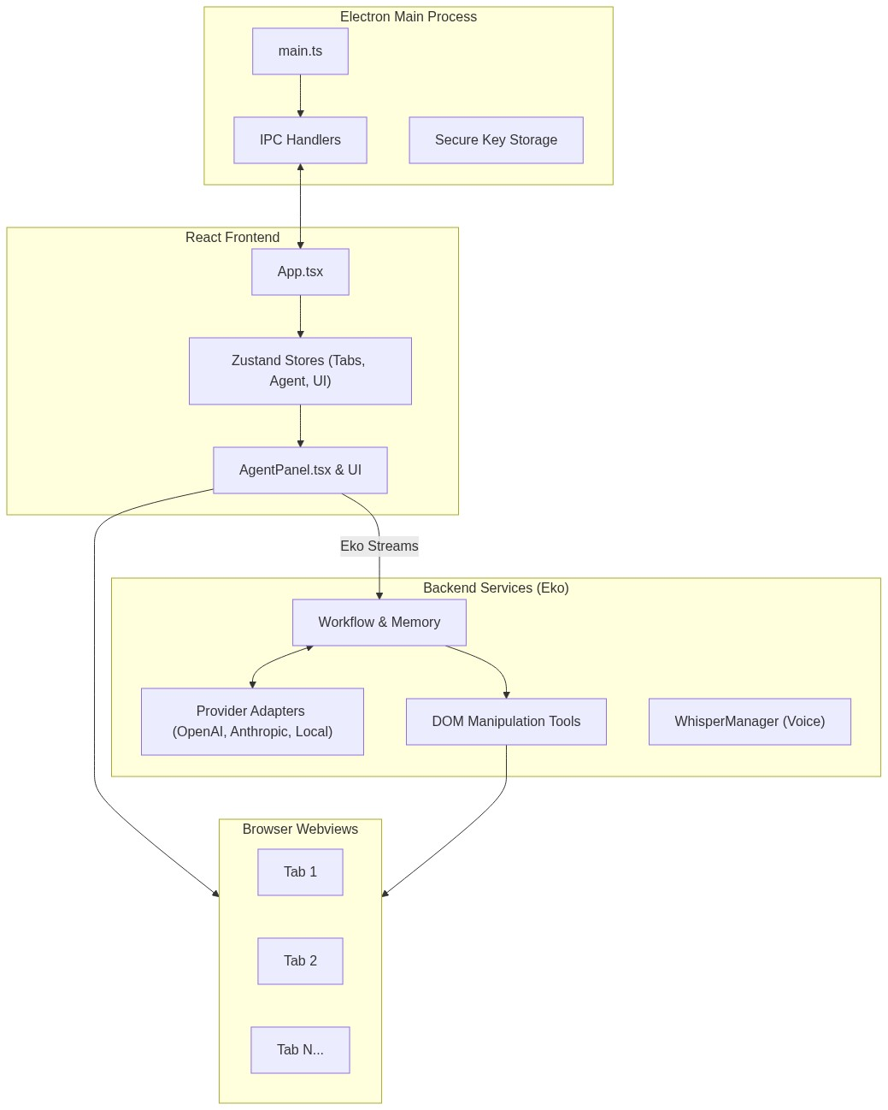
Mermaid Diagram 1

3.2 State Management
The frontend relies heavily on Zustand to decouple the global state from React's render cycle, preventing unnecessary component re-renders. The UI states naturally respond to changes in the AgentStore and TabStore, preventing prop-drilling.
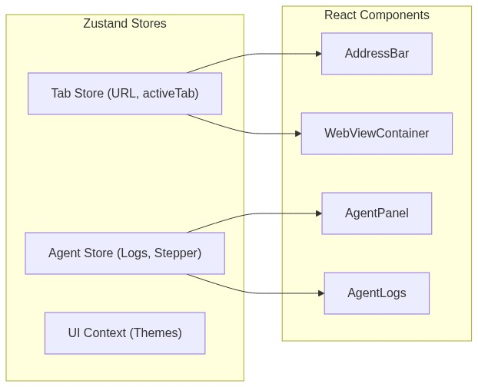
Mermaid Diagram 2

4. Agent Execution Engine
The autonomous generation capability relies on an iterative prompt-action-observation loop.
The user provides a prompt by typing or speaking in the AgentPanel.tsx. The frontend calls the backend eko.run(prompt) method, which initializes a streaming API back to the UI.

4.1 Real-Time Streaming and Reasoning
The front end parses real-time JSON events from the backend to construct an animated log of the Agent's thought process. Events include:
- workflow: The agent's global plan and inner monologue.
- agent_start: The specific sub-task being undertaken.
- tool_use: What DOM element or function is being run (e.g., navigate, click, input).
- tool_result: The observation returned by the browser DOM back to the LLM.
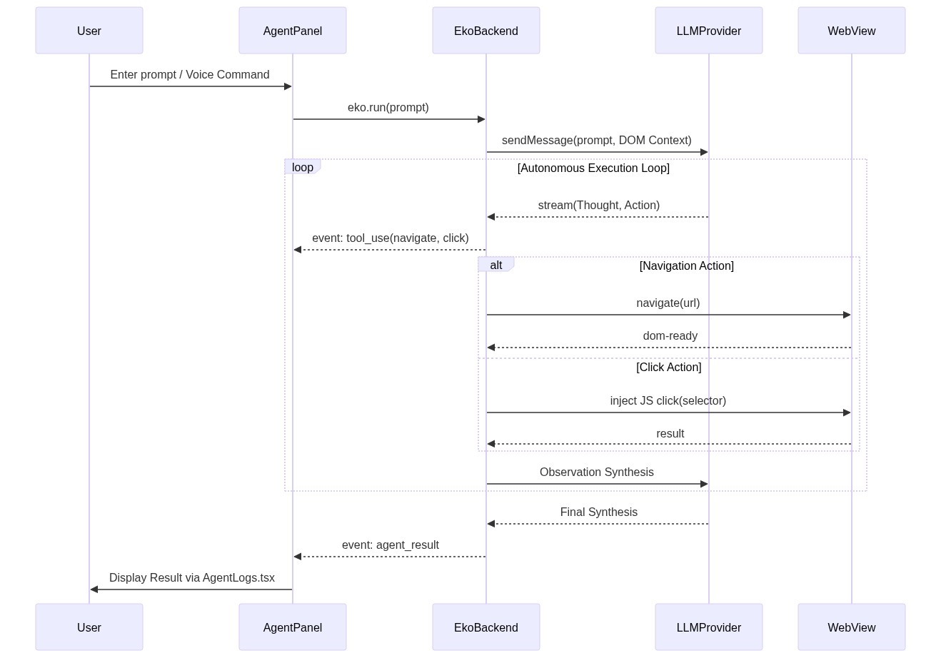
Mermaid Diagram 3

5. Local Voice Transcription Pipeline (WhisperManager)
A pinnacle engineering aspect of the Agentic Browser is its offline, real-time voice transcription pipeline inside backend/voice/WhisperManager.ts. Because the application is a desktop browser, forcing users to use Cloud APIs for voice would compromise privacy. Instead, the browser packages native whisper-cli and whisper-stream executables.

5.1 Dynamic Model Fallbacks
The manager defaults to the highly capable ggml-small.en.bin model. However, hardware capabilities differ across users. WhisperManager continuously monitors its own CPU inference speed via a rolling average calculation (inferenceTimesMs).
If the average inference time exceeds an established threshold (INFERENCE_SLOW_THRESHOLD_MS = 5000ms) for three consecutive chunks, the application autonomously downgrades to the lighter ggml-base.en.bin model on the next run to prevent audio backlog and freezing.

5.2 Sliding Context and Stream Chunking Strategy
Voice Activity is handled via whisper-stream.exe. Rather than waiting for a user to finish talking, it uses a highly tuned sliding window configuration:
- stepMs = 4500: Dispatches audio to the model chunk every 4.5 seconds.
- lengthMs = 7000: Analyzes a full 7-second context window.
- keepMs = 2000: Maintains a 2-second overlap from the previous step.
This explicit 2-second overlap directly mitigates "word cutting" at arbitrary chunk boundaries, heavily improving real-time transcription accuracy. The system additionally passes overlapping suffix texts through a custom deduplicateOverlap filter before appending it to the UI stream.

5.3 Process Isolation and "Smart Drain"
The C++ inference engine runs on a completely separate spawned Node child-process. This ensures the Electron Main Thread and React Frontend never drop below 60fps, even when the CPU is saturated at 100%.
When the user halts transcription, simply killing the process results in trailing words being lost. The WhisperManager incorporates a "Smart Drain" algorithm: it calculates the next inference tick (Math.max(8000, this.streamStepMs + Math.round(this.avgInferenceTimeMs * 2) + 2000)) and safely blocks process termination until the final partial transcript finishes rendering, guaranteeing sentence completion.

6. Security and Hardware Isolation Boundaries
Traditional Chrome extensions share context spaces with the web pages they modify, heavily restricting what LLMs can safely inject. The Agentic Browser strictly bifurcates permissions:
- Context Isolation: The React frontend operates over secured Preload IPC bridges (electronAPI.eko.*). The UI has zero native Node.js filesystem access.
- BrowserView Isolation: User tabs run as BrowserView or isolated WebContents, completely sandboxed away from the core eko agent processes.
- Encrypted Credential Stores: API keys (OpenAI, Anthropic) are inherently high-value. Instead of local storage, they are encrypted at rest using OS-level secure enclaves (safeStorage).

7. Limitations and Future Work
While the architecture demonstrates significant advancements in agent-desktop integration, a few limitations persist:
1. DOM Saturation Limit: Extremely complex SPAs (Single Page Applications) present DOM trees too large for lightweight local model context windows. Future work involves implementing tree-pruning or accessibility-tree mapping to condense HTML into tighter semantic JSON.
2. Multi-Agent Orchestration: Currently, a single agent loop dominates a single tab. Future work will attempt concurrent multi-agent processes operating on hidden WebViews to parallelize tasks (e.g. cross-referencing three competitor sites simultaneously).

8. Conclusion
The Agentic Browser successfully bridges the gap between traditional manual web exploration and autonomous AI automation. By creating an architecture tailored specifically for agents—bypassing extension limitations via Electron, introducing CPU-aware local voice streaming with Whisper, and utilizing advanced state management with Zustand—the system delivers a highly capable, private, and frictionless automated browsing experience. Future developments in DOM reduction and multi-agent topologies will position this architecture as a standard for post-chat LLM human-computer integration.

