**Front End Engineering**

Project Report

Semester-IV (Batch–2022)

**Food App**



**Supervised By: Submitted By:**

Mr. Amitabh Srivastava

Ishaan Singla (2210992582) {G22}  
Sameer Chandra (2210992237) {G22}  
Samiksha Singh (2210992238) {G22}  
Sanjal Jain (2210992248) {G22}

**Department of Computer Science and Engineering**

**Chitkara University Institute of Engineering & Technology,**

**Chitkara University, Punjab**

**Abstract**

The Food Application Project is an educational endeavours undertaken by our team to create a comprehensive platform for food enthusiasts. Utilizing React, a popular JavaScript library, we developed a web application that integrates various aspects of meal preparation into a single platform. The application includes features such as an ingredient purchase system to purchase the everyday ingredient we need for cooking, a vast recipe library, a to-do list for cooking tasks, and a social section for sharing culinary creations. This project served as a practical application of our technical skills in React and an opportunity to gain experience in full-stack web development.

**Table of Contents:**

1. Introduction
2. Minimum Software and Hardware Requirement
3. Results
4. References
5. **Introduction**

The Food Application Project is an initiative to create a comprehensive platform for food enthusiasts. Our team utilized React, a popular JavaScript library, to develop a web application that integrates various aspects of meal preparation into a single platform. The application includes features such as an ingredient purchase system, a vast recipe library, a to-do list for cooking tasks, and a social section for sharing culinary creations. Despite the inherent challenges and complexities, we strived to develop a user-friendly and feature-rich application, showcasing our understanding of React and the principles of full-stack web development. The objective of this project was not only to apply our technical skills but also to create a practical tool that simplifies the cooking process for users

**1.1 Objectives:**

* **User-Friendly Interface**: To design and implement a user-friendly interface with a navigation bar for easy access to all features of the application.
* **Personalized User Experience**: To provide a personalized user experience by displaying the logged-in user's name and offering personalized recommendations.
* **Recipe Browsing**: To create a comprehensive recipe library where users can browse and select recipes based on their preferences.
* **Ingredient Purchase System**: To implement an ingredient purchase system where users can buy the necessary ingredients for their chosen recipes.
* **Social Interaction**: To provide a social platform where users can share their culinary creations, interact with other users, and get inspiration for their next meals.
* **To-Do List**: To incorporate a to-do list feature in the recipe section to help users keep track of their cooking tasks.
* **Integration with social media**: To provide links to the application's social media pages for users to follow and subscribe to updates.
* **Interactive Cooking Guide**: To provide an interactive cooking guide with step-by-step instructions and a to-do list to assist users in their cooking process.
* **Shopping Cart**: To implement a shopping cart feature for the ingredient purchase system, allowing users to review their items before purchase.
* **Real-Time Interaction**: To facilitate real-time interaction among users in the social section, including text, image, gif, and emoji sharing.
  1. **Need**
* **Simplifying Meal Preparation**: Cooking involves various steps, from finding a recipe to buying ingredients and following the cooking process. A platform that integrates all these aspects can significantly simplify meal preparation.
* **Promoting Home Cooking**: With the increasing awareness of healthy eating, more people are turning to home cooking. Our application provides a vast recipe library and an ingredient purchase system, promoting and facilitating home cooking.
* **Social Interaction**: Sharing food experiences is a fundamental part of food culture. A platform where users can share their culinary creations and interact with other food enthusiasts can enrich the cooking experience.
* **Personalized Experience**: With the abundance of recipes available, finding ones that suit personal preferences can be overwhelming. An application that offers personalized recommendations can enhance the user experience.
* **Learning Opportunity**: For beginners, learning to cook can be a daunting task. An interactive cooking guide with step-by-step instructions can make the learning process easier and more enjoyable.
* **Efficient Shopping**: Remembering all the ingredients needed for a recipe can be challenging. An integrated shopping cart feature can make ingredient shopping more efficient.

1. **Minimum Software and Hardware Requirements**
   1. **Software Requirements: -**

* **Operating System:** Any modern operating system that can run Node.js (Windows, macOS, Linux, etc.)
* JavaScript (ES6 or later) , React JS
* npm package manager
* VS code for development environment
* Google Fonts , font awesome (for fonts , logos)
* GitHub (for filesharing , collaboration , version control)
  1. **Hardware Requirements**
* **Internet Connection**: A stable internet connection for accessing the application, collaborating via GitHub, and downloading necessary libraries or tools.
* **RAM**: Minimum - 2 GB, Recommended - 4 GB or more
* **Hard Disk**: Minimum - 20 GB of available hard disk space, Recommended - 50 GB or more

1. **Code snippets**

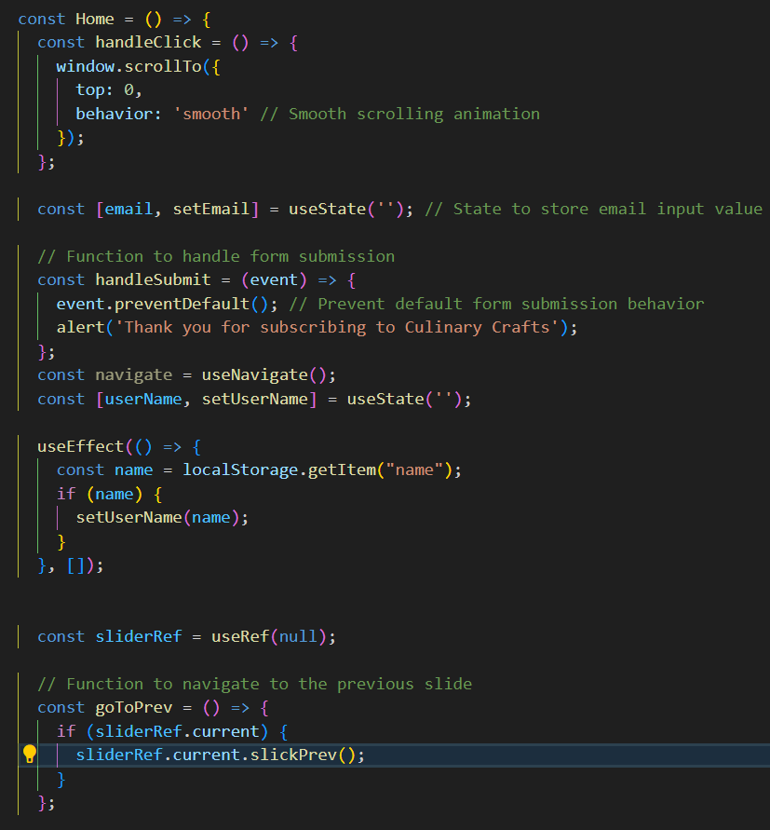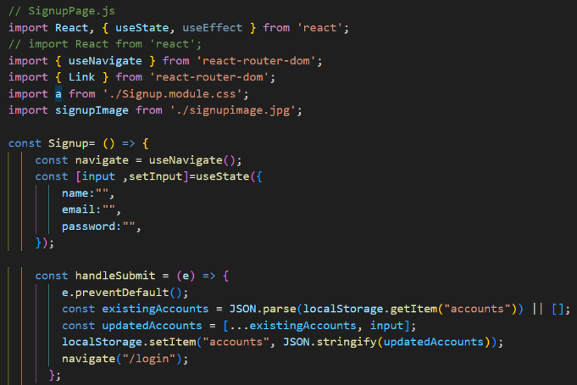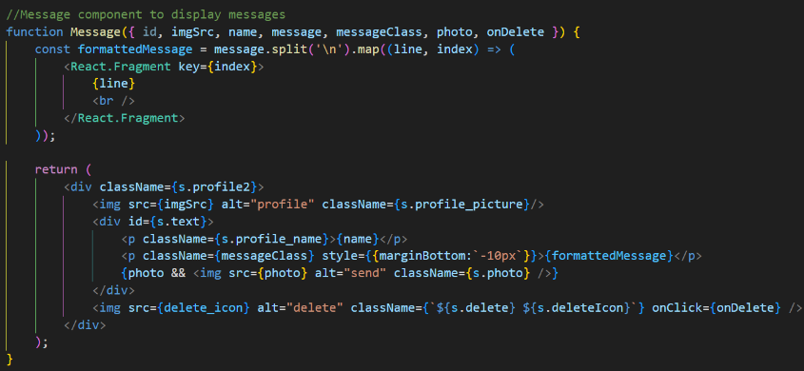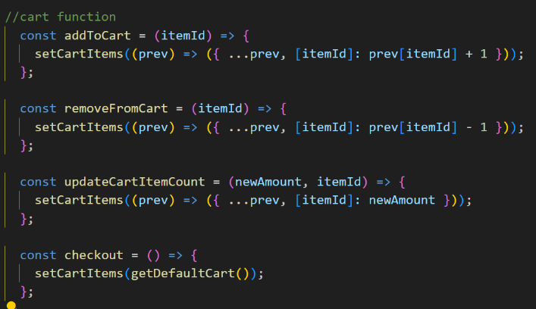The github repo for project 🡪 <https://github.com/Ishaan1106/food-app>

1. 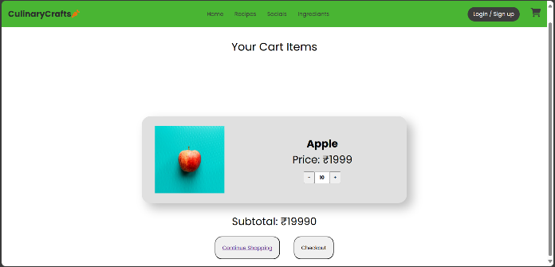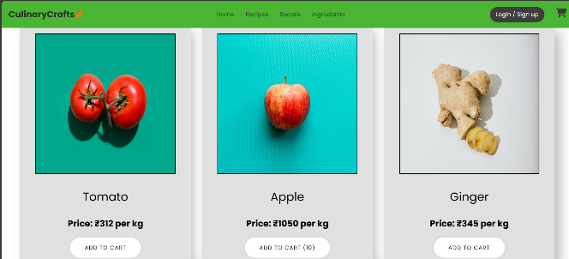**A screenshot of a computer

   Description automatically generated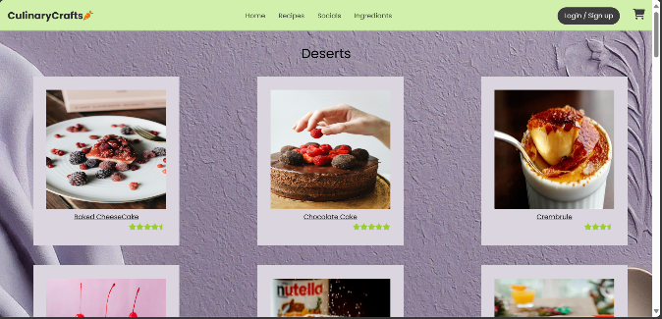A screenshot of a computer

   Description automatically generatedA screenshot of a recipe

   Description automatically generatedA green background with text and images of food

   Description automatically generatedA screenshot of a video

   Description automatically generatedA plate of salad with a picture of food

   Description automatically generatedA green background with a chef and a spatula

   Description automatically generatedA person cooking in a kitchen

   Description automatically generated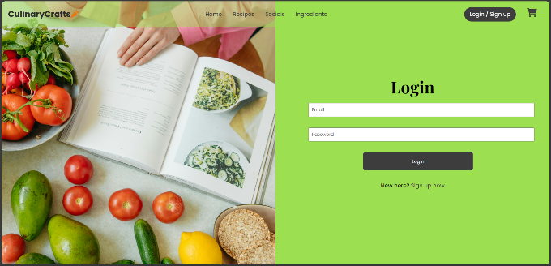Results**
2. **References**

* <https://reactjs.org/docs/getting-started.html>
* <https://nodejs.org/en/docs/>
* <https://docs.npmjs.com/>
* <https://fonts.google.com/>
* <https://fontawesome.com/>