**INTEGRATED PROJECT REPORT**

**On**

# Dev Insights

Submitted in partial fulfillment of the requirement for the Course Integrated Project (CS 203) of

**COMPUTER SCIENCE AND ENGINEERING**

## B.E. Batch-2022 (VI Semester)



### 

|  |  |
| --- | --- |
| **Under the Guidance of :**  Dr. Lekha Rani | **Submitted by :**  **Name:** Sanskriti **Roll. No. :** 2210992252  **Name**: Sanya **Roll. No. :** 2210992255  **Name:** Ishaan Singla  **Roll. No. :** 2210992582  **Name:** Nutan **Roll. No. :**2210992005 |

### 

**DEPARTMENT OF COMPUTER SCIENCE AND ENGINEERING**

# CHITKARA UNIVERSITY

**PUNJAB**

**(Annexure–C)**

## CERTIFICATE

This is to be certified that the project entitled “Dev Insights” has been submitted for the Bachelor of Computer Science Engineering at Chitkara University, Punjab during the academic semester January 2025-

May-2025 is a bonafide piece of project work carried out by “Sanskriti (2210992252), Sanya (2210992255),Ishaan Singla (2210992582), Nutan (221099)” towards the partial fulfillment for the award of the course Integrated Project (CS 203) under the guidance of “Dr. Lekha Rani” and supervision.

**Sign. of Project Guide**

Dev Insights

Dr. Lekha Rani

## (Annexure–D)

## CANDIDATE’SDECLARATION

We, **“Sanskriti (2210992252), Sanya (2210992255), Ishaan Singla (2210992582),**

**Nutan(2210992005)”,** B.E.-2022 of the Chitkara University, Punjab hereby declare that the Integrated Project Report entitled **“Dev Insights”** is an original work and data provided in the study is authentic to the best of our knowledge. This report has not been submitted to any other Institute for the award of any other course.

|  |  |  |  |
| --- | --- | --- | --- |
| **Sign.of Student1** | **Sign.of Student2** | **Sign.of Student3** | **Sign.of Student4** |
| Sanskriti | Sanya | Ishaan Singla | Nutan |
| ID No. 2210992252 | ID No. 2210992255 | ID No. 2210992236 | ID No. 2210992005 |

**Place: Rajpura**

**Date: 3-03-2025**

**(Annexure-E)**

## ACKNOWLEDGEMENT

It is our pleasure to be indebted to various people, who directly or indirectly contributed in the development of this work and who influenced my thinking, behavior and acts during the course of study.

We express our sincere gratitude to all for providing mean opportunity to undergo Integrated Project as the part of the curriculum.

We are thankful to “Project Guide Name” for his support, cooperation, and motivation provided to us during the training for constant inspiration, presence and blessings.

We also extend our sincere appreciation to **Dr. Lekha Rani**Who provided his valuable suggestions and precious time in accomplishing our Integrated project report.

Lastly, we would like to thank the almighty and our parents for their moral support and friends with whom we share dour day-to day experience and received lots of suggestions that improve our quality of work.

|  |  |  |  |
| --- | --- | --- | --- |
| Sanskriti | Sanya | Ishaan Singla | Nutan |
| ID No. 2210992252 | ID No. 2210992255 | ID No. 2210992236 | ID No. 2210992005 |

## Table of Content

|  |  |  |
| --- | --- | --- |
| **Sr No.** | **Title** | **Page No.** |
| 1 | Abstract/Keywords | 1 |
| 2 | Introduction to the project | 1 |
| 3 | Software and Hardware Requirement Specification | 2 |
| 4 | Database Analyzing, design and implementation | 3 |
| 5 | Program’s Structure Analyzing and GUI Constructing | 4 |
| 6 | Code-Implementation and Database Connections | 6 |
| 7 | System Testing | 6 |
| 8 | Limitations | 7 |
| 9 | Conclusion | 7 |
| 10 | Future Scope | 7 |
|  |  | 8 |
| 11 | Bibliography/References |  |

### 1. Abstract/Keywords

DevInsights is an AI-powered web application designed to assist developers in understanding and managing code changes in large repositories efficiently. The system provides AI-generated commit summaries and enables natural language-based code search, significantly reducing the time spent on manual review and code navigation. This project enhances productivity by integrating AI-driven insights, seamless repository management, and intuitive user authentication.

**Keywords:**

AI-Powered Code Insights, Commit Summarization, Natural Language Code Search, Repository Management, Next.js, Google Gemini AI, GitHub API, Clerk Authentication, Neon PostgreSQL, Bun.

## 2. Introduction to the Project

In today's fast-paced development environment, keeping track of code changes and maintaining clear documentation can be challenging. DevInsights is a full-stack Next.js application designed to simplify project management by leveraging AI to generate insightful summaries of GitHub repositories.

With DevInsights, users can upload their GitHub repositories and receive AI-generated commit summaries, making it easier to understand recent changes and track progress. Additionally, the platform allows users to ask questions about their project's code and files, streamlining code comprehension and collaboration.

Beyond code analysis, DevInsights also offers AI-powered meeting transcription and summarization. Users can upload audio recordings of team meetings, and the system will generate structured summaries, ensuring that key discussions and decisions are well-documented.

### 2.1 Background

With the rapid growth of software development, managing repositories efficiently has become crucial. Developers often rely on commit messages and manual code reviews, which can be time-consuming and error-prone. Existing tools offer limited AI-driven insights. DevInsights leverages Next.js, AI models like Google Gemini, and GitHub

API to streamline repository management and enhance productivity

### 2.2 Problem Statement

The major issues in the current market include:

* **Time-consuming code reviews:** Manually reviewing commit messages and searching through code is inefficient.
* **Lack of intelligent insights:** Existing tools do not provide AI-powered commit summarization.
* **Complex repository navigation:** Developers struggle to locate specific code changes.
* **Inefficient onboarding:** New team members face difficulties understanding project history.

## 3. Software and Hardware Requirement Specification

### 3.1 Methods

DevInsights follows an Agile development approach, allowing continuous feedback and iterative improvements.

The system is developed using modern web technologies and AI integrations.

### 3.2 Programming/Working Environment

The Dev Insights is developed using:

1. **Bun** -- Fast JavaScript runtime & package manager
2. **Next.js** -- React framework for Server Side rendering & static sites
3. **TypeScript** -- Typed superset of JavaScript for safer code
4. **Prisma** – Database Management
5. **Gemini** **API** -- Google’s AI model for NLP tasks
6. **Assembly** **API**– For generating Meeting Summary
7. **GitHub** **API** -- Interface for repo & data access
8. **LangChain** – Framework for AI-driven applications
9. **TailwindCSS** – Utility-first CSS framework for styling
10. **ShadCN** – Prebuilt UI components for React
11. **SupaBase**—For Storing Files of the meetings

### 3.3 Requirements to Run the Application

* Hardware Requirements:
* Processor: Intel i5 or higher
* RAM: Minimum 4GB (Recommended: 8GB)
* Storage: Minimum 20GB free space
* Display: Minimum 1024x768 resolution
* Software Requirements:
* Operating System: Windows, Linux, or macOS
* Development Tools: Visual Studio Code, Node.js, Bun
* Database: Neon PostgreSQL
* Browser: Google Chrome, Firefox, or Edge

## 4. Database Analyzing, Design, and Implementation

The database is structured using PostgreSQL (Neon Console) to ensure scalability and efficiency.

**Database Design:**

The DevInsights database is designed to efficiently manage user data, project details, AI-generated insights, and collaborative features. Below is an overview of the key database entities:

1. **User** : Stores user-related data, including authentication details and profile information.
2. **Project** : Stores details of projects uploaded by users, including repository metadata and associated files.
3. **UserToProject** : Establishes a many-to-many relationship between users and projects, allowing multiple users to collaborate on a shared project.
4. **SourceCodeEmbedding** : Stores AI-generated embeddings of the uploaded source code.
5. **Meeting** : Stores details of meetings uploaded by users, including audio files and metadata.
6. **Issue** : Records key discussions from meetings along with timestamps, enabling users to track important topics.
7. **Question** : Stores user-submitted questions about the project. Contains AI-generated responses based on the source code embeddings.
8. **Commit** : Stores commits fetched from GitHub repositories. Includes AI-generated summaries for each commit to help users quickly understand code changes.

This database structure ensures efficient data management, facilitating AI-driven insights, project tracking, and seamless collaboration.

**Normalization:**

The database is optimized to Third Normal Form (3NF) to eliminate redundancy and enhance performance.

## 5. Program’s Structure Analyzing and GUI Constructing

**5.1 High-Level Design:**

* Flowchart & Use Case Diagram: Shows user interactions with the system.
* Architecture Diagram: Explains system components (frontend, backend, database).

**5.2 GUI Screenshots:**

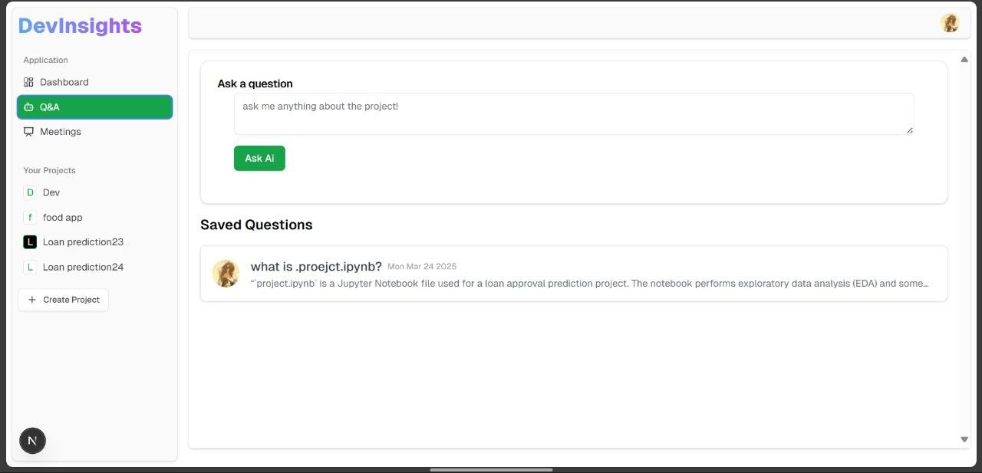

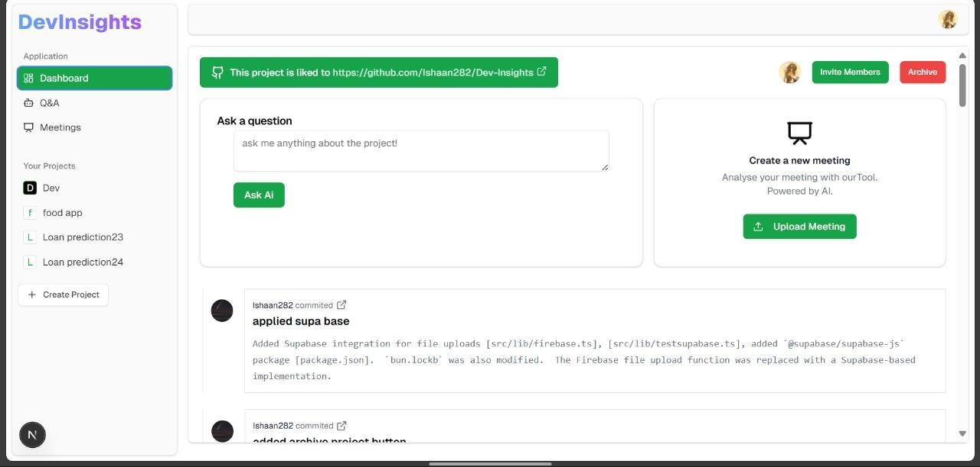

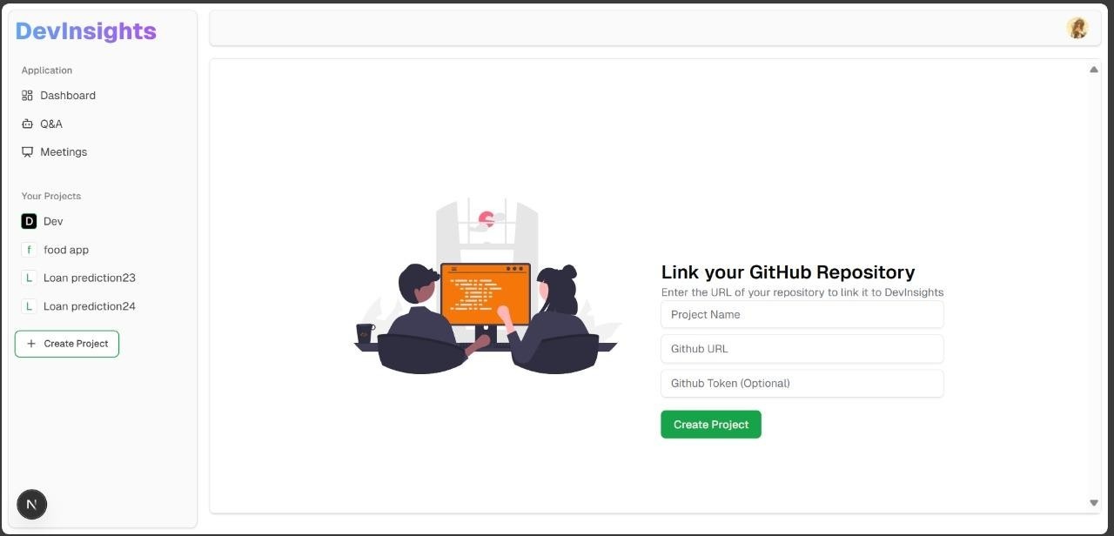

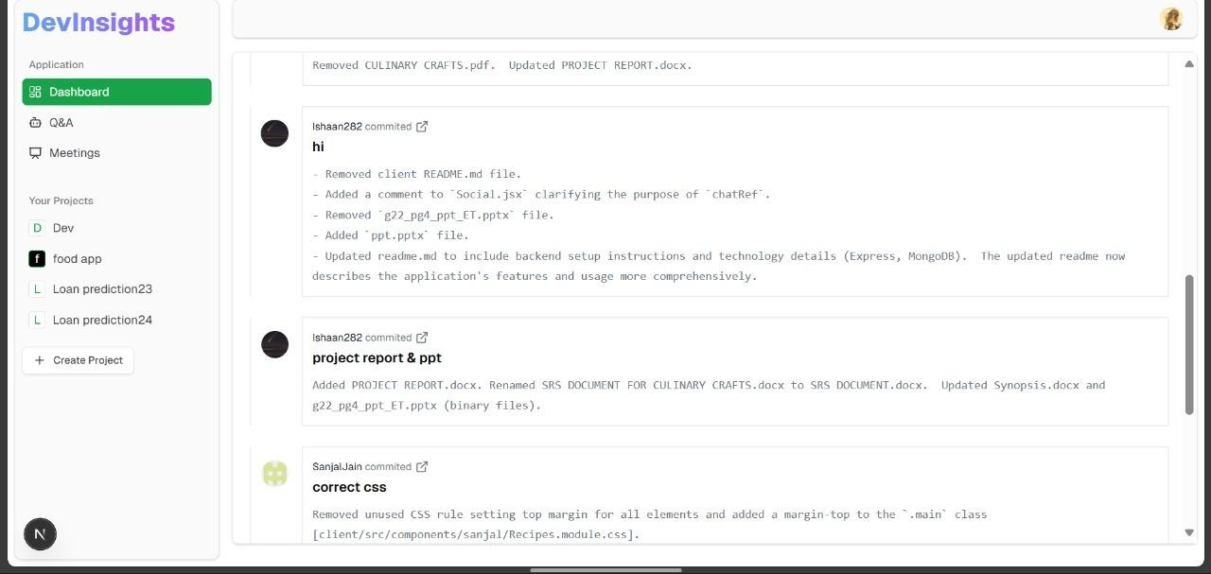

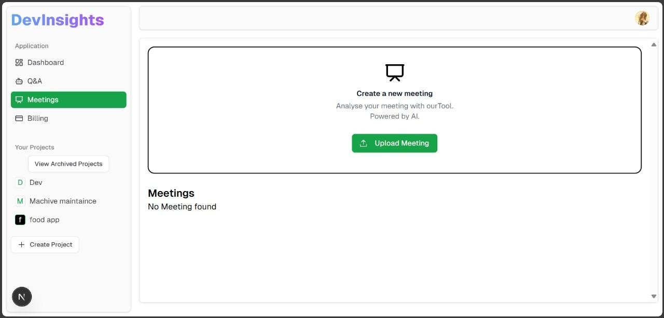

## 6. Code Implementation and Database Connections

* Frontend Code: Next.js components for UI elements and API interactions.
* Backend Code: Node.js API endpoints handling commit summaries and search queries.
* Database Connection: PostgreSQL , Supabase, queries using Neon Console for efficient data retrieval.

## 7. System Testing

Types of Testing Performed:

* Unit Testing: Verifies individual components and API endpoints.
* Integration Testing: Ensures seamless interaction between frontend, backend, and database.
* User Acceptance Testing (UAT): Ensures the application is intuitive and user-friendly.
* Performance Testing: Measures response times and server load efficiency using Bun.

## 8. Limitations

Some limitations of the Dev Insights include:

**Accuracy of AI-Generated Summaries**

* The accuracy of commit and meeting summaries depends on the quality of AI models. Misinterpretations or incomplete summaries may occur, especially for complex discussions or code changes. **Limited Context in AI Responses**
* AI responses rely on source code embeddings, which might not always capture the complete project context, leading to potential gaps in answering user queries. **Scalability Challenges**
* As the number of projects and users grows, storing and retrieving embeddings efficiently may require advanced optimization and scaling strategies. **Dependency on External Services**
* The project relies on third-party services like GitHub APIs and Assembly AI for fetching commits and transcribing meetings. Any downtime or API rate limits could impact functionality.

## 9. Conclusion

DevInsights revolutionizes the way developers interact with their code by providing AI-powered commit summarization, natural language code search, and meeting transcription. By simplifying repository navigation and enhancing collaboration, it boosts productivity and ensures that critical project insights are easily accessible. While the platform has certain limitations, continuous improvements in AI models and system scalability can further refine its accuracy and performance. With its innovative approach to project management, DevInsight**s** serves as a valuable tool for developers seeking efficient code understanding and seamless teamwork.

## 10. Future Scope

Several upgrades and improvements can be made in the future, such as:

* Enhanced AI Training: Improve AI models for more precise commit summaries.
* Offline Functionality: Develop local repository analysis for offline use.
* Collaboration Tools: Implement team-based insights and discussion forums.
* Expanded Language Support: Support additional programming languages for code search.

## 11. Bibliography/References

Include references to books, research papers, websites, and online tutorials used during project development.

Example:

* Next.js Documentation –<https://nextjs.org/docs>
* Google Gemini AI -<https://ai.google.dev/gemini-api/docs>
* GitHub API Documentation -<https://docs.github.com/en/rest>
* Vercel Documentation -<https://vercel.com/docs>
* Neon PostgreSQL -<https://neon.tech/docs/reference/api-reference>
* Clerk Authentication -<https://clerk.com/docs/quickstarts/nextjs>
* ShadCN UI -<https://ui.shadcn.com/docs>
* assemblyAI - <https://www.assemblyai.com/docs/>