

https://app.hackthebox.com/machines/Cap?tab=machine_info

Step-1:

Nmap Scanning

Scan Results for 10.129.9.72
- Operating System: The scan identifies the target as Linux, specifically running Ubuntu.
- Open Ports:
  - 21 (FTP): Running vsftpd 3.0.3.
  - 22 (SSH): Running OpenSSH 8.2p1.
  - 80 (HTTP): A web server is active using Gunicorn.
- Status: Multiple scans (service detection and TCP connect) confirmed these three ports are open, while 997 other ports were closed.
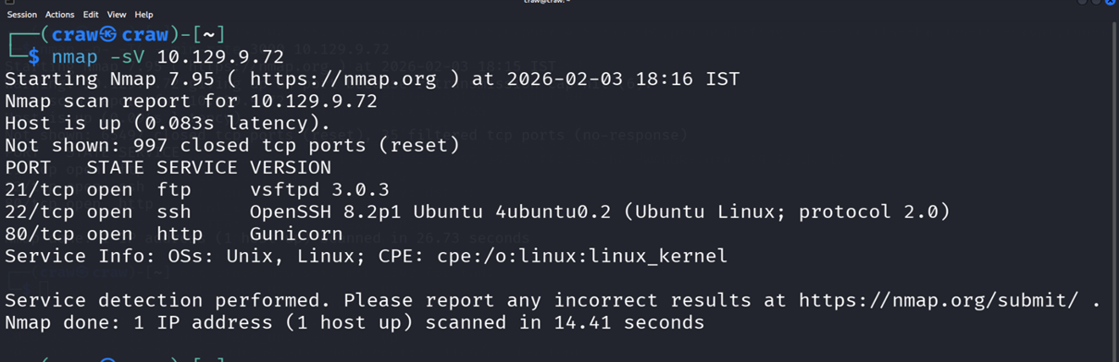

Step-2:

Advanced Port Scanning (TCP Aggressive)

Scan Results for 10.129.9.72
- Scan Method: A TCP connect scan (-sT) was performed to verify the state of the ports without requiring root privileges or using stealth SYN scans.
- Port Confirmation:
  - 21/tcp: Confirmed open.
  - 22/tcp: Confirmed open.
  - 80/tcp: Confirmed open.
- Network Response: The scan completed in 5.25 seconds, showing that 997 ports returned a conn-refused status, confirming a lack of firewall filtering for those specific closed ports.
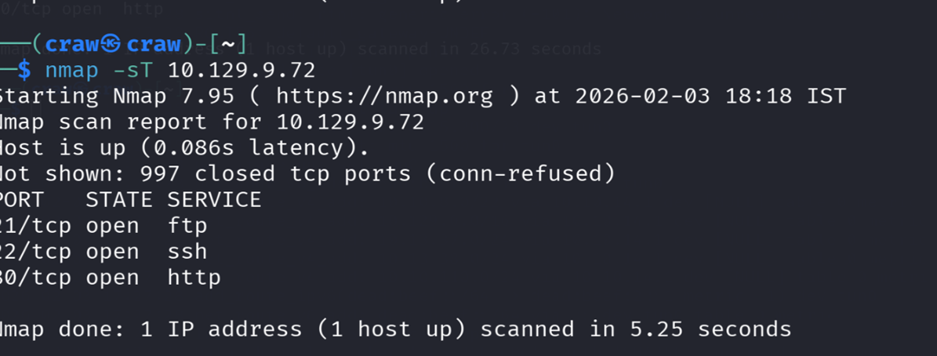

Step-3:

Configure Local DNS Resolution
- The Problem: The target machine uses a private domain name that is not recognized by public DNS servers.
- The Fix: Manually mapping the IP address to the domain name in the local hosts file.
- Execution:
  - The /etc/hosts file was opened using GNU nano 8.6.
  - The following line was added to the file: 10.129.9.72 cap.htb.
  - The file was saved with a total of 8 lines written.
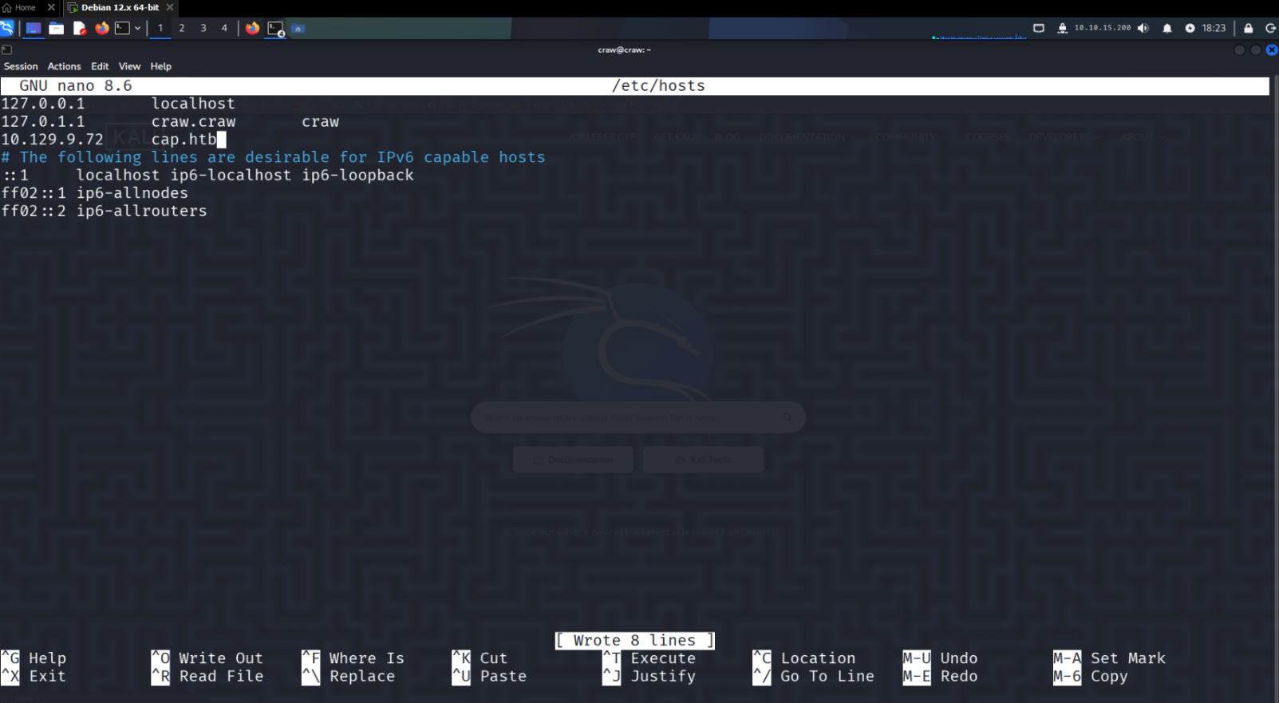

Step 4:

Web Application Discovery
- Access: Navigating to the target IP (redirecting to cap.htb) reveals a web-based Security Dashboard.
- User Context: The application appears to be logged in as a user named Nathan.
- Features Identified:
  - Security Events: Displays a chart tracking events, showing 1,560 in the last 24 hours.
  - Failed Login Attempts: Shows 357 attempts.
  - Port Scans: Tracks unique IPs performing scans, identifying 27.
  - Sidebar Tools: Provides access to a Dashboard, Security Snapshot (PCAP Analysis), IP Config, and Network Status.
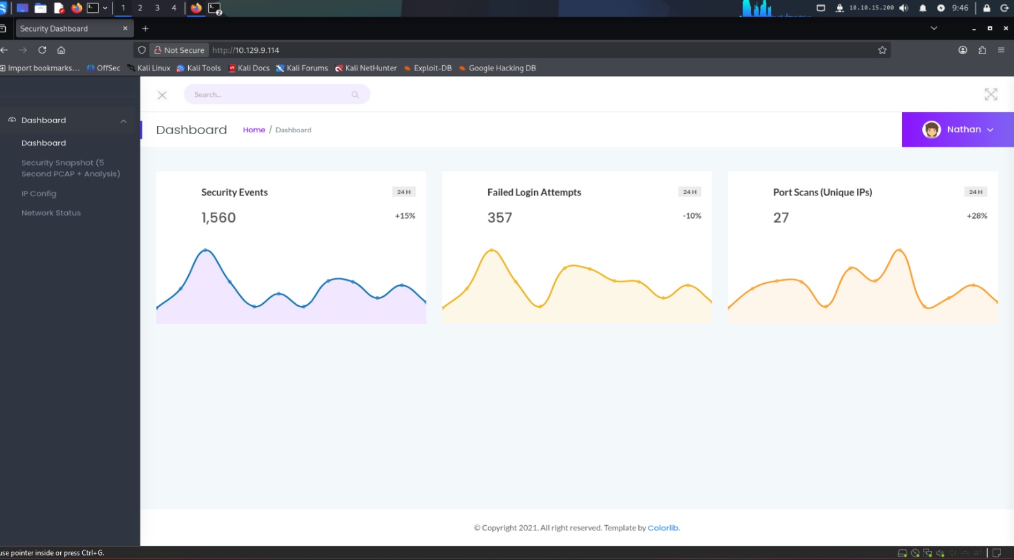

Step 5:

IDOR Vulnerability Testing
- Discovery: Navigating to the Security Snapshot feature exposes a data retrieval endpoint at http://10.129.9.114/data/2.
- Observation: The identifier /2 in the URL suggests a predictable sequence for accessing capture logs.
- Preparation: To systematically test for Insecure Direct Object Reference (IDOR), a wordlist of identifiers was created:
  - Command: seq 0 100 > numbers.txt.
- Automated Enumeration: ffuf was used to fuzz the /data/FUZZ endpoint using the generated wordlist.
  - Command: ffuf -u http://10.129.9.114/data/FUZZ -w numbers.txt -fs 0.
- Findings: The fuzzing results identified three valid identifiers returning a 200 OK status:
  - ID 0: Size 17147.
  - ID 1: Size 17150.
  - ID 2: Size 17144.
- Conclusion: Most other IDs (e.g., 43, 46-64) returned a 302 Redirect, confirming that ID 0 and ID 1 are accessible and likely contain historical capture data belonging to other sessions or users.
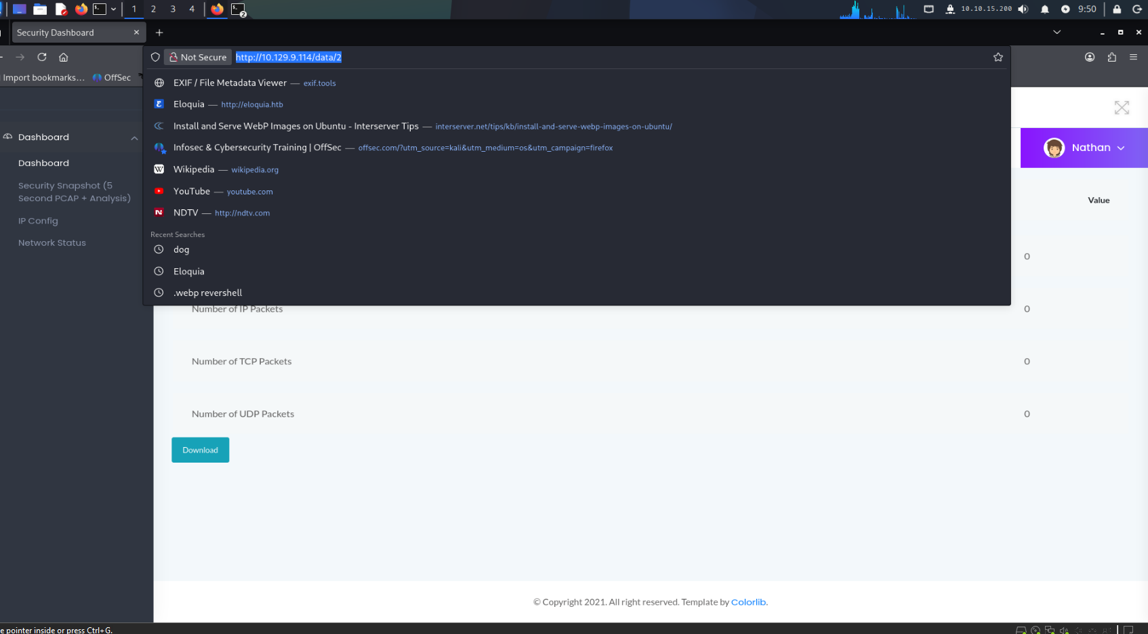

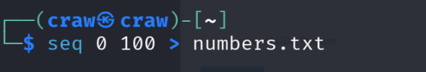

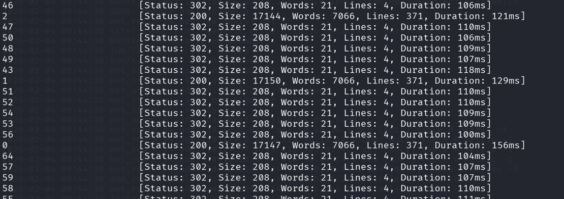

Step 6:

PCAP Analysis & Credential Harvesting
- Accessing the Data: Navigating to http://10.129.9.114/data/0 allows for the download of a packet capture file named 0(1).pcap.
- Traffic Inspection: Opening the file in Wireshark reveals captured network traffic between the source IP 192.168.196.1 and the destination IP 192.168.196.16.
- Sensitive Data Recovery: Filtering for FTP traffic reveals a plaintext login sequence:
  - User Request: A request for user nathan is sent to the server.
  - Password Request: The server prompts for a password.
  - Credentials Found: The capture exposes the plaintext password in packet 40: Buck3th4Tf0RM3!.
  - Login Success: The server responds with 230 Login successful.
- Vulnerability Impact: This confirms that the IDOR vulnerability identified in Step-5 directly leads to a complete compromise of user credentials by allowing unauthorized access to historical network snapshots.
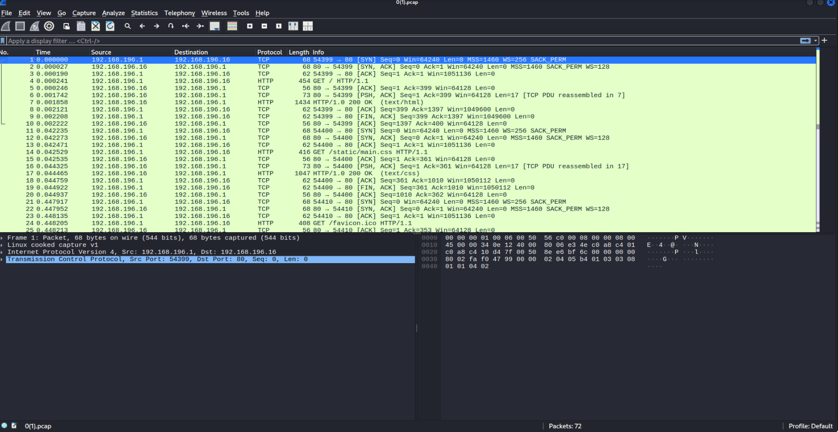

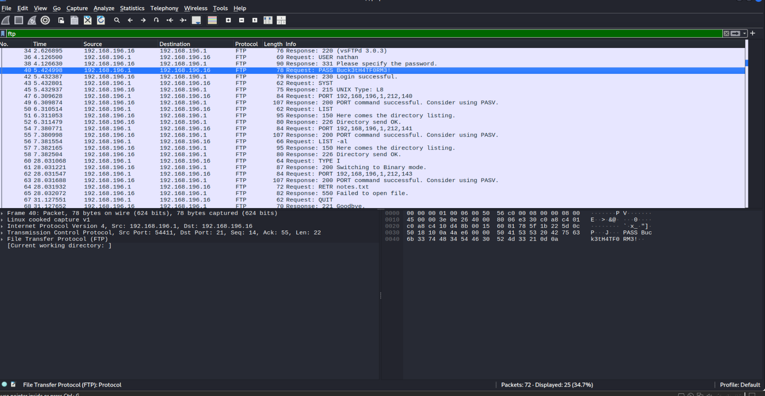

Step 7:

Initial Access via SSH
- Action: Using the harvested credentials (nathan : Buck3th4Tf0RM3!), an SSH connection was attempted to the target IP 10.129.9.114.
- Connection Details:
  - Host Authenticity: The ED25519 key fingerprint was accepted and added to the list of known hosts.
  - Target System: The connection was successful, revealing the target is running Ubuntu 20.04.2 LTS with Linux kernel 5.4.0-80-generic.
- Persistence Check: The user nathan is logged into the system, and the session is active.
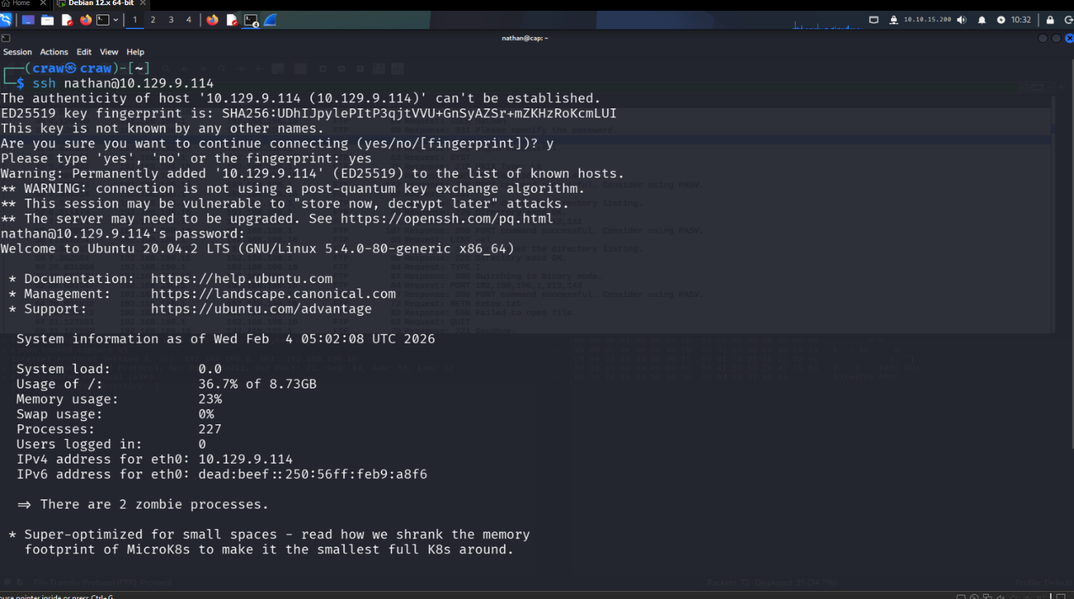

Step 8:
User Flag Retrieval
- Enumeration: Upon logging in, the current directory was listed using ls.
- Finding: A file named user.txt was found in the home directory.
- Retrieval: The contents of the file were read using cat user.txt.
- User Flag: 2015ae72c82ae273c73651b52d5a72db.
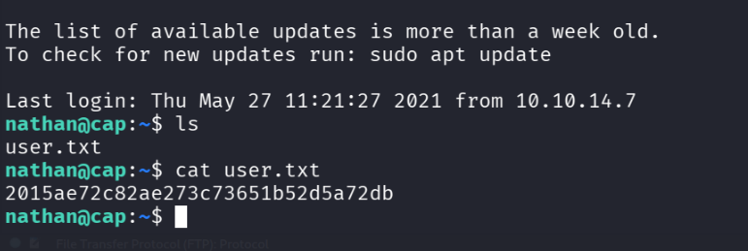

Step 9:

Privilege Escalation Enumeration
- Capability Scan: Checked for files with extended capabilities using getcap -r / 2>/dev/null.
- Critical Finding: Found that python3.8 has the cap_setuid capability set:
  - /usr/bin/python3.8 = cap_setuid,cap_net_bind_service+eip
- Vulnerability: This allows Python to change its UID to 0 (root) without needing sudo permissions.

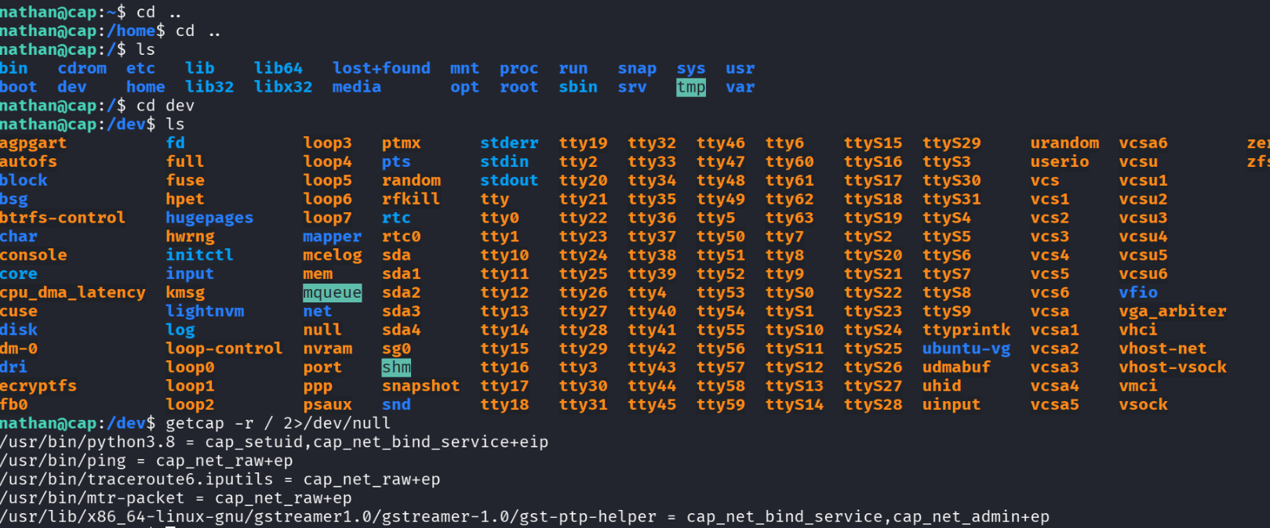

Step 10:

Privilege Escalation to Root
- Exploitation: Executed a Python one-liner to set the UID to 0 and spawn a shell.
  - Command: /usr/bin/python3.8 -c 'import os; os.setuid(0); os.system("/bin/sh")'.
- Verification: Confirmed root access using the whoami command.
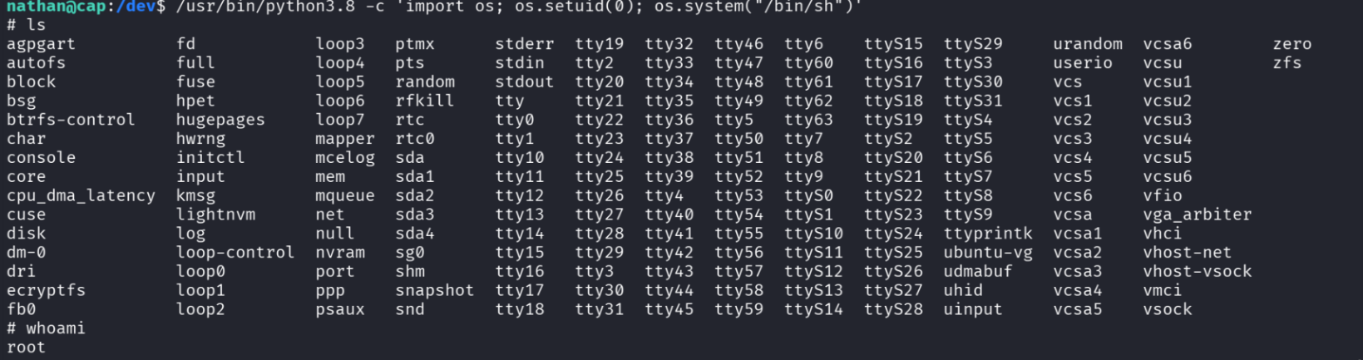

Step 11:

Root Flag Retrieval
- Action: Navigated to the root directory and listed the files.
- Retrieval: Read the contents of root.txt.
- Root Flag: 7effa9fd99b4bf5ad5638e3200207027.
