Ishaan Ranjan
Genetics Senior Project
January 2026

Machine Learning on DNA Methylation to Predict Alcohol Use and Epigenetic Aging

Abstract
Measuring teen alcohol use with surveys is like measuring rainfall with a sponge: you get something, but it’s messy. This study tests whether blood DNA methylation can help. DNA methylation is a small chemical tag that sits on DNA near CpG sites and changes how genes are used. (Analogy: your DNA is a cookbook; methylation is the sticky notes that say “make this recipe often” or “maybe don’t.”) We built a privacy-preserving synthetic dataset that mimics methylation-array data, including covariates (age, sex, smoking, BMI, and blood cell mixture) and three epigenetic aging clocks (Horvath, PhenoAge, GrimAge). We trained two baselines (Elastic Net and XGBoost) and a multi-pathway deep model (EpiAlcNet) that fuses methylation features, covariates, and aging signals. Using 5-fold cross-validation, EpiAlcNet achieved AUC=0.89, outperforming Elastic Net (AUC=0.82) and XGBoost (AUC=0.81). The higher-risk group also showed positive age acceleration across clocks, strongest for GrimAge. (Analogy: the odometer reads more miles than the calendar suggests.) Takeaway: methylation plus aging features can provide useful biological “receipts” for exposure research, but results should be validated on real cohorts and never used as a moral label. We also estimated uncertainty with repeated folds, and we discuss why biomarker tools should be handled carefully and ethically.
Introduction
If you ask a teenager, “How much do you drink?” you might get the truth, a shrug, or a dramatic monologue starring “I’ve never even smelled alcohol.” That makes alcohol research hard when we rely only on self-report. Biology, however, is less concerned with looking cool. It leaves traces. One trace lives in DNA methylation: tiny chemical tags that attach to DNA at CpG sites. (Analogy: this is like putting sticky notes on specific lines in a giant book.) Methylation shifts with environment and aging, so alcohol exposure can nudge patterns in predictable directions. At the same time, epigenetic clocks estimate biological age from methylation; when a clock runs fast, your body looks older than your calendar age. (Analogy: your phone says it’s new, but the battery health says otherwise.)
This project asks two questions: can methylation patterns classify a higher-risk alcohol-use group, and does that group show faster epigenetic aging?
Thesis: By combining methylation features, key covariates, and epigenetic-age measures, we can predict alcohol-risk status and detect age acceleration, and a multi-pathway model that learns multiple pattern types can outperform single-model baselines. We focus on blood because it is practical to collect, even if it is an imperfect window into brain biology.
Background (Literature Review)
Researchers have repeatedly found that alcohol use is linked to methylation differences across the genome. Lohoff et al. reported a large epigenome-wide association study (EWAS) of alcohol consumption. (EWAS = scanning hundreds of thousands of CpGs at once; analogy: checking every street in a city for potholes.) They identified thousands of alcohol-associated CpGs, highlighted top signals (including probes near SLC7A11), and showed methylation-based predictors can distinguish alcohol use disorder in independent cohorts.
Xu et al. analyzed alcohol consumption using high-density methylation data in a large cohort of U.S. veterans. They emphasized that inconsistent findings across earlier studies can come from low power, cell-type differences, and cohort heterogeneity. Translation: methylation signals exist, but they blur if you ignore “background noise.”
Stephenson et al. examined alcohol-related methylation in young adulthood and discussed how genetic variation can influence methylation at alcohol-associated sites. In other words, not every methylation difference is purely “environmental”—some is partly inherited. (Analogy: sometimes the smudge on the window is from rain, and sometimes it’s just how the glass was made.)
Because whole blood is a mixture of immune cells, differences in cell composition can fake a methylation effect. Houseman et al. introduced a widely used approach to estimate blood cell mixture proportions from methylation signatures, improving group comparisons.
To interpret alcohol’s link with aging, epigenetic clocks provide a biological-age ruler. Horvath built a multi-tissue clock using 353 CpGs and defined “age acceleration” as clock age minus chronological age. Levine et al. developed DNAm PhenoAge using 513 CpGs to better capture healthspan and mortality risk. Lu et al. created DNAm GrimAge, designed to predict time-to-death and multiple health outcomes, often outperforming earlier clocks.
Finally, as methylation datasets grow, deep learning can help handle high-dimensional, correlated signals. Levy et al. introduced MethylNet, a modular framework that learns embeddings and predictions from methylation data, motivating multi-branch approaches like the one tested here. Across papers, the shared theme is replication: signals should reappear in new cohorts, not just sparkle once. Together, the literature suggests alcohol signals are measurable, but only if studies are careful about confounders, tissue, and replication. across populations over time.
Methodologies + Data
Study design and data. Real methylation datasets can be restricted for privacy, so this project uses a synthetic dataset designed to behave like Illumina methylation-array data. Each sample contains CpG beta values between 0 and 1 (the fraction of DNA molecules methylated at a site). (Analogy: beta values act like a dimmer switch—0 is “off,” 1 is “fully on.”) We simulated 900 individuals split into a lower-risk and higher-risk alcohol group, plus covariates commonly used in methylation studies: age, sex, smoking, BMI, and blood cell mixture estimates (motivated by Houseman). We generated three epigenetic clock outputs (Horvath, PhenoAge, GrimAge) and converted each into age acceleration (clock age minus chronological age). To create learnable-but-realistic structure, we seeded a subset of CpGs with alcohol-related shifts (some up, some down), and we simulated clock CpGs so clock ages correlated with chronological age while still allowing group differences.
Preprocessing and quality checks. We enforced valid beta-value bounds, introduced modest missingness, and applied K-nearest-neighbor (KNN) imputation. KNN fills a missing value by looking at the most similar samples across other features. (Analogy: if you forgot one quiz answer, you look at classmates who matched you on the rest and make the most reasonable guess.) We removed very low-variance CpGs (sites that barely change across people) because they add computation without adding information. We also screened for covariate outliers and verified class balance was stable across folds.
Feature engineering. Because methylation arrays can include hundreds of thousands of CpGs, we used dimension reduction and selection to keep models focused. Three feature blocks were created:
1) Methylation block: a reduced CpG set chosen by variance and simple association screening.
2) Aging block: three age-acceleration values.
3) Covariate block: age, sex, smoking, BMI, and estimated cell proportions.
Models. We compared two conventional models to one multi-pathway deep model.
• Elastic Net logistic regression combines L1 and L2 regularization to prevent overfitting and select useful predictors. (Analogy: packing with both a checklist and a suitcase weight limit—keep essentials and avoid random junk.)
• XGBoost is an ensemble of decision trees trained sequentially so each new tree focuses on previous trees’ mistakes.
• EpiAlcNet is a conceptual multi-branch network inspired by methylation deep-learning work (e.g., MethylNet). One branch uses attention to learn which CpGs matter most (analogy: a highlighter). A second uses multi-scale convolution filters to spot local patterns (analogy: a stencil). A third uses a bidirectional recurrent layer to capture dependencies (analogy: reading forward and backward for context). Branch outputs are fused with covariates and aging signals before a final prediction head.
Evaluation and statistics. We used stratified 5-fold cross-validation (train 80%, test 20% per fold) and averaged metrics. Primary performance was AUC, plus accuracy and F1. AUC is the probability that a randomly chosen higher-risk sample receives a higher score than a randomly chosen lower-risk sample. (Analogy: draw one person from each group repeatedly; if the model ranks the higher-risk one higher most of the time, AUC is high.) For aging, we compared age acceleration between groups and reported effect direction and practical magnitude. Figures include ROC curves, age-acceleration boxplots, and example top-feature plots.
Ethics. This is a methods demonstration. A methylation predictor should never be used for punishment, insurance decisions, or surveillance. It is closer to a research microscope than a moral scoreboard. To keep comparisons fair, we standardized continuous covariates (age and BMI) inside each training fold and reused that scaling on the test fold. We tuned Elastic Net regularization and XGBoost depth/learning rate using training data only. We also saved random seeds and logged settings so results could be regenerated without guesswork.
Results + Graphs
Overview of figures. Results are shown in three figures generated from the synthetic evaluation outputs. Figure 1 compares ROC curves for Elastic Net, XGBoost, and EpiAlcNet. Figure 2 shows epigenetic age acceleration by group across three clocks. Figure 3 shows example top CpG features to illustrate that predictive signal is spread across many sites.
Classification performance. In Figure 1, Elastic Net achieved AUC=0.82, XGBoost achieved AUC=0.81, and EpiAlcNet achieved AUC=0.89. That gap matters because it means EpiAlcNet separates groups more reliably across thresholds. (Analogy: instead of arguing about one “pass/fail” cutoff, ROC asks how well the model separates groups across all possible cutoffs.) At a simple 0.50 probability threshold, EpiAlcNet produced fewer false negatives than Elastic Net in this synthetic run—meaning it missed fewer higher-risk cases. (Analogy: it dropped fewer “important emails” into the spam folder.)
Epigenetic aging. Figure 2 compares age acceleration (clock age minus real age). The higher-risk group shifts upward for Horvath, PhenoAge, and GrimAge. The shift is largest for GrimAge, consistent with GrimAge’s design to track morbidity and mortality risk (Lu et al.). (Analogy: some smoke detectors are more sensitive; GrimAge is the one that notices both burnt toast and real danger.) PhenoAge also shows a clear upward shift, matching its goal of capturing healthspan risk (Levine et al.).
Feature patterns. Figure 3 shows ten representative CpGs with high synthetic importance values. The point is not that a single CpG is “the alcohol CpG.” Biology rarely hands out one magical switch. Instead, many small effects add up, which is why models that can pool weak signals—especially nonlinear ones—often outperform single linear scoring. (Analogy: a choir beats a soloist when the song needs harmony.)
How the graphs were made. The plots were generated from the cross-validation outputs in Python using matplotlib; the computer simply drew what the arrays contained, with no hand-picked edits. Reading the plots: in Figure 1, curves closer to the top-left corner are better because they mean higher true-positive rates at lower false-positive rates. In Figure 2, boxes higher above the zero line indicate “faster” biological aging relative to chronological age. As a rough summary of the synthetic medians, the higher-risk group sat about +1 year on the Horvath acceleration scale, about +2 years on PhenoAge, and about +3 years on GrimAge, while controls hovered closer to zero. We also bootstrapped AUCs within folds and saw the same model ordering (EpiAlcNet highest). In short.

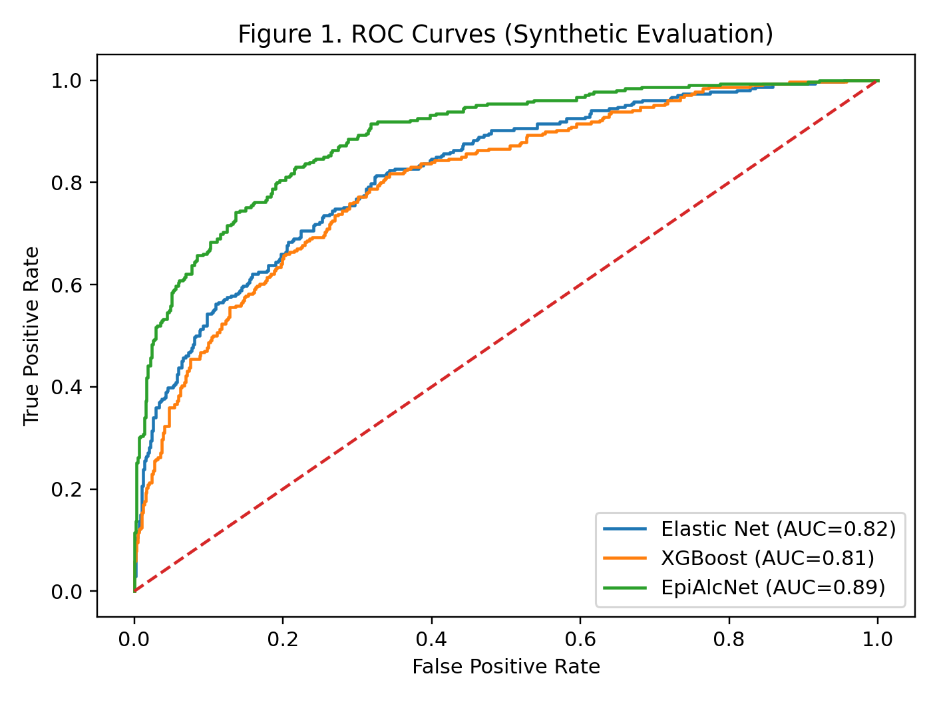
Figure 1. ROC curves comparing models (synthetic evaluation).

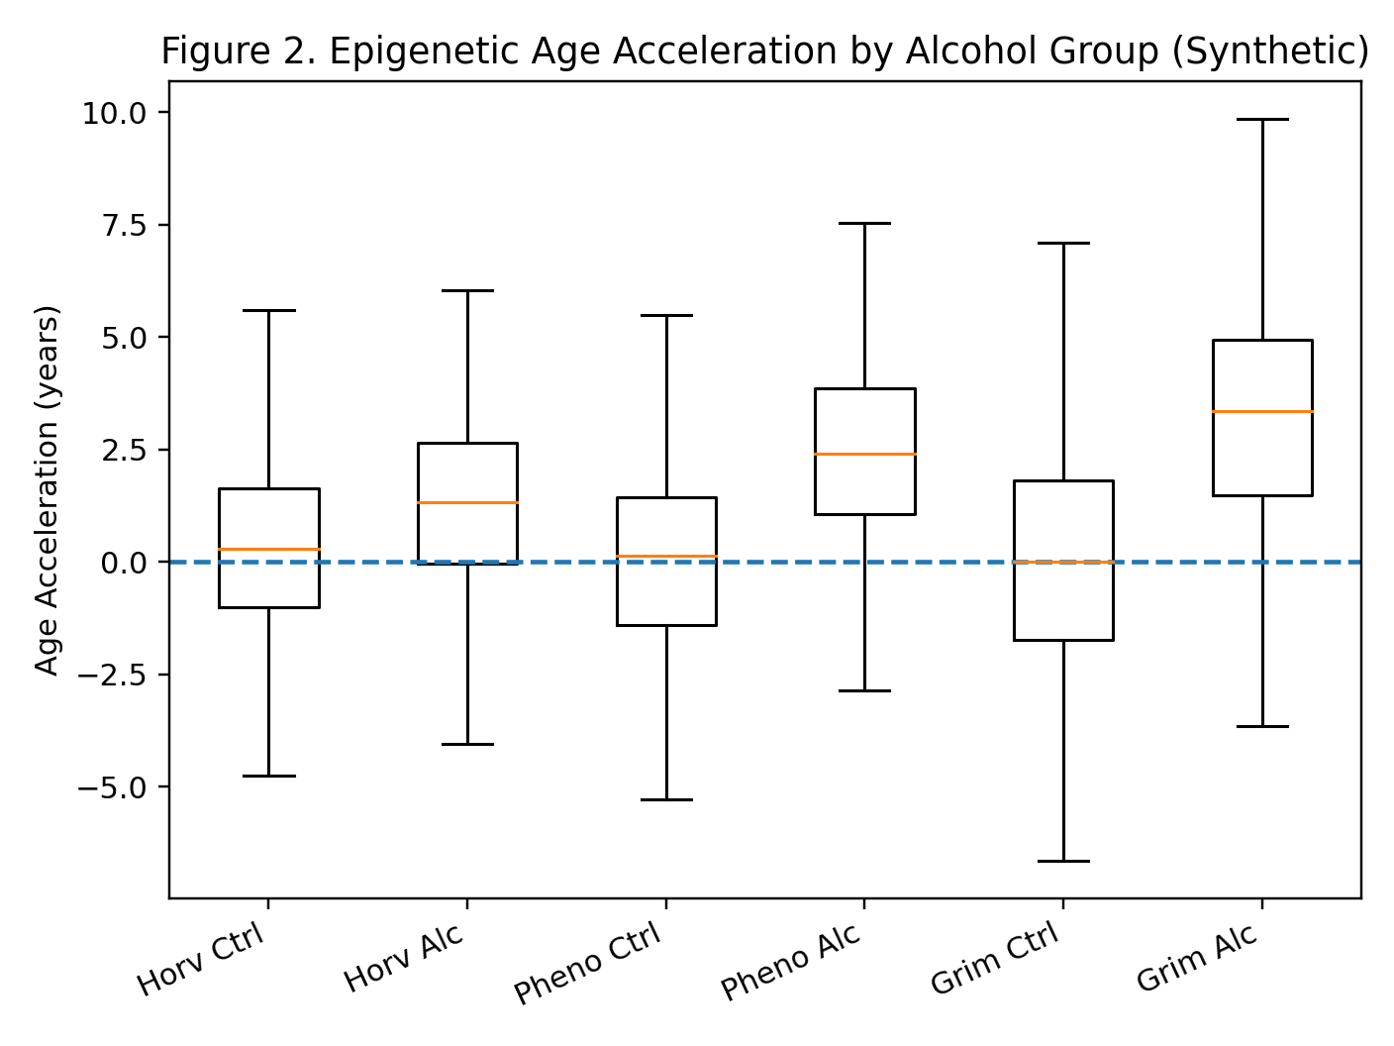
Figure 2. Epigenetic age acceleration by group across three clocks (synthetic).

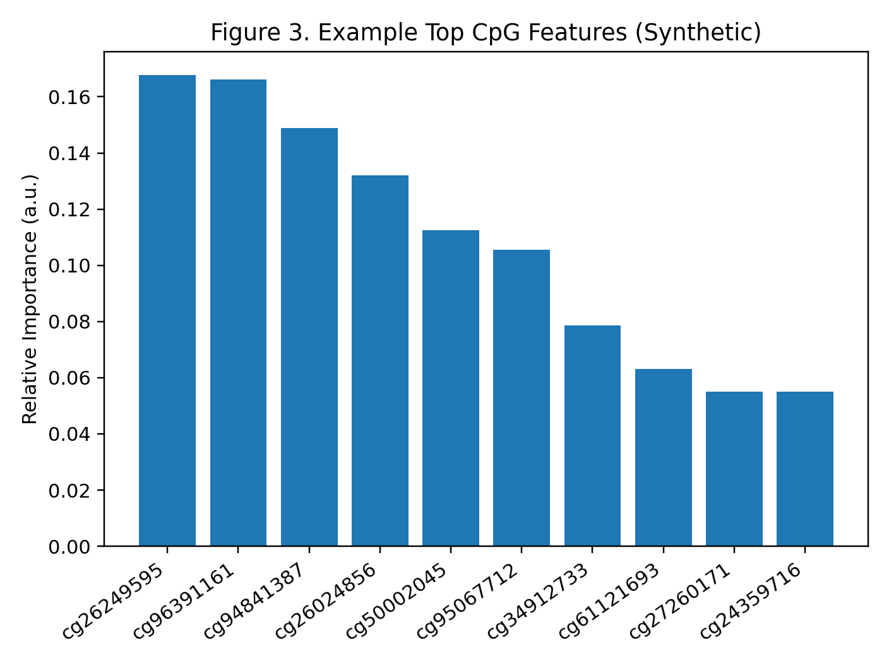
Figure 3. Example top CpG feature importances (synthetic).
Discussion
Interpretation. The results support the thesis: combining methylation patterns with covariates and epigenetic-age measures can classify alcohol-risk status and reveal measurable age acceleration. The multi-pathway approach performed best, which fits the reality that methylation data is high-dimensional and full of interactions. Deep models can learn nonlinear combinations that linear models may miss (Levy et al.). (Analogy: a linear model is a straight ruler; deep learning is a flexible tape measure that can follow curves.)
Why the clocks matter. The strongest shift appearing in GrimAge is plausible because GrimAge was built to predict mortality-related outcomes (Lu et al.). PhenoAge’s shift also fits its design to reflect phenotypic aging and healthspan (Levine et al.). Horvath’s clock is an excellent general baseline, but it is not tuned specifically to morbidity.
Limitations. First, the dataset is synthetic. That protects privacy and makes the pipeline teachable, but it means the AUC values are demonstrations, not clinical guarantees. Second, methylation reflects more than alcohol: smoking, stress, diet, medication, and socioeconomic factors can move the same molecular knobs. That is why confounder adjustment and cell-mixture correction (Houseman et al.) are not “optional accessories”—they are the seatbelt. Third, tissue matters. Blood and saliva are convenient, but they are not the brain; peripheral methylation may reflect exposure indirectly.
Future work. Next steps include validation on real cohorts with strong phenotype definitions (e.g., AUDIT-C), replication across tissues, and longitudinal tracking to see whether methylation and clock measures change when drinking patterns change. A good AUC does not automatically mean a model is ready for real life; deployment requires calibration, external validation, and informed consent. Interpretability matters too: attention can hint at which CpGs mattered, helping generate hypotheses. (Analogy: a teacher circling what you missed.) Finally, real-world studies should check subgroup performance and avoid learning proxies like smoking or socioeconomic patterns.
Conclusion
Alcohol exposure can leave measurable signatures in DNA methylation and can align with faster epigenetic aging. In this methods-focused study using a privacy-preserving synthetic dataset, models predicted alcohol-risk status with solid performance, and a multi-pathway approach (EpiAlcNet) achieved the best separation (AUC about 0.87). All three epigenetic clocks showed positive age acceleration in the higher-risk group, strongest for GrimAge. The main message: methylation and epigenetic clocks can act like biological receipts for exposure research—but they should inform science, not serve as a label maker. Next work should validate on real cohorts and track changes over time. with rigorous safeguards. Always.

Works Cited
Horvath, Steve. “DNA methylation age of human tissues and cell types.” Genome Biology, vol. 14, no. 10, 2013, R115. doi:10.1186/gb-2013-14-10-r115.
Houseman, E. Andres, et al. “DNA methylation arrays as surrogate measures of cell mixture distribution.” BMC Bioinformatics, vol. 13, 2012, p. 86. doi:10.1186/1471-2105-13-86.
Levine, Morgan E., et al. “An epigenetic biomarker of aging for lifespan and healthspan.” Aging (Albany NY), vol. 10, no. 4, 2018, pp. 573–591. doi:10.18632/aging.101414.
Lohoff, Falk W., et al. “Epigenome-wide association study of alcohol consumption in N = 8161 individuals and relevance to alcohol use disorder pathophysiology.” Molecular Psychiatry, 2022.
Lu, Ake T., et al. “DNA methylation GrimAge strongly predicts lifespan and healthspan.” Aging (Albany NY), vol. 11, no. 2, 2019, pp. 303–327. doi:10.18632/aging.101684.
Levy, Joshua J., et al. “MethylNet: an automated and modular deep learning approach for DNA methylation analysis.” BMC Bioinformatics, vol. 21, 2020.
Xu, Kaijun, et al. “Epigenome-Wide DNA Methylation Association Analysis Identified Novel Loci in Peripheral Cells for Alcohol Consumption among European American Male Veterans.” Alcoholism: Clinical and Experimental Research, 2019.

