Computing Networking Lab
BSDS-3A

Name : Ishaan Lalani
ID : Ds241008

ASSIGNMENT # 01


. What is EIGRP?
1

EIGRP (Enhanced Interior Gateway Routing Protocol) is a
dynamic routing protocol

developed by Cisco. It is used to
share routing information

between routers in the same
network so they can choose the
best path

to reach a destination.

2.

What is AS number?

The
Autonomous System (AS) number

is a
unique number

used to identify routers that
belong to the same EIGRP routing process. Routers must have the
same AS number

to
become EIGRP neighbors and exchange routes.

3
. What is DUAL algorithm?

DUAL (Diffusing Update Algorithm) is the
path
-
selection algorithm

used by EIGRP. It
ensures
loop
-
free routing

and allows EIGRP to
quickly find the best backup route

if the
main route fails.

4
. What is Feasible Distance and Reported Distance?

Feasible Distance (FD)

is the
best total metric

from the local router to a destination.

Reported Distance (RD)

is the
distance reported by a neighboring router

to reach that
same destination.

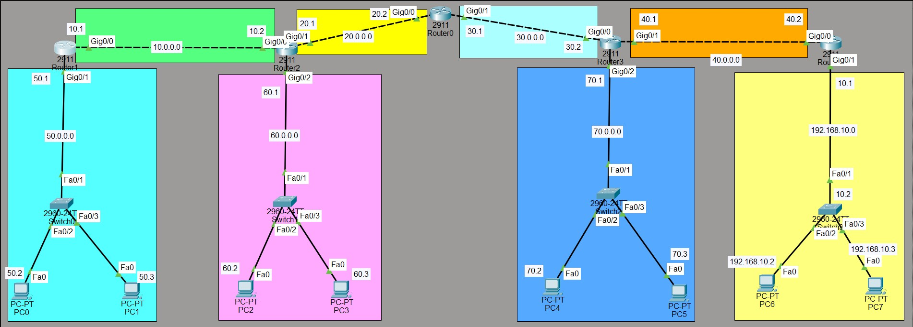

5
. What are Successor and Feasible Successor?

A
Successor

is the main (best) route used to reach a destination.

A
Feasible Successor

is a backup route that can be used immediately if the main route
fails.

6
. What is Hello and Hold timer?

The
Hello timer

decides how often routers send messages to keep the connection alive
.

The
Hold timer

decides how long a router waits before declaring a neighbor down.

Topology Diagram

IP addressing on routers

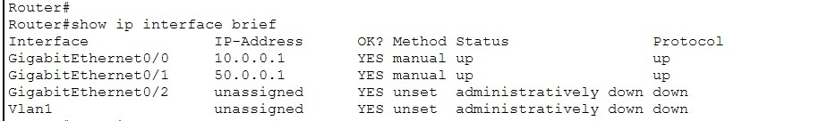

IP Protocols

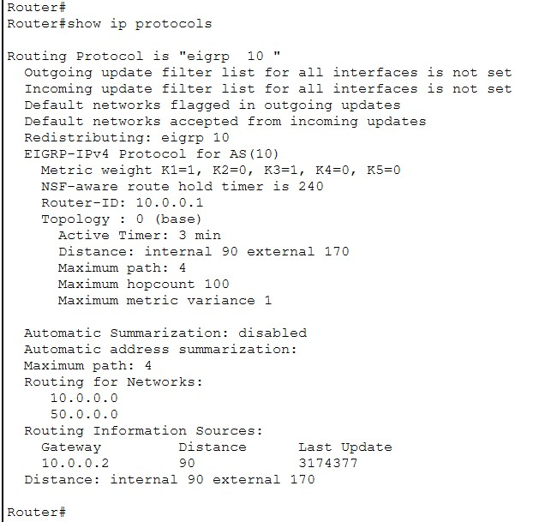

IP EIGRP Neighbors

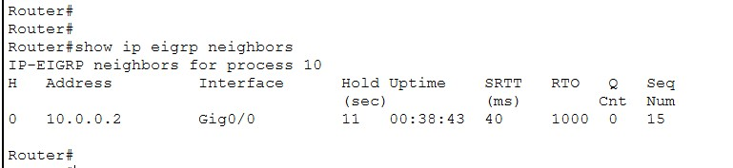

Ping Test Between PC’s

From PC0 to PC7

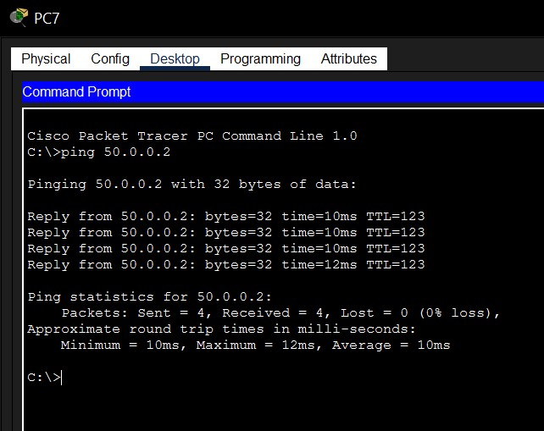

IP Routes

