DYNAMIC ROUTING LAB (RIP)
Cisco Packet Tracer Network Configuration & Analysis
Source File: Dynamic Routing.pkt
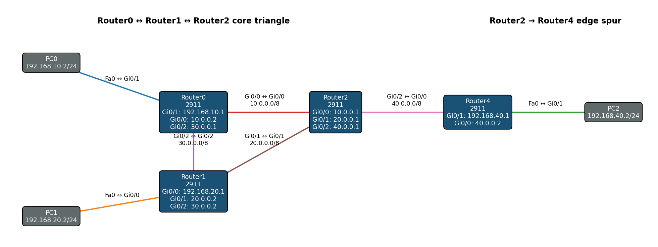
RIP-based dynamic routing across four Cisco 2911 routers and three LANs

1. Introduction
This lab demonstrates dynamic routing using the Routing Information Protocol (RIP) in Cisco Packet Tracer. Four Cisco 2911 routers form a routed core and edge topology connecting three separate PC LANs. Unlike static routing, the routers use RIP to exchange route information automatically.

2. Objectives
- Configure IPv4 addresses on all router interfaces.
- Connect three end-device LANs through a four-router topology.
- Enable RIP and advertise the required directly connected networks.
- Understand how routers learn remote networks dynamically.
- Verify RIP-learned routes and end-to-end connectivity.

3. Network Topology
The topology contains a triangle between Router0, Router1, and Router2, with Router4 connected to Router2 as an edge branch. PC0, PC1, and PC2 each reside on their own /24 LAN.

Example logical paths
PC0 → Router0 → Router2 → Router1 → PC1
PC0 → Router0 → Router2 → Router4 → PC2
The core triangle provides multiple possible routed paths; the forwarding path depends on routing information learned through RIP.

4. Devices and Roles
Device | Model | Role
Router0 | Cisco 2911 | Core router; connects PC0 LAN to the routed core
Router1 | Cisco 2911 | Core router; connects PC1 LAN to Router0 and Router2
Router2 | Cisco 2911 | Core hub; connects Router0, Router1, and Router4
Router4 | Cisco 2911 | Edge router; connects PC2 LAN to Router2
PC0 | PC-PT | 192.168.10.2/24, gateway 192.168.10.1
PC1 | PC-PT | 192.168.20.2/24, gateway 192.168.20.1
PC2 | PC-PT | 192.168.40.2/24, gateway 192.168.40.1
Power Distribution Device0 | iot_pdu | Present but unconnected

5. IP Addressing Plan
Link / LAN | CIDR | Router A | Router B | Host | Purpose
R0 ↔ R2 | 10.0.0.0/8 | R0 Gi0/0 = 10.0.0.2 | R2 Gi0/0 = 10.0.0.1 | — | Core link
R0 ↔ R1 | 30.0.0.0/8 | R0 Gi0/2 = 30.0.0.1 | R1 Gi0/2 = 30.0.0.2 | — | Core link
R1 ↔ R2 | 20.0.0.0/8 | R1 Gi0/1 = 20.0.0.2 | R2 Gi0/1 = 20.0.0.1 | — | Core link
R2 ↔ R4 | 40.0.0.0/8 | R2 Gi0/2 = 40.0.0.1 | R4 Gi0/0 = 40.0.0.2 | — | Edge link
PC0 LAN | 192.168.10.0/24 | R0 Gi0/1 = 192.168.10.1 | — | PC0 = 192.168.10.2 | LAN
PC1 LAN | 192.168.20.0/24 | R1 Gi0/0 = 192.168.20.1 | — | PC1 = 192.168.20.2 | LAN
PC2 LAN | 192.168.40.0/24 | R4 Gi0/1 = 192.168.40.1 | — | PC2 = 192.168.40.2 | LAN

6. Routing Design with RIP
RIP is enabled on all four routers. Each router advertises the networks directly connected to it, allowing neighboring routers to learn remote routes dynamically.

RIP network statements
Router | Advertised Networks
Router0 | 10.0.0.0, 30.0.0.0, 192.168.10.0
Router1 | 20.0.0.0, 30.0.0.0, 192.168.20.0
Router2 | 10.0.0.0, 20.0.0.0, 40.0.0.0
Router4 | 40.0.0.0, 192.168.40.0

How dynamic learning works
- Routers start with directly connected networks.
- RIP shares routing information with neighboring routers.
- Remote networks are learned dynamically.
- The routing table is updated as route information is exchanged.
- Remote PC subnets become reachable without static routes.

7. Router Configurations

Router0
hostname Router0
interface GigabitEthernet0/0
ip address 10.0.0.2 255.0.0.0
interface GigabitEthernet0/1
ip address 192.168.10.1 255.255.255.0
interface GigabitEthernet0/2
ip address 30.0.0.1 255.0.0.0
router rip
network 10.0.0.0
network 30.0.0.0
network 192.168.10.0

Router1
hostname Router1
interface GigabitEthernet0/0
ip address 192.168.20.1 255.255.255.0
interface GigabitEthernet0/1
ip address 20.0.0.2 255.0.0.0
interface GigabitEthernet0/2
ip address 30.0.0.2 255.0.0.0
router rip
network 20.0.0.0
network 30.0.0.0
network 192.168.20.0

Router2
hostname Router2
interface GigabitEthernet0/0
ip address 10.0.0.1 255.0.0.0
interface GigabitEthernet0/1
ip address 20.0.0.1 255.0.0.0
interface GigabitEthernet0/2
ip address 40.0.0.1 255.0.0.0
router rip
network 10.0.0.0
network 20.0.0.0
network 40.0.0.0

Router4
hostname Router4
interface GigabitEthernet0/0
ip address 40.0.0.2 255.0.0.0
interface GigabitEthernet0/1
ip address 192.168.40.1 255.255.255.0
interface GigabitEthernet0/2
no ip address
shutdown
router rip
network 40.0.0.0
network 192.168.40.0

8. PC Configuration
PC | IP Address | Subnet Mask | Default Gateway
PC0 | 192.168.10.2 | 255.255.255.0 | 192.168.10.1
PC1 | 192.168.20.2 | 255.255.255.0 | 192.168.20.1
PC2 | 192.168.40.2 | 255.255.255.0 | 192.168.40.1

9. Example Packet Flow
Consider PC0 (192.168.10.2) communicating with PC2 (192.168.40.2). PC0 sends the packet to Router0 at 192.168.10.1, and Router0 uses RIP-learned information to reach 192.168.40.0/24.
Step | Device / Segment | Action
1 | PC0 | Sends the packet to Router0 at 192.168.10.1.
2 | Router0 | Uses a RIP-learned route toward 192.168.40.0/24.
3 | Core routers | Forward the packet using the RIP-selected path.
4 | Router4 | Recognizes 192.168.40.0/24 as directly connected on Gi0/1.
5 | PC2 | Receives the packet at 192.168.40.2.
PC0 → Router0 → [RIP-selected core path] → Router4 → PC2

10. RIP vs Static Routing
Aspect | Static Routing | RIP Dynamic Routing
Route configuration | Manual | Learned through RIP updates
Route changes | Manual changes required | Can be learned dynamically
Scalability | More manual configuration | Reduces manual route configuration
Protocol overhead | No routing-protocol updates | Routing updates are exchanged
This lab | Not used | Primary routing mechanism

11. Verification and Testing
Useful Cisco IOS commands:
show ip interface brief
show ip route
show ip protocols
show ip route rip
show running-config
ping <destination-ip>
traceroute <destination-ip>
Example end-to-end tests:
From PC0:
ping 192.168.40.2
From PC1:
ping 192.168.10.2
ping 192.168.40.2
From PC2:
ping 192.168.10.2
ping 192.168.20.2
RIP-learned entries are normally identified with code 'R' in the routing table, while directly connected networks appear as connected routes. The exact preferred path depends on the routing information learned during the simulation.

12. Key Networking Concepts
- Dynamic routing protocols
- Routing Information Protocol (RIP)
- Directly connected and RIP-learned routes
- Default gateways
- Routing tables
- End-to-end ICMP testing

13. Conclusion
This lab demonstrates dynamic routing with RIP across four Cisco 2911 routers. Each router advertises its directly connected networks, and RIP distributes that information so remote LANs can be reached without static routes. The topology illustrates how routing tables are built from information exchanged between neighboring routers.

14. Configuration Summary
Device | Key Interfaces | RIP Advertisements
Router0 | Gi0/0 10.0.0.2; Gi0/1 192.168.10.1; Gi0/2 30.0.0.1 | 10.0.0.0; 30.0.0.0; 192.168.10.0
Router1 | Gi0/0 192.168.20.1; Gi0/1 20.0.0.2; Gi0/2 30.0.0.2 | 20.0.0.0; 30.0.0.0; 192.168.20.0
Router2 | Gi0/0 10.0.0.1; Gi0/1 20.0.0.1; Gi0/2 40.0.0.1 | 10.0.0.0; 20.0.0.0; 40.0.0.0
Router4 | Gi0/0 40.0.0.2; Gi0/1 192.168.40.1 | 40.0.0.0; 192.168.40.0

