STATIC ROUTING LAB
Cisco Packet Tracer Network Configuration & Analysis

Source File: Static Routing.pkt
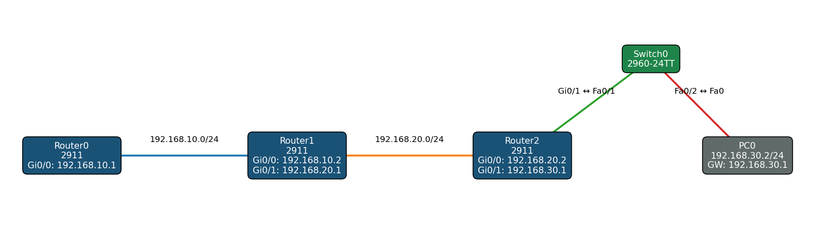
Three-router static routing topology with end-to-end IPv4 connectivity

1. Introduction
This lab demonstrates static routing using Cisco Packet Tracer. Three Cisco 2911 routers are connected in a linear topology, with Router2 providing access to a local PC network through a Cisco 2960-24TT Layer 2 switch. Static routes are manually configured so that the routers can reach networks that are not directly connected to their interfaces.

2. Objectives
- Configure IPv4 addresses on router interfaces.
- Connect multiple IP networks using Cisco routers.
- Configure static routes using next-hop addresses.
- Configure a PC with an appropriate default gateway.
- Understand how routers select paths using their routing tables.
- Verify end-to-end connectivity using ping and routing-table commands.

3. Network Topology
The topology consists of Router0, Router1, Router2, Switch0, and PC0. Router0 and Router1 communicate over 192.168.10.0/24. Router1 and Router2 communicate over 192.168.20.0/24. Router2 connects the 192.168.30.0/24 LAN to PC0.

Logical path
PC0 → Switch0 → Router2 → Router1 → Router0

4. Devices and Roles
Device | Model | Role
Router0 | Cisco 2911 | Edge router; connected to the 192.168.10.0/24 network
Router1 | Cisco 2911 | Middle router; connects the 10.x and 20.x networks
Router2 | Cisco 2911 | Access router; connects the 20.x network to the PC LAN
Switch0 | Cisco 2960-24TT | Layer 2 switch connecting PC0 to Router2
PC0 | PC-PT | End device on 192.168.30.0/24
Power Distribution Device0 | iot_pdu | Present in the Packet Tracer file but unconnected

5. IP Addressing Plan
Network | Device | Interface | IP Address | Purpose
192.168.10.0/24 | Router0 | Gi0/0 | 192.168.10.1 | Router0 ↔ Router1
192.168.10.0/24 | Router1 | Gi0/0 | 192.168.10.2 | Router0 ↔ Router1
192.168.20.0/24 | Router1 | Gi0/1 | 192.168.20.1 | Router1 ↔ Router2
192.168.20.0/24 | Router2 | Gi0/0 | 192.168.20.2 | Router1 ↔ Router2
192.168.30.0/24 | Router2 | Gi0/1 | 192.168.30.1 | PC LAN / default gateway
192.168.30.0/24 | PC0 | Fa0 | 192.168.30.2 | End device
PC0 configuration:
IP Address: 192.168.30.2
Subnet Mask: 255.255.255.0
Default Gateway: 192.168.30.1

6. Static Routing Design
Each router automatically knows the networks directly connected to its interfaces. Static routes are therefore required only for remote networks. The next-hop address identifies the neighboring router that should receive the packet.

Router0
ip route 192.168.20.0 255.255.255.0 192.168.10.2
ip route 192.168.30.0 255.255.255.0 192.168.10.2
Both remote networks are reached through Router1 at 192.168.10.2.

Router1
ip route 192.168.30.0 255.255.255.0 192.168.20.2
The PC LAN is reached through Router2 at 192.168.20.2.

Router2
ip route 192.168.10.0 255.255.255.0 192.168.20.1
Router0's network is reached through Router1 at 192.168.20.1.

7. Router Configurations

Router0
hostname Router0
interface GigabitEthernet0/0
ip address 192.168.10.1 255.255.255.0
interface GigabitEthernet0/1
shutdown
interface GigabitEthernet0/2
shutdown
ip route 192.168.20.0 255.255.255.0 192.168.10.2
ip route 192.168.30.0 255.255.255.0 192.168.10.2

Router1
hostname Router1
interface GigabitEthernet0/0
ip address 192.168.10.2 255.255.255.0
interface GigabitEthernet0/1
ip address 192.168.20.1 255.255.255.0
interface GigabitEthernet0/2
shutdown
router rip
ip route 192.168.30.0 255.255.255.0 192.168.20.2

Router2
hostname Router2
interface GigabitEthernet0/0
ip address 192.168.20.2 255.255.255.0
interface GigabitEthernet0/1
ip address 192.168.30.1 255.255.255.0
interface GigabitEthernet0/2
shutdown
ip route 192.168.10.0 255.255.255.0 192.168.20.1

Switch0
Switch0 operates at Layer 2 for this lab. Fa0/1 connects to Router2 and Fa0/2 connects to PC0. Both ports use the default VLAN 1, and no Layer 3 routing configuration is required.

8. Packet Flow Example
Consider PC0 sending traffic to Router0 at 192.168.10.1. Because the destination is outside PC0's local 192.168.30.0/24 subnet, PC0 sends the packet to its default gateway.
Step | Device | Action
1 | PC0 | Sends the packet to 192.168.30.1, the Router2 gateway.
2 | Router2 | Uses its static route for 192.168.10.0/24 and forwards the packet to 192.168.20.1.
3 | Router1 | Receives the packet and forwards it through its directly connected 192.168.10.0/24 network.
4 | Router0 | Receives the packet at 192.168.10.1, completing the path.

Complete path
PC0 → Router2 → Router1 → Router0

9. Routing Tables – Expected Logic
Router | Destination Network | Path / Next Hop
Router0 | 192.168.10.0/24 | Directly connected
Router0 | 192.168.20.0/24 | 192.168.10.2
Router0 | 192.168.30.0/24 | 192.168.10.2
Router1 | 192.168.10.0/24 | Directly connected
Router1 | 192.168.20.0/24 | Directly connected
Router1 | 192.168.30.0/24 | 192.168.20.2
Router2 | 192.168.20.0/24 | Directly connected
Router2 | 192.168.30.0/24 | Directly connected
Router2 | 192.168.10.0/24 | 192.168.20.1

10. Verification and Testing
Useful Cisco IOS verification commands include:
show ip interface brief
show ip route
show running-config
ping <destination-ip>
traceroute <destination-ip>
Example tests from PC0:
ping 192.168.30.1
ping 192.168.20.1
ping 192.168.10.1
Successful replies from these addresses verify local gateway connectivity, inter-router connectivity, and end-to-end reachability to Router0.

11. RIP Configuration Note
Router1 contains an empty 'router rip' configuration block. Because no network statements are configured under RIP, the supplied configuration does not advertise the lab networks through RIP. The routing design therefore remains static-routing based.

12. Key Networking Concepts
- IPv4 addressing and /24 subnetting
- Default gateways
- Directly connected routes
- Static routes and next-hop addresses
- Layer 2 switching
- Layer 3 routing
- Routing table interpretation
- End-to-end packet forwarding
- Connectivity verification and troubleshooting

13. Conclusion
The lab successfully models a three-router static routing chain connecting three IPv4 networks. Router0, Router1, and Router2 are configured with the minimum static routes required to reach their remote networks. PC0 uses Router2 as its default gateway, while Switch0 provides Layer 2 connectivity between PC0 and Router2. The topology demonstrates how routers use destination networks and next-hop addresses to forward traffic without depending on a dynamic routing protocol.

14. Appendix – Configuration Summary
Device | Interface Addressing | Static Routing / Gateway
Router0 | 192.168.10.1 | 192.168.20.0/24 via 192.168.10.2; 192.168.30.0/24 via 192.168.10.2
Router1 | 192.168.10.2 / 192.168.20.1 | 192.168.30.0/24 via 192.168.20.2
Router2 | 192.168.20.2 / 192.168.30.1 | 192.168.10.0/24 via 192.168.20.1
PC0 | 192.168.30.2 | Default gateway: 192.168.30.1

