SWITCH ROUTER LAB
Cisco Packet Tracer Network Configuration & Analysis
Source File: Switch Router.pkt
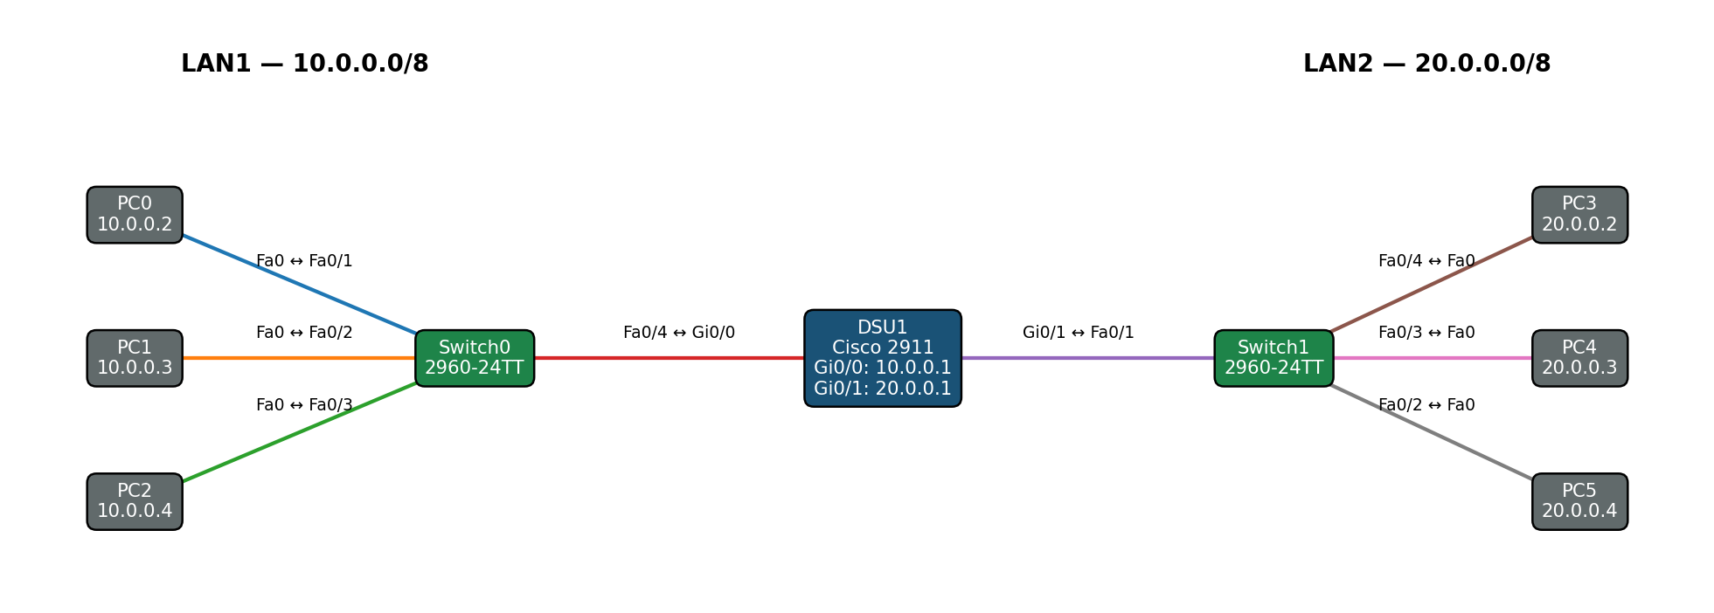
Two Layer-2 LANs connected through a single Layer-3 router

1. Introduction
This lab demonstrates basic LAN switching and inter-network routing using Cisco Packet Tracer. Two Cisco 2960-24TT switches provide Layer 2 connectivity for six PCs. A Cisco 2911 router, hostname DSU1, connects the two /8 networks and routes traffic between them.

2. Objectives
- Connect multiple PCs to Layer 2 switches.
- Configure IPv4 addressing on router interfaces and end devices.
- Use default gateways to enable communication beyond each local subnet.
- Understand how a router forwards traffic between directly connected networks.
- Verify connectivity between hosts on separate LANs.
- Distinguish Layer 2 switching from Layer 3 routing.

3. Router Substitution Note
The original Router1 in the Packet Tracer source was a generic Router-PT with two FastEthernet interfaces. It was re-exported as a Cisco 2911 while retaining the hostname DSU1, the two active interfaces, and their IP configuration. The active interfaces were renamed to GigabitEthernet0/0 and GigabitEthernet0/1 to match the 2911 hardware. Unused serial/fiber interfaces and enable password boilerplate were not carried over.

4. Network Topology
LAN1 uses the 10.0.0.0/8 network and LAN2 uses the 20.0.0.0/8 network. DSU1 is the Layer 3 boundary between the two LANs.

Logical path
LAN1 PCs → Switch0 → DSU1 → Switch1 → LAN2 PCs

5. Devices and Roles
Device | Model | Role
Switch0 | 2960-24TT | Layer 2 access switch for 10.0.0.0/8
Switch1 | 2960-24TT | Layer 2 access switch for 20.0.0.0/8
Router1 / DSU1 | Cisco 2911 | Inter-LAN Layer 3 router
PC0–PC2 | PC-PT | Hosts on LAN1
PC3–PC5 | PC-PT | Hosts on LAN2
Power Distribution Device0 | iot_pdu | Present but unconnected

6. IP Addressing Plan
Subnet | Router Interface | Router IP | Hosts | Default Gateway
LAN1: 10.0.0.0/8 | Gi0/0 | 10.0.0.1 | PC0 .2, PC1 .3, PC2 .4 | 10.0.0.1
LAN2: 20.0.0.0/8 | Gi0/1 | 20.0.0.1 | PC3 .2, PC4 .3, PC5 .4 | 20.0.0.1

7. Routing Design
No static routes or dynamic routing protocols are required. DSU1 has an interface in each LAN, so both networks appear as directly connected routes in its routing table.
10.0.0.0/8 → directly connected via Gi0/0
20.0.0.0/8 → directly connected via Gi0/1
When a PC sends traffic to the other LAN, it forwards the packet to its default gateway. DSU1 receives the packet and forwards it through the interface belonging to the destination subnet.

8. Router Configuration — DSU1
hostname DSU1
interface GigabitEthernet0/0
ip address 10.0.0.1 255.0.0.0
duplex auto
speed auto
interface GigabitEthernet0/1
ip address 20.0.0.1 255.0.0.0
duplex auto
speed auto
interface GigabitEthernet0/2
no ip address
shutdown

9. Switch Configurations

Switch0
hostname Switch0
interface FastEthernet0/1 ! PC0
interface FastEthernet0/2 ! PC1
interface FastEthernet0/3 ! PC2
interface FastEthernet0/4 ! uplink to DSU1 Gi0/0
interface Vlan1
no ip address
shutdown

Switch1
hostname Switch1
interface FastEthernet0/1 ! uplink to DSU1 Gi0/1
interface FastEthernet0/2 ! PC5
interface FastEthernet0/3 ! PC4
interface FastEthernet0/4 ! PC3
interface Vlan1
no ip address
shutdown
The switches operate as Layer 2 devices in this topology. No inter-VLAN routing is configured, and no switch management IP is required for the forwarding function demonstrated by the lab.

10. PC Configuration
PC | IP Address | Subnet Mask | Default Gateway
PC0 | 10.0.0.2 | 255.0.0.0 | 10.0.0.1
PC1 | 10.0.0.3 | 255.0.0.0 | 10.0.0.1
PC2 | 10.0.0.4 | 255.0.0.0 | 10.0.0.1
PC3 | 20.0.0.2 | 255.0.0.0 | 20.0.0.1
PC4 | 20.0.0.3 | 255.0.0.0 | 20.0.0.1
PC5 | 20.0.0.4 | 255.0.0.0 | 20.0.0.1

11. Packet Flow Example
Consider PC0 (10.0.0.2) sending a packet to PC3 (20.0.0.2). Because 20.0.0.2 is outside PC0's 10.0.0.0/8 local network, PC0 sends the frame to its default gateway, 10.0.0.1.
Step | Device | Action
1 | PC0 | Sends the packet to its default gateway, DSU1 Gi0/0 at 10.0.0.1.
2 | Switch0 | Forwards the Ethernet frame from PC0 to DSU1.
3 | DSU1 | Recognizes 20.0.0.0/8 as directly connected through Gi0/1 and routes the packet.
4 | Switch1 | Forwards the resulting Ethernet frame to PC3.
5 | PC3 | Receives the packet at 20.0.0.2.
PC0 → Switch0 → DSU1 → Switch1 → PC3

12. Routing Table Concept
Because both networks are directly attached to DSU1, the router does not need manually configured static routes. The expected routing logic is:
Destination | Route Type | Interface
10.0.0.0/8 | Connected | Gi0/0
20.0.0.0/8 | Connected | Gi0/1

13. Verification and Testing
Useful router commands:
show ip interface brief
show ip route
show running-config
ping <destination-ip>
Example connectivity tests:
From PC0:
ping 10.0.0.1
ping 20.0.0.1
ping 20.0.0.2
From PC3:
ping 20.0.0.1
ping 10.0.0.1
ping 10.0.0.2
Successful replies verify local gateway connectivity and end-to-end communication between the two LANs.

14. Layer 2 vs Layer 3 Roles
Component | Layer | Primary Function
Switch0 / Switch1 | Layer 2 | Forward Ethernet frames within each LAN
DSU1 | Layer 3 | Route IP packets between 10.0.0.0/8 and 20.0.0.0/8
PCs | End hosts | Generate and receive IP traffic

15. Key Networking Concepts
- IPv4 addressing with /8 subnet masks
- Default gateways
- Directly connected routes
- Layer 2 Ethernet switching
- Layer 3 IP routing
- Inter-LAN communication
- Routing table interpretation
- Connectivity testing with ICMP ping

16. Conclusion
This lab demonstrates how two separate LANs can communicate through a single router. Switch0 and Switch1 provide Layer 2 connectivity for their respective hosts, while DSU1 provides Layer 3 routing between the 10.0.0.0/8 and 20.0.0.0/8 networks. Because both networks are directly connected to the router, no static route or dynamic routing protocol is necessary. Correct default gateway configuration on the PCs is sufficient to enable inter-LAN communication.

17. Configuration Summary
Device | Addressing | Routing Role
DSU1 | Gi0/0 = 10.0.0.1/8; Gi0/1 = 20.0.0.1/8 | Routes between both directly connected LANs
PC0–PC2 | 10.0.0.2–10.0.0.4/8 | Gateway 10.0.0.1
PC3–PC5 | 20.0.0.2–20.0.0.4/8 | Gateway 20.0.0.1
Switch0 | Layer 2 | Connects LAN1 hosts to DSU1
Switch1 | Layer 2 | Connects LAN2 hosts to DSU1

