Game Design Document

Fill up the following document

1. Write the title of your project.

The Ghost

1. What is the goal of the game?

To earn as much points as possible

1. Write a brief story of your game.

Ghost is flying up, has to collect coins to get points. Only has 3 life, will die if he hits a broken gem. Played on laptop using the arrow keys. Code.org

1. Which are the playing characters of this game?

* Playing characters are the ones who respond to the user based on the input from the user.
* Cars, monkeys, dinos, wizards, etc., are the playing characters in the game.

|  |  |  |
| --- | --- | --- |
| Number | Character Name | What can this character do? |
| 1 | Ghost man | Fly up and collect coins |
| 2 |  |
| 3 |  |  |
| 4 |  |  |
| 5 |  |  |
| 6 |  |  |
| 7 |  |  |
| 8 |  |  |

1. Which are the Non-Playing Characters of this game?

* Non-Playing characters are the ones that don't have an action or behavior when the user interacts with the game.
* Hurdles, stones, bananas, coins, etc., are non-playing characters in the game.

|  |  |  |
| --- | --- | --- |
| Number | Character Name | What can this character do? |
| 1 | Coins | Points for the ghost and player |
| 2 | Broken gems | If it is hit, one live lost |
| 3 |  |  |
| 4 |  |  |
| 5 |  |  |
| 6 |  |  |
| 7 |  |  |
| 8 |  |  |

Draw your imagination of this game. What does this game look like?

* Draw the game either on your computer or on paper.
* Add images of the game scenes to show each of the playing and non-playing characters at least once.

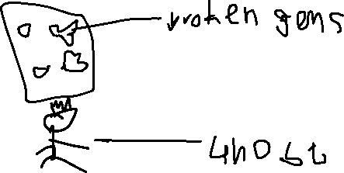

How do you plan to make your game engaging?

Go faster more points you get