Course Name: | Web Development Laboratory (316U01L306) | Semester: | III
Date of Performance: | __12_ / __08_ / __26____ | DIV/ Batch No: | B-2
Student Name: | Ishaan Singh Khanka | Roll No: | 16010125107

Experiment No: 2
Title: Design web Portal using CSS3.

Aim of the Experiment: To apply CSS3 style sheets to an existing HTML5-based Web Portal for the given Use Case study in order to enhance layout, responsiveness, visual aesthetics, and user interaction using modern CSS3 features.

Objectives for the Experiment:
- Implement different CSS3 styling techniques
- Design responsive layouts using Flexbox and media queries
- Enhance user interaction using animations
- Maintain separation of content and presentation

COs to be achieved:
CO1: Use CSS to prepare the layout of web pages.

Books/ Journals/ Websites references:
- Students should write ……..

Theory:
Students should write about CSS3 (citation needed for content taken (IEEE or APA7 style))

Problem statement: Demonstrate the implementation of CSS3 features to enhance the layout, responsiveness, and aesthetics of the selected HTML-based web portal for the selected Use Case in experiment 1.
Note: All tasks are compulsory to use.

Task 1: Style the Homepage Header (Inline CSS)
Requirements:
- Use inline CSS to:
  - Set background color for header
  - Change text color of store name
  - Center align slogan
  - Add padding and border
- Apply inline style to:
  - <h1>, <p>, <header>
Concepts tested:
Inline CSS, color, background, padding, text-align, border.

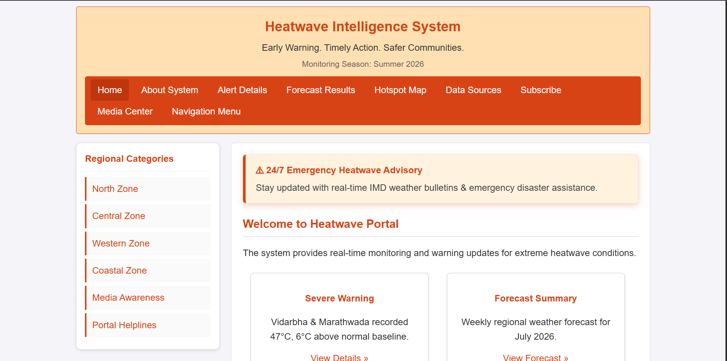

Task 2: Internal CSS for Navigation Menu
Navigation menu should look professional and consistent across the page.
Requirements:
- Use internal CSS (<style> in <head>)
- Style navigation menu:
  - Remove bullet points
  - Display menu items horizontally
  - Add hover effect
  - Change link colors
- Use:
  - :hover, text-decoration, display: inline-block
Concepts tested:
Internal CSS, selectors, pseudo-class, styling links.
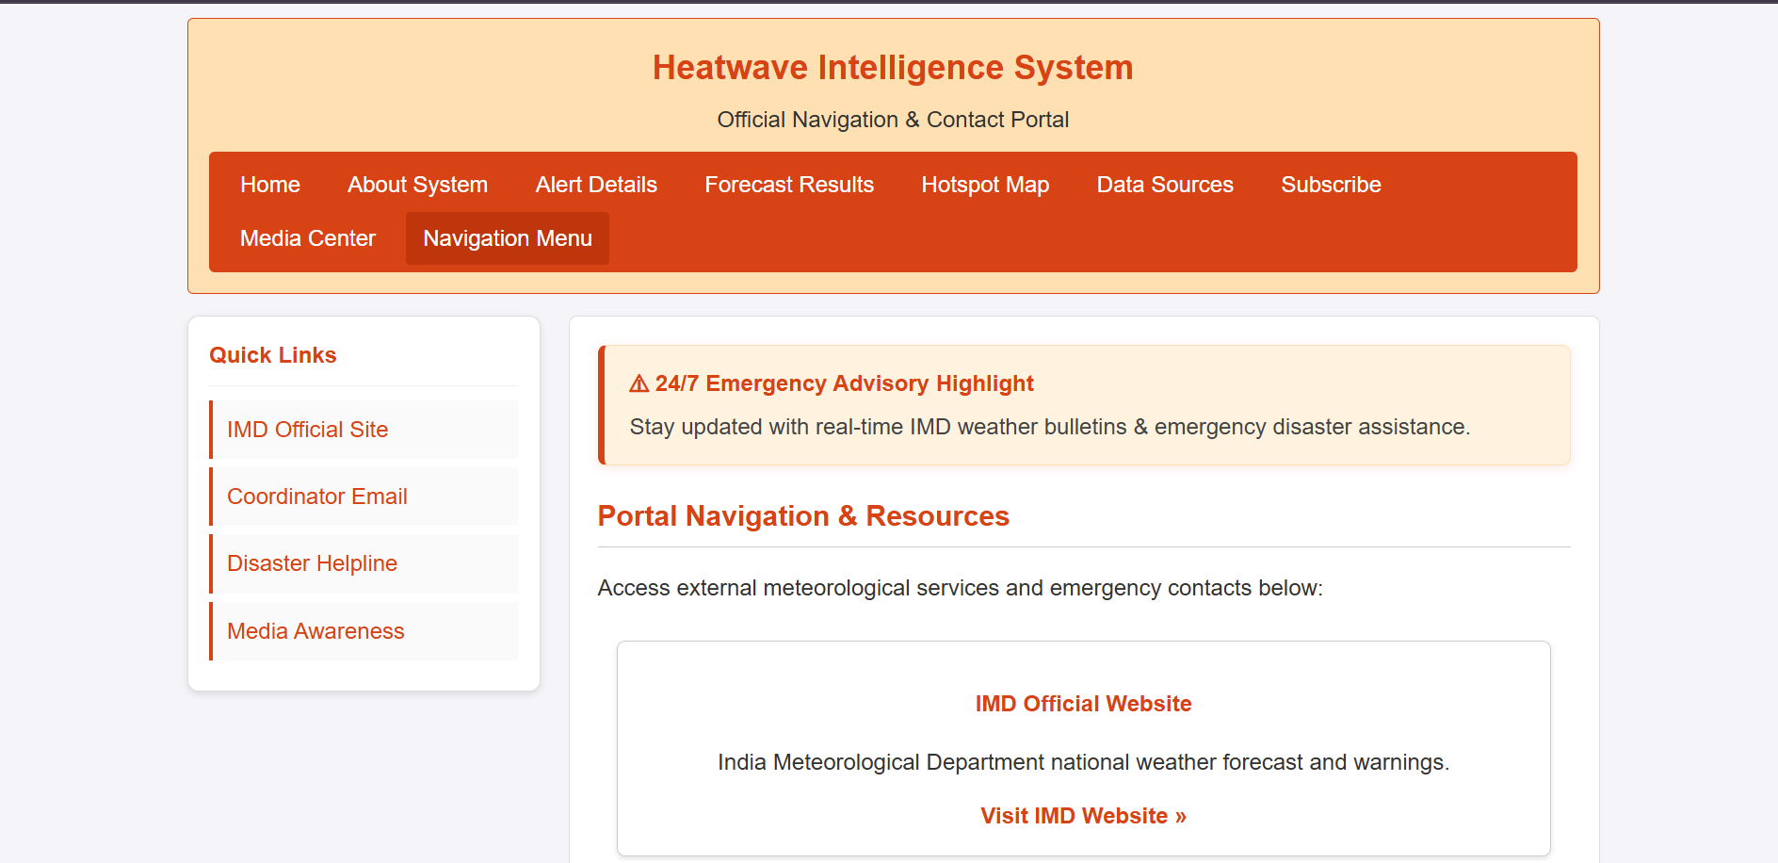

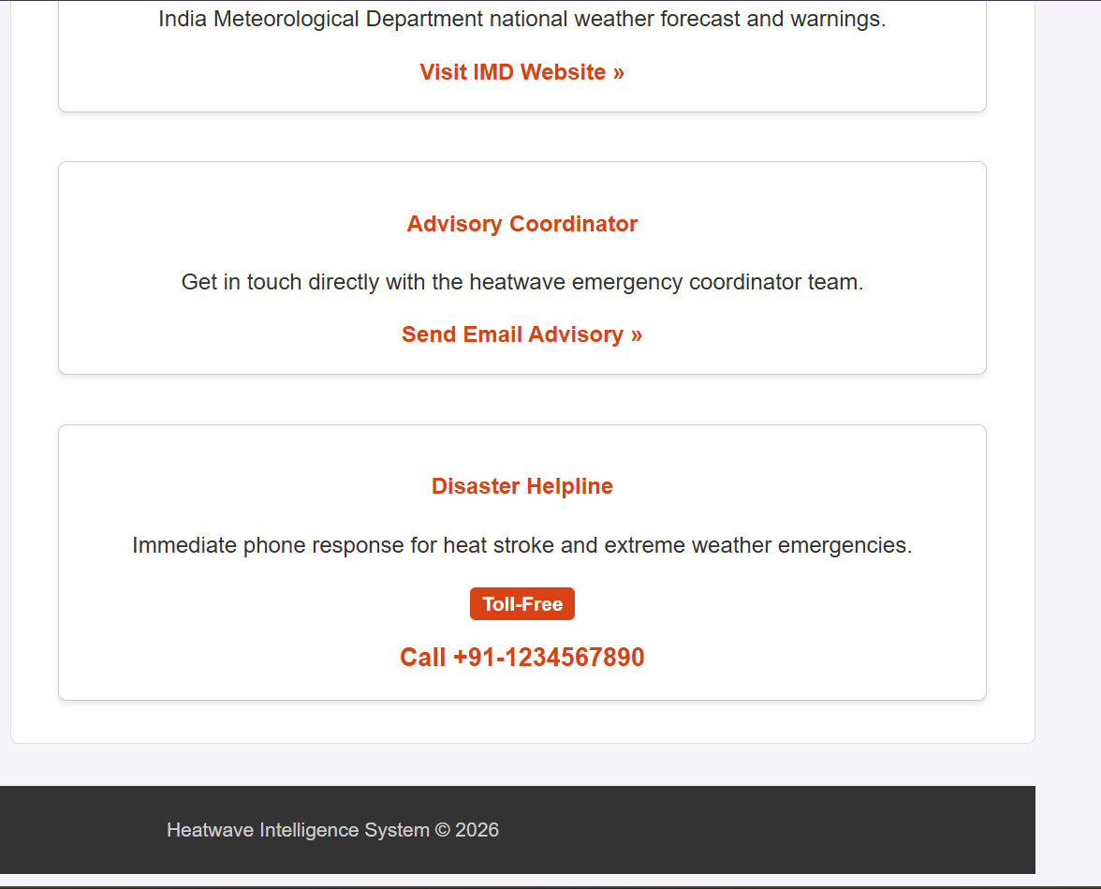

Task 3: External CSS for Whole Website Theme

For a consistent look across all pages.
Requirements:
- Create file: style.css
- Link it using <link>
- Apply:
  - Body font-family
  - Background color
  - Common heading color
  - Common footer style
Concepts tested:
External CSS, reusable styles, site-wide theming.
Deliverables : style.css linked with book.html

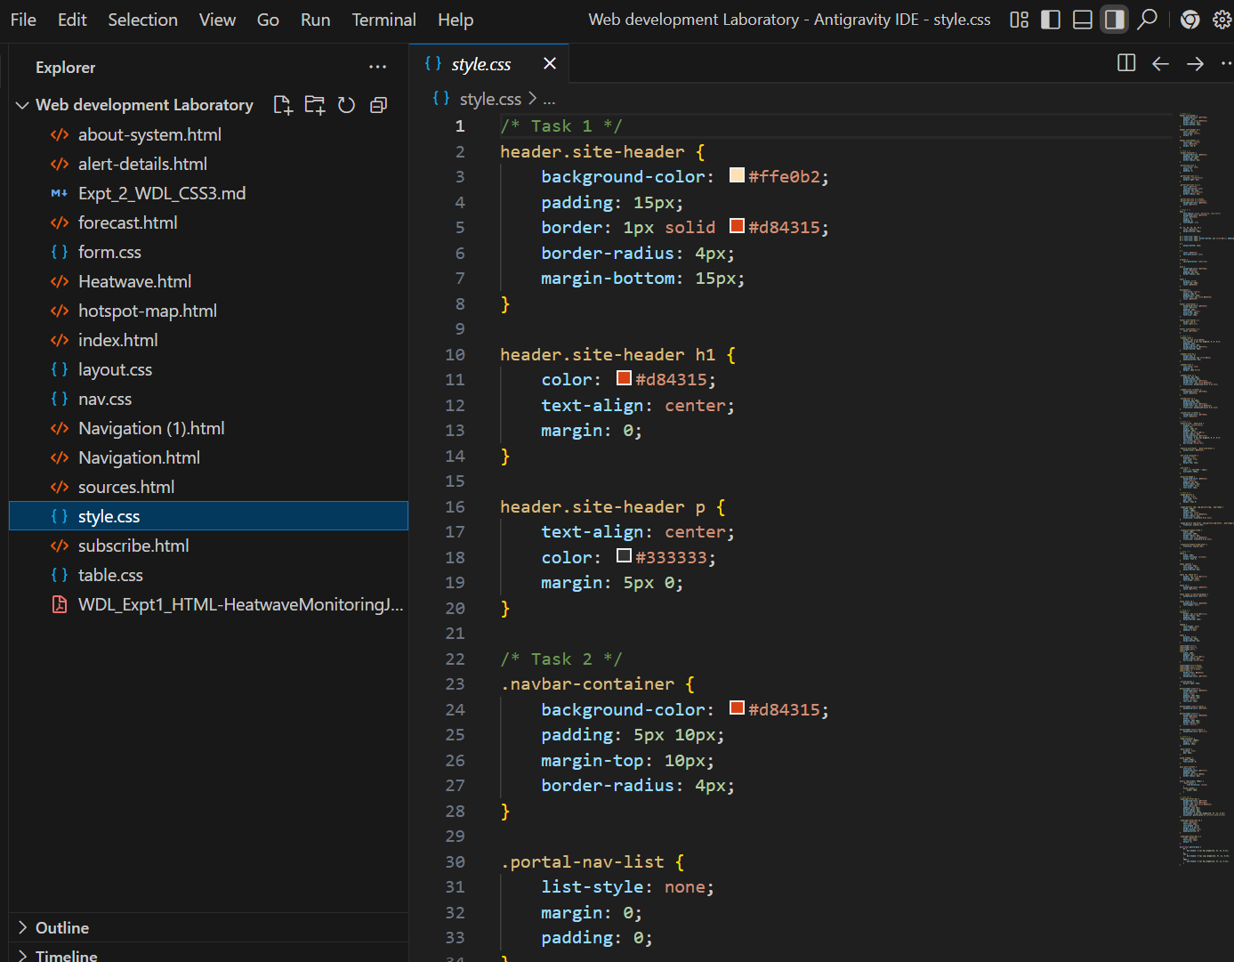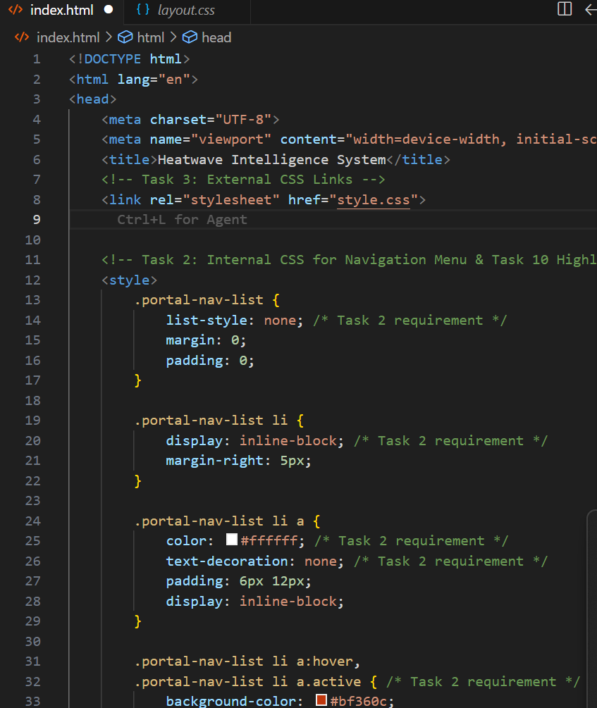
Task 4: Style Book Categories Sidebar
The categories section should look like a card.
Requirements:
- Use external or internal CSS
- Apply:
  - Border
  - Box shadow
  - Padding
  - Rounded corners
- Style list items with:
  - Spacing
  - Hover color change
Concepts tested:
Box model, border-radius, box-shadow, list styling.
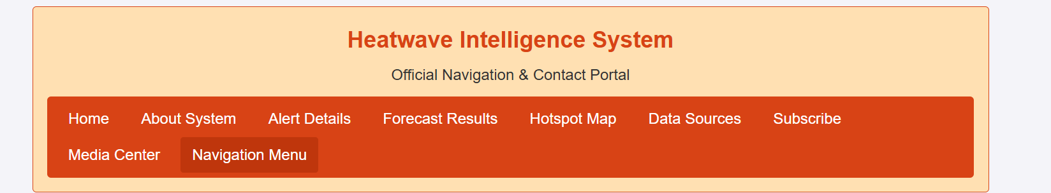

Task 5: Book Card Layout Using CSS Box Model
To make Each item appear as a product card.
Requirements:
- Style a <div> as a book card:
  - Width, margin, padding, border
  - Center align content
- Use:
  - display: inline-block
  - Add background color and shadow
Concepts tested:
Box model, margin, padding, display property.
Deliverable : link this .css file with book.html
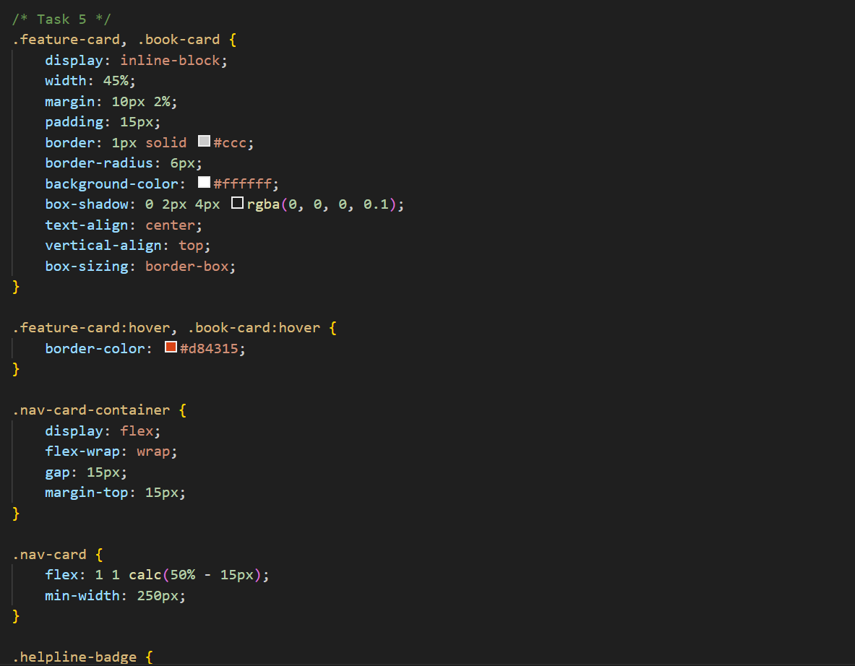
Task 6: Image Gallery Styling with CSS
To make Featured appropriate items/ attributes, whichever applicable in the Use Case look like a grid.
Requirements:
- Use CSS to:
  - Set same size for all images
  - Add border and hover zoom effect
  - Add spacing between images
- Use:
  - transition, transform: scale()
Concepts tested:
Image styling, hover effects, transitions.
Deliverable nav.css , link to nav bar of expt1
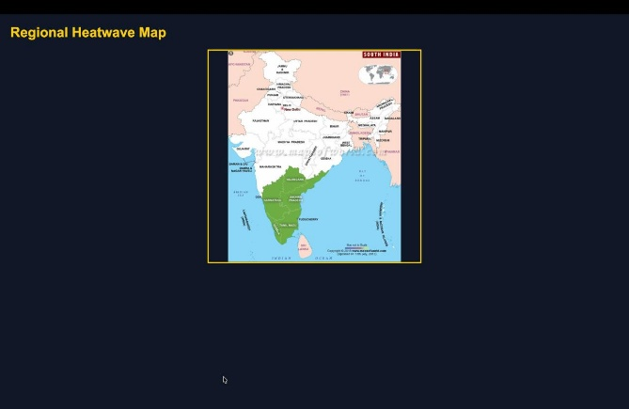
Task 7: Table Styling for Price List
Requirements:
- Use CSS to:
  - Collapse borders
  - Add header background color
  - Zebra-striping rows
  - Center align text
- Use:
  - border-collapse, nth-child(even)
Concepts tested:
Table styling, pseudo-classes.
Deliverable table.css , link to the corresponding file.
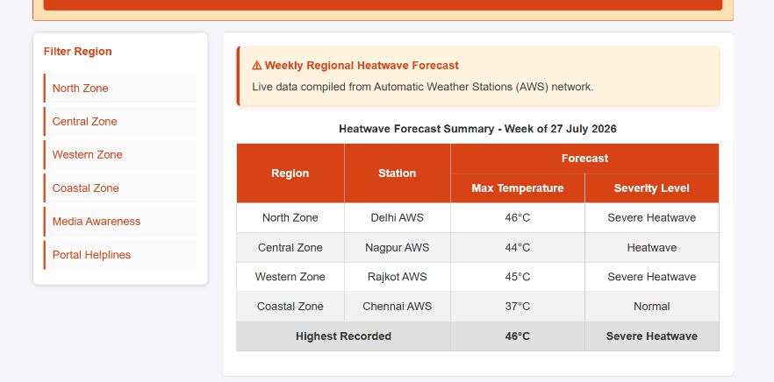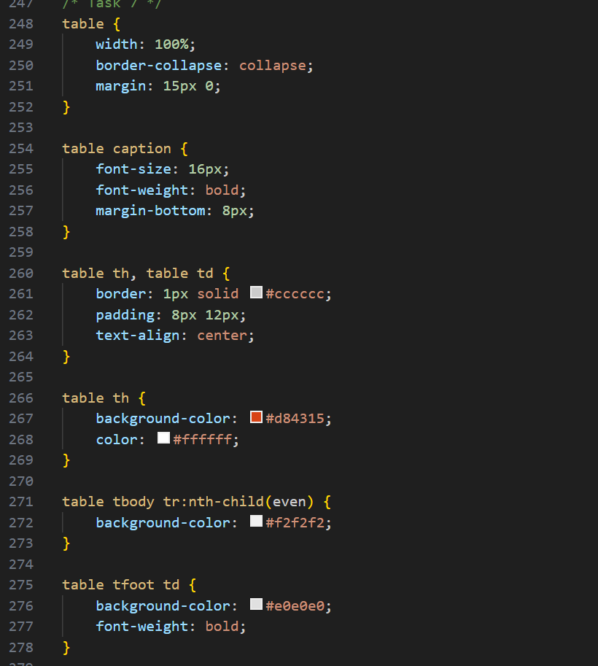
Task 8: Style Registration Form
Requirements:
- Style:
  - Input boxes width, padding
  - Submit button color and hover effect
  - Fieldset and legend
- Use:
  - :focus, :hover
  - border-radius
Concepts tested:
Form UI styling, pseudo-classes, layout.
Deliverable : form.css
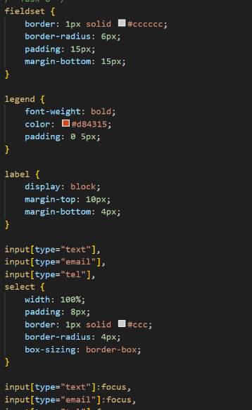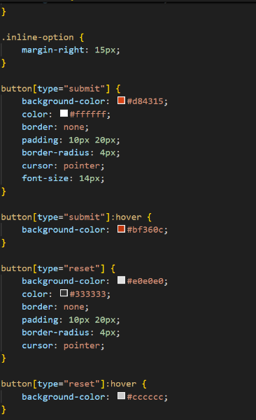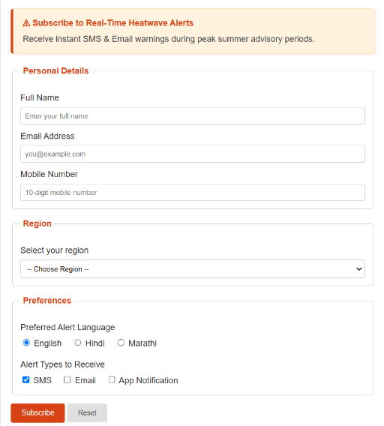
Task 9: Page Layout Using CSS (Header, Sidebar, Content, Footer)
To Create a proper website layout.
Requirements:
- Use CSS to:
  - Set sidebar to left
  - Content to right
  - Footer at bottom
- Use:
  - float or flex
  - Set widths and spacing
Concepts tested:
Layout design, positioning, float/flex.
Deliverable : layout.css
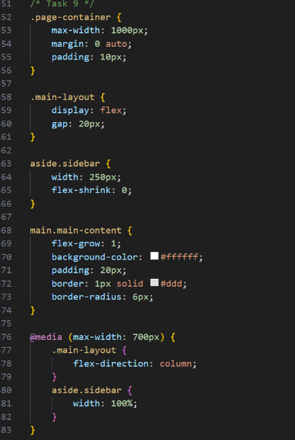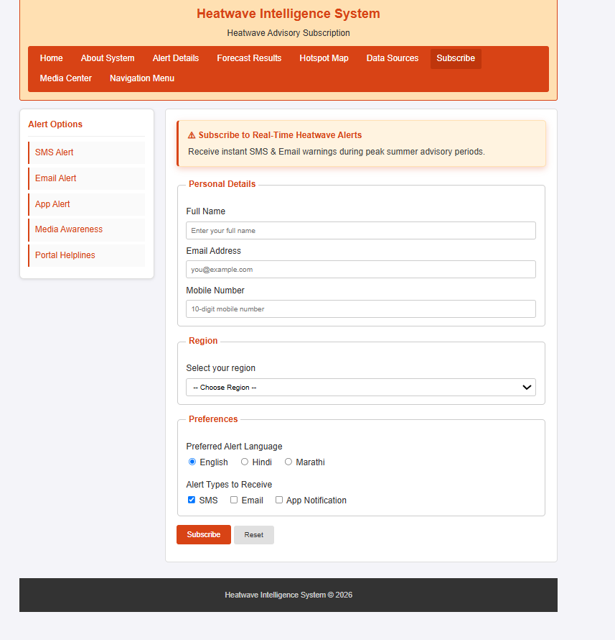

Task 10: CSS Effects & Highlighting.
To attract attention for Special events/data/section, etc..
Requirements:
- Create an “Offer” box:
  - Blinking or glowing effect
  - Different background color
  - Bigger font
- Use:
  - @keyframes animation OR hover effect
  - text-shadow, box-shadow
Concepts tested:
CSS animations, effects, visual emphasis.
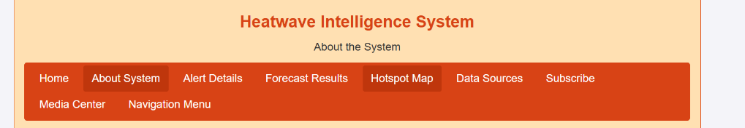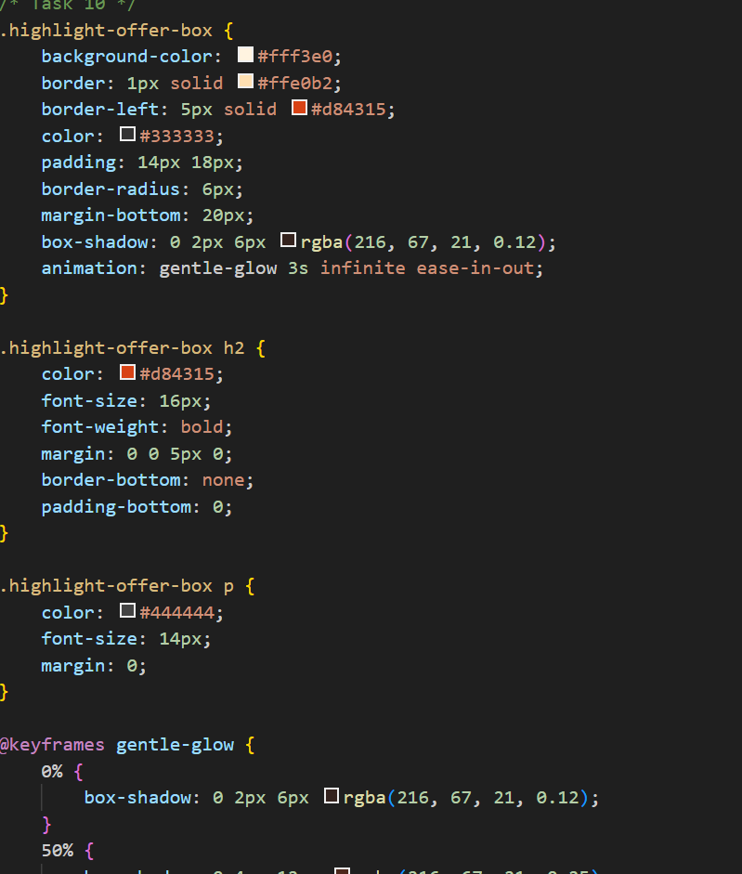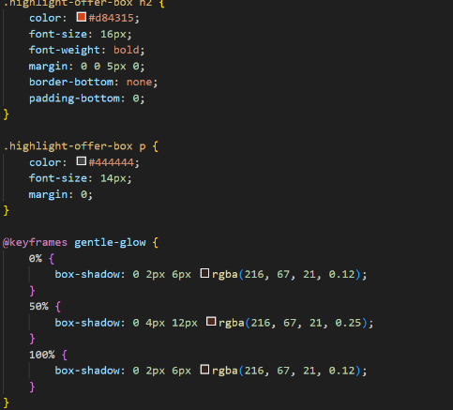

Code:

Output / Screenshot:

Post Lab Subjective/Objective type Questions:
- Use Bootstrap for CSS.

Conclusion and Discussion:
(students should write in your words)
(Also get feedback from fellow classmates (minimum 3) and faculty to add here)

