
PRESIDENCY SCHOOL, R.T Nagar
SUBJECT: PHYSICS
WORKSHEET Grade: VIII

.

 | SECTION A
 | Question :1
 | Choose the correct answers to the questions from the given options :
i | When heat is constantly supplied by a burner to boiling water, then the temperature of the water during vaporisation:  (a) Rises very slowly  (b) Rises rapidly until steam is produced  (c) First rises and then becomes constant  (d) Does not rise at all
ii | A pressure of 10 kPa acts on an area of 0.3 m². The force acting on the area will be:  - 3000N  - 30N  - 3N  - 300N
iii | Only one of these is true. Which one?  - α =2 β  - ϒ=3 β  - α= β =ϒ  - α=β/2
iv | The feet of lizards act like  (a) moving pads  (b) drilling pads  (c) suction pads  (d) none of the above
v | An object with which of the following densities will float on water?  - 1.2 g / cm³  - 0.7 g / cm³  - 3.5 g / cm³  - 11.4 g / cm³
vi | The value of the atmospheric pressure at sea level is:  - 760 cm of mercury column  - 176 cm of mercury column  - 76 cm of mercury column  - 7.6 cm of mercury column
vii | 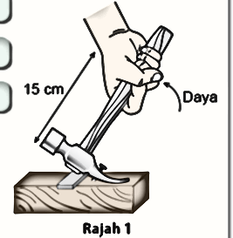  If a force of 5N is required to remove the nail, what is the moment of force required to pull the hammer in the direction shown?  - 0.75 nm  - 0.75 Nm  - 75Nm  - 1125 Nm
viii | Evaporation takes place from the:  (a) surface of liquid  (b) throughout the liquid  (c) mid-portion of the liquid  (d) bottom of liquid
ix | 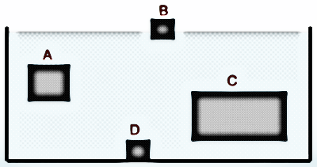  Objects A to D are in water. Which is the most dense?  (a) A  (b) B  (c) C  (d) D
x | Express the relationship between the C.G.S and S.I. units of density.  (a) 1 g cm⁻³= 1000 kg m⁻³  (b) 1 g cm⁻³= 100 kg m⁻³  (c) 1 g cm⁻³ = 10 kg m⁻³  (d) 1000 g cm⁻³ = 1 kg m⁻³
xi | Fig. shows how the temperature of a substance changed as it was heated. Which segment of  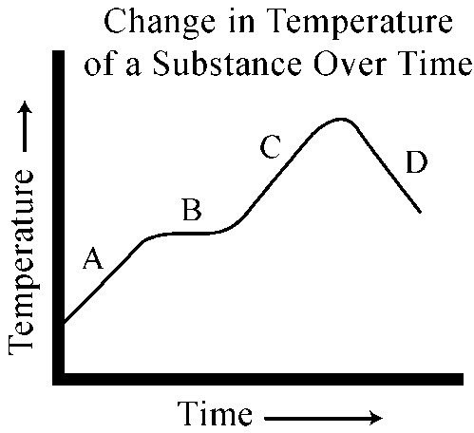  the graph indicates that the substance was undergoing a change of state?  (a) A  (b) B  (c) C  (d) D
xii | 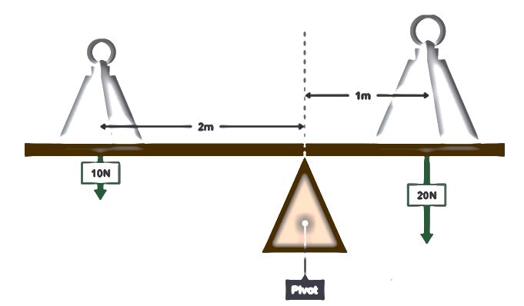  What is the moment of force acting on the left side of the pivot?  - 2Nm  - 20Nm  - 200Nm  - 0.2Nm
xiii | The intermolecular space is maximum in  (a) liquids  (b) solids  (c) gases  (d) none of the above..
xiv | Many objects, such as train tracks and road joints, are specifically designed to allow extra space for:  - Thermal expansion  - thermal energy  - thermal equilibrium  - thermal venting
xv | Which of the following conditions will increase the rate of evaporation?  - Increase in temperature of water  - Decrease the wind speed  - Decrease the surface area of water  - Adding impurities to water
 | Question:2
 | Complete the following by choosing the correct answers from the bracket:
i | - Pressure decreases when the surface area over which the force is applied increases: _____. [True /False]  - Melting point of ice ____with increase of pressure on it. [decreases/increases]  - The density of a liquid decreases with increase in its temperature.[True/False].  - If the weight of the water displaced is the same as the weight of the object placed in the water, the object will sink. [True /False]  - A solid is completely immersed in a liquid. The force exerted by the liquid on the solid will be in vertically ………….. direction. [upward/ downward ]  - The S.I. unit of upthrust is_________. [N/Pa]
ii | A man first swims in sea water and then in river water.  - Compare the weights of sea water and river water displaced by him.  - Where does he find it easier to swim and why?
iii | Distinguish between density and relative density.
 | Question :3
i | 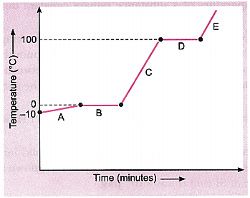  Analyse the temperature versus time graph of water, given above:  (a) Which region contains all liquids?  (b) What happens to KE in that region mentioned by you?
ii | A gum bottle rests on its base.If it placed upside down, how does the  a) thrust and b) Pressure change?
iii | Where is the pressure greater, 10 m below the surface of the sea or 20 m below the surface of sea? Why?
iv | (a) We observe no change in volume of water when we dissolve a specific amount of salt/sugar into a given volume. This observation illustrates which characteristic of matter?  (b) Give one way in which melting points and boiling point of the substance can be useful.
v | (a) Name the physical quantity measured in terms of dyne cm.  (b) How is dyne cm related to the SI unit of above physical quantity?
vi | Write two examples of disadvantages of thermal expansion of solids in daily life.
vii | A density bottle weighs 20.25 g when empty, 40.75 g when filled with a liquid and 50.25 g when filled with water. Find: (a) volume of bottle (b) density of liquid. (c) RD of a liquid.
 | SECTION B
 | Question: 4
i | (a) Difference between thrust and pressure.[2 points]  (b) The moment of force of 10 N about a pivot is 5 N m. Calculate the distance of force from the pivot.
ii | 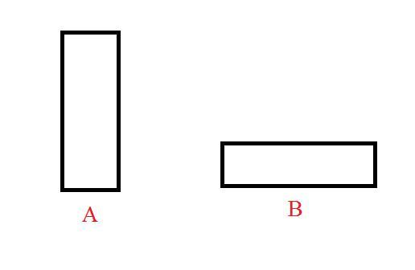  - Which of the following bricks will go deeper into the sand and why?  - The hand flour grinder is provided with a handle near the rim. Give reason.
iii | (a) We sweat a lot in hot and humid weather than in dry weather. Give reason.  (b) In which of the three states of matter - solids, liquids or gases is the movement of atoms about their own position. Give a reason for the same. Draw the molecular model for the same.
 | Question:5
i | (a) The pendulum of a clock is made of invar. Why?  (b) The thermal coefficient of linear expansion of a material is α. Then the thermal coefficient of its volume expansion will be ____  (c) Water is heated from 0°C to 4°C. Will it expand?
ii | The mass of a ball is 125 g. What should be its volume to have a density of 0.5 g /cm³ ? Also find the density in SI unit and relative density.
iii | (a) Why do the liquids and gases have no linear or superficial expansion?  (b) Iron rims are heated before they are fixed on the wooden wheels. Give reason.  (c ) Write the conclusion for the given figure:  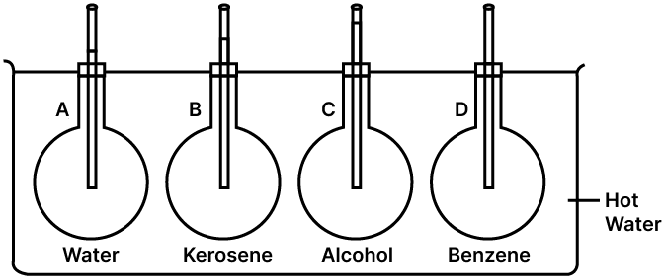
 | Question:6
i | 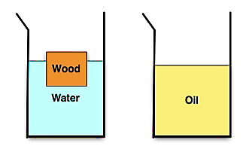  What change will occur in the state of floatation, if:  (a) some salt is added to water  (b) water is heated. Give reason.
ii | A force of 10 N acts normally on a surface area 0.2 m².Find the pressure exerted on the surface in CGS unit and SI unit.
iii | (a) A boy opens a nut by applying a force of 150 N using a wrench of length 30 cm. If he wants to open it by a force of 50 N, what should be the length of wrench?  (b) The moment of force of 10 N about a pivot is 5 N m. Find the distance of force from the pivot.
 | Question :7
i | A girl of weight 500 N has her feet on the ground with a total area of 200 cm². What pressure does she apply on the ground?
ii | (a) Two identical rods - one hollow and the other solid, are heated to the same rise in temperature. Which will expand more? Justify your answer.  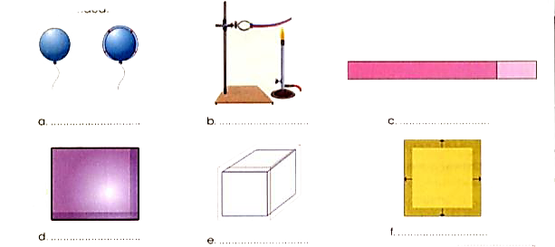  (b) What kind of expansion is taking place in the figure given below?
iii | (a) State the factors on which the moment of force depends upon.    (b) Figure showing the wrench to tighten or loosen a screw. Identify the type of moment and its sign convention.
 | Question: 8
i | Name the following:  (a) Fixed temperature at which a liquid turns to gas –  (b) Fixed temperature at which a liquid turns to solid –  (c) Fixed temperature at which a gas turns to liquid --
ii | - For the following figure shows three identical blocks of wood floating in three different liquids A, B and C of densities d₁, d₂ and d₃ respectively. Which of these liquids has the highest density? Give reasons to justify your answer.  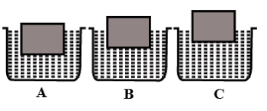  - State the principle of floatation.
iii | (a) How does the density of a liquid vary with temperature?  (b) A balloon filled with hydrogen rises in air. Explain the reason..
 | Question:9
i | (a) The mass of a density bottle is 35 g when empty,65 g when filled with water, and 59 g when filled with alcohol. Find the relative density of alcohol.  (b) 1kgf m = _____N m.
ii | 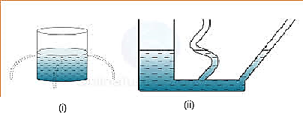  (a) Write the conclusions of the figure (i) & (ii)  (b) Sea divers wear specially designed suits before diving into the sea. Give reason.
iii | (a) In the given figure, the mass of the object is 51.8 g, Find density in S.I. unit.  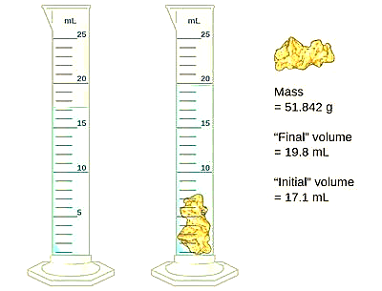  (b) A body is held immersed in a liquid:  Name the two forces acting on body and draw a diagram to show these forces.

****************************************

