**PROGRAMING FOR SCIENTIFIC COMPUTING**

“Smart Eat”

SPECIAL ASSIGNMENT REPORT

Team Members:

22BEC040: Jinansh Doshi

22BEC053: Ishaan Patel

22BEC057: Roshni Jariwala

Dept. of Electronics and Communication Engineering

and minor in Data Science

Institute of Technology,

Nirma University, Ahmedabad

**1. Abstract:**

This project presents a personalized nutrition recommendation system designed to help users to choose foods based on specific nutrient deficiencies. Using dataset, that includes nutritional values for various foods, the system helps key nutrients like vitamins, minerals, and macronutrients. It then connects these nutrients to certain health diseases such as cancer, stroke, and heart disease.

Users have to input their nutrients deficiencies, and this will generate a list of top 10 food items that are rich in that nutrients This allows individuals to make informed decisions about their diet, addressing deficiencies and improving their overall health.

**2.Introduction:**

The main idea of this project is to maintain the healthy diet in our life in efficient manner so that user can live very happy and healthy life, here user have to just enter the name of the diseases and this project sorts the food items according to it. Nutrient deficiencies can lead to various health degradation, such as immune systems, chronic diseases, and even. While many tools exist to help individuals track their food intake, there is a growing need for systems that provide personalized recommendations based on specific health needs.

This system not only helps individuals in making healthier food choices but also has the potential to be a better tool for healthcare professionals in creating customized diet plans. By putting nutrient deficiencies in a targeted manner, the project promotes better health outcomes and disease prevention through dietary interventions.

**3. Methodology:**

The “Smart Eat” recommendation system was developed using a structured approach involving data collection, condition mapping, user input processing, and data sorting.

1. **Data Set:** A collective food dataset was obtained, containing detailed nutritional information for various food items. The dataset includes key nutrients such as vitamins (A, C, D, E), minerals (calcium, potassium, sodium, iron), fibres, protein, fats, and others. The dataset was cleaned and pre-processed to ensure consistency and accuracy for further analysis. The merging of these CSV datasets is done with the help of python and pandas library. This makes a single DataFrame, which simplifies analysis and recommendation generation. This combined dataset will be used for identifying nutrient deficiencies and providing food recommendations.
2. **Data Cleaning:** For data cleaning we have used python code to fill the missing the values by replacing it with mean and mode. This step is essential for understanding the quality of the data. Missing values can lead to inaccurate analysis or faulty recommendations.

**c)Health Condition Mapping:** A set of health conditions (e.g., cancer, stroke, Alzheimer’s disease) were identified, and specific nutrient thresholds were defined based on scientific literature. For example:

* Cancer Prevention: Foods with vitamin A > 300, vitamin C > 20, and fibres> 5.
* Stroke Prevention: Foods with potassium > 300 and sodium < 300.
* Alzheimer's Prevention: Foods with vitamin E > 2, omega-3 > 0.5, and saturated fat < 3.

**d)User Input Handling:** The system provides the user to enter the number of nutritional deficiencies they wish to address (e.g., vitamin C, iron, etc.). Based on this input, the system dynamically adjusts the selection criteria for food recommendations.

**e)Data Sorting and Recommendation:** Once the user inputs the deficient nutrients, the system filters the food dataset to prioritize items rich in those nutrients. The sorted data is then displayed,showing the top 10 food items that are most beneficial for addressing the user’s deficiencies.

The sorting algorithm works by:

* **Extracting the relevant nutrient columns based on user input.**
* **Ranking the food items in descending order of nutrient concentration.**
* **Displaying the top 10 results to the user in a tabular format.**

**4. Code Explanation:** This code implements a Food Recommendation System that personalizes recommendations based on the user's health condition, dietary preference, nutrient deficiencies, and health goals.

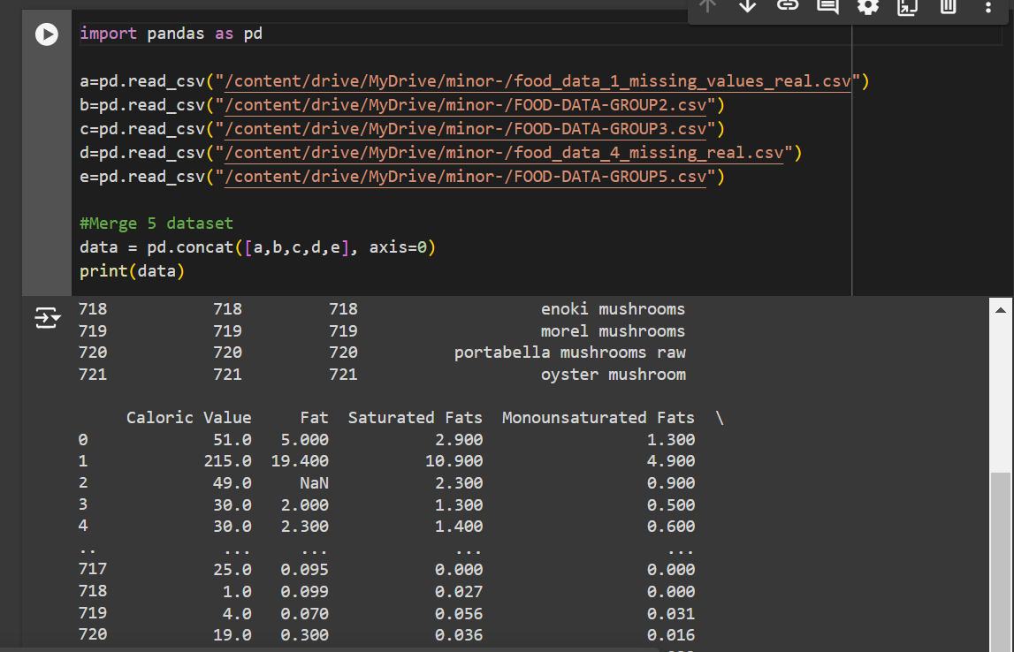

The process involves loading each dataset from its respective CSV file, checking that the column names properly across all the datasets, and then merging them using the pd.concat() function. This method concatenates the datasets vertically, adding rows from each dataset to the bottom of the others, while resetting the index to avoid duplicates from the original datasets.

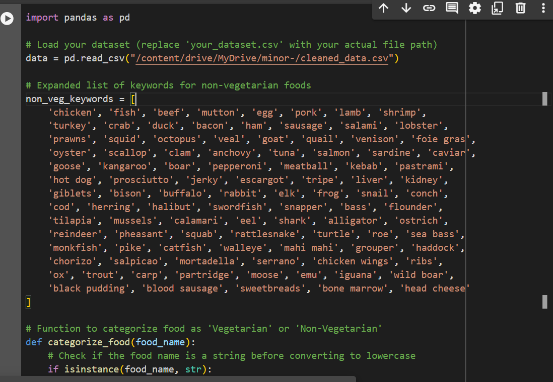

1)**Ask About Diseases:** The program checks if the user has any special diseases (like diabetes or heart disease). If yes, it lets them pick from a list.

2)**Ask About Dietary Preference:** The user is asked if they are vegetarian.

3)**Select Nutrient Deficiencies:** The user can choose up to 3 nutrients they are lacking (like protein or vitamins) from a provided list.

4)**Ask for Health Goal:** The user selects their primary health goal: muscle gain, weight loss, or overall health.

5)**Store User Data:** The collected data is stored in a dictionary (a type of data structure).

6)**Filter Food Data Based on Disease:** The code defines a function that filters foods based on specific dietary needs for each disease. For example, it checks if foods have low sugars for diabetes.

7)**Filter Foods for Nutrient Deficiencies:** Another function checks if the foods are high in the nutrients the user is deficient in. It combines conditions for all selected nutrients.

8)**Filter Foods for Health Goals:** A function checks if the foods match the user’s health goal, like having high protein for muscle gain or low fat for weight loss.

The program starts by gathering information from the user about their health and dietary needs. It then filters a set of food data to recommend suitable foods based on the user’s conditions and goals. Finally, it presents the recommendations in a clear format.

**5) Future Scope:**

1. More Diseases and Nutrients: Adding more range of diseases and nutrients to provide more personalized recommendations.
2. Recipe Suggestions: Including healthy recipes that user can made easily, the recommended foods, making meal planning easier.
3. Integration with Health Apps: Connecting the system with fitness and health tracking apps to offer more personalized suggestions based on user activity and health data.
4. Machine Learning: Using machine learning to improve recommendations over time by learning from user feedback and choices.

**6) Conclusion:**

The Food Recommendation System is a valuable tool designed to help individuals in making healthy food choices. By collecting essential information about diseases, dietary restrictions, nutrient deficiencies, and health goals, the system provides personalized food recommendations that promote better nutrition and overall well-being. As the system evolves, the potential for enhancements such as expanded databases, recipe suggestions, and integration with health apps presents exciting opportunities for further personalization and effectiveness. Ultimately, this system aims to empower users to adopt healthier eating habits, improving their quality of life and supporting their health journeys.

**Reference:** [**https://www.kaggle.com/datasets/utsavdey1410/food-nutrition-dataset**](https://www.kaggle.com/datasets/utsavdey1410/food-nutrition-dataset)

[**https://i-base.info/guides/side/diet-a-balanced-diet-and-your-health**](https://i-base.info/guides/side/diet-a-balanced-diet-and-your-health)