CineBook
A Movie Ticket Booking System Using Oracle PL/SQL
Mini Project Report
BCSE302P – Database Systems Laboratory
Submitted by
Ishaan Singh (24BCE0671)
Under the guidance of
Dr. G. M. Karthik
School of Computer Science and Engineering (SCOPE)
Vellore Institute of Technology, Vellore
Date of submission: 24 October 2026

Declaration
I hereby declare that the mini project report entitled “CineBook: A Movie Ticket Booking System Using Oracle PL/SQL”, submitted for BCSE302P – Database Systems Laboratory, is a record of original work carried out by me under the guidance of Dr. G. M. Karthik. All code and screenshots in this report are from my own execution, and this work has not been submitted for any other course.
Ishaan Singh (24BCE0671)
Vellore, 24 October 2026

Abstract
CineBook is a database-driven movie ticket booking system built on Oracle AI Database 26ai Free. It models a two-screen cinema with users, movies, screens, individual seats, shows, bookings, booked seats and an audit log, stored in eight relations normalised to Boyce–Codd Normal Form. The business logic lives in the database: a PL/SQL package, movie_pkg, provides four functions (seat pricing, seat availability, refund calculation and a seat map returned as a REF CURSOR) and four procedures (booking, cancellation, a per-show report and a daily schedule). Three triggers price each booked seat, keep booking totals up to date and log every cancellation with its refund. A booking locks its show row with SELECT ... FOR UPDATE, so two customers can never reserve the same seat, and any failure rolls the whole booking back. Sixteen scripted test cases cover normal bookings, premium pricing, double booking, invalid input, the seat limit, refund rules and constraint violations, and all sixteen pass. A desktop web front-end, served by a Python FastAPI server through python-oracledb, lets users browse showtimes, pick seats on a live seat map, view and cancel tickets, and run the PL/SQL reports. Online payment and password authentication are outside the project's scope.

Table of Contents
1. Introduction 4
2. System Requirements 4
3. Database Design 4
4. Implementation 5
5. Front-End 6
6. Verification and Testing 7
7. Results and Discussion 8
8. Conclusion 8
References 9
Appendix 9

1. Introduction
Small cinemas often sell tickets from a paper seat chart, so a seat can be sold twice, refunds are inconsistent and there is no reliable sales record. CineBook solves this with an Oracle database that keeps seat inventory correct under simultaneous bookings, applies pricing and refund rules automatically and logs every change, plus a desktop application for booking and reporting.
A DBMS is essential here: row-level locking handles concurrent users, transactions make a multi-seat booking all-or-nothing, constraints reject invalid data from any program, and PL/SQL keeps the rules in one place for every client.

2. System Requirements
Table 1: System requirements
Item | Details
Hardware | 64-bit processor, 8 GB RAM, 10 GB free disk
Software | Windows 11; Oracle AI Database 26ai Free (PDB FREEPDB1) with SQL*Plus; Python 3.14 with FastAPI, Uvicorn and python-oracledb; HTML, CSS and JavaScript front-end in Microsoft Edge app mode

3. Database Design
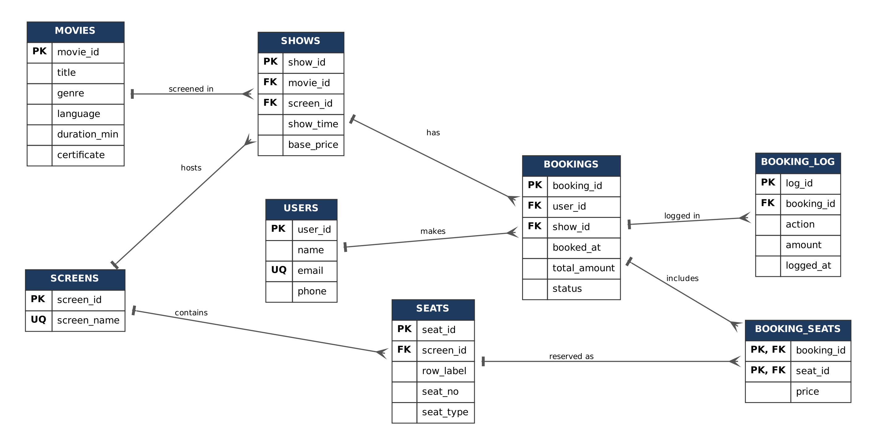
Figure 1: ER diagram
Movies and screens each have many shows; screens have many seats; users and shows each have many bookings (all 1 : N). Bookings and seats are M : N, resolved by BOOKING_SEATS, which also stores the price charged. BOOKING_LOG is the audit trail.
Table 2: Schema (27 named constraints)
Table | Columns | Constraints
USERS | user_id (PK), name, email (UQ), phone | CHECK phone is 10 digits starting 6–9
MOVIES | movie_id (PK), title, genre, language, duration_min, certificate | CHECK duration > 0; certificate IN (U, UA, A)
SCREENS | screen_id (PK), screen_name (UQ)
SEATS | seat_id (PK), screen_id (FK), row_label, seat_no, seat_type | UQ (screen_id, row_label, seat_no); type REGULAR or PREMIUM
SHOWS | show_id (PK), movie_id (FK), screen_id (FK), show_time, base_price | UQ (screen_id, show_time); price > 0
BOOKINGS | booking_id (PK), user_id (FK), show_id (FK), booked_at, total_amount, status | status CONFIRMED or CANCELLED; total set by trigger
BOOKING_SEATS | booking_id (PK, FK), seat_id (PK, FK), price | price set by trigger
BOOKING_LOG | log_id (PK), booking_id (FK), action, amount, logged_at | action BOOKED or CANCELLED

Normalisation: a paper ticket with a repeating group of seats was split into one seat per row (1NF); booking and seat details were separated from the composite key, leaving price in BOOKING_SEATS (2NF); user, show, movie and screen details were moved out of BOOKINGS to remove transitive dependencies (3NF). Every determinant is a candidate key, so the schema is in BCNF. Seat availability is computed, never stored.

4. Implementation
Table 3: PL/SQL objects
Feature | Implemented as
Functions | seat_price (premium seats cost 1.5×), available_seats, refund_calc (100% / 50% / 0%), seat_map (returns a SYS_REFCURSOR)
Procedures | book_seats (validate, lock, book, log, commit), cancel_booking, show_report, daily_schedule
Package | movie_pkg groups all of the above, with the constant c_max_seats = 6
Triggers | trg_seat_price (BEFORE INSERT, sets each seat's price), trg_booking_total (AFTER INSERT, keeps the total), trg_booking_cancel (AFTER UPDATE with WHEN, logs the refund)
Cursors | Explicit cursor with OPEN/FETCH/CLOSE and %ROWTYPE, %NOTFOUND, %ROWCOUNT (show_report); parameterised cursor FOR loop (daily_schedule); REF CURSOR (seat_map); implicit cursors (SELECT INTO)
Exceptions | RAISE_APPLICATION_ERROR codes -20001 to -20009 for business rules; NO_DATA_FOUND handling; ROLLBACK on any failure

book_seats locks the show row before checking seats, so two users choosing the same seat are served one after the other and the second gets ORA-20003. Any error rolls back the whole booking:
SELECT screen_id, show_time INTO v_screen, v_time
FROM shows WHERE show_id = p_show_id
FOR UPDATE; -- serialises bookings for this show
...
SELECT COUNT(*) INTO v_taken
FROM booking_seats bs JOIN bookings b ON bs.booking_id = b.booking_id
WHERE b.show_id = p_show_id AND b.status = 'CONFIRMED' AND bs.seat_id = v_seat;
IF v_taken > 0 THEN
RAISE_APPLICATION_ERROR(-20003, 'Seat ' || v_tok || ' already booked');
END IF;
INSERT INTO booking_seats (booking_id, seat_id) VALUES (p_booking_id, v_seat);
...
EXCEPTION
WHEN OTHERS THEN
ROLLBACK;
RAISE;
Listing 1: Key part of book_seats
The cancellation trigger fires only when a booking changes from CONFIRMED to CANCELLED and records the refund calculated by refund_calc:
CREATE OR REPLACE TRIGGER trg_booking_cancel
AFTER UPDATE OF status ON bookings
FOR EACH ROW
WHEN (OLD.status = 'CONFIRMED' AND NEW.status = 'CANCELLED')
DECLARE
v_time shows.show_time%TYPE;
BEGIN
SELECT show_time INTO v_time FROM shows WHERE show_id = :NEW.show_id;
INSERT INTO booking_log (booking_id, action, amount)
VALUES (:NEW.booking_id, 'CANCELLED', movie_pkg.refund_calc(:NEW.total_amount, v_time));
END;
Listing 2: Trigger trg_booking_cancel

5. Front-End
The interface calls a Python FastAPI server, which connects to Oracle through python-oracledb and calls movie_pkg: booking runs book_seats, the seat map comes from the seat_map REF CURSOR, cancelling runs cancel_booking, and the Reports page shows show_report output captured from DBMS_OUTPUT.
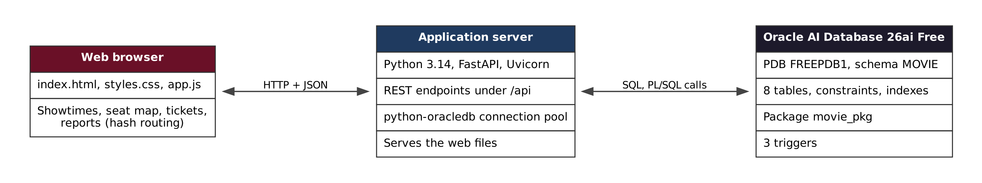
Figure 2: System architecture
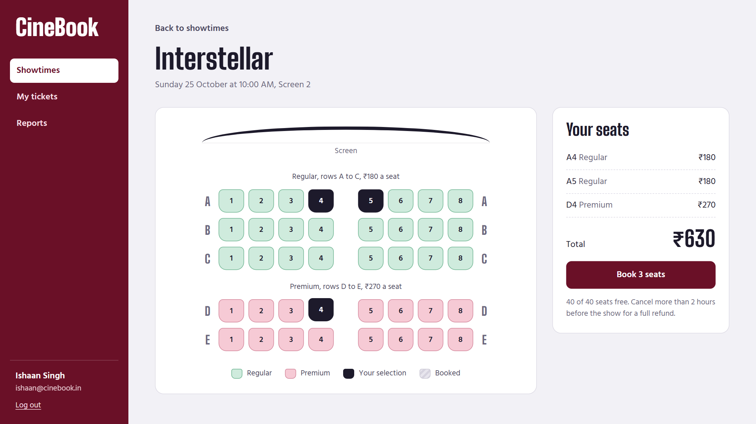  Figure 3: Seat selection | 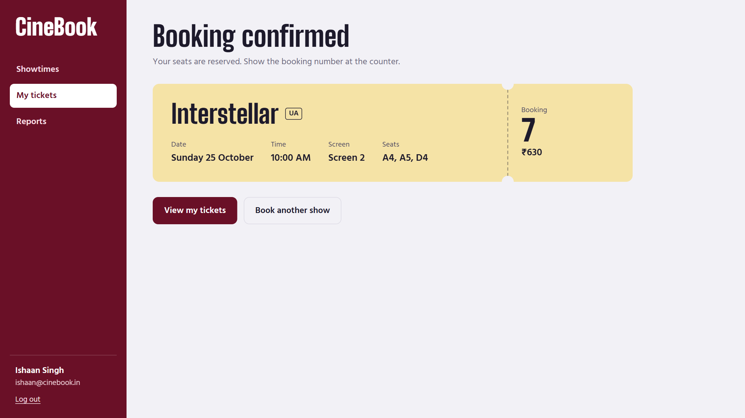  Figure 4: Booking confirmed
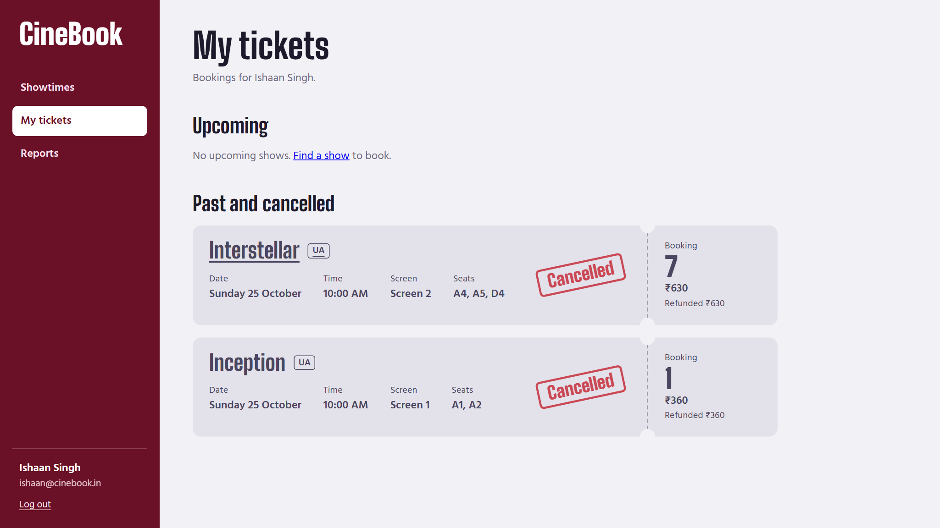  Figure 5: Cancelled booking with refund | 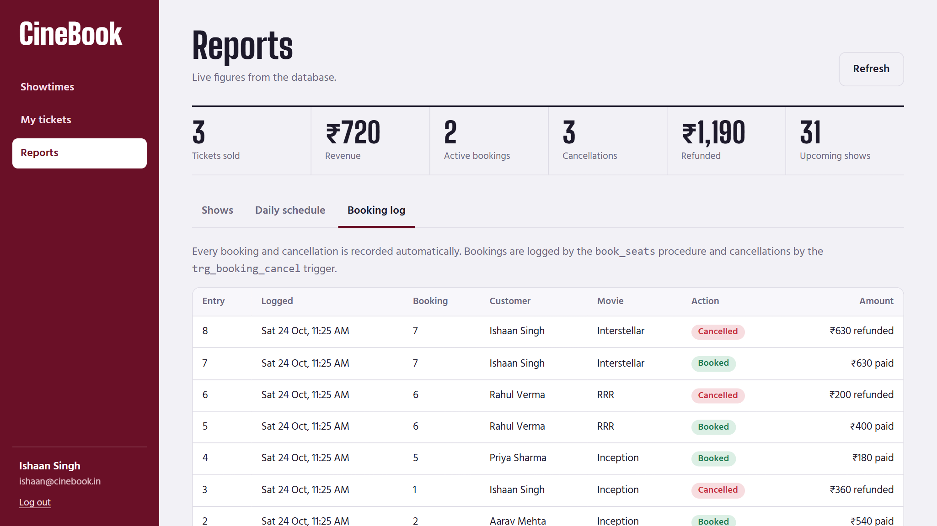  Figure 6: Booking log written by the procedure and trigger
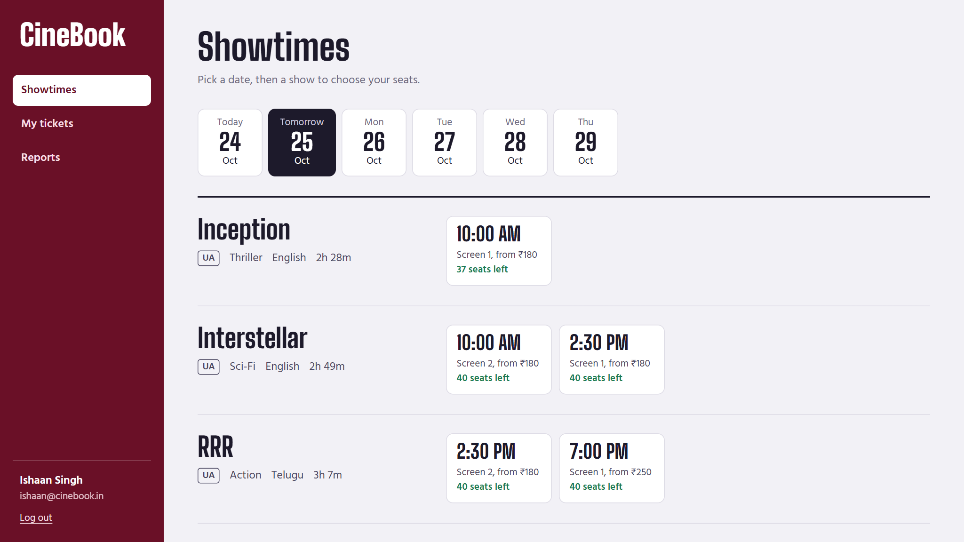  Figure 7: Showtimes with seats left | 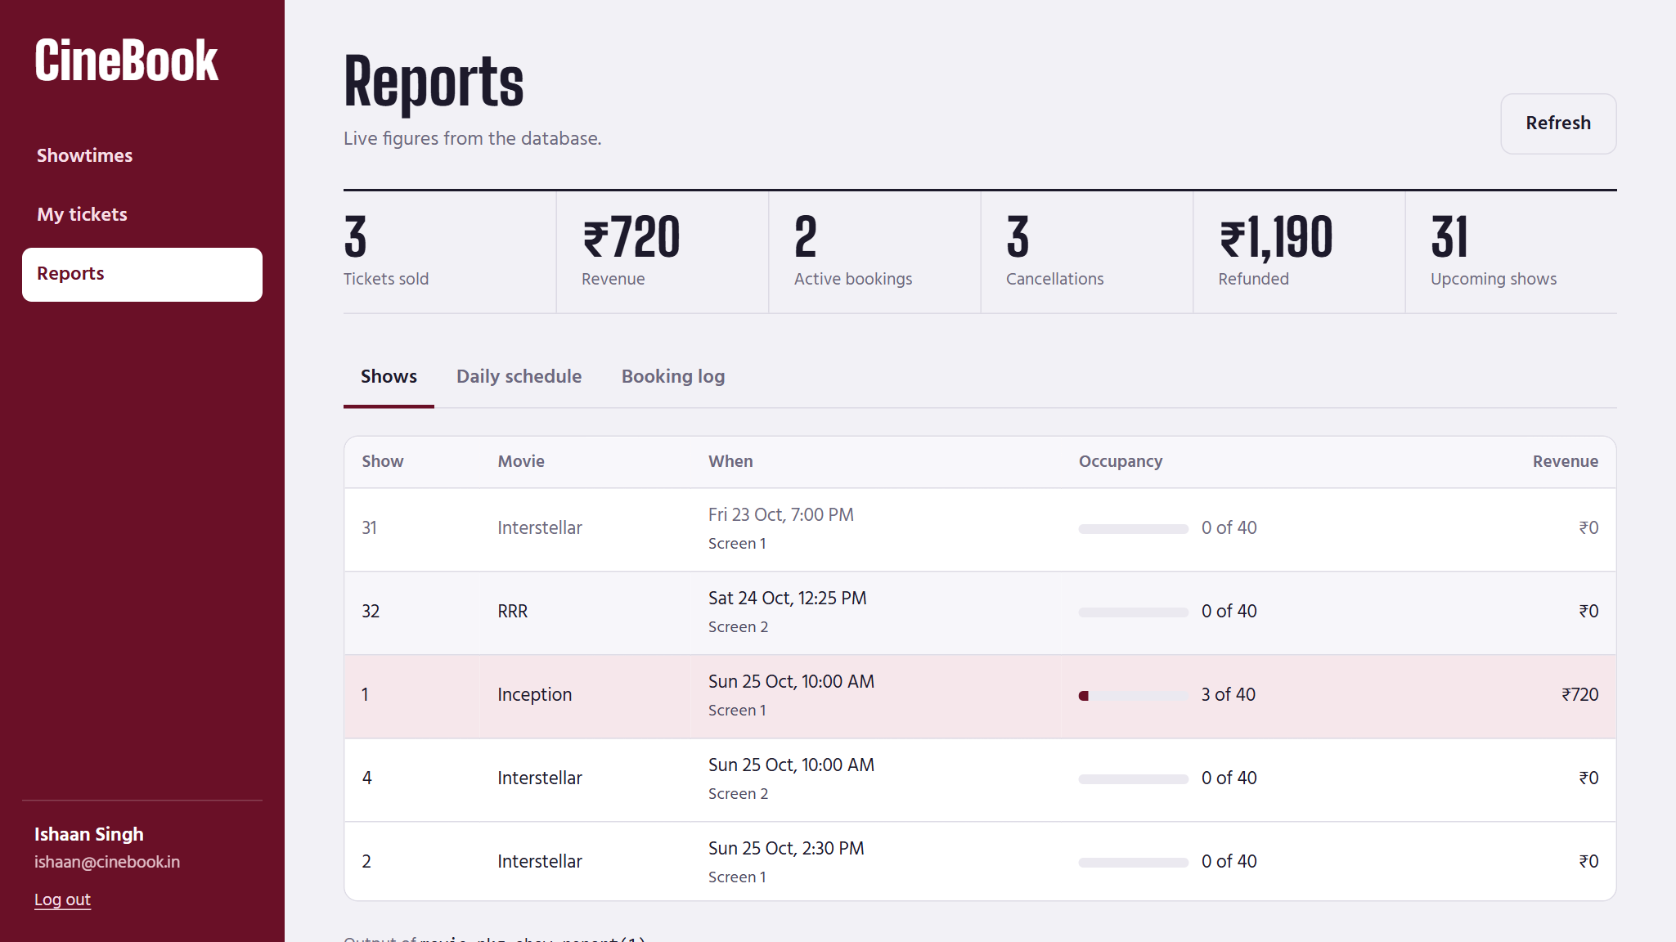  Figure 8: Reports with show_report output

6. Verification and Testing
04_tests.sql runs 16 self-checking tests on fresh data and prints PASS or FAIL. All 16 passed.
Table 4: Test cases
ID | Test | Expected and actual result
TC01 | Free seats on a new show | 40 of 40 free
TC02 | Book regular seats A1, A2 | Booking created, 38 seats left
TC03 | Book premium seats D1, D2 | ₹270 per premium seat; totals ₹360 and ₹540
TC04 | Book A3, A2 when A2 is taken | ORA-20003; A3 rolled back, 36 seats still free
TC05 | Book seat Z9 | ORA-20002 Invalid seat Z9
TC06 | Book with an empty seat list | ORA-20004 No seats selected
TC07 | Book 7 seats in one booking | ORA-20009 Maximum 6 seats per booking
TC08 | Book a show that has started | ORA-20001 Show has already started
TC09 | Cancel more than 2 hours before | Refund ₹360 (100%), A1 and A2 released
TC10 | Cancel the same booking twice | ORA-20006 Booking already cancelled
TC11 | Rebook released seat A1 | New booking succeeds
TC12 | Cancel within 2 hours of the show | Paid ₹400, refund ₹200 (50%)
TC13 | Insert user with phone 12345 | ORA-02290 CHK_USERS_PHONE violated
TC14 | Fetch the seat map of show 1 | 40 seats returned, 3 booked
TC15 | Report for show 1 | Occupancy 3/40, revenue ₹720
TC16 | Schedule for tomorrow | Schedule printed with free seats

To prove that the application stores data in Oracle, check.sql was run in SQL*Plus right after booking in the application: it shows the same booking number (7), seats and trigger-set prices as the ticket above.
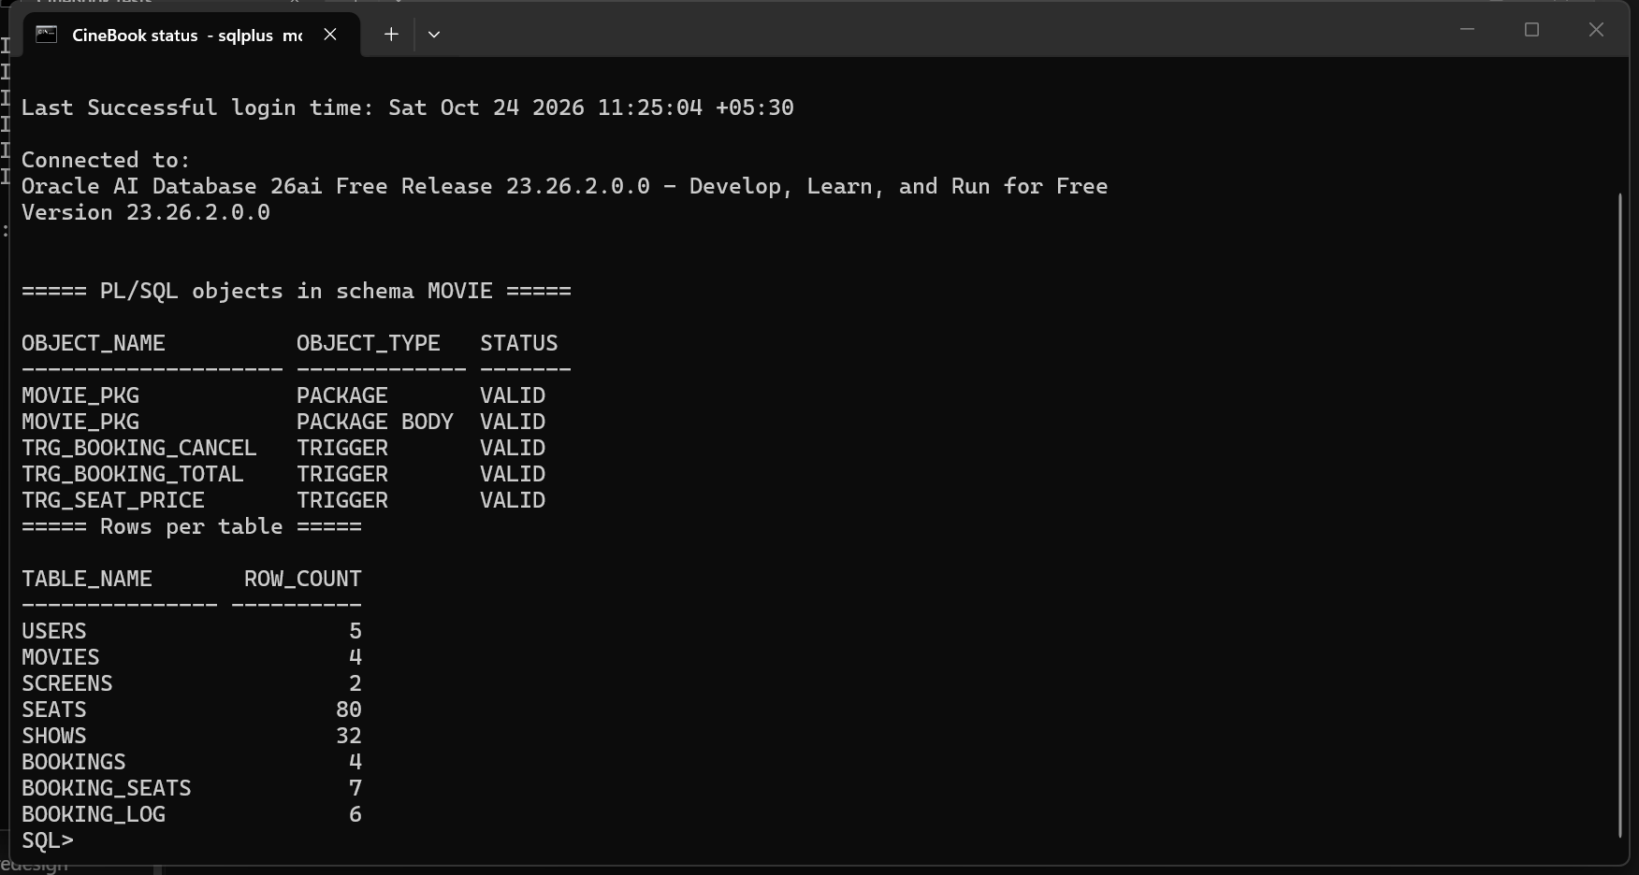  Figure 9: Package and triggers compiled VALID | 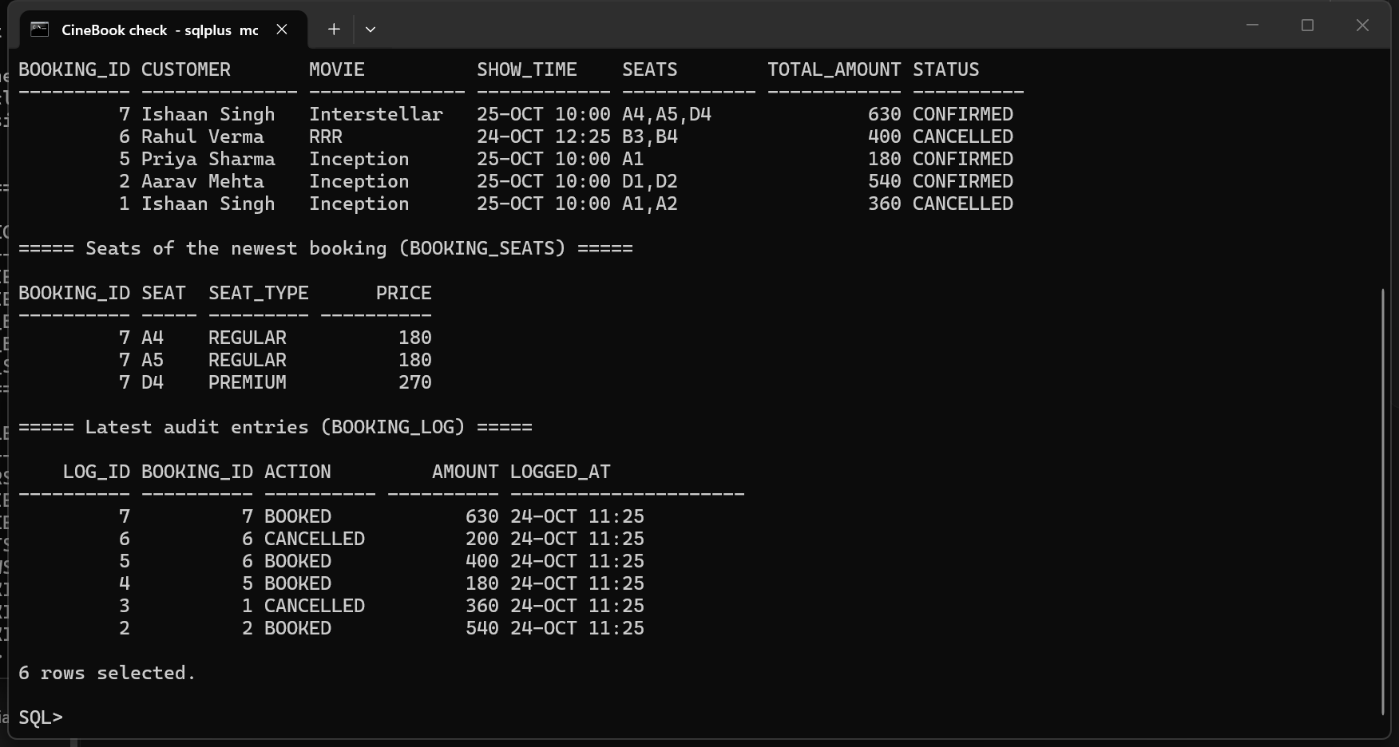  Figure 10: The same booking read in SQL*Plus

7. Results and Discussion
The project delivers a BCNF schema, a package of four functions and four procedures, three triggers, all cursor types, double-booking prevention, automatic pricing, refunds and logging, and a working front-end. The main challenges were concurrent bookings (solved with SELECT ... FOR UPDATE), keeping the stored total consistent (only a trigger changes it) and testing time-based refunds. Future work: login with roles, temporary seat holds and online payment.

8. Conclusion
CineBook shows that consistency, pricing and record keeping are best enforced inside the database, and gave practical experience in normalisation, PL/SQL, triggers, cursors, transactions and connecting an application to Oracle.

References
[1] A. Silberschatz, H. F. Korth, and S. Sudarshan, Database System Concepts, 7th ed. New York, NY, USA: McGraw-Hill, 2019.
[2] Oracle Corporation, “Database PL/SQL Language Reference, 23ai,” Oracle Help Center. [Online]. Available: https://docs.oracle.com/en/database/oracle/oracle-database/23/lnpls/ (accessed Oct. 23, 2026).
[3] Oracle Corporation, “python-oracledb documentation.” [Online]. Available: https://python-oracledb.readthedocs.io/ (accessed Oct. 23, 2026).

Appendix
Project files: sql/ (schema, data, PL/SQL, tests, check.sql), api/ (server and desktop launcher), web/ (front-end). Full test output is in sql/test_results.txt.

