R Notebook

Ishaan Yadav

df<-read.csv("C:/Users/Admin/Downloads/Expt 2- Data set_Travelled abroad_csv.csv")  
head(df)

## Sr..No. Name Travelledabroad  
## 1 1 Asmita Y  
## 2 2 Anita Y  
## 3 3 Yashodhan N  
## 4 4 Rangappa Y  
## 5 5 Kamala Y  
## 6 6 Kirti N

1. Find out the % of Indians in the sample who have travelled abroad using the data source.

percen=nrow(subset(df,Travelledabroad=='Y'))/nrow(df)*100  
cat("Percentage of Indians in the sample who have tarvelled aboard is :",percen,"%")

## Percentage of Indians in the sample who have tarvelled aboard is : 56 %

1. Treating this value as ‘p’, calculate the following probabilities –
2. What is the probability that in a randomly chosen sample of 10 persons, no one has travelled abroad?

ans4=dbinom(0,10,0.56)  
ans4

## [1] 0.0002719736

1. What is the probability that in a randomly chosen sample of 10 persons, exactly one has travelled abroad?

ans5=dbinom(1,10,0.56)  
ans5

## [1] 0.003461482

1. What is the probability that in a randomly chosen sample of 10 persons, exactly two persons have travelled abroad?

ans6=dbinom(2,10,0.56)  
ans6

## [1] 0.01982485

1. What is the probability that in a randomly chosen sample of 10 persons, exactly three persons have travelled abroad?

ansd=dbinom(3,10,0.56)  
ansd

## [1] 0.06728435

1. What is the probability that in a randomly chosen sample of 10 persons, exactly four persons have travelled abroad?

anse=dbinom(4,10,0.56)  
anse

## [1] 0.1498606

1. What is the probability that in a randomly chosen sample of 10 persons, exactly five persons have travelled abroad.

ansf=dbinom(5,10,0.56)  
ansf

## [1] 0.228878

1. What is the probability that in a randomly chosen sample of 10 persons, exactly six persons have travelled abroad?

ansg=dbinom(6,10,0.56)  
ansg

## [1] 0.2427494

1. What is the probability that in a randomly chosen sample of 10 persons, exactly seven persons have travelled abroad?

ansh=dbinom(7,10,0.56)  
ansh

## [1] 0.176545

1. What is the probability that in a randomly chosen sample of 10 persons, exactly eight persons have travelled abroad?

ansi=dbinom(8,10,0.56)  
ansi

## [1] 0.08426012

1. What is the probability that in a randomly chosen sample of 10 persons, exactly nine persons have travelled abroad?

ansj=dbinom(9,10,0.56)  
ansj

## [1] 0.02383115

1. What is the probability that in a randomly chosen sample of 10 persons, all 10 persons have travelled abroad?

ansk=dbinom(10,10,0.56)  
ansk

## [1] 0.003033055

1. Plot the probability values as a Table / Bar graph/plot and interpret plot.

barplot(dbinom(0:10,10,0.56))

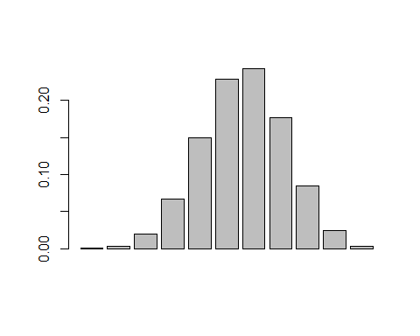 Interpretation:Binomial probablities in this example are nearly normally distributed

1. What is the probability that in the randomly chosen sample of 100 persons at least 59 have travelled abroad?  
   Hint: Expected to perform Normal approximation for the binary distribution.

ansp=pbinom(59,100,0.56,lower.tail=F)  
ansd=dbinom(59,100,0.56) #including the i th value that is 59  
ansp+ansd

## [1] 0.3084356

Using normal approxiamation to binomail distribution

mu<-100*0.56  
sigma<-sqrt(100*0.56*(1-0.56))  
pnorm(58.5,mu,sigma,lower.tail=F)

## [1] 0.3072574