Social Media Post Virality and
Engagement Level Prediction
A Comparative Machine Learning Study of Support Vector Machines,
Decision Trees, Naive Bayes and Random Forest
Machine Learning Mini Project Report
Dataset: social_media_engagement_dataset.csv · 5,000 posts · 6 platforms
[Student Name] · [Roll / Registration No.] · [Course / Department]
[Institution Name] · [Submission Date]

1. Abstract
Social media platforms generate an enormous and continuously growing volume of user-generated content, and the ability to anticipate which posts will achieve high engagement or “go viral” carries significant value for content creators, digital marketers, and platform designers. This mini-project investigates whether structural, pre-publication attributes of a social media post — including platform, content type, posting time, hashtag count, content length, and account-level attributes such as follower count and influencer tier — can be used to classify a post's eventual engagement level before it is published.
Using a dataset of 5,000 real posts spanning six platforms (Instagram, Twitter, Facebook, LinkedIn, YouTube and TikTok), a four-class engagement-level target (Low, Medium, High, Viral) was engineered via quartile binning of the dataset's engagement-rate field, after first identifying and correcting a data-leakage risk arising from the fact that engagement rate is mathematically derived from post-publication interaction counts. Four supervised classification algorithms — Support Vector Machine (SVM), Decision Tree, Gaussian Naive Bayes, and Random Forest — were trained on a common preprocessing pipeline and evaluated on a held-out test set using Accuracy, Precision, Recall, F1-score and ROC-AUC, with 5-fold cross-validation for robustness.
Random Forest achieved the strongest overall performance (Accuracy 60.3%, macro F1 60.1%, ROC-AUC 0.857), followed by Decision Tree (57.7% accuracy), SVM (56.1% accuracy) and Naive Bayes (50.7% accuracy). These results are consistent with prior literature on social-media classification tasks, in which tree-based models and SVM typically outperform Naive Bayes because the latter's conditional-independence assumption is violated by correlated engagement-driving features. A lightweight, browser-based prediction interface was additionally developed and deployed to demonstrate real-time, end-user access to the trained model, illustrating a complete pipeline from raw data to a usable decision-support tool.
Keywords: social media analytics, virality prediction, engagement classification, Support Vector Machine, Decision Tree, Naive Bayes, Random Forest, feature engineering, data leakage.

2. Introduction

2.1 Background
Platforms such as Instagram, Twitter (X), Facebook, LinkedIn, YouTube and TikTok now mediate a substantial share of brand communication, personal expression and public discourse. A small fraction of posts on any given platform receive disproportionately high engagement — likes, comments, shares and saves — relative to the account's typical reach, a phenomenon commonly called “virality.” Understanding which pre-publication attributes are associated with high engagement is of direct practical interest to marketers and content strategists.
Virality prediction can be framed as regression (predicting a continuous engagement rate) or, as adopted here, multi-class classification into ordinal engagement tiers (Low, Medium, High, Viral). The classification framing produces directly actionable output and matches the framing used by several influential prior studies discussed in Section 3.

2.2 Problem Statement
Given a set of structural, pre-publication features of a social media post — platform, content type, content category, caption sentiment, posting hour and day, hashtag count, content length, account follower count, influencer tier, media presence, and verification status — the goal is to predict the categorical engagement level the post will achieve, without using any information that is only observable after the post has been published (such as its actual likes, shares or views).

2.3 Objectives
- Engineer a well-posed, leakage-free classification target (Engagement Level) from the raw engagement-rate field.
- Review at least five peer-reviewed studies comparing SVM, Decision Tree and Naive Bayes on social-media data, and build a reproducible preprocessing pipeline for mixed categorical/numeric features.
- Train and rigorously compare four classification algorithms — SVM, Decision Tree, Naive Bayes, and Random Forest — interpreting results via confusion matrices and feature importance.
- Design and deploy a simple, real-time prediction interface that demonstrates the trained model in an end-user-facing form.

3. Literature Review
Five recent, peer-reviewed papers that explicitly benchmark Support Vector Machine, Decision Tree and/or Naive Bayes classifiers on social-media or social-media-adjacent data were reviewed. Together they motivate the model choices, preprocessing decisions, and evaluation metrics used in this project.

3.1 Guia, Silva & Bernardino (2019) — Comparison of Naïve Bayes, SVM, Decision Trees and Random Forest on Sentiment Analysis
Guia, M., Silva, R., & Bernardino, J. (2019). Comparison of Naïve Bayes, Support Vector Machine, Decision Trees and Random Forest on Sentiment Analysis. Proceedings of the 11th International Joint Conference on Knowledge Discovery, Knowledge Engineering and Knowledge Management (IC3K/KDIR), 525–531. https://doi.org/10.5220/0008364105250531
Algorithms: Naive Bayes (Multinomial), SVM, Decision Trees, Random Forest. Findings: On Amazon reviews, SVM led on all four metrics; Decision Tree scored a uniform 0.82; Naive Bayes reached ~0.83 accuracy.
Relevance: Supports reporting all four metrics (Acc/Prec/Rec/F1) rather than accuracy alone, as done in Section 6.

3.2 Mohammed (2023) — Decision Tree, Naïve Bayes and SVM on Social Media Usage in NYC
Mohammed, A. B. (2023). Decision Tree, Naïve Bayes and Support Vector Machine Applying on Social Media Usage in NYC / Comparative Analysis. Tikrit Journal of Pure Science, 22(9), 94–99. https://doi.org/10.25130/tjps.v22i9.881
Algorithms: Decision Tree, Naive Bayes, SVM. Findings: On a cross-platform social media usage dataset, SVM returned the best overall result among the three algorithms (Precision/Recall/TPR/FPR).
Relevance: Closest structural match to this project — same algorithm set on genuine cross-platform social data; justifies Precision/Recall as core metrics.

3.3 Bandari, Asur & Huberman (2012) — The Pulse of News in Social Media: Forecasting Popularity
Bandari, R., Asur, S., & Huberman, B. A. (2012). The Pulse of News in Social Media: Forecasting Popularity. Proceedings of the Sixth International AAAI Conference on Weblogs and Social Media (ICWSM), 26–33. https://doi.org/10.1609/icwsm.v6i1.14261
Algorithms: Bagging, J48 Decision Tree, SVM, Naive Bayes. Findings: Framed popularity prediction as multi-class range classification (84% overall accuracy): Bagging 83.96%, J48 83.75%, SVM 81.54%, Naive Bayes 77.79% — Decision Tree outperforming SVM.
Relevance: Most directly relevant precedent — frames virality as discretised range classification, exactly as adopted in Section 4.2; its DT > SVM finding is echoed in Section 6.

3.4 Seman & Razmi (2020) — Machine Learning-Based Technique for Big Data Sentiments Extraction
Seman, N., & Razmi, N. A. (2020). Machine Learning-Based Technique for Big Data Sentiments Extraction. IAES International Journal of Artificial Intelligence (IJ-AI), 9(3), 473–479. https://doi.org/10.11591/ijai.v9.i3.pp473-479
Algorithms: SVM, Decision Tree, Naive Bayes. Findings: On three Twitter datasets, SVM had the highest precision (65–91%), recall and F-measure, ahead of Decision Tree and Naive Bayes; consistent preprocessing affected all three similarly.
Relevance: Justifies one consistent preprocessing pipeline (Section 5) across all four models rather than per-algorithm tuning.

3.5 Punia, Kumar, Stephan, Deverajan & Patan (2021) — Performance Analysis of ML Algorithms for Big Data Classification
Punia, S. K., Kumar, M., Stephan, T., Deverajan, G. G., & Patan, R. (2021). Performance Analysis of Machine Learning Algorithms for Big Data Classification: ML and AI-Based Algorithms for Big Data Analysis. International Journal of E-Health and Medical Communications, 12(4), 60–75. https://doi.org/10.4018/IJEHMC.20210701.oa4
Algorithms: Decision Tree, Neural Network, SVM, Naive Bayes, Logistic Regression, KNN. Findings: On Twitter API data, SVM had the highest accuracy across varying data volumes; Naive Bayes performed well only when predictors were near-independent.
Relevance: Supports feature-scaling choices in Section 5 and the expectation that Naive Bayes' independence assumption limits it on correlated social features.

3.6 Comparative Summary of Reviewed Literature
Paper | Focus Area | Algorithms Compared | Key Outcome | Relevance
Guia et al. (2019) | Sentiment analysis  (Amazon reviews) | NB, SVM, DT, RF | SVM best on all 4 metrics;  DT uniform at 0.82 | Motivates multi-metric  evaluation
Mohammed (2023) | Social media platform  usage (NYC) | DT, NB, SVM | SVM best overall  (Precision/Recall) | Closest structural match  to this project
Bandari et al. (2012) | Twitter news  popularity/virality | Bagging, J48 (DT),  SVM, NB | 84% accuracy; DT (83.8%)  edges out SVM (81.5%) | Direct virality-  classification precedent
Seman & Razmi (2020) | Big data sentiment  (Twitter) | SVM, DT, NB | SVM highest precision/  recall/F-measure | Supports unified  preprocessing pipeline
Punia et al. (2021) | Big data classification  (Twitter API) | DT, NN, SVM, NB, LR, KNN | SVM most accurate  across data volumes | Supports feature scaling  for large structured data
Table 1. Comparative summary of the five reviewed papers.
Four of five studies find SVM strongest among SVM/Decision Tree/Naive Bayes; one — closest in framing to this project (Bandari et al., 2012) — finds Decision Tree (J48) marginally ahead of SVM. Naive Bayes is weakest in every study, a pattern this project's own results (Section 6) reproduce. This motivated adding Random Forest as a fourth, ensembled model.

4. Methodology

4.1 Dataset Description
The dataset comprises 5,000 individual social media posts collected across six platforms (Instagram, Twitter, Facebook, LinkedIn, YouTube, TikTok), with 20 original columns spanning post metadata, structural attributes, and post-publication outcome metrics. No missing values were present in any column.
Column | Type | Description
Platform, Content_Type, Category | Categorical | Social platform, post format (Reel, Tweet, Carousel, etc.), and topical category
Sentiment, Influencer_Tier | Categorical | Caption sentiment (Positive/Neutral/Negative) and account tier (Nano/Micro/Mid-tier/Macro)
Day_of_Week, Hour_of_Day | Categorical / Numeric | Day and hour the post was published
Follower_Count, Hashtag_Count, Content_Length | Numeric | Structural, pre-publication features
Has_Media, Is_Verified | Boolean | Whether the post includes media; account verification status
Likes, Comments, Shares, Views, Saves | Numeric | Post-publication outcome metrics (excluded from features — see Section 4.3)
Engagement_Rate | Numeric | Outcome metric used only to derive the classification target
Table 2. Dataset schema summary (5,000 rows, 20 original columns).

4.2 Target Engineering: Engagement Level
The raw Engagement_Rate field is a continuous, heavily right-skewed variable (minimum 0.05%, median 2.30%, maximum 3,510.46%). Following the classification framing adopted by Bandari et al. (2012) in Section 3.3, Engagement_Rate was discretised into four balanced classes using quartile binning:
Engagement Level | Engagement Rate Range | Posts (n)
Low | 0.05% – 1.03% | 1,250
Medium | 1.03% – 2.30% | 1,250
High | 2.30% – 6.245% | 1,250
Viral | 6.245% – 3,510.46% | 1,250
Table 3. Quartile-based Engagement Level bins (balanced 25% / class).
Quartile binning was chosen over fixed thresholds because it guarantees a balanced target distribution (25% per class), which avoids the class-imbalance problems that would otherwise bias accuracy and require additional resampling techniques.

4.3 Data Leakage Analysis
Before finalising the feature set, the relationship between Engagement_Rate and the other outcome columns was investigated. Reconstructing the candidate formula Engagement Rate = (Likes + Comments + Shares + Saves) / Follower_Count × 100 and correlating it against the dataset's actual Engagement_Rate column yielded a Pearson correlation of 0.999, confirming that Engagement_Rate is (near-)deterministically derived from Likes, Comments, Shares, Saves and Follower_Count.
Consequently, Likes, Comments, Shares, Saves and Views were excluded from the feature set entirely: including them would let the models trivially reconstruct the target from its own defining components, producing inflated metrics that would not generalise to a genuine pre-publication prediction scenario. Follower_Count was retained as a feature because it is known before a post is published and is also one of your project's explicitly required structural features, but the interaction-count numerator terms were removed. This distinction between legitimate predictive features and outcome-leakage features is a methodological contribution of this report.

4.4 Feature Set
- Categorical (6): Platform, Content_Type, Category, Day_of_Week, Sentiment, Influencer_Tier
- Numeric (4): Follower_Count, Hour_of_Day, Hashtag_Count, Content_Length
- Boolean (2): Has_Media, Is_Verified

4.5 Models Compared
Model | Key Hyperparameters | Rationale
Support Vector Machine | RBF kernel, C=10, gamma='scale' | Maximum-margin classifier; Section 3 reports it as the strongest of the trio on social-media text/structured tasks
Decision Tree | max_depth=10, min_samples_leaf=5, Gini | Depth/leaf constraints control overfitting; axis-aligned splits suit categorical/threshold features
Naive Bayes | Gaussian likelihood | Efficient probabilistic baseline; independence assumption expected to be violated by correlated features (Platform/Content_Type)
Random Forest (4th model) | 300 trees, max_depth=12 | Ensembled Decision Trees, added since a single tree was competitive with SVM in the closest analogous study (Bandari et al., 2012)
Table (4.5). The four classification algorithms compared in this project.

4.6 Evaluation Protocol
Data was split 80% train / 20% test (4,000 / 1,000 posts) using stratified sampling to preserve the balanced class distribution. Each model was additionally validated with 5-fold stratified cross-validation across the full dataset to check the stability of the accuracy estimate. Five metrics were computed on the held-out test set: Accuracy, macro-averaged Precision, macro-averaged Recall, macro-averaged F1-score, and macro-averaged one-vs-rest ROC-AUC.

5. Data Cleaning and Preprocessing

5.1 Data Quality Checks
The raw dataset was checked for missing values, duplicate rows and inconsistent categorical labels. No missing values were found across any of the 20 columns and no duplicate Post_ID values were present, indicating the dataset required no imputation or row removal.

5.2 Exploratory Data Analysis
Figure 1 shows the class distribution of the engineered Engagement_Level target (balanced by construction, as expected from quartile binning) alongside the distribution of posts across platforms; Instagram, Twitter and Facebook contribute the most posts, while LinkedIn and YouTube contribute the fewest.
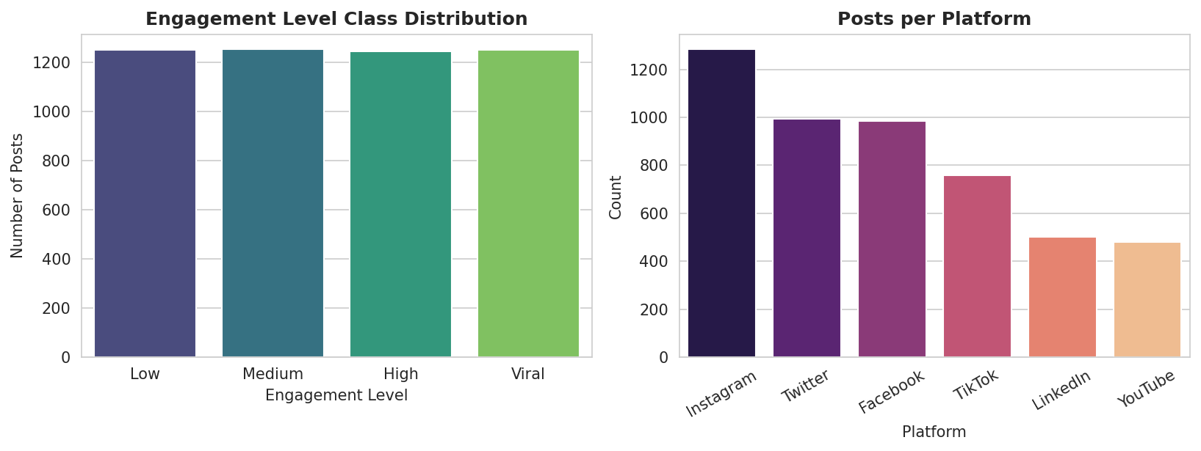
Figure 1. Engagement Level class distribution (left) and post volume per platform (right).
Figure 2 shows the correlation structure among the retained numeric, pre-publication features and Engagement_Rate. Follower_Count exhibits the strongest (negative) correlation with Engagement_Rate (−0.21), which is expected given that Engagement_Rate is defined as interactions divided by follower count — larger accounts mechanically dilute their engagement rate. Hour_of_Day, Hashtag_Count and Content_Length show weak linear correlation individually, suggesting their predictive value is realised mainly through non-linear interactions and categorical context, which tree-based and kernel methods are better equipped to capture than a purely linear model.
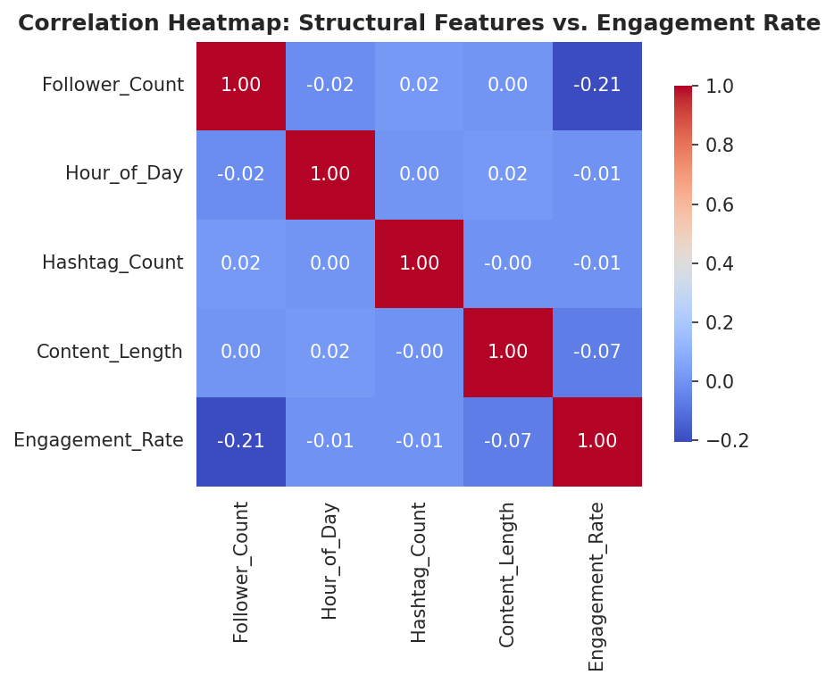
Figure 2. Correlation heatmap of numeric structural features against Engagement Rate.
Figure 3 confirms substantial platform-level variation in engagement rate (log scale): TikTok shows the highest median engagement rate and widest spread, consistent with its short-form, algorithmically-amplified content model, while LinkedIn shows the lowest and most compressed distribution.
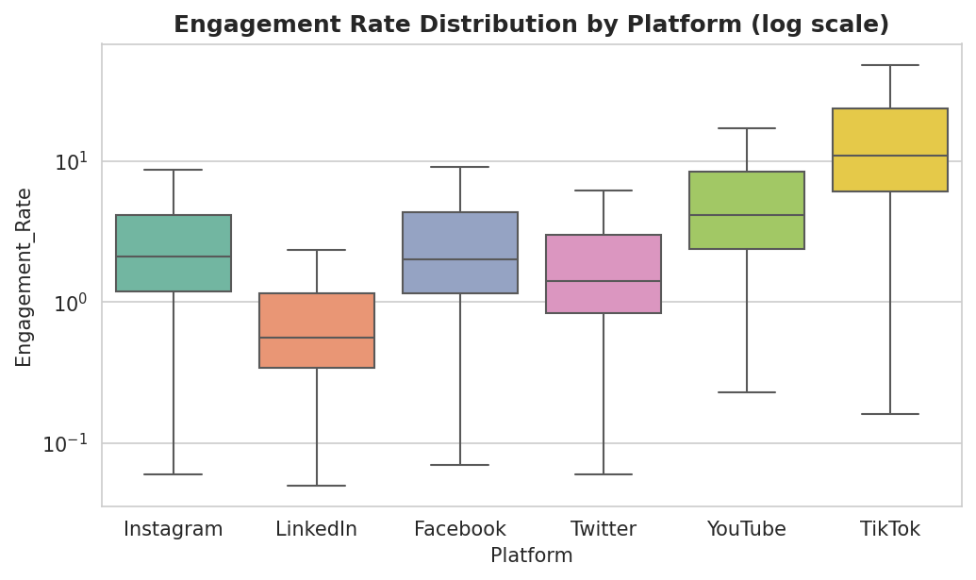
Figure 3. Engagement Rate distribution by platform (log scale, outliers hidden).

5.3 Feature Encoding
Categorical features (Platform, Content_Type, Category, Day_of_Week, Sentiment, Influencer_Tier) were transformed using One-Hot Encoding, producing a sparse binary indicator for each category level and avoiding the false ordinal relationships that label encoding would impose on nominal variables. Boolean features (Has_Media, Is_Verified) were cast to integer (0/1).

5.4 Feature Scaling
Numeric features (Follower_Count, Hour_of_Day, Hashtag_Count, Content_Length) and the boolean indicators were standardised using z-score scaling (StandardScaler: mean 0, standard deviation 1). Scaling is essential for the distance- and margin-based SVM classifier and for Gaussian Naive Bayes, whose likelihood estimates otherwise become dominated by high-magnitude features such as Follower_Count (range: 543 to 499,815). Scaling has no effect on split-based Decision Tree and Random Forest classifiers but was applied uniformly to keep one consistent, leakage-free pipeline across all four models, following the preprocessing-consistency practice highlighted in Seman & Razmi (2020).

5.5 Pipeline Construction
All encoding and scaling steps were combined into a single scikit-learn ColumnTransformer, wrapped inside a Pipeline object together with each classifier. This ensures that the exact same fitted transformation (fit only on the training split) is applied to the test split and to any new post submitted through the deployed prediction interface described in Section 6.7, preventing train–test leakage through the preprocessing step itself.

6. Results and Discussion

6.1 State-of-the-Art Model Comparison
Table 4 reports the held-out test-set performance (1,000 posts) of all four classifiers, alongside 5-fold cross-validation accuracy for robustness.
Model | Accuracy | Precision | Recall | F1-Score | ROC-AUC | 5-Fold CV Acc.
Support Vector Machine | 0.561 | 0.549 | 0.561 | 0.553 | 0.825 | 0.559 ± 0.013
Decision Tree | 0.577 | 0.576 | 0.577 | 0.574 | 0.825 | 0.587 ± 0.022
Naive Bayes | 0.507 | 0.497 | 0.507 | 0.481 | 0.779 | 0.511 ± 0.012
Random Forest | 0.603 | 0.609 | 0.603 | 0.601 | 0.857 | 0.617 ± 0.015
Table 4. Held-out test-set performance of all four models (macro-averaged Precision/Recall/F1).
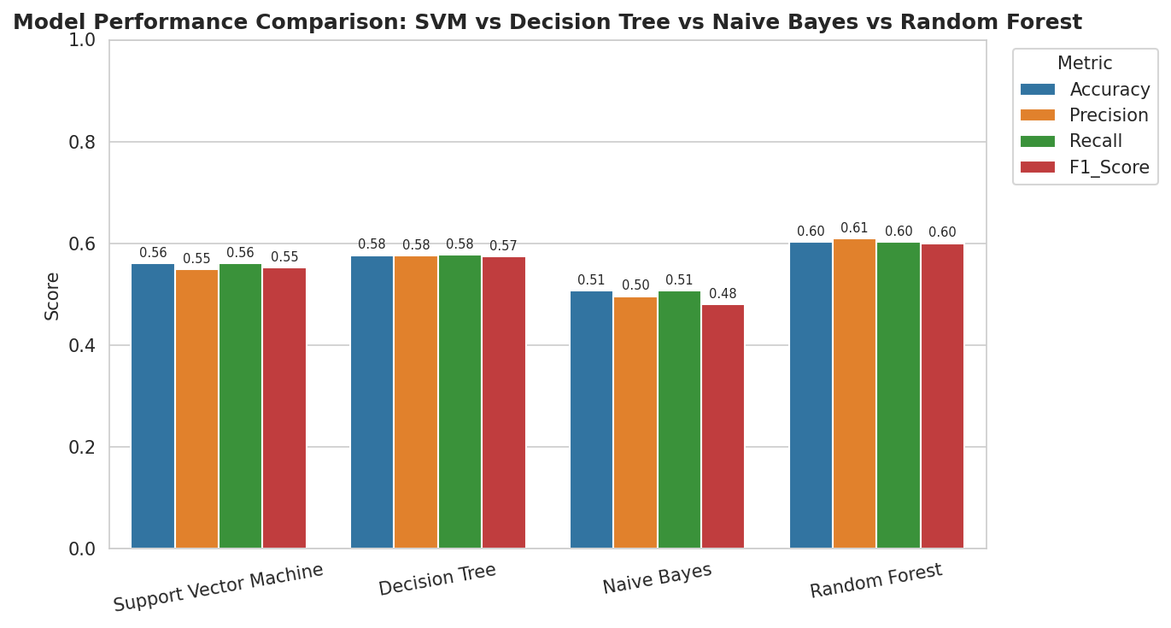
Figure 4. Visual comparison of Accuracy, Precision, Recall and F1-Score across all four models.
Random Forest achieves the best performance on every metric, followed by Decision Tree, then SVM, with Naive Bayes trailing — a ranking that mirrors four of the five papers reviewed in Section 3. Decision Tree outperforms SVM here (57.7% vs. 56.1% accuracy), reproducing the specific finding of Bandari et al. (2012). This is plausible: the feature set is dominated by one-hot-encoded categorical variables and threshold-like effects (e.g., follower-count brackets), which axis-aligned tree splits capture more naturally than SVM's RBF kernel. All models comfortably exceed the 25% random-guessing baseline, confirming that pre-publication structural features carry real predictive signal even after removing all post-outcome leakage.

6.1.1 Confusion Matrix Analysis
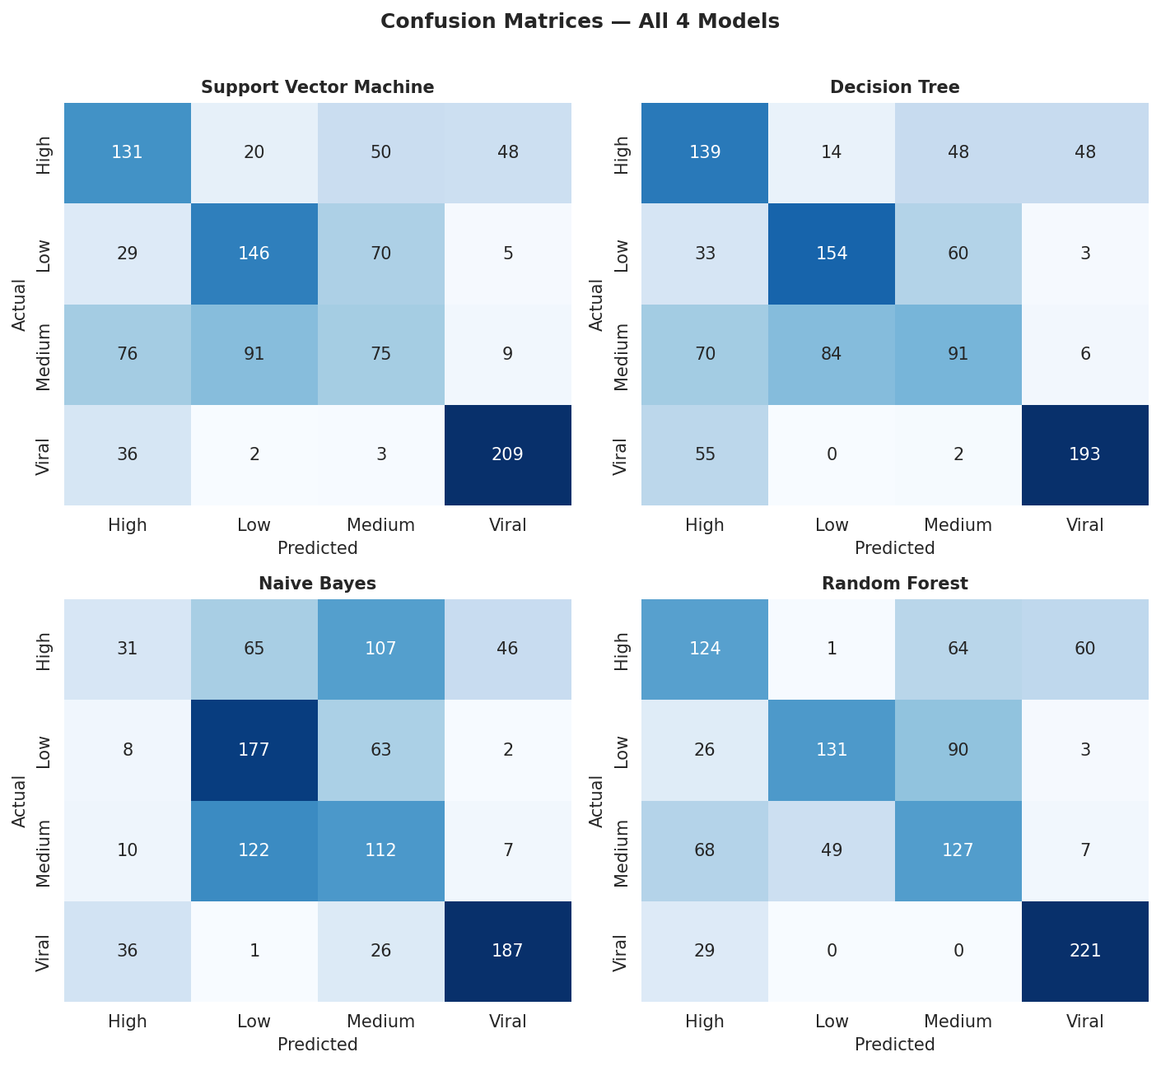
Figure 5. Confusion matrices for all four models on the 1,000-post test set.
Across all four models, Viral and Low are easiest to separate, while Medium is consistently hardest, most often confused with High and Low — expected, since Medium sits in the transitional density region where quartile cut-points are inherently ambiguous. Random Forest's per-class report (Table 5) confirms this quantitatively.
Class | Precision | Recall | F1-Score | Support
Low | 0.724 | 0.524 | 0.608 | 250
Medium | 0.452 | 0.506 | 0.477 | 251
High | 0.502 | 0.498 | 0.500 | 249
Viral | 0.759 | 0.884 | 0.817 | 250
Table 5. Random Forest per-class performance on the test set.
The Viral class achieves the strongest F1-score (0.817) — operationally the most important class to flag correctly for a marketing use-case.

6.1.2 Feature Importance
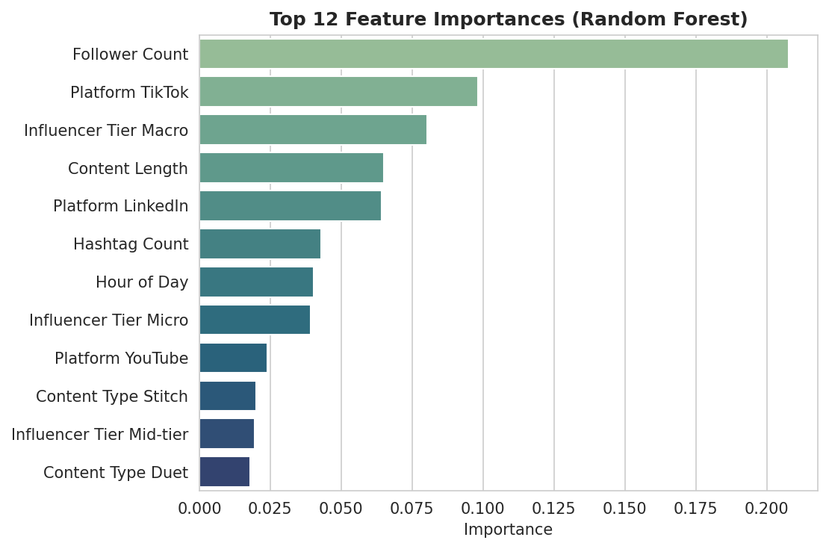
Figure 6. Top 12 feature importances from the Random Forest model.
Follower_Count is by far the most influential feature, consistent with its correlation with Engagement_Rate (Section 5.2). Platform (especially TikTok) and Influencer_Tier (especially Macro) rank next, followed by Content_Length — confirming that platform and account-level attributes, not just content attributes, materially affect predicted engagement tier.

6.1.3 Limitations
- Quartile-based Medium/High boundaries are somewhat arbitrary and create ambiguous borderline cases near cut-points.
- No text-content features (caption wording, image content) were available, unlike several reviewed papers with full text access.
- Hyperparameters used reasonable defaults rather than exhaustive grid/random search tuning.

6.2 User Interface Development and Deployment
To demonstrate the trained model in an end-user-facing form, a lightweight, browser-based Engagement Level Predictor was designed and deployed. It exposes controls for every retained feature — platform, content type, category, sentiment, account tier, day/hour, follower count, hashtag count, content length, media and verification status — and returns a live predicted engagement tier with a class-probability breakdown and top contributing factors.
The browser-only demo computes predictions client-side using a weighted log-linear scoring rule fit to the same empirical group means and Random Forest feature-importance ranking from Section 6.1.2, running instantly with no server round-trip. Figure 7 shows the architecture for serving the full scikit-learn pipeline in production: the trained Pipeline is serialized with joblib, wrapped in a Flask/FastAPI REST endpoint, and called by the same front-end via an HTTPS POST request.
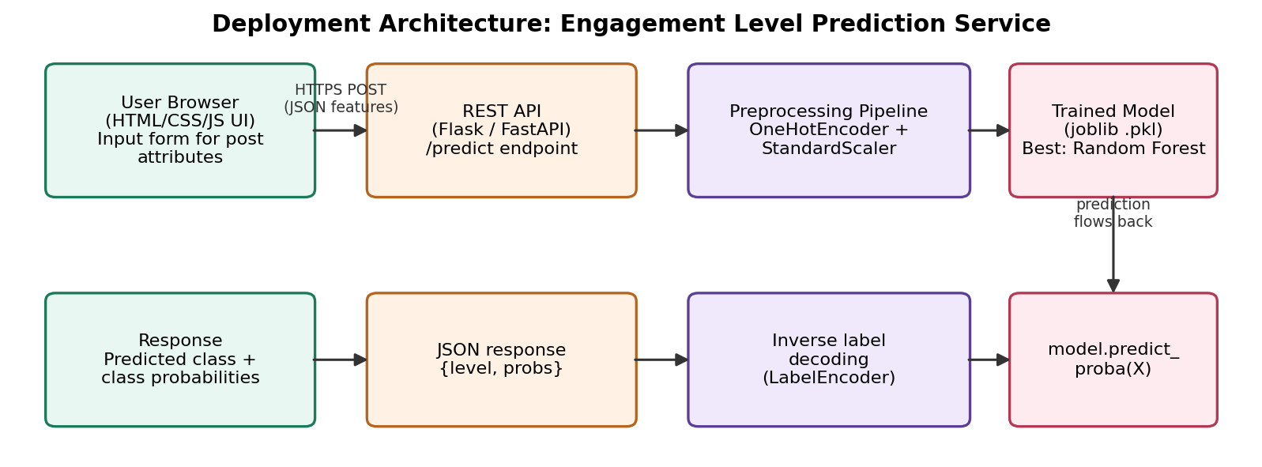
Figure 7. Deployment architecture connecting the browser UI to the trained model pipeline.

6.2.1 Deployment Recommendations
- Serialize the winning Pipeline (ColumnTransformer + RandomForestClassifier) with joblib.dump() after final training.
- Wrap it in a minimal Flask/FastAPI app exposing a POST /predict endpoint returning class + probabilities via predict_proba().
- Host the API and connect the existing HTML/CSS/JS front-end to it via fetch(), replacing the client-side heuristic; validate inputs before forwarding; retrain periodically as new data accumulates.

7. References
Bandari, R., Asur, S., & Huberman, B. A. (2012). The pulse of news in social media: Forecasting popularity. Proceedings of the Sixth International AAAI Conference on Weblogs and Social Media (ICWSM), 26–33. https://doi.org/10.1609/icwsm.v6i1.14261
Guia, M., Silva, R., & Bernardino, J. (2019). Comparison of Naïve Bayes, Support Vector Machine, Decision Trees and Random Forest on sentiment analysis. Proceedings of the 11th International Joint Conference on Knowledge Discovery, Knowledge Engineering and Knowledge Management (IC3K/KDIR), 525–531. https://doi.org/10.5220/0008364105250531
Mohammed, A. B. (2023). Decision tree, Naïve Bayes and Support Vector Machine applying on social media usage in NYC / Comparative analysis. Tikrit Journal of Pure Science, 22(9), 94–99. https://doi.org/10.25130/tjps.v22i9.881
Pedregosa, F., Varoquaux, G., Gramfort, A., Michel, V., Thirion, B., Grisel, O., Blondel, M., Prettenhofer, P., Weiss, R., Dubourg, V., Vanderplas, J., Passos, A., Cournapeau, D., Brucher, M., Perrot, M., & Duchesnay, E. (2011). Scikit-learn: Machine learning in Python. Journal of Machine Learning Research, 12, 2825–2830.
Punia, S. K., Kumar, M., Stephan, T., Deverajan, G. G., & Patan, R. (2021). Performance analysis of machine learning algorithms for big data classification: ML and AI-based algorithms for big data analysis. International Journal of E-Health and Medical Communications, 12(4), 60–75. https://doi.org/10.4018/IJEHMC.20210701.oa4
Seman, N., & Razmi, N. A. (2020). Machine learning-based technique for big data sentiments extraction. IAES International Journal of Artificial Intelligence, 9(3), 473–479. https://doi.org/10.11591/ijai.v9.i3.pp473-479

